**Intro to OOP + Composer**

Create a small library package and consume via Composer

1. Create a Project Name “StringUtils” which will be used as a Package for some Other Project.
2. In Terminal Type “composer init”.

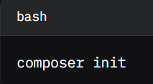

1. Input the Details like Package-name,Description etc:

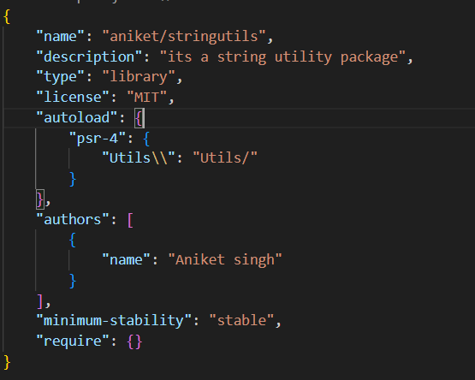

1. Create a Utils folder and add your Class there.

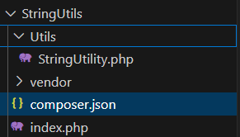

1. Test the class in that folder if wanted using the index.php file
2. Create a New Folder Name “ConsumerApp” in which we will use this StringUtils Package.
3. Use “composer init”
4. Input all the details like done above.
5. In “composer.json” add two lines: (Note: In “require” use the package name to be installed like in our case “aniket/stringutils”)

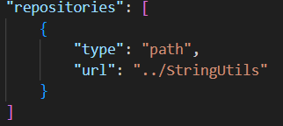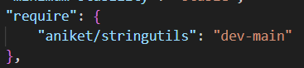

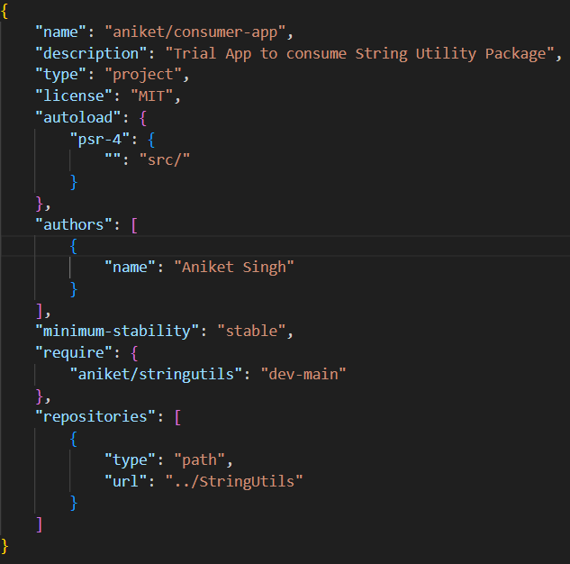

1. Now Run “composer install” it will install the packages in the “require” from the path given in the “repositories”

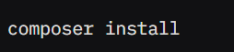

1. Now use the package using the “use” command.

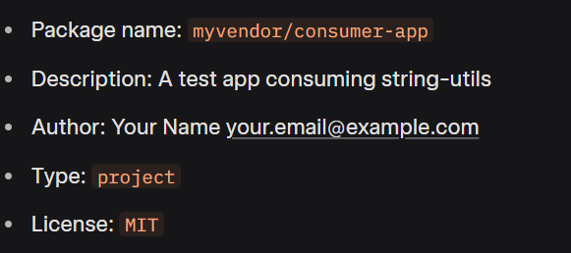

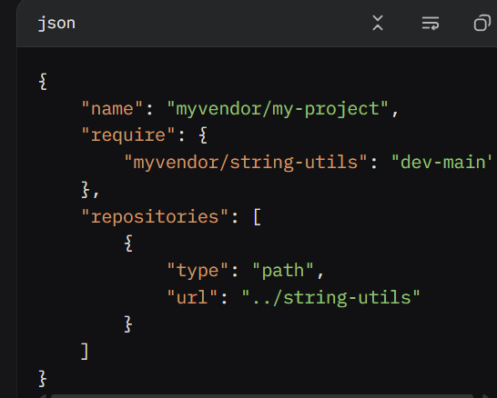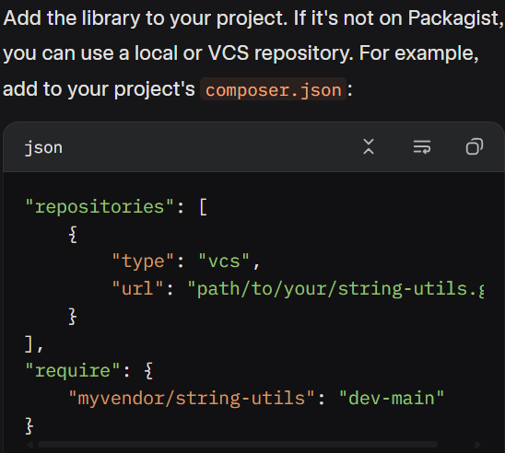

**PSR-12**

### Key PSR-12 Coding Standards

1. **General**:
   1. Files must use <?php or <?= tags, with no other variations.
   2. Files must use UTF-8 without BOM.
   3. One file should declare either new symbols (classes, functions, etc.) or perform side effects (e.g., output), but not both.
2. **Indentation and Lines**:
   1. Use 4 spaces for indentation (no tabs).
   2. Lines should not exceed 120 characters; aim for 80 characters where possible.
   3. No trailing whitespace at the end of lines.
   4. Blank lines should be used sparingly to separate logical sections.
   5. Files must end with a single blank line.
3. **Namespaces and Use Statements**:
   1. Namespace declarations must have one blank line after them.
   2. use statements must follow the namespace with one blank line after the block.
   3. Group related use statements together (e.g., all class imports, then functions).
4. **Classes, Properties, and Methods**:
   1. Class names must use StudlyCaps.
   2. Method names must use camelCase.
   3. Opening braces for classes and methods go on the next line.
   4. All properties and methods must have visibility declared (public, protected, or private).
   5. Use one property or method declaration per statement.
5. **Control Structures**:
   1. Use one space after control structure keywords (e.g., if, for, while).
   2. Opening braces for control structures go on the same line.
   3. Parentheses must have no spaces inside them (e.g., if ($condition)).
6. **Operators**:
   1. All binary operators (e.g., +, =, ==) must have a space on either side.
   2. Unary operators (e.g., !, ++) should not have spaces.
7. **Closures and Anonymous Functions**:
   1. Closures must declare function and use with a space after each.
   2. Opening brace goes on the same line as the declaration.
8. **Comments**:
   1. Use // or /* */ for comments; avoid #.
   2. PHPDoc blocks (/** */) are recommended for classes, methods, and properties.

Inheritance & composition • Interfaces & abstract classes • Traits & namespaces • SPL & iterators • Magic methods

**Inheritance & composition:**

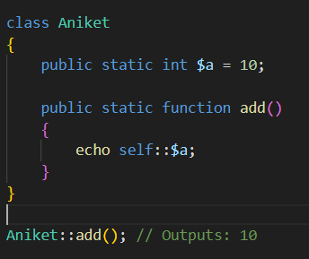 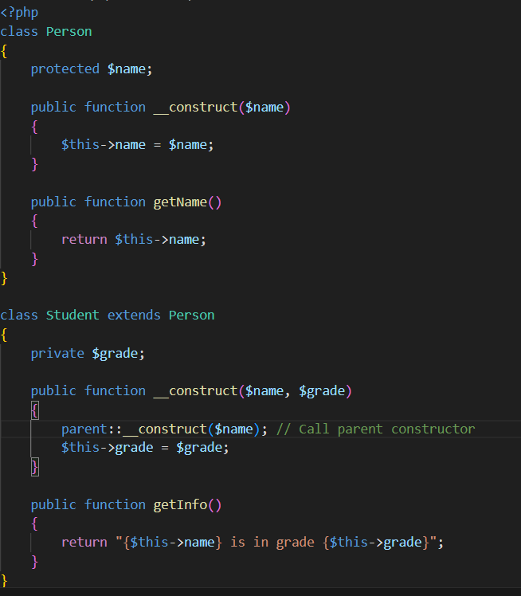

#### Composition

* **Definition**: A class includes an instance of another class as a property, favoring “has-a” relationships over “is-a” (inheritance).
* **Use**: More flexible than inheritance; promotes loose coupling and reusability.

#### Inheritance vs. Composition

* **Inheritance**: Use for clear “**is-a**” relationships (e.g., Student is a Person).
* **Composition**: Use for “**has-a**” relationships or when flexibility is needed (e.g., User has an Address).
* **Best Practice**: Prefer composition over inheritance to avoid tight coupling and complex hierarchies.

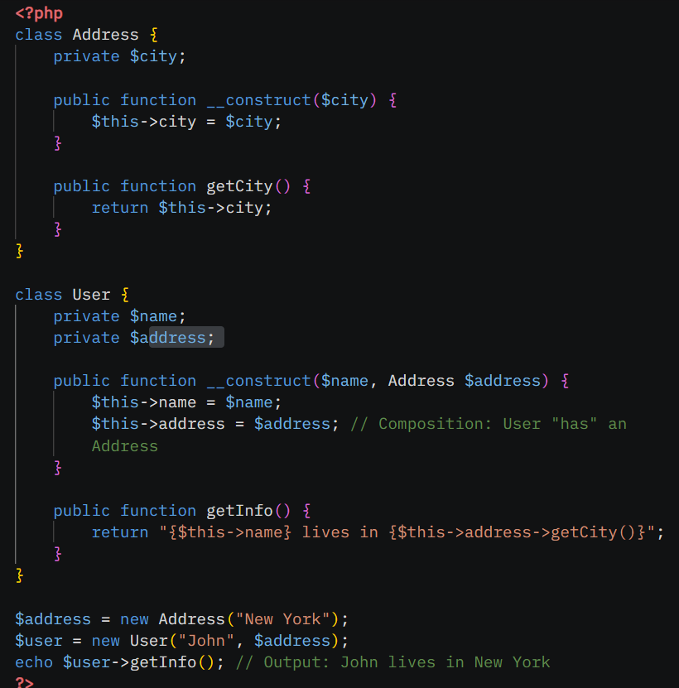

2. Interfaces & Abstract Classes

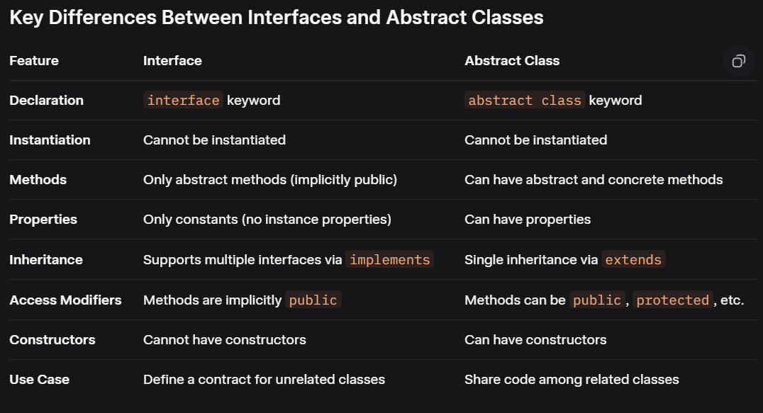

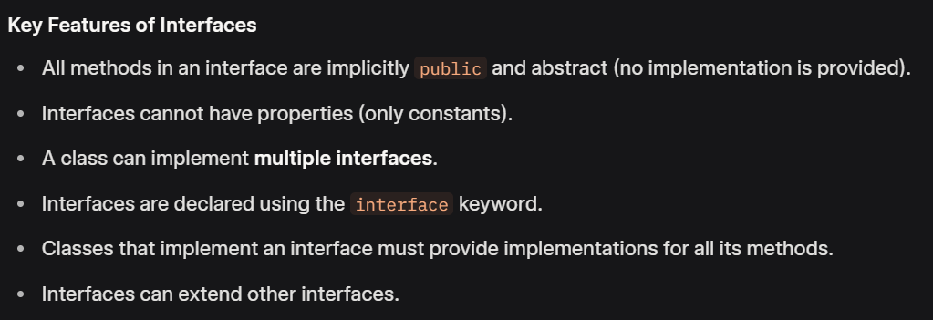

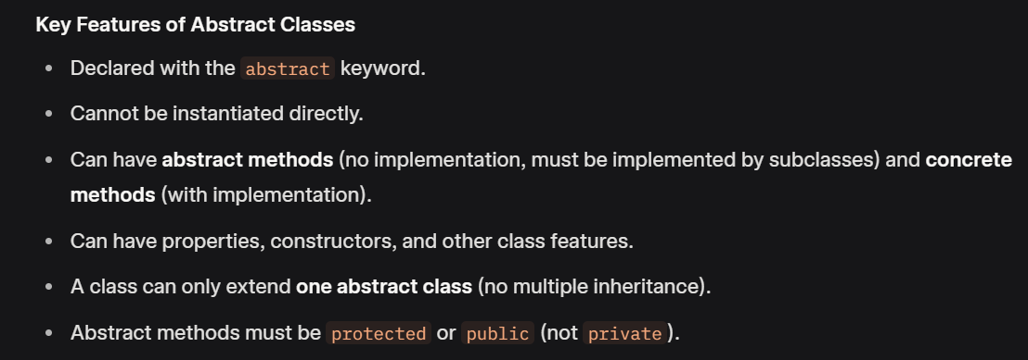

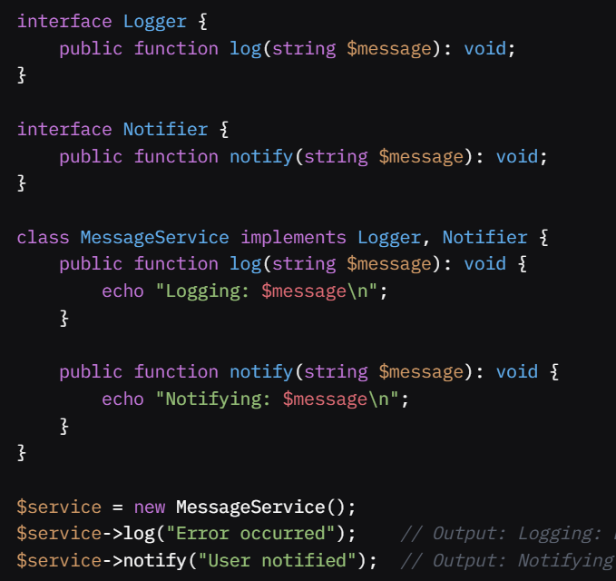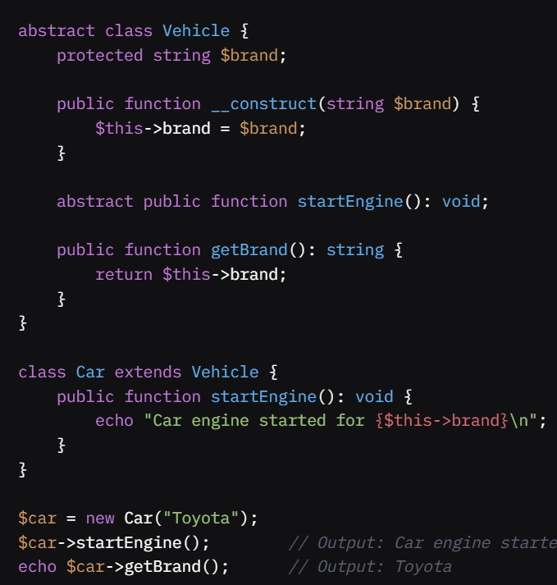

**3. Traits & Namespaces**

### *****Traits in PHP*****

**Traits** are a mechanism for code reuse in PHP, allowing you to share methods across multiple classes without relying on inheritance. They are particularly useful for horizontal code reuse, where functionality is shared among unrelated classes.

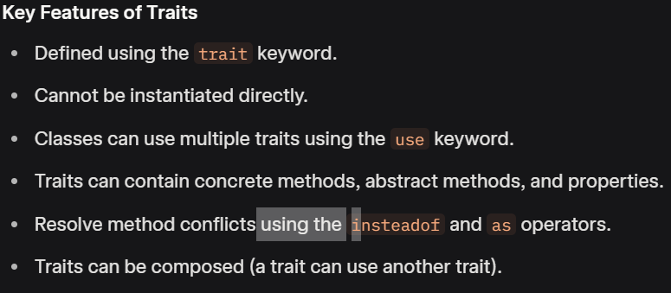

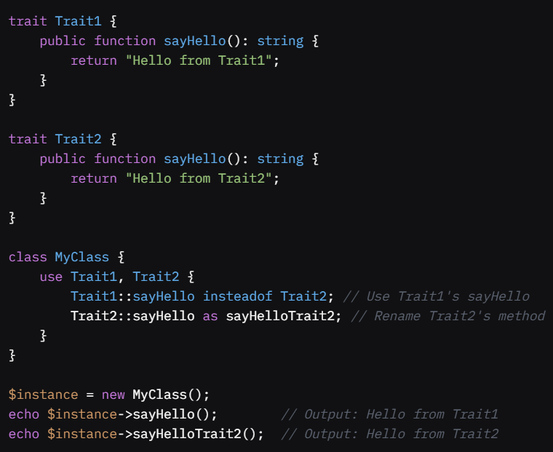

### ****Namespaces in PHP****

**Namespaces** provide a way to organize code by grouping classes, interfaces, traits, and functions under a virtual directory-like structure. They prevent naming conflicts and improve code readability and maintainability.

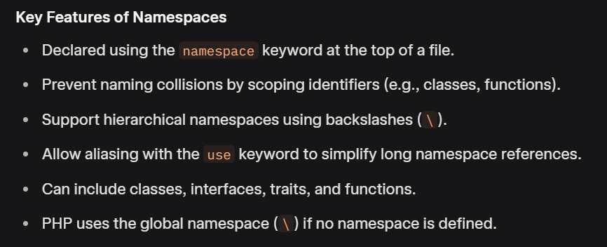

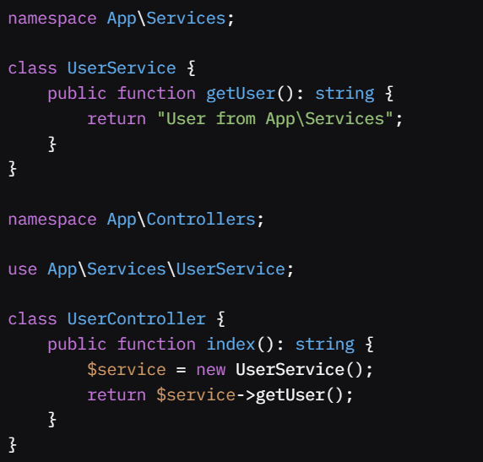 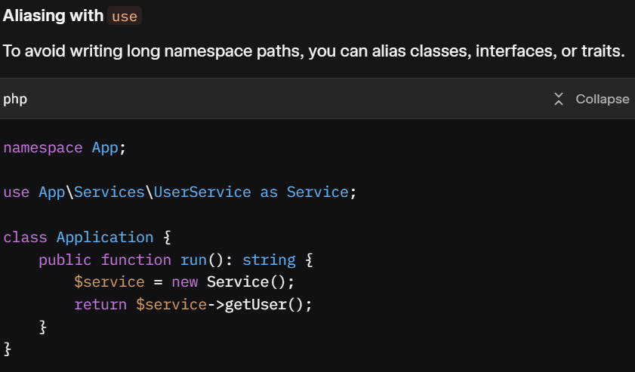

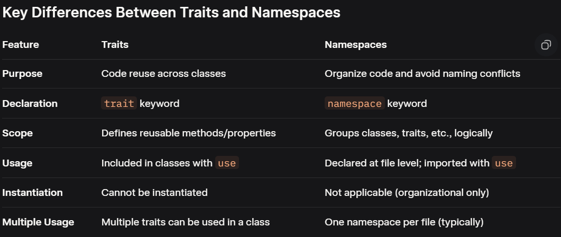

**Magic Methods**

Magic methods are special methods with names starting and ending with double underscores (e.g., __methodName). They are automatically called by the PHP engine in response to specific events or actions, allowing developers to customize object behavior.

### ****Common Magic Methods****

1. **__construct()**
   1. **Purpose**: Called when an object is instantiated with new.
   2. **Use Case**: Initialize object properties or perform setup tasks.

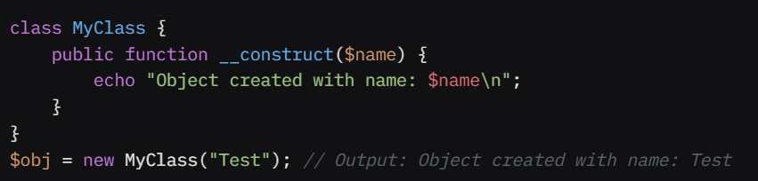

1. **__destruct()**

* **Purpose**: Called when an object is destroyed or the script ends.
* **Use Case**: Clean up resources (e.g., close database connections, release files).

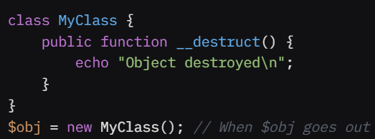

1. **__get($name)**

* **Purpose**: Called when accessing an undefined or inaccessible property.
* **Use Case**: Implement dynamic property access or lazy loading.

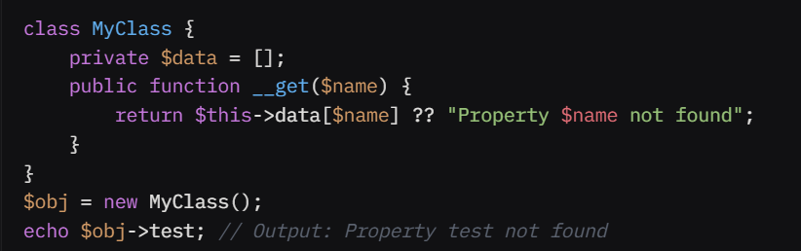

1. **__set($name, $value)**

* **Purpose**: Called when setting a value to an undefined or inaccessible property.
* **Use Case**: Store dynamic properties or enforce validation.

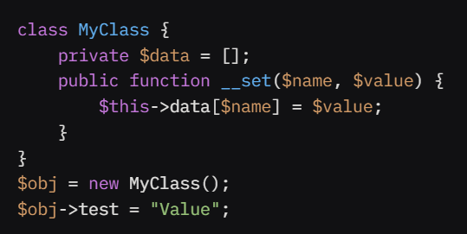

1. **__isset($name)**

* **Purpose**: Called when isset() or empty() is used on an undefined or inaccessible property.
* **Use Case**: Check if a dynamic property exists.

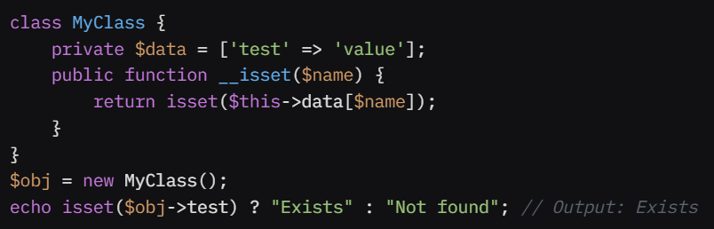

1. **__unset($name)**

* **Purpose**: Called when unset() is used on an undefined or inaccessible property.
* **Use Case**: Remove dynamic properties.

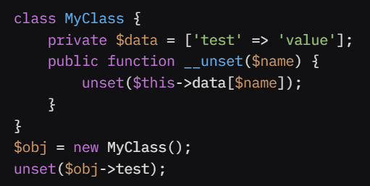

1. **__call($name, $arguments)**

* **Purpose**: Called when an undefined or inaccessible method is invoked.
* **Use Case**: Handle dynamic method calls or create method proxies.

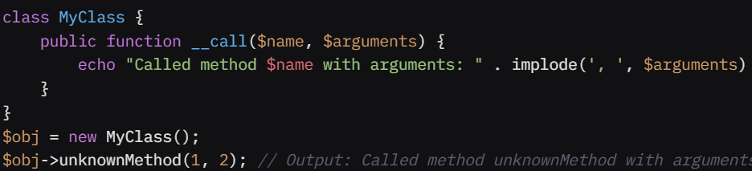

1. **__callStatic($name, $arguments)**

* **Purpose**: Called when an undefined or inaccessible static method is invoked.
* **Use Case**: Handle dynamic static method calls.

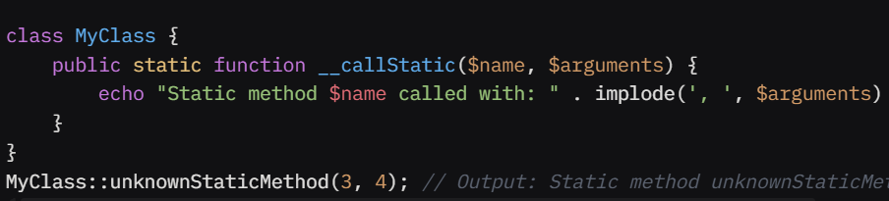

1. **__toString()**

* **Purpose**: Called when an object is used as a string (e.g., in echo or print).
* **Use Case**: Define a string representation of an object.

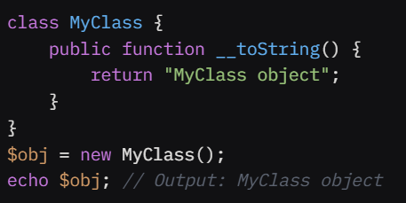

1. **__invoke($arguments...)**

* **Purpose**: Called when an object is used as a function.
* **Use Case**: Create callable objects.

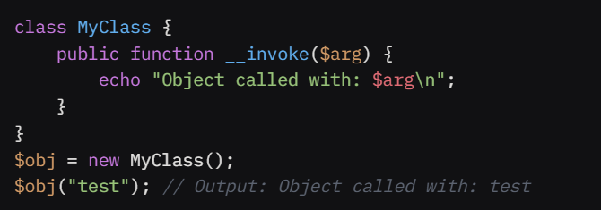

1. **__clone()**

* **Purpose**: Called when an object is cloned using clone.
* **Use Case**: Customize cloning behavior (e.g., deep copy).

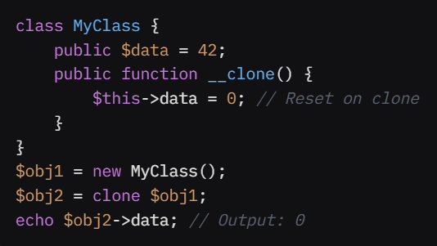

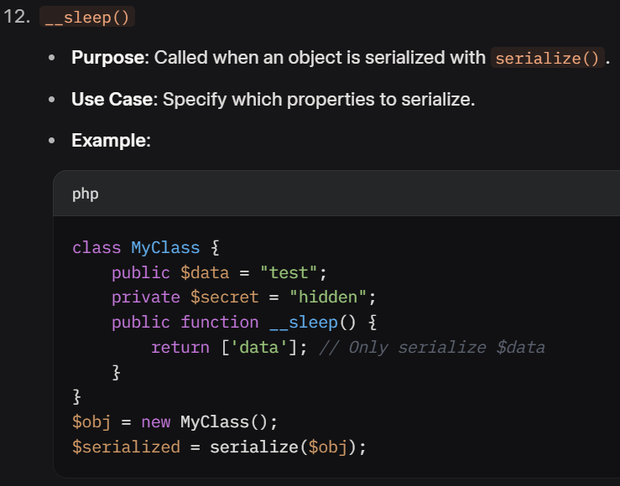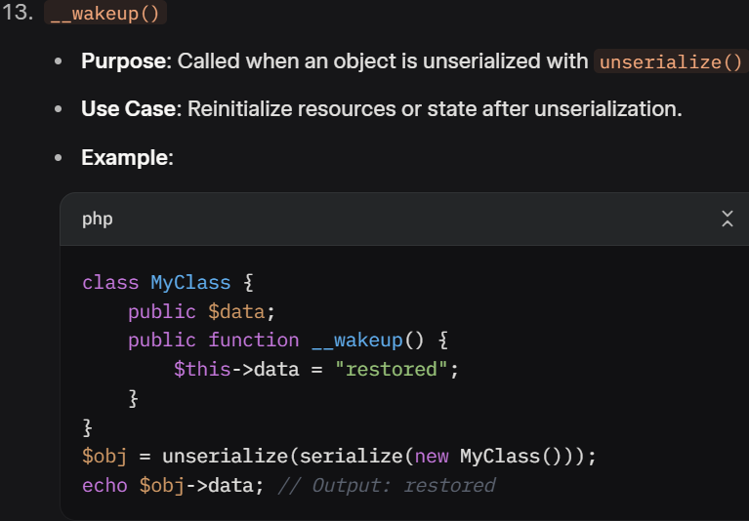

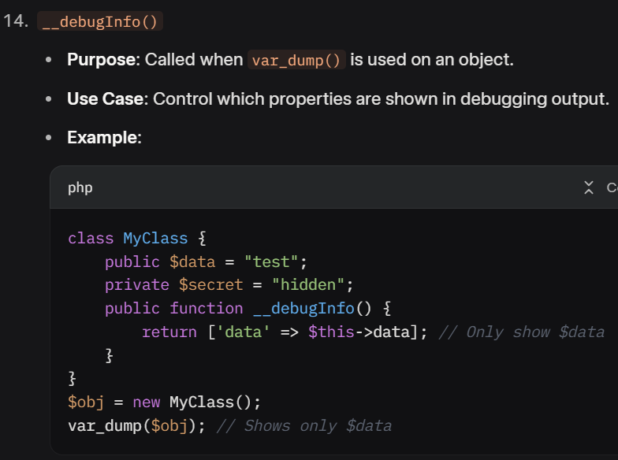

**Error types • Exception handling patterns • Custom exceptions • Monolog basics • Config & env mgmt**

* **Error types**

### 1. Error Types

PHP has three main types of errors, each with different severity and handling mechanisms:

#### Fatal Errors

* **Description**: Severe errors that halt script execution (e.g., calling an undefined function, class not found).
* **Handling**: Cannot be caught with try-catch. Requires checking conditions beforehand or using error_handler.
* **Example**:

*// Fatal error: undefined function*

nonExistentFunction(); *// Script stops*

#### Warnings

* **Description**: Non-fatal errors that allow the script to continue (e.g., missing file in include, invalid array index).
* **Example**:

$array = [];

echo $array[0]; *// Warning: Undefined offset: 0*

#### Notices

* **Description**: Informational errors for non-critical issues (e.g., accessing an undefined variable).
* **Example**:

echo $undefinedVar; *// Notice: Undefined variable: undefinedVar*

#### Error Reporting

* Control error visibility with error_reporting() or php.ini settings:

error_reporting(E_ALL); *// Show all errors*

ini_set('display_errors', '1'); *// Display errors (development only)*

ob_clean(); // Clean output buffer to avoid unexpected output

error_reporting(E_ALL);

ini_set('log_errors', 1);

ini_set('display_errors', 0);

ini_set('error_log', 'error_log.txt');

* **Exception handling patterns**

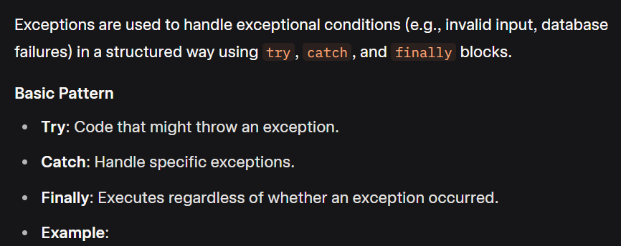

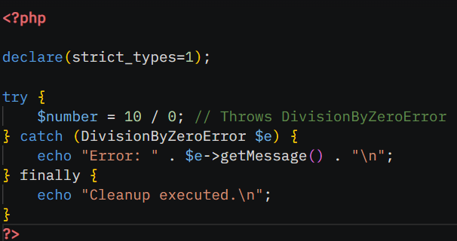

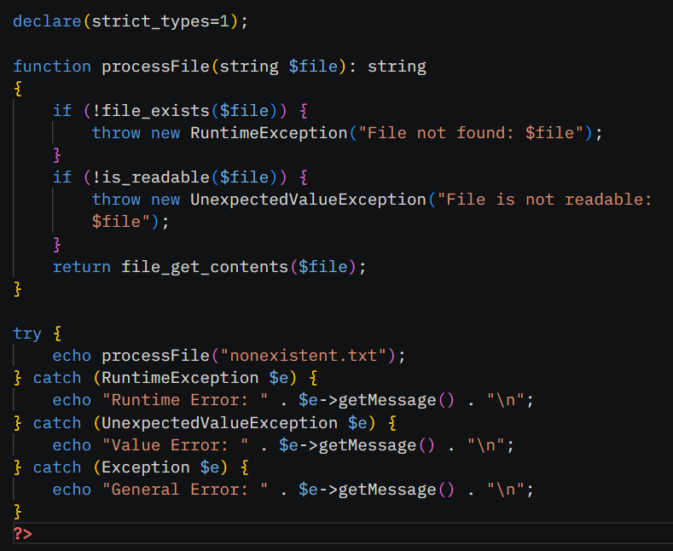

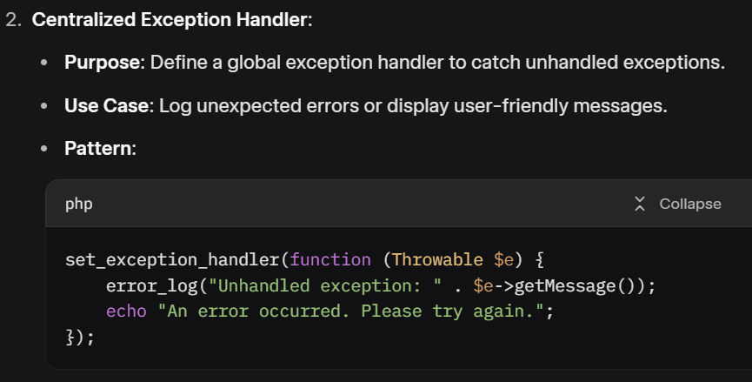

* **Custom exceptions:**

Custom exceptions allow you to create specific exception types for your application, improving clarity and handling.

#### Creating a Custom Exception

* Extend the Exception class or a subclass.
* Add custom properties or methods as needed.
* **Example**: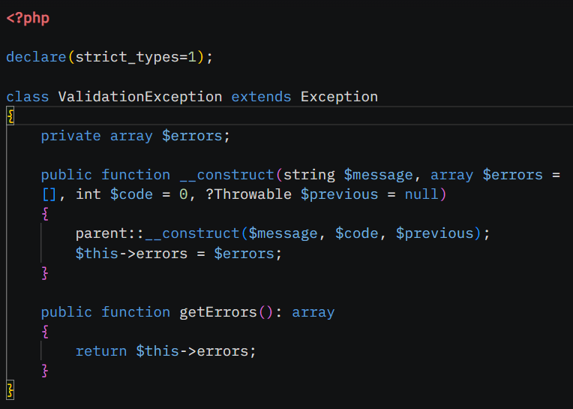

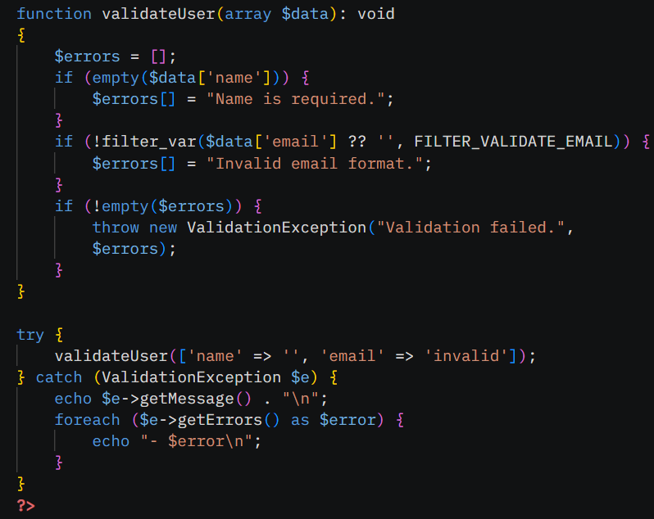

**• Monolog basics**

### ****Monolog Basics****

**Monolog** is a powerful, flexible PHP logging library that adheres to the PSR-3 standard. It’s widely used to log messages (e.g., debug, info, errors) to various destinations like files, databases, or third-party services (e.g., Slack, Sentry).

#### ****Key Concepts****

1. **Logger**: The main class for logging messages, identified by a channel name (e.g., "app").
2. **Handlers**: Define where logs are sent (e.g., files, streams, email, external services).
3. **Processors**: Add extra data to logs (e.g., user ID, request details).
4. **Formatters**: Control the log message format (e.g., JSON, plain text).
5. **Log Levels**: Based on RFC 5424, ranging from DEBUG (least severe) to EMERGENCY (most severe).

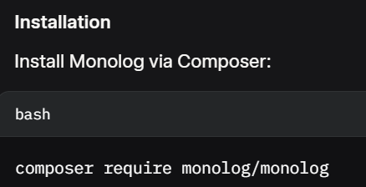

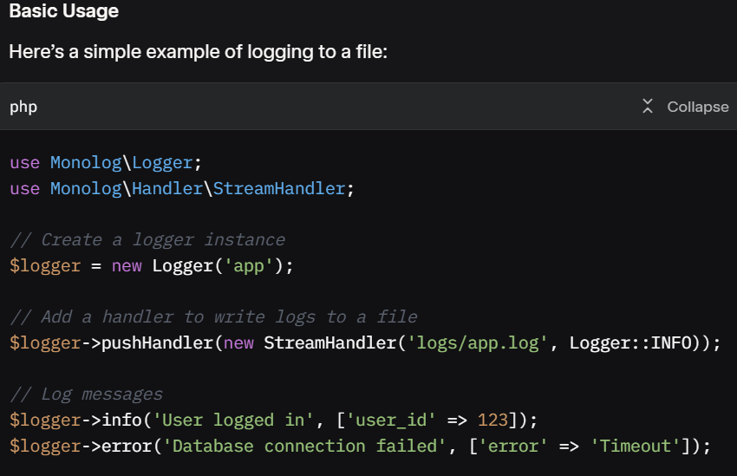

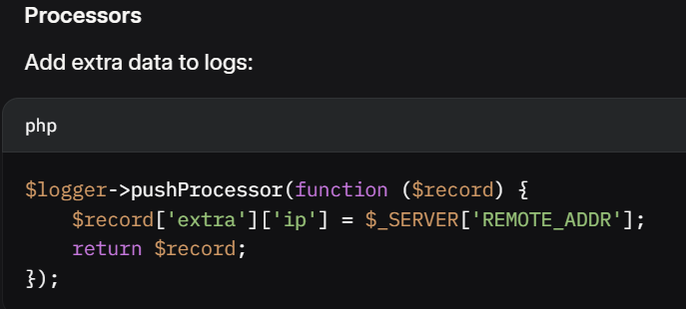

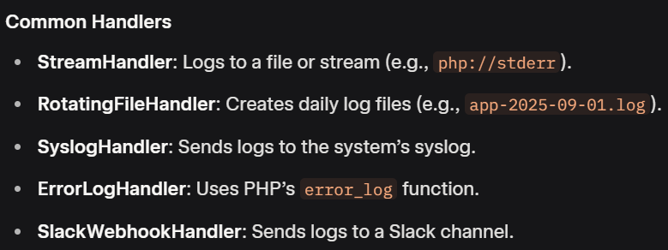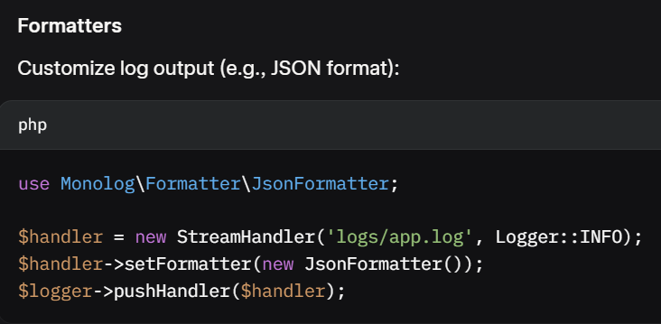

#### ****Log Levels****

* **DEBUG:** Detailed debug info.
* **INFO:** Interesting events (e.g., user login).
* **NOTICE:** Uncommon events.
* **WARNING**: Exceptional occurrences (e.g., deprecated API usage).
* **ERROR:** Runtime errors.
* **CRITICAL:** Critical conditions (e.g., component unavailable).
* **ALERT:** Action must be taken immediately.
* **EMERGENCY:** System is unusable.

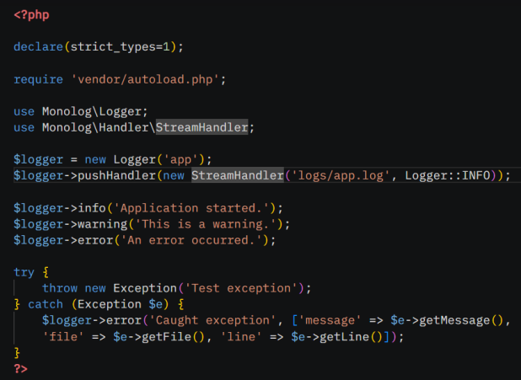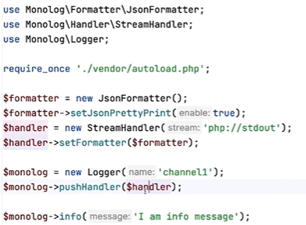

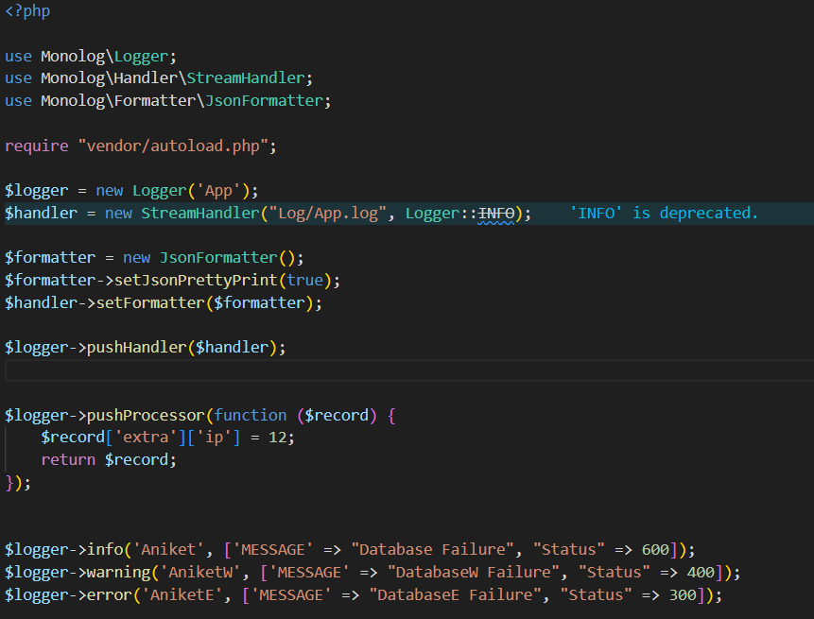

* **Configuration & Environment Management in PHP**

### ****Configuration & Environment Management in PHP****

Managing configuration and environment variables in PHP ensures your application is **secure, portable,** and **adaptable** across environments (e.g., development, staging, production).

#### ****Key Concepts****

1. **Environment Variables**: Store sensitive or environment-specific settings (e.g., database credentials, API keys) outside the codebase.
2. **Configuration Files**: Store non-sensitive, structured settings (e.g., app name, log paths) in files like config.php or config.yaml.
3. **Dotenv**: A popular library to load environment variables from a .env file.
4. **Environment Variable (.env):**

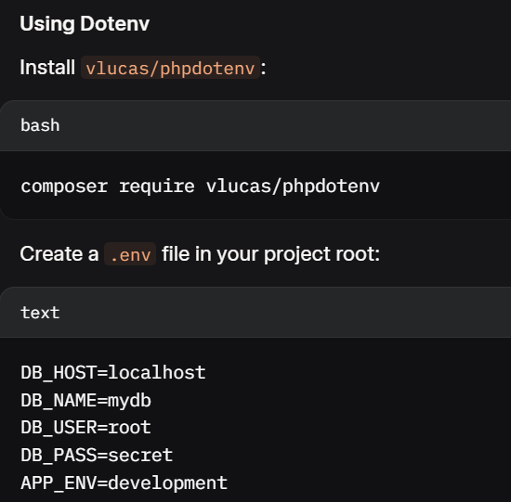

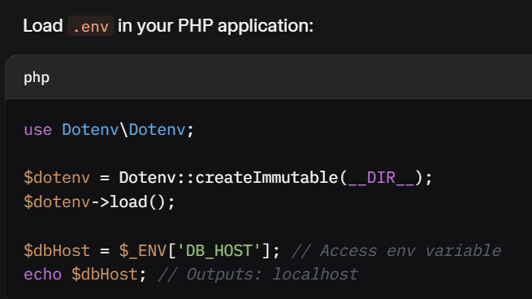

1. **Configuration file (config.php/config.ini):**

Store settings in a PHP file (e.g., config.php) or JSON/YAML.

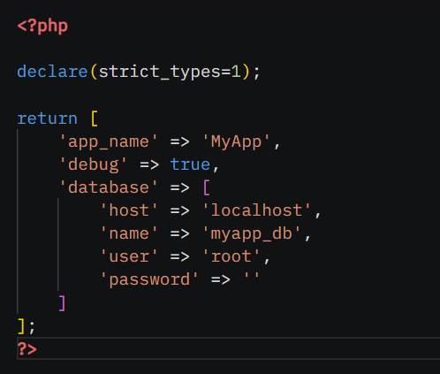

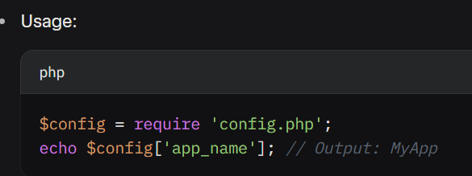

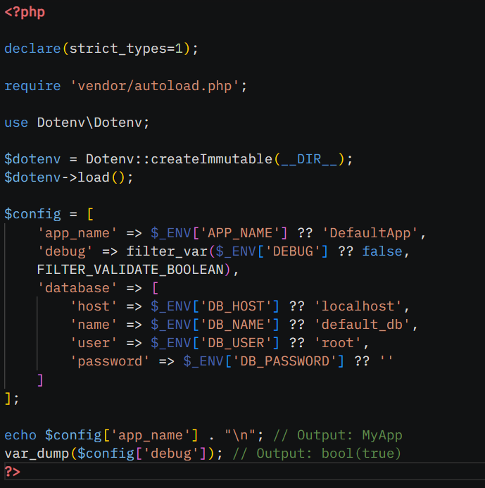

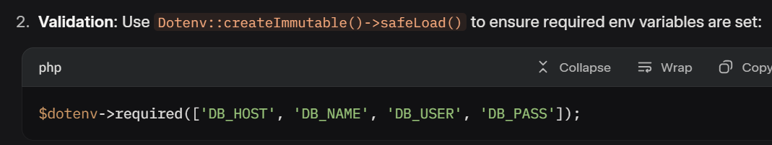

**“Config.ini”**  **“index.php”**

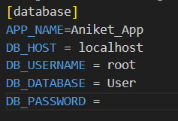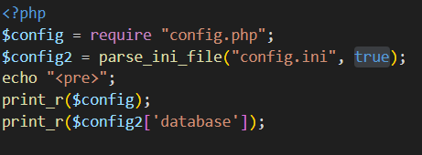

**PDO connection • Prepared statements • Transactions • DAO pattern • Pagination**

* **PDO connection**

### 1. PDO Connection

**PDO (PHP Data Objects)** is a database abstraction layer that provides a consistent interface for interacting with various databases (e.g., MySQL, PostgreSQL, SQLite).

#### Setting Up a PDO Connection

* **Requirements**: Database server (e.g., MySQL), credentials, and PDO enabled (default in PHP).
* **Steps**:
  1. Create a PDO instance with DSN (Data Source Name), username, and password.
  2. Set error mode to exceptions for better error handling.
  3. Optionally configure attributes (e.g., fetch mode).

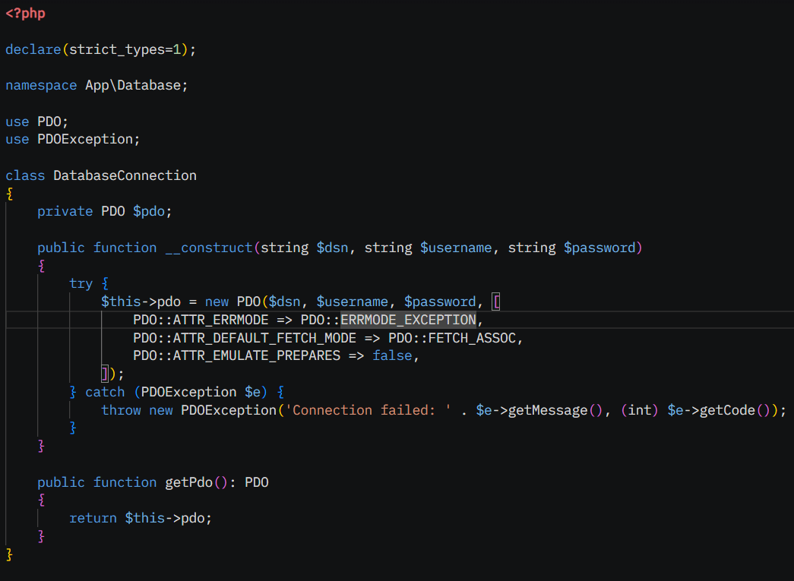

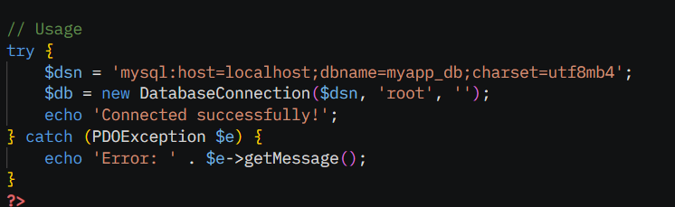

**OR**

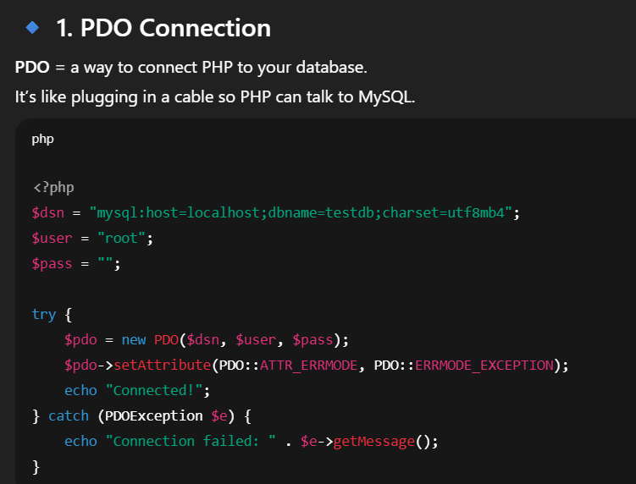

#### Key Notes

* **DSN Format**: Varies by database (e.g., ***mysql:host=localhost;dbname=myapp_db*** for MySQL).
* **Attributes**:
  + **PDO::ATTR_ERRMODE => PDO::ERRMODE_EXCEPTION**: Throws exceptions on errors.
  + **PDO::ATTR_DEFAULT_FETCH_MODE => PDO::FETCH_ASSOC**: Returns associative arrays.
  + **PDO::ATTR_EMULATE_PREPARES** => false: Uses native prepared statements.

### 2. **Prepared Statements**

Prepared statements prevent SQL injection by separating SQL logic from user input, using placeholders (? or named :param).

#### Using Prepared Statements

* **Types**:
  + Positional (?): Bind values by position.
  + Named (:name): Bind values by parameter name.
* **Methods**:
  + prepare($sql): Prepares the SQL statement.
  + bindValue($param, $value, $type): Binds a value to a placeholder.
  + execute(): Executes the prepared statement.
  + fetch(), fetchAll(): Retrieve results.

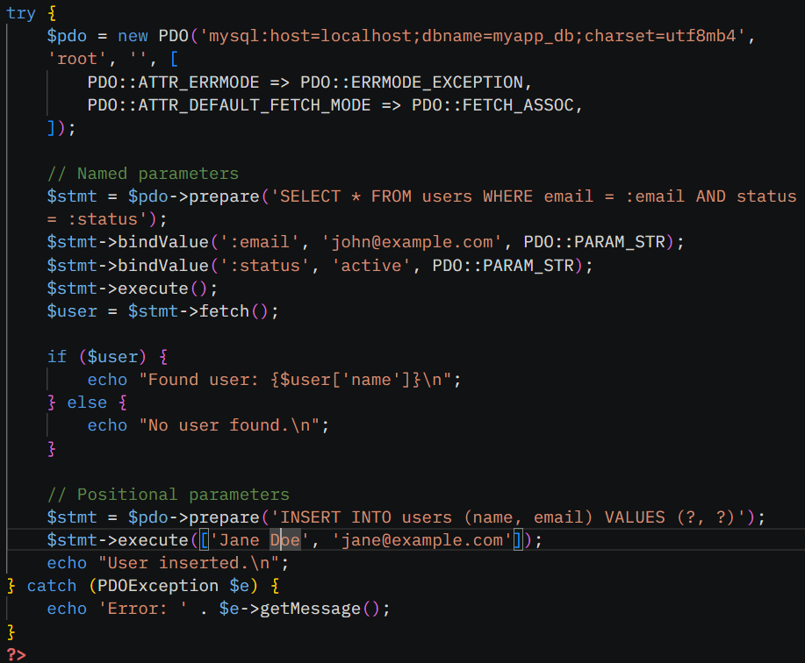

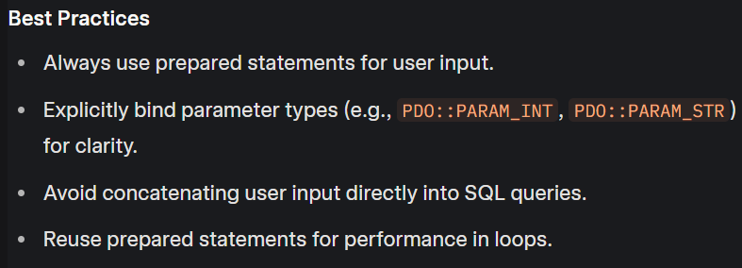

### 3. **Transactions**

Transactions ensure multiple database operations are executed atomically (all succeed or all fail), maintaining data integrity.

#### Transaction Methods

* beginTransaction(): Starts a transaction.
* commit(): Saves changes if all operations succeed.
* rollBack(): Reverts changes if an error occurs.

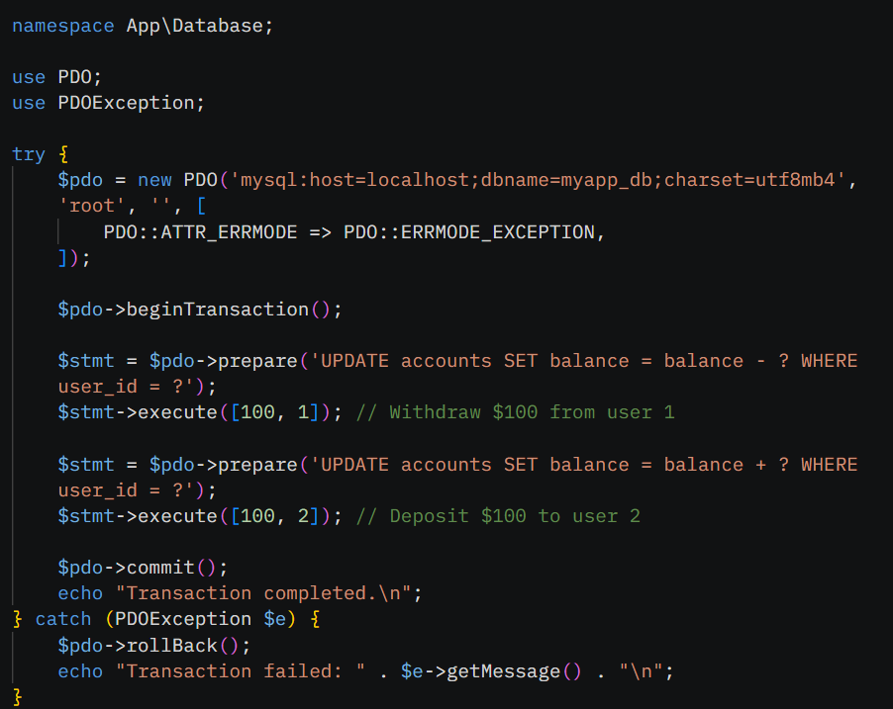

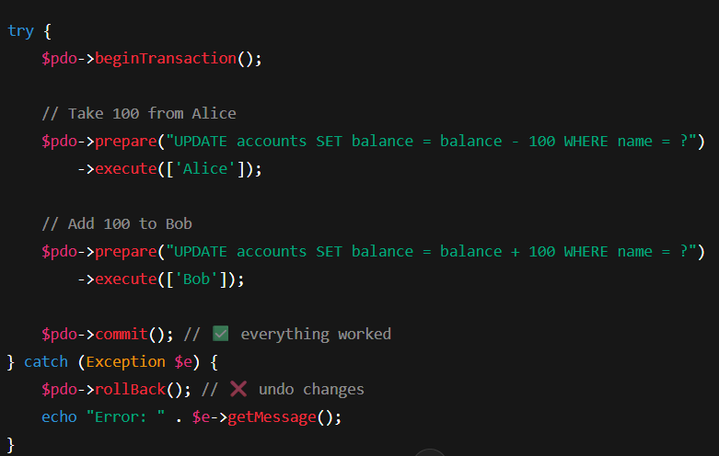

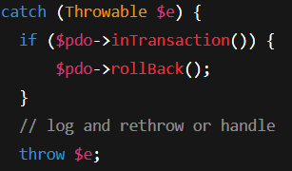

### 4. DAO Pattern

The **Data Access Object (DAO)** pattern separates database logic from business logic, providing a clean interface for data operations.

#### Key Concepts

* **DAO Class**: Encapsulates database operations for a specific entity (e.g., User).
* **Dependency**: Typically depends on a PDO connection.
* **Methods**: CRUD operations (Create, Read, Update, Delete).
* **Example** (Assumes a users table with id, name, email columns):

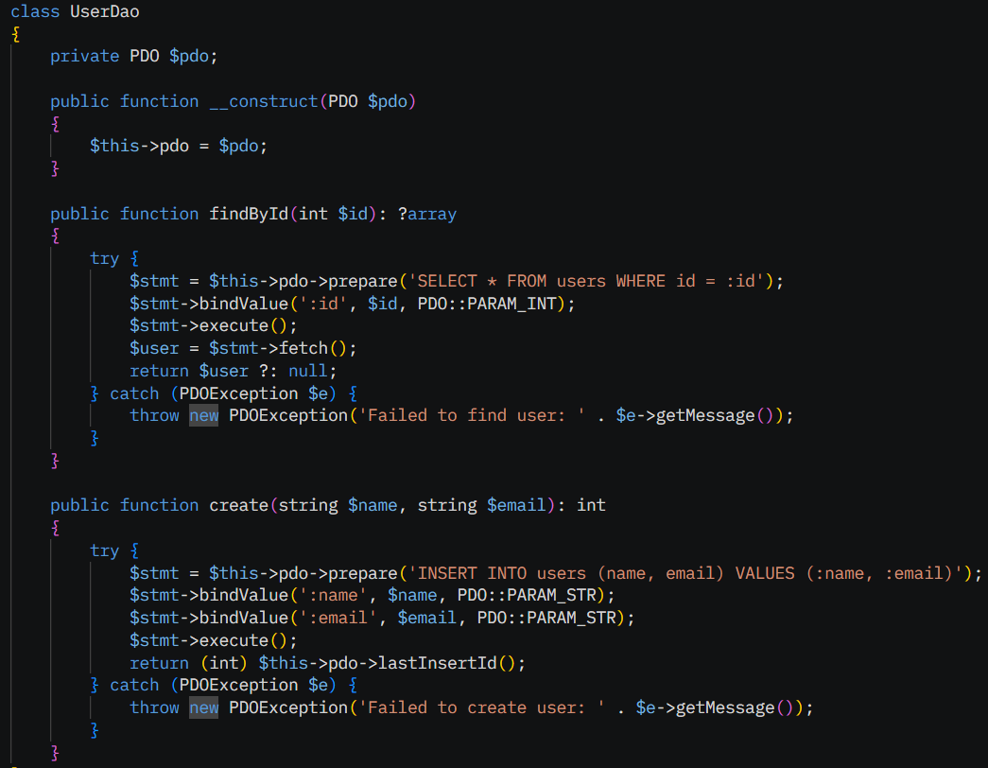

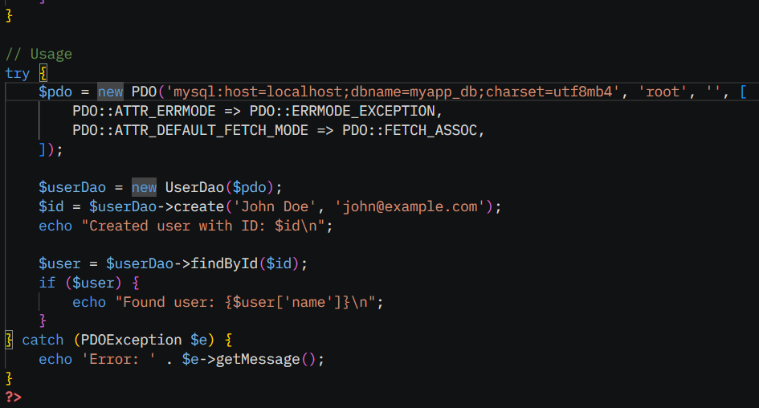

### 5. Pagination

Pagination splits large datasets into smaller pages, improving performance and user experience.

#### Approach

* Use SQL **LIMIT** and **OFFSET** to fetch a subset of records.
* Calculate total pages based on total records and page size.
* Pass the current page via query parameters (e.g., ?page=2).
* **Example** (Web-based pagination with a users table):

Pagination = showing results in pages (like Google search results).  
Instead of showing **all users at once**, you show 5 per page.

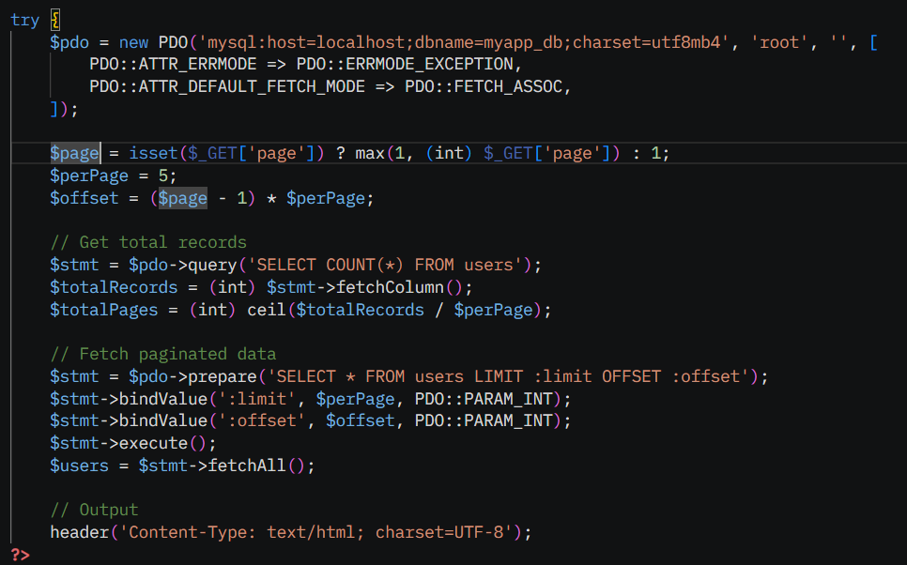

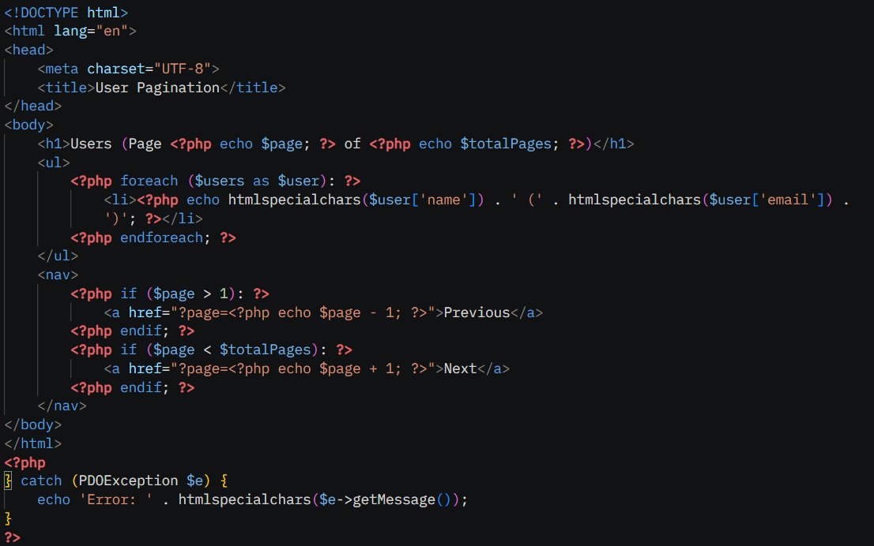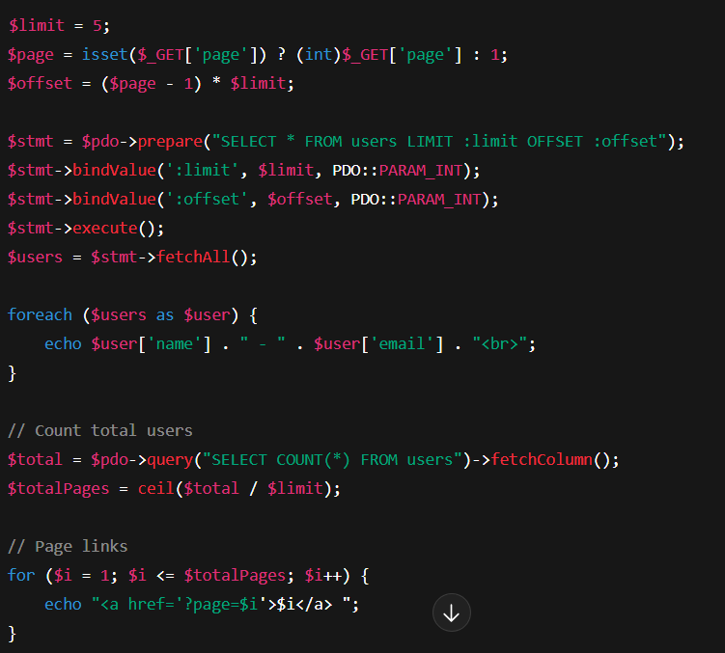

**XSS/CSRF/SQLi prevention • Password hashing (bcrypt/argon2) • Rate limiting (concept) • Input validation libraries • Secure file handling**

* XSS/CSRF/SQLi prevention

#### Cross-Site Scripting (XSS) Prevention

* **Description**: XSS occurs when malicious scripts are injected into web pages viewed by users, often via user input displayed without sanitization.
* **Prevention**:
  + Escape output with htmlspecialchars() or equivalent to convert special characters (e.g., <, >) to HTML entities.
  + Use Content Security Policy (CSP) headers to restrict script sources.
  + Validate and sanitize input to reject malicious content.

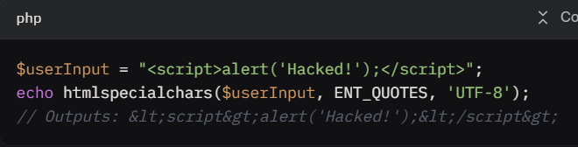

**Content Security Policy (CSP)**:

* Add a CSP header to restrict script sources:

*header("Content-Security-Policy: default-src 'self'; script-src 'self' trusted.cdn.com");*



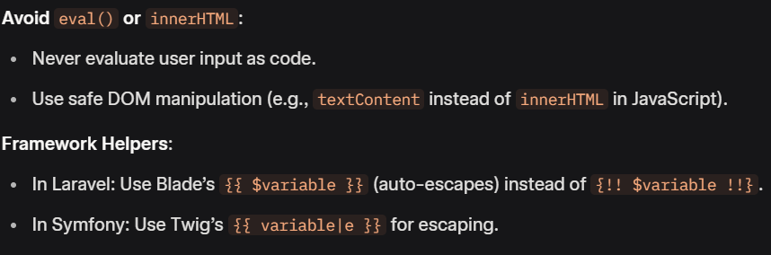

### ****2. CSRF (Cross-Site Request Forgery) Prevention****

CSRF tricks a user’s browser into making unintended requests (e.g., changing a password) using their active session.

#### ****Prevention Techniques****

1. **CSRF Tokens**:

* Generate a unique, unpredictable token for each form and validate it on submission.
* Example in PHP:

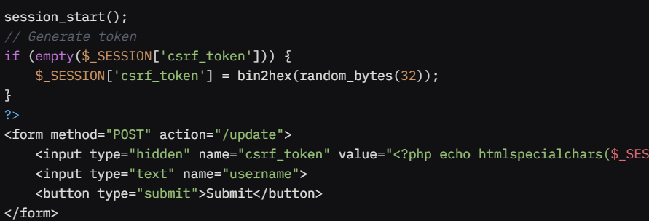

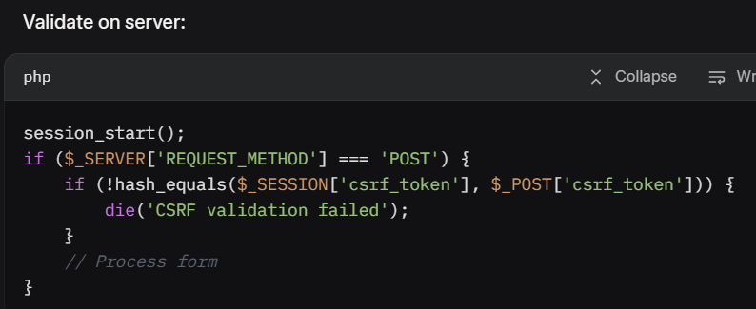

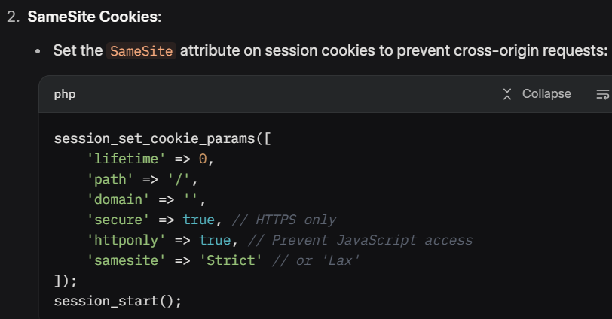

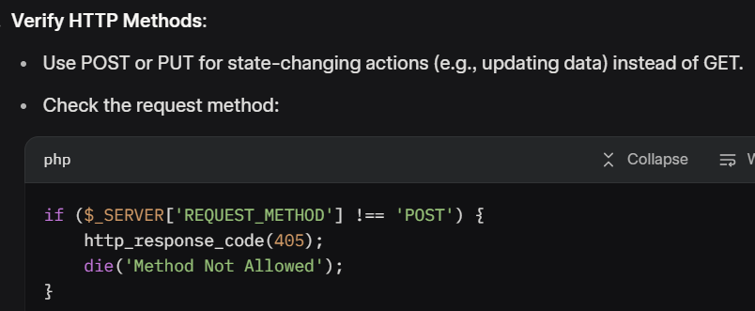

### ****3. SQL Injection (SQLi) Prevention****

SQLi occurs when an attacker injects malicious SQL code into a query, potentially exposing or manipulating database data.

#### ****Prevention Techniques****

1. **Use Prepared Statements and Parameterized Queries**:

* Avoid concatenating user input into SQL queries.
* Use PDO or MySQLi with prepared statements:

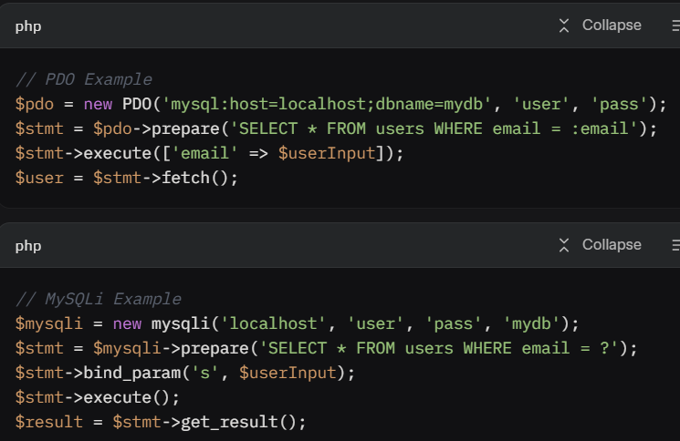

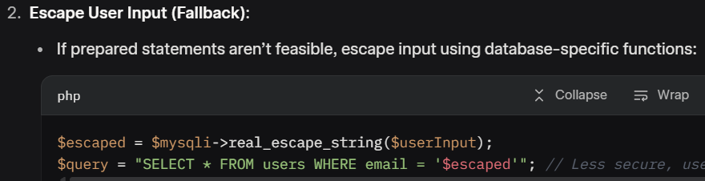

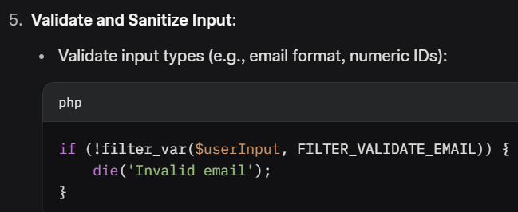

### **Password Hashing (bcrypt/Argon2)**

Secure password hashing protects user passwords by storing them in a way that’s computationally expensive to reverse, even if the database is compromised.

· **bcrypt**: A widely used, battle-tested algorithm based on Blowfish. It’s the **default** in PHP’s password hashing functions and is known for simplicity and security.

· **Argon2**: A newer algorithm, winner of the 2015 Password Hashing Competition. It’s highly configurable, resistant to GPU-based attacks, and suitable for modern applications.

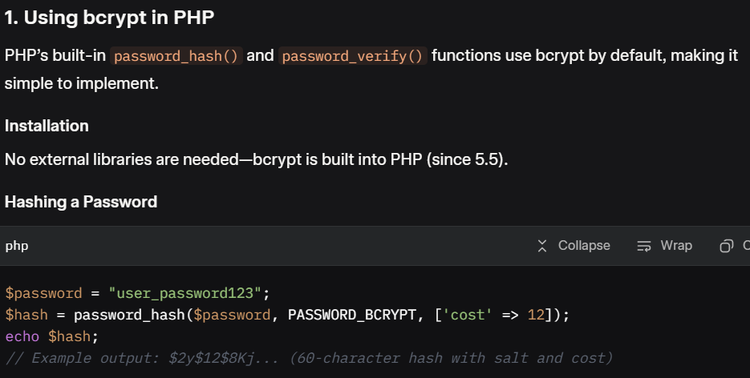

**Options**:

* **cost:** Controls computational effort (default is 10). Higher values (e.g., 12) are more secure but slower. Adjust based on server performance (aim for ~100-300ms per hash).

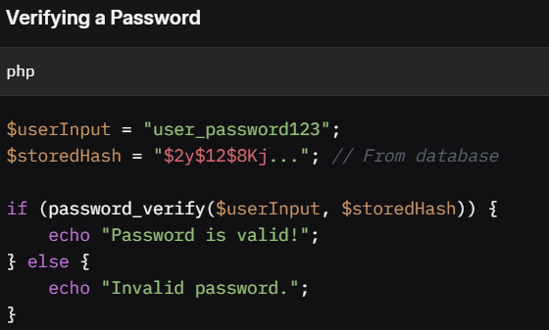

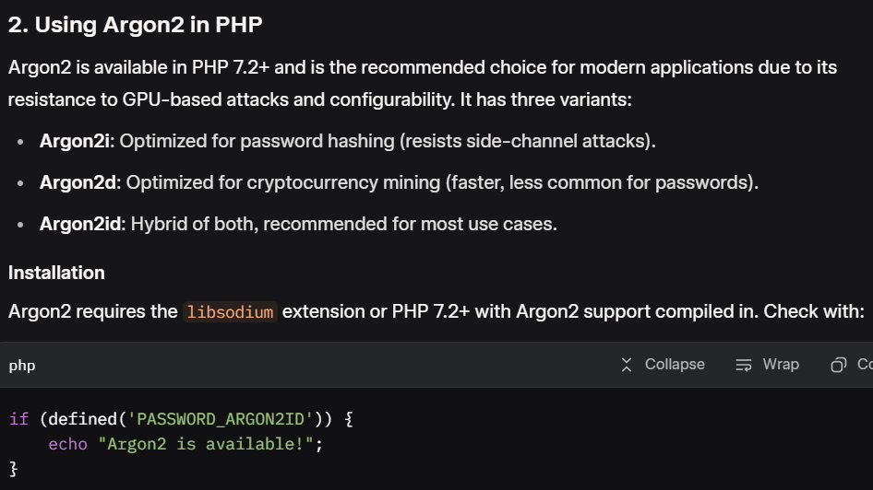

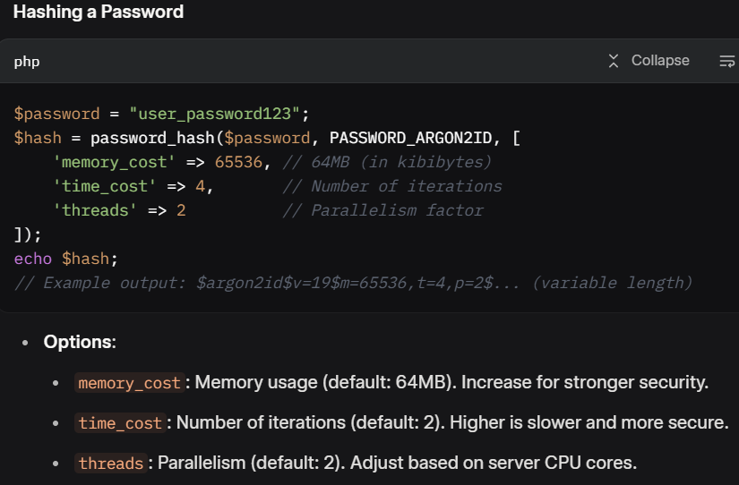

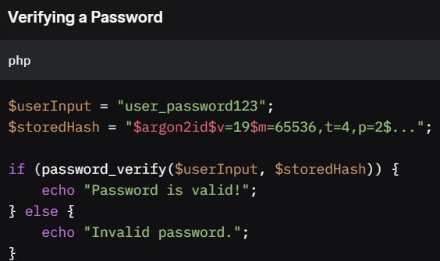

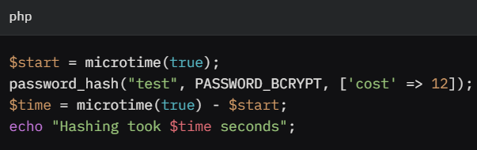

* **Rate Limiting (Concept)**

### ****Concept of Rate Limiting****

Rate limiting restricts the number of requests (e.g., API calls, login attempts, form submissions) a client can make to a server in a specific period (e.g., per second, minute, or hour). It mitigates threats like brute-force attacks, denial-of-service (DoS) attacks, and API abuse while ensuring system stability.

#### ****Key Components****

1. **Identifier**: Determines who is making the request (e.g., user ID, IP address, API key).
2. **Limit**: The maximum number of allowed requests (e.g., 100 requests/hour).
3. **Time Window**: The duration for tracking requests (e.g., 1 hour, 1 minute).
4. **Action**: What happens when the limit is exceeded (e.g., block request, return HTTP **429** Too Many Requests).

#### ****How It Works****

* Track requests per identifier in a storage system (e.g., in-memory like Redis, database, or session).
* For each request, check if the limit is exceeded within the time window.
* If exceeded, reject the request; otherwise, allow it and update the counter.

#### Implementation Options

* **Database**: Store request counts with timestamps.
* **Redis**: Use expiring keys for high-performance tracking (e.g., INCR with EXPIRE).
* **Session**: Track requests per session (less reliable for anonymous users).
* **Third-Party**: Use libraries like bandwidth-throttle/token-bucket.



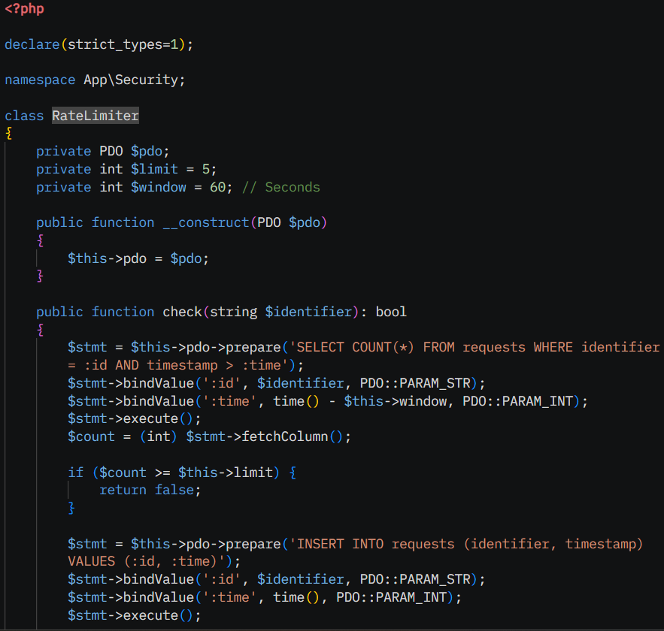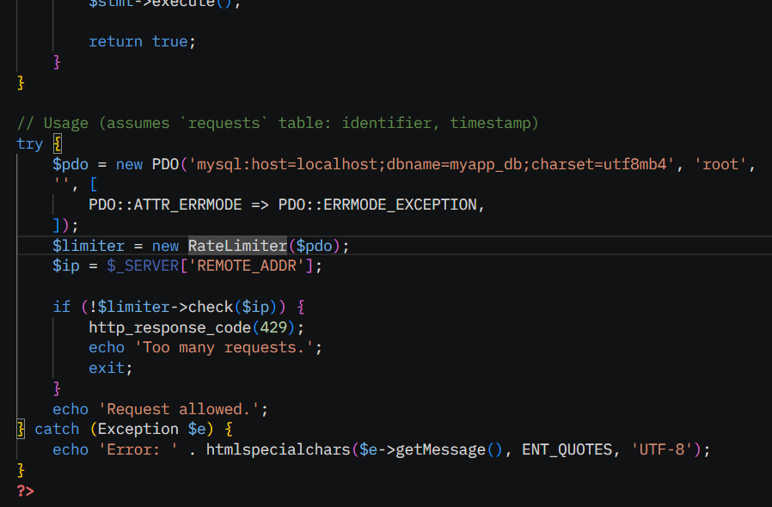

### **Input Validation Libraries**

Input validation libraries simplify and standardize input validation, reducing errors and improving security.

#### Popular Libraries

* **Respect/Validation**: Flexible, chainable validation rules.
  + Install: *composer require respect/validation*
* **Symfony Validator**: Robust, reusable validator (part of Symfony).
  + Install: *composer require symfony/validator*
* **Rakkit/Validator**: Lightweight, inspired by Laravel’s validator.
  + Install: *composer require rakit/validation*

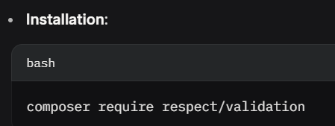

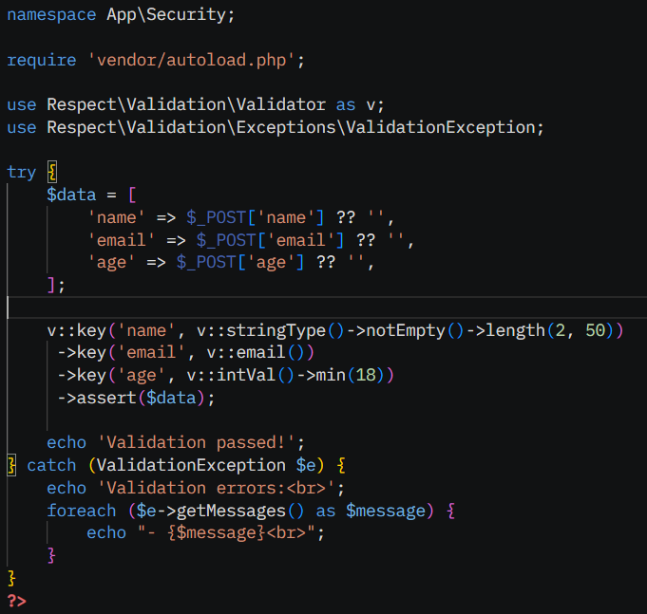

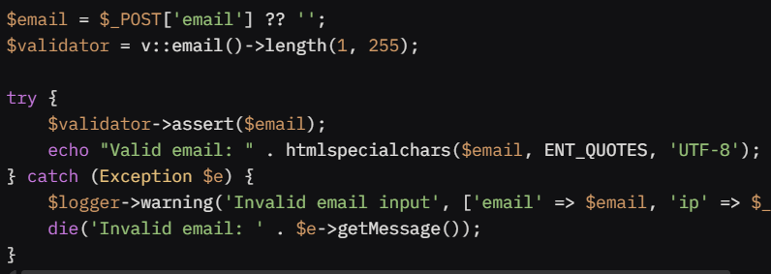

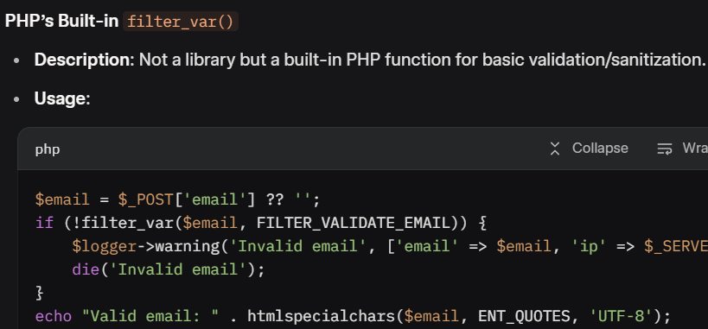

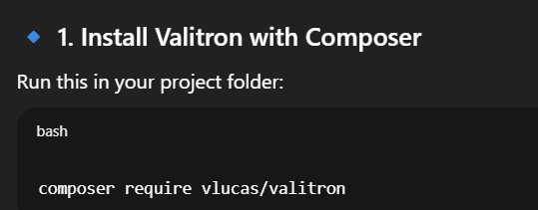

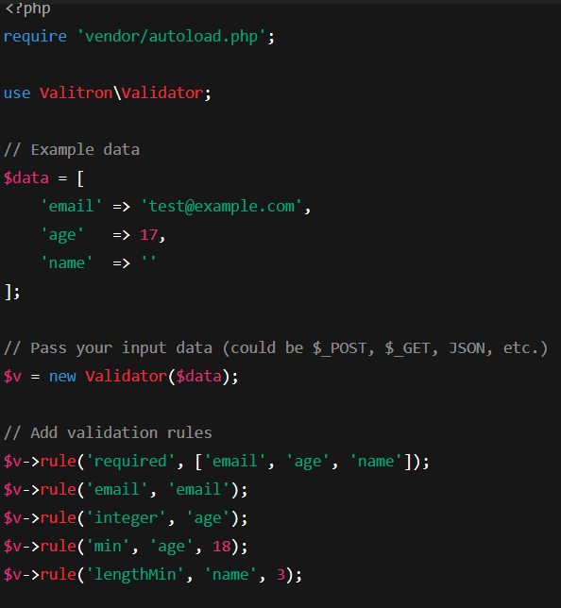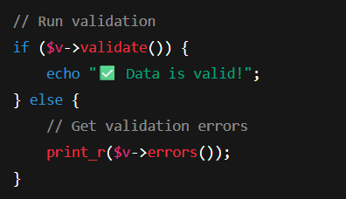

### Secure File Handling

Secure file handling prevents vulnerabilities like unauthorized access, malicious uploads, or directory traversal.

#### Key Principles

* Validate file types and sizes.
* Use secure storage locations (outside web root).
* Generate unique filenames to prevent overwrites.
* Check MIME types with finfo for reliability.

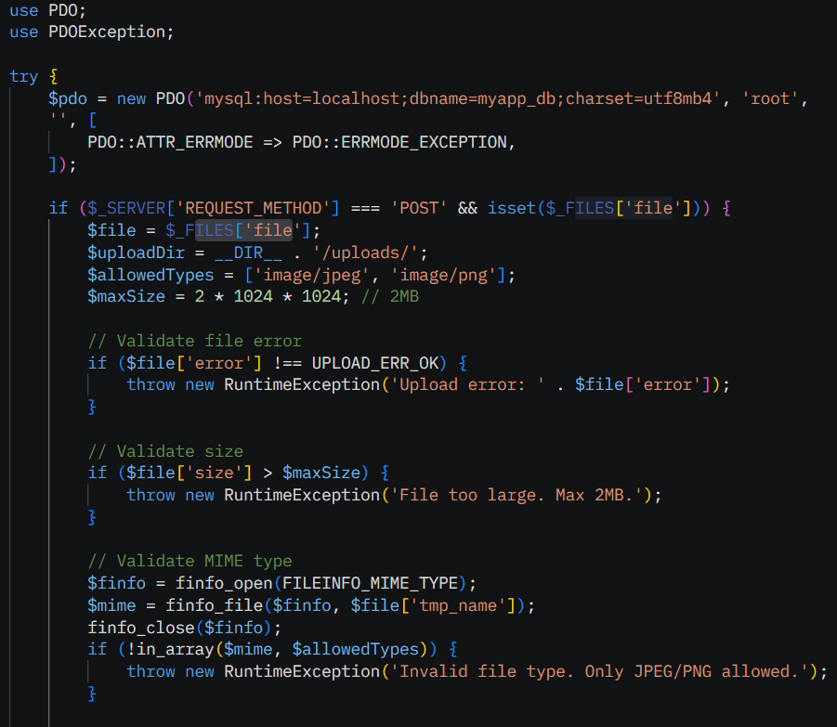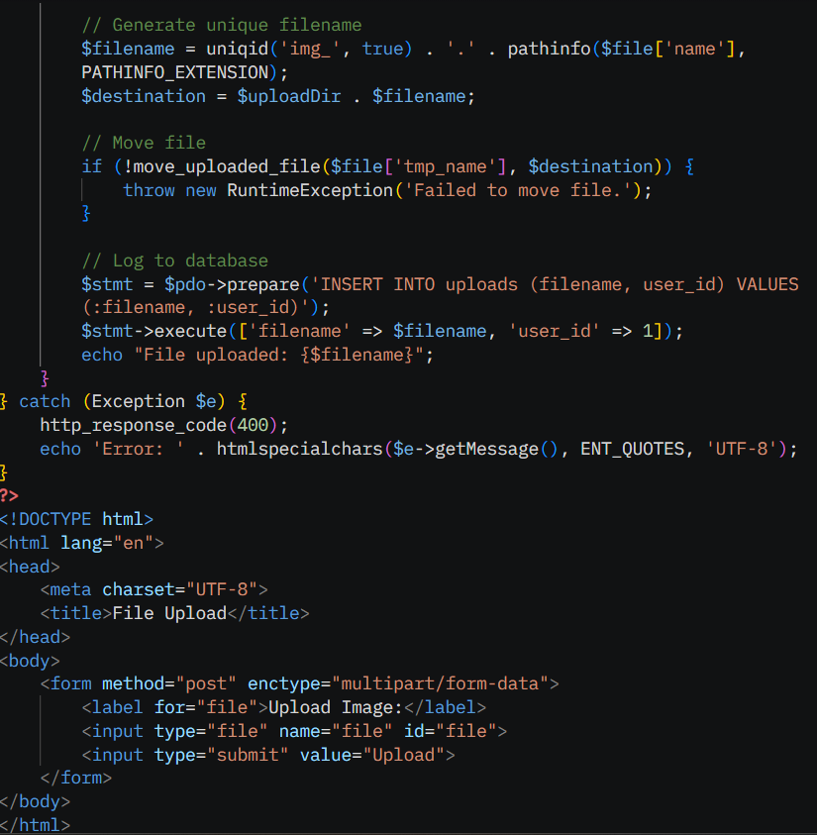

* **SPL & iterators**

### ****What is SPL?****

The **Standard PHP Library (SPL)** is a collection of built-in classes, interfaces, and functions in PHP designed to solve common problems, such as data structure manipulation, iteration, and file handling. It’s available by default in PHP 5.0+ and includes:

* **Data Structures**: Classes like ***SplFixedArray, SplStack, SplQueue, SplHeap,*** etc.
* **Iterators**: Interfaces and classes for iterating over data (e.g., ***arrays, files, directories***).
* **File Handling**: Classes like **SplFileObject** for simplified file operations.
* **Interfaces**: **Iterator, IteratorAggregate, Countable**, etc., for custom iteration.
* **Autoloading:** Support for custom autoloaders.(**spl_autoload_register()**)

### ****SPL Iterators****

**Iterators** allow you to traverse data structures (arrays, objects, files, etc.) in a standardized way, implementing the **Iterator** or **IteratorAggregate** interfaces. SPL provides several iterator classes to handle specific use cases, making it easier to process collections or files securely and efficiently.

#### ****Core Iterator Interfaces****

* **Iterator**: Defines methods for iteration (current(), key(), next(), rewind(), valid()).
* **IteratorAggregate**: Allows objects to define a custom iterator via getIterator().

Instead of using traditional foreach over arrays, iterators let you iterate over complex objects in a consistent way.

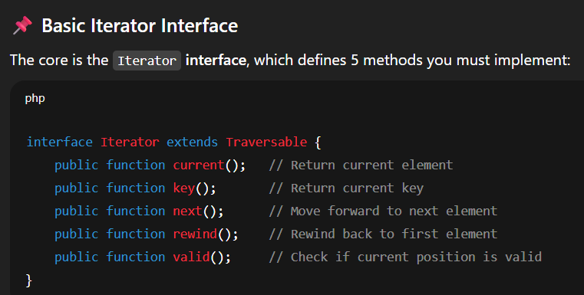

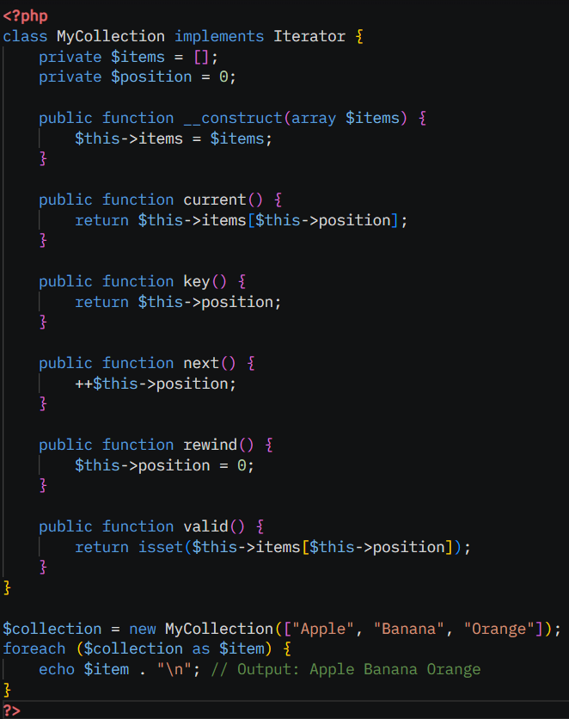

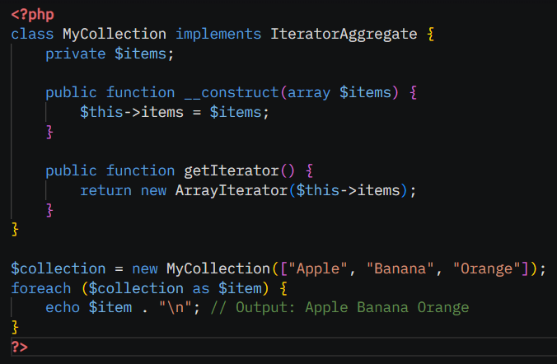

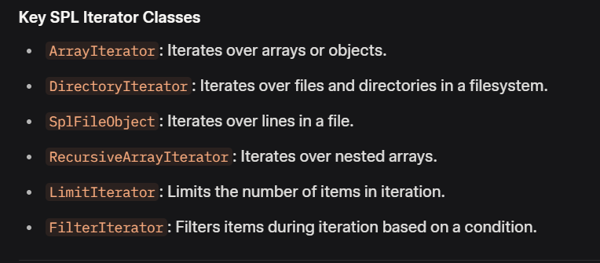

* **Common SPL Iterator Classes**

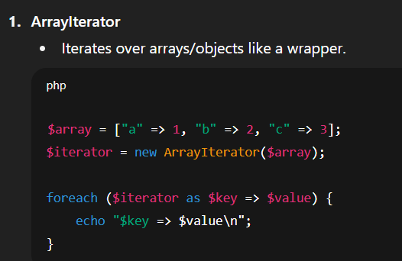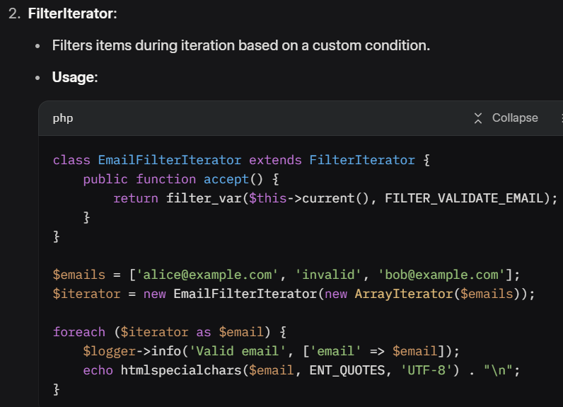

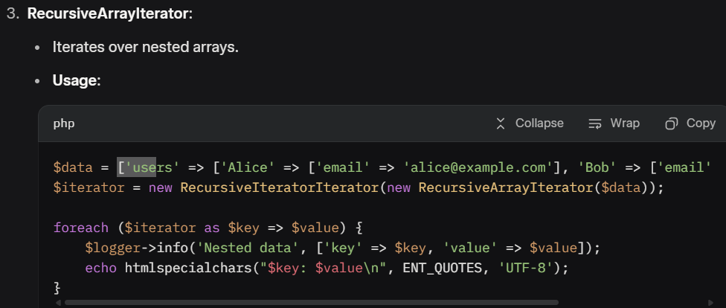

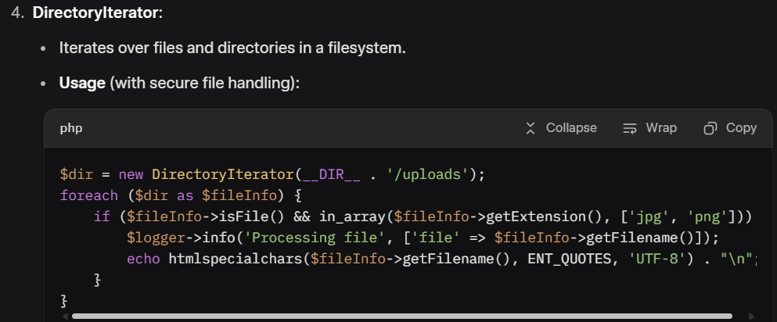

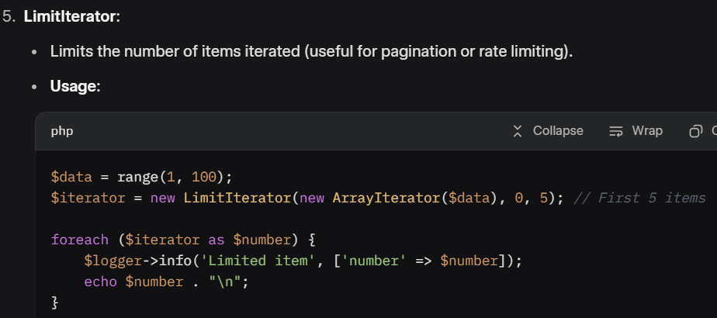

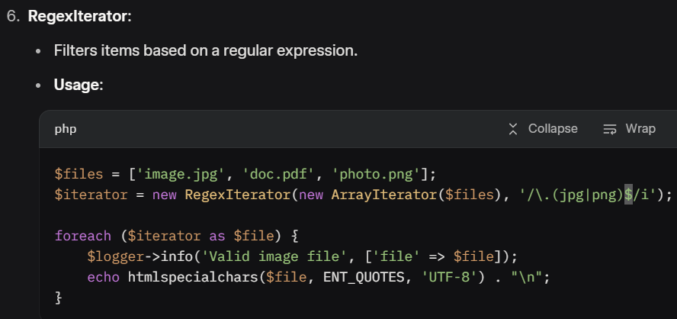

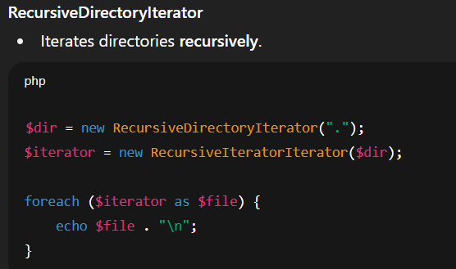

### ****SPL Data Structures****

SPL provides data structures that work well with iterators, enhancing collection handling:

1. **SplFixedArray**:

* Fixed-size array, faster than native arrays for large datasets.
* Usage:

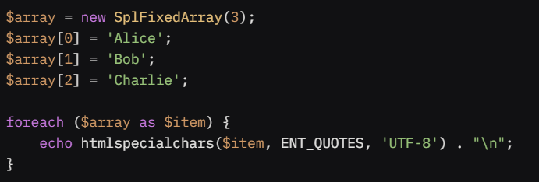

1. **SplDoublyLinkedList**:

* A linked list supporting FIFO/LIFO iteration.

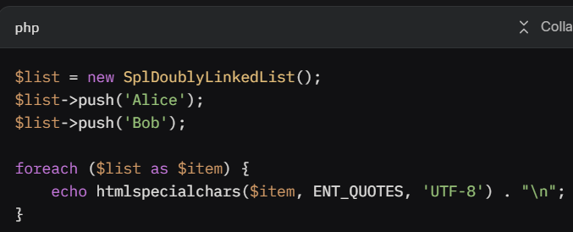

1. **SplStack:**

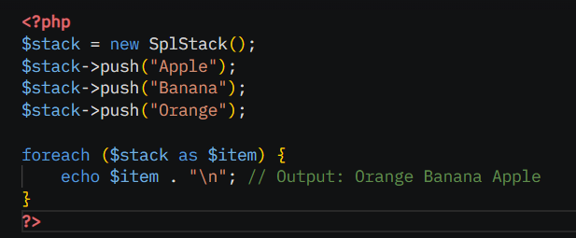

**WEEK-3**

**Relational modeling • Keys & constraints • 1NF/2NF/3NF • ER diagrams • Data types & collation**

* **Relational modeling**

**Relational Modeling** is the process of designing a database using tables (relations) to store data, where each table represents an entity, and relationships between entities are defined using keys.

#### Key Concepts

* **Entities**: Real-world objects (e.g., Users, Orders) represented as tables.
* **Attributes**: Properties of entities (e.g., name, email) represented as columns.
* **Relationships**: Connections between entities (e.g., a User places many Orders).
  + **One-to-One**: Each record in Table A relates to one record in Table B (e.g., User to Profile).
  + **One-to-Many**: One record in Table A relates to multiple records in Table B (e.g., User to Orders).
  + **Many-to-Many**: Multiple records in Table A relate to multiple records in Table B, requiring a junction table (e.g., Students to Courses via Enrollments).

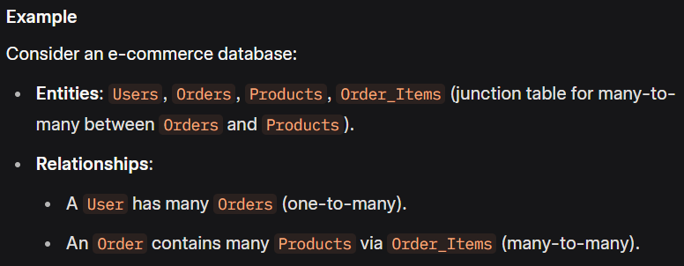

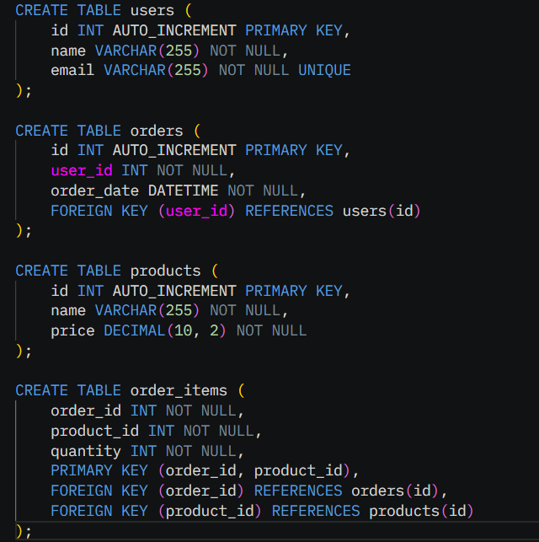

### ****Keys & Constraints****

Keys and constraints enforce data integrity and define relationships in a relational database.

#### ****Keys****

* **Primary Key**: A unique identifier for each row in a table (e.g., StudentID in a Students table). It must be unique and non-null.
* **Foreign Key**: A column (or set of columns) in one table that references the primary key of another table, establishing a relationship (e.g., DepartmentID in Students referencing DepartmentID in Departments).
* **Candidate Key**: A set of attributes that could uniquely identify a row (e.g., Email or StudentID could both be candidate keys).
* **Composite Key**: A primary key made of multiple columns (e.g., OrderID + ProductID in an OrderDetails table).

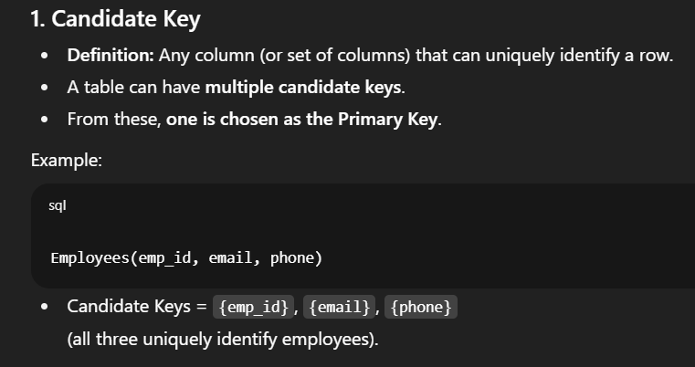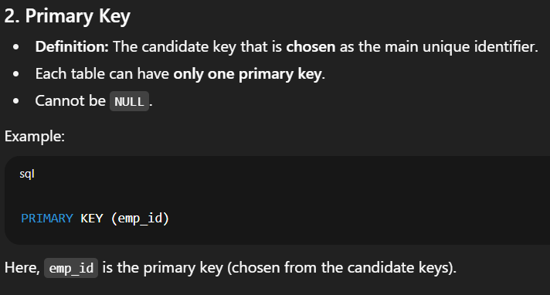

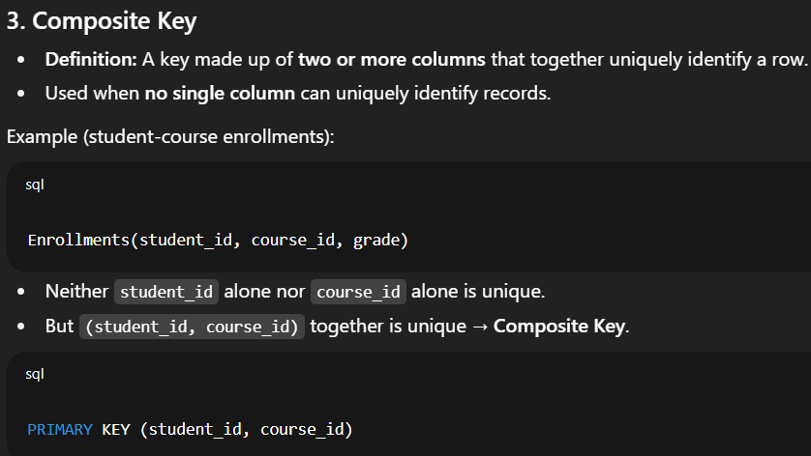

#### Constraints

* **NOT NULL**: Ensures a column cannot be null.
* **UNIQUE**: Ensures column values are unique.
* **FOREIGN KEY**: Ensures valid references to another table.
* **CHECK**: Enforces a condition (e.g., price > 0) (supported in MySQL 8.0+).
* **DEFAULT**: Sets a default value for a column.
* **PRIMARY KEY**: Combines NOT NULL and UNIQUE to uniquely identify rows.

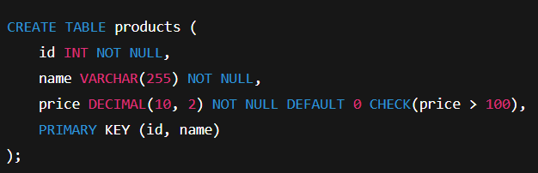

### ****Normalization (1NF, 2NF, 3NF)****

Normalization organizes data to eliminate redundancy and anomalies (insertion, deletion, update) by decomposing tables into smaller, related tables. It uses normal forms (NF).

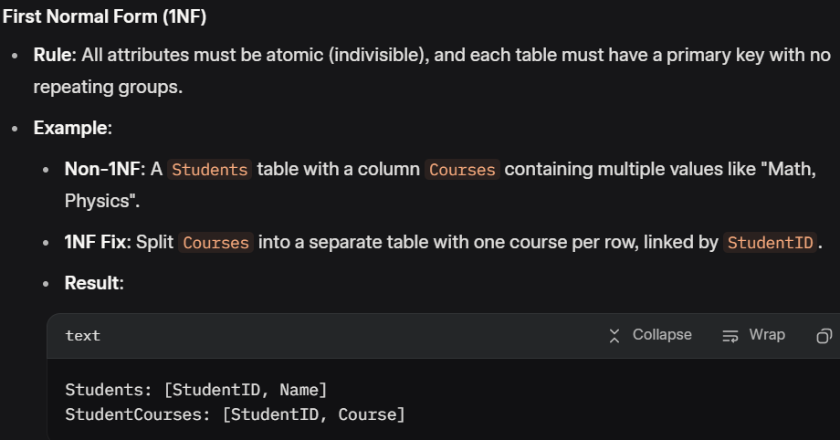

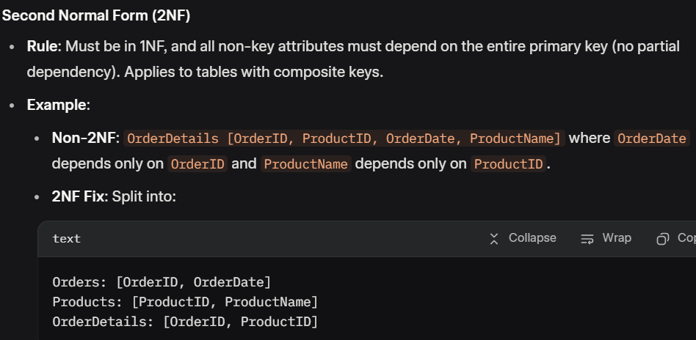

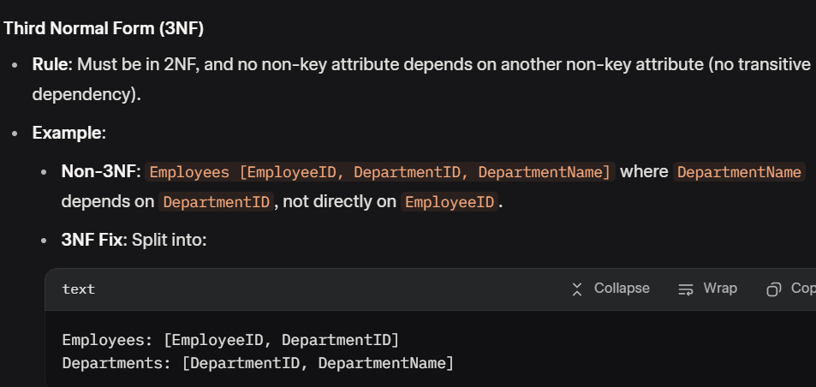

#### First Normal Form (1NF)

* **Rules**:
  + All attributes must be atomic (no multi-valued attributes).
  + Each column must have a single value.
  + No repeating groups or arrays in a single column.
* **Example (Non-1NF to 1NF)**:
  + **Non-1NF**: A table with a phones column storing multiple numbers (e.g., "123-456,789-012").
  + **1NF**: Split into a separate user_phones table.

#### Second Normal Form (2NF)

* **Rules**:
  + Must be in 1NF.
  + All non-key attributes must depend on the entire primary key (no partial dependency).
* **Example**:
  + **Non-2NF**: A table order_details with order_id, product_id, product_name, where product_name depends only on product_id.
  + **2NF**: Move product_name to a separate products table.

#### Third Normal Form (3NF)

* **Rules**:
  + Must be in 2NF.
  + No transitive dependencies (non-key attributes must not depend on other non-key attributes).
* **Example**:
  + **Non-3NF**: A users table with id, name, city, country, where city determines country.
  + **3NF**: Move city and country to a separate cities table.

### ****ER Diagrams****

Entity-Relationship (ER) diagrams visually represent the database structure, showing entities, attributes, and relationships.

* **Components**:
  + **Entities**: Objects (e.g., Student, Course) represented as rectangles.
  + **Attributes**: Properties of entities (e.g., StudentID, Name) shown as ovals.
  + **Relationships**: Connections between entities (e.g., Enrolls) shown as diamonds.
  + **Cardinality**: Specifies relationship constraints (e.g., 1:1, 1:N, M:N):
    - **One-to-One** (1:1): One Student has one Passport.
    - **One-to-Many** (1:N): One Department has many Employees.
    - **Many-to-Many** (M:N): Students enroll in many Courses, resolved using a junction table (e.g., StudentCourses).

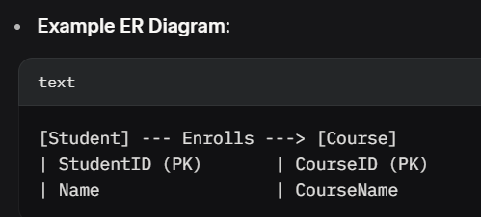

### Data Types & Collation

#### **Data Types**

Choosing appropriate data types ensures efficient storage and querying. Common MySQL data types:

* **Numeric**:
  + **INT:** Whole numbers (e.g., id).
  + **DECIMAL(M, D)**: Fixed-point numbers (e.g., price DECIMAL(10, 2) for $1234.56).
  + **FLOAT, DOUBLE**: Floating-point numbers (less precise).
* **String**:
  + **VARCHAR(N):** Variable-length strings (e.g., name VARCHAR(255)).
  + **TEXT**: Large text (e.g., descriptions).
  + **CHAR(N)**: Fixed-length strings (e.g., country_code CHAR(2)).
* **Date/Time**:
  + **DATETIME:** Date and time (e.g., 2025-09-04 13:06:00).
  + **DATE:** Date only.
  + **TIMESTAMP:** Auto-updates on changes.
* **Boolean**: **TINYINT(1)** (0 or 1, e.g., is_active).
* **Binary**: **BLOB** for binary data (e.g., images).

#### ****Collation****

Collation defines how string data is compared and sorted, affecting case sensitivity, accent sensitivity, and language-specific rules.

* **Examples**:
  + **utf8mb4_unicode_ci**: Case-insensitive, supports Unicode (e.g., "Apple" = "apple").
  + **utf8mb4_bin**: Binary comparison, case-sensitive (e.g., "Apple" ≠ "apple").
  + **latin1_swedish_ci**: Case-insensitive, Swedish-specific sorting rules.
* **Use Cases**:
  + Choose **ci** (case-insensitive) for user-facing fields like usernames.
  + Use **bin** for case-sensitive fields like passwords.
  + Match collation to the application’s language and region (e.g., **utf8mb4_spanish_ci** for Spanish).

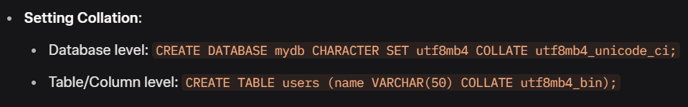 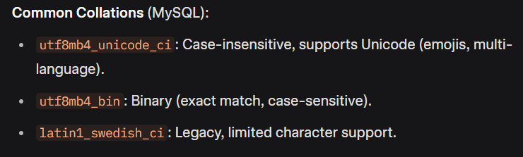

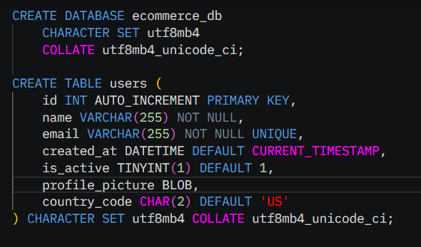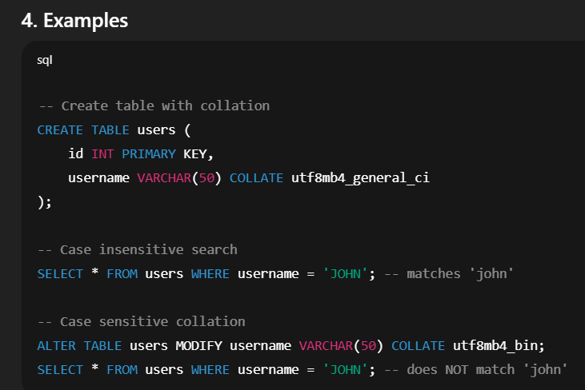

**SELECT/INSERT/UPDATE/DELETE • INNER/LEFT/RIGHT joins • GROUP BY/HAVING • Views • Subqueries**

* **SQL Operations**

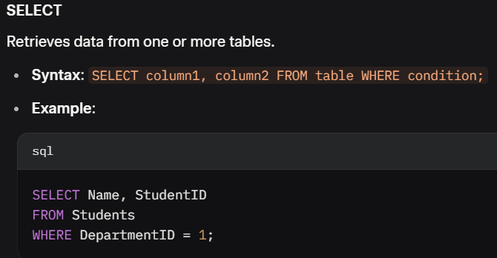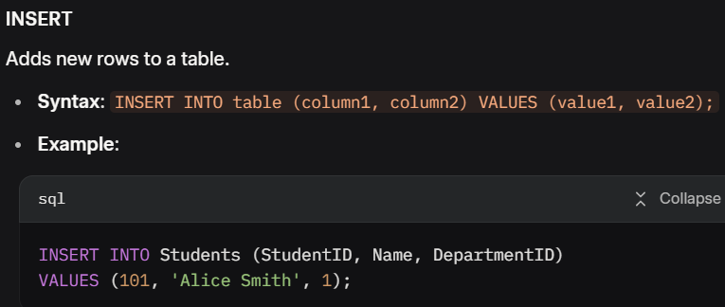

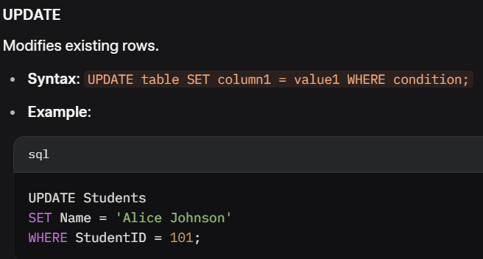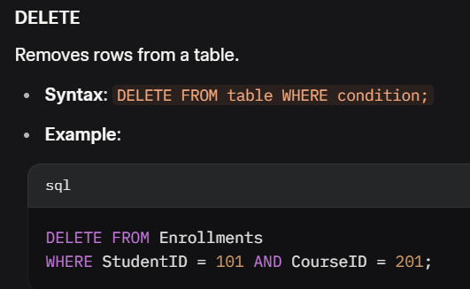

### ****Joins****

Joins combine rows from multiple tables based on a related column.

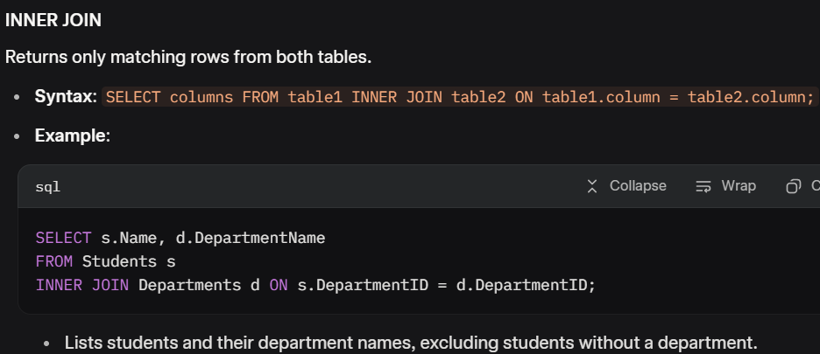

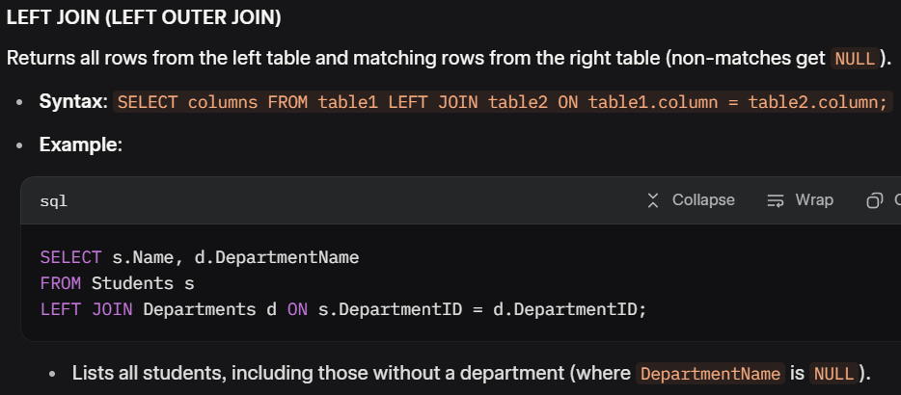

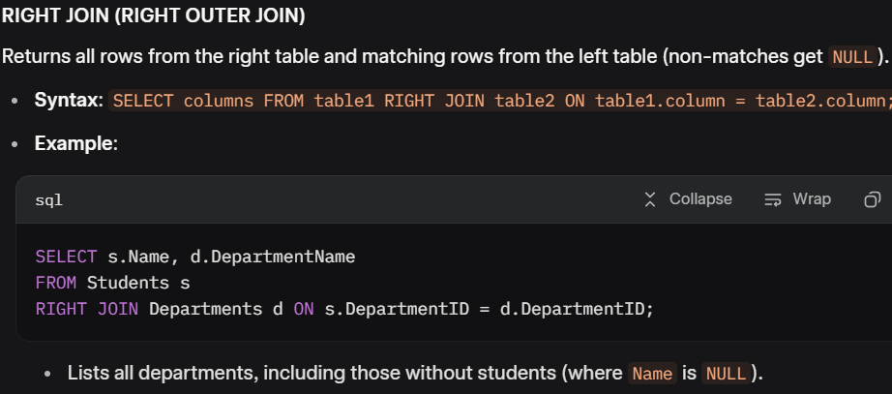

### ****GROUP BY and HAVING****

#### ****GROUP BY****

Groups rows with the same values in specified columns into summary rows, often used with aggregate functions (**COUNT, SUM, AVG**, etc.).

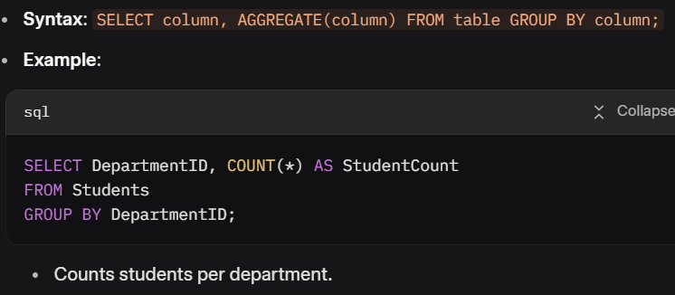

#### ****HAVING****

Filters grouped results (like **WHERE** for **GROUP BY**).

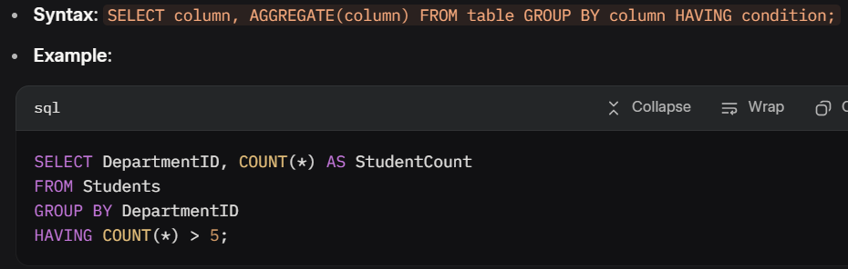

* **Views :**

A view is a virtual table based on a SELECT query, stored for reuse but not physically storing data.

A **saved query** that acts like a virtual table.

* **Syntax**: *CREATE VIEW view_name AS SELECT ...;*

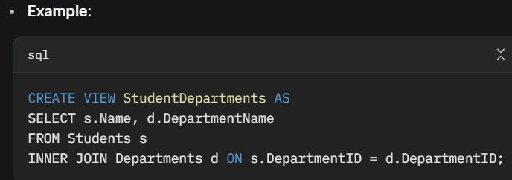

· **Usage**: Query like a table: SELECT * FROM StudentDepartments;

· **Benefits**:

* Simplifies complex queries.
* Enhances security by restricting access to specific columns.
* Does not store data, so updates dynamically with the underlying tables.

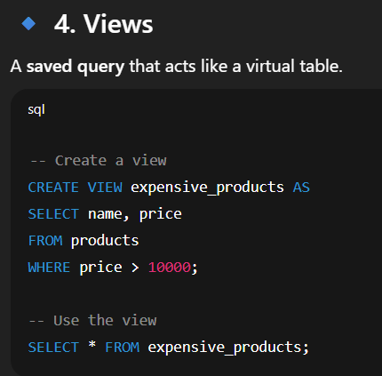

### ****Subqueries****

A subquery is a query nested within another query, used to return data for the outer query.

* **Types**:
  + **Single-row**: Returns one row (used with operators like =).
  + **Multi-row**: Returns multiple rows (used with IN, ANY, ALL).
  + **Correlated**: References the outer query, executed for each row.

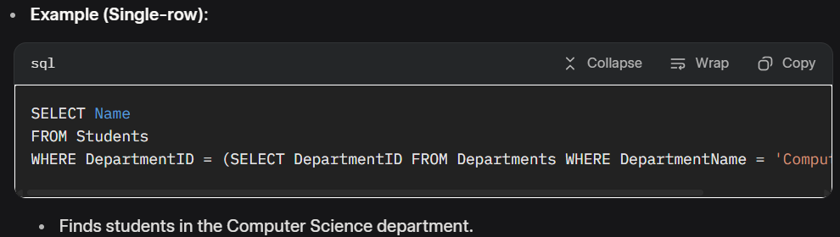

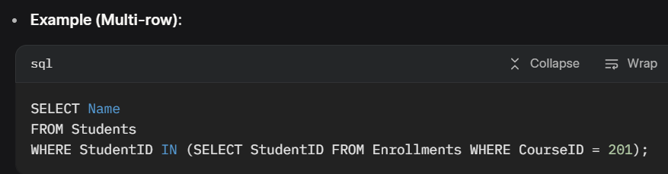

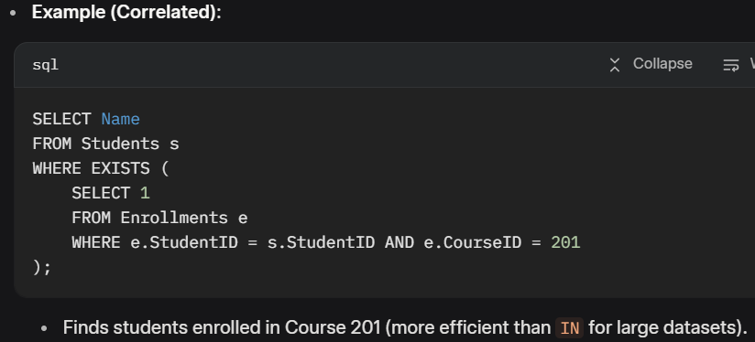 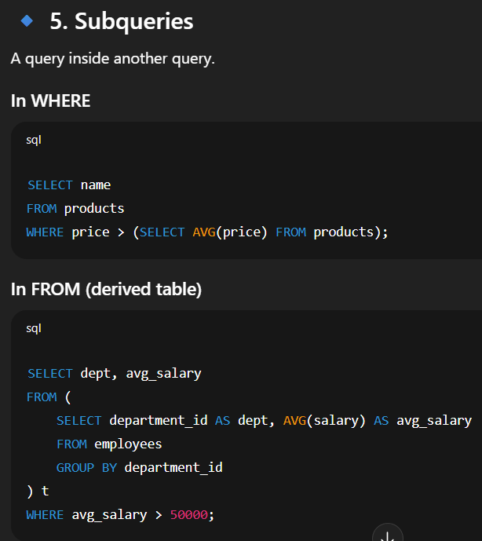

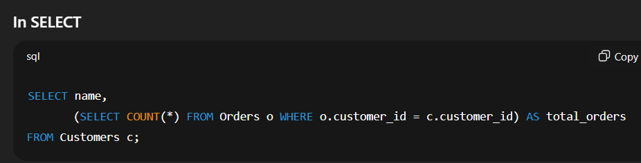

**Indexes (BTREE/Fulltext) • EXPLAIN & Query Plan • Covering indexes • Transactions & isolation • Backups (mysqldump)**

### ****Indexes (BTREE/Fulltext)****

Indexes improve query performance by allowing faster data retrieval, but they increase storage and slow down write operations (**INSERT, UPDATE, DELETE**).

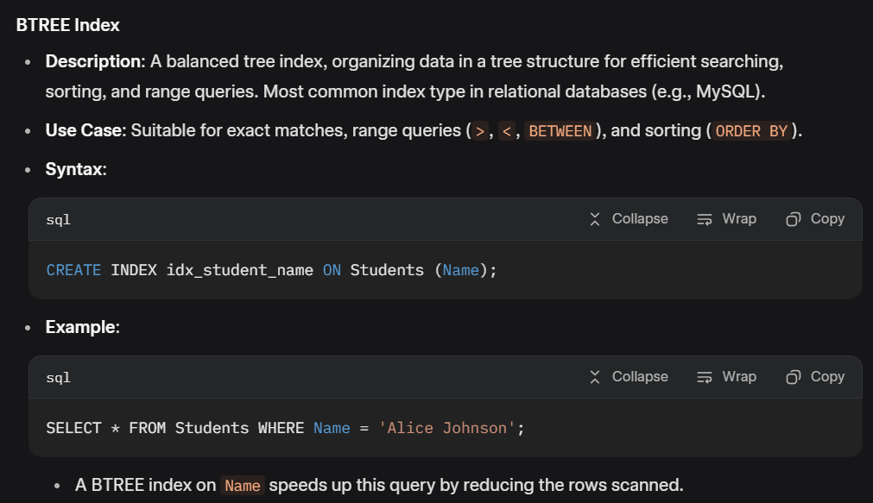

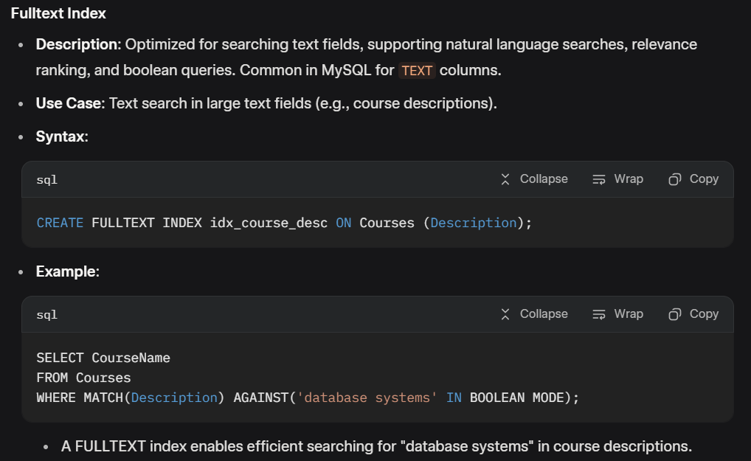

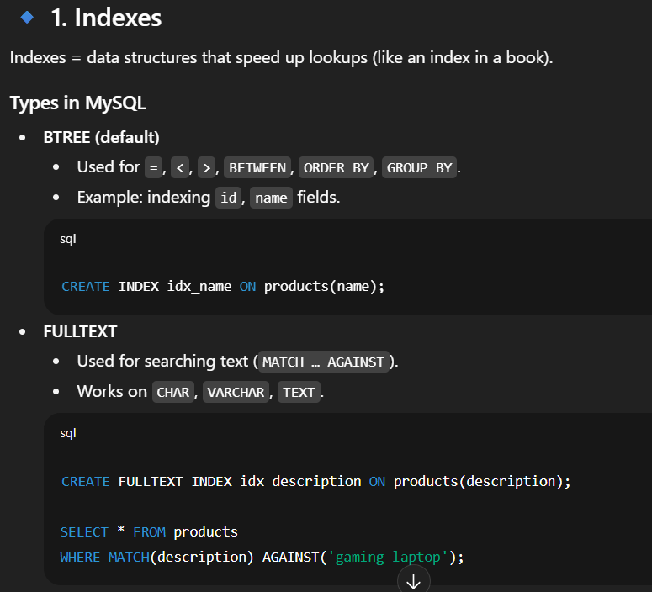

### ****EXPLAIN & Query Plan****

The EXPLAIN command in MySQL shows how a query is executed, including which indexes are used and how tables are scanned.

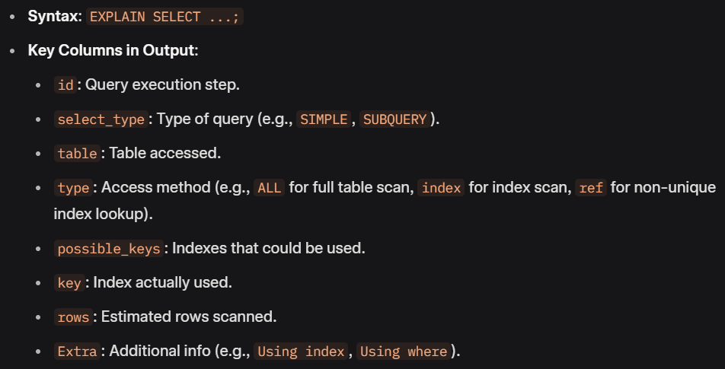

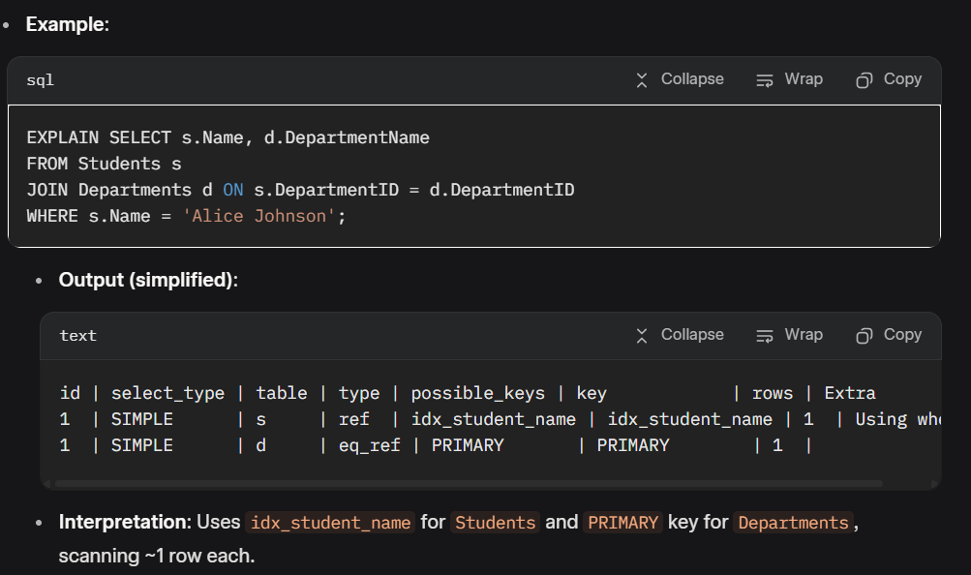

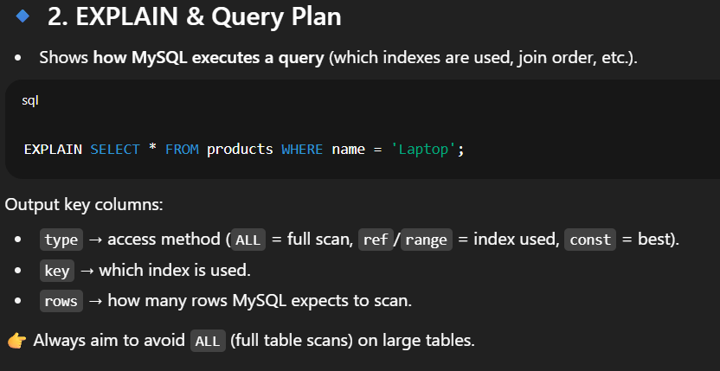

### ****Covering Indexes****

A covering index satisfies a query entirely from the index without accessing the table data, improving performance.

* **How It Works**: The index includes all columns used in the **SELECT, WHERE, JOIN,** and **GROUP BY** clauses.
* **Syntax**: Create a composite index covering multiple columns.

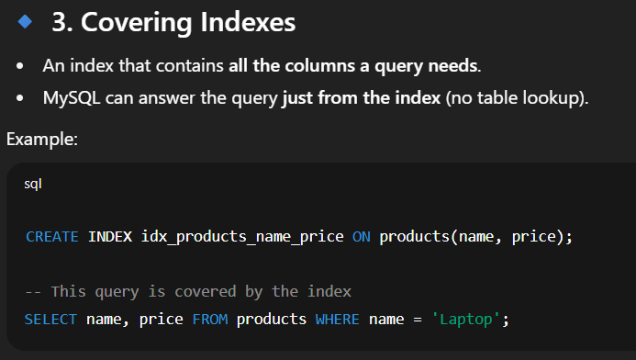

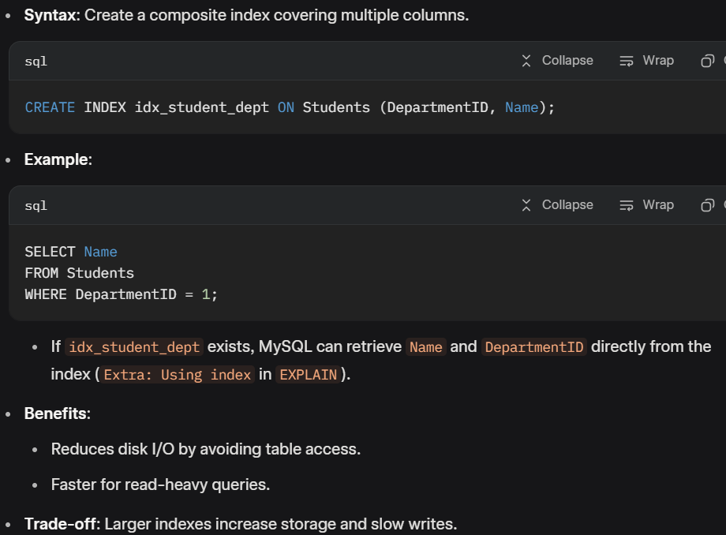

### ****Transactions & Isolation Levels****

#### ****Transactions****

A transaction is a sequence of operations treated as a single unit, ensuring data consistency (**ACID** properties: ***Atomicity, Consistency, Isolation, Durability***).

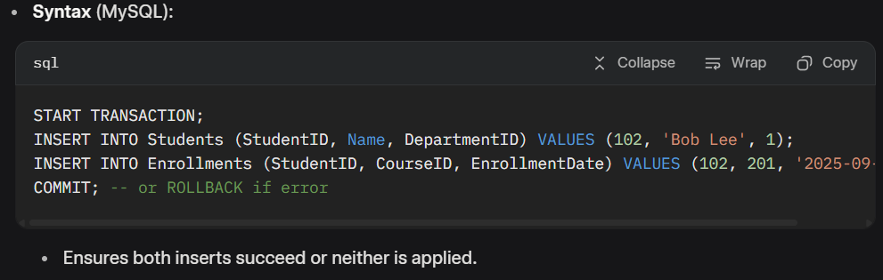

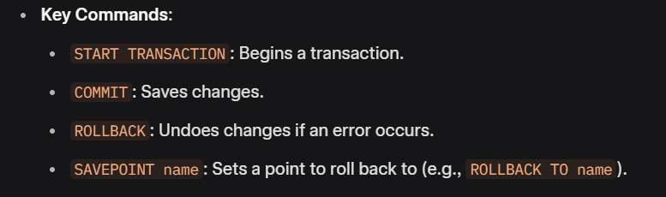

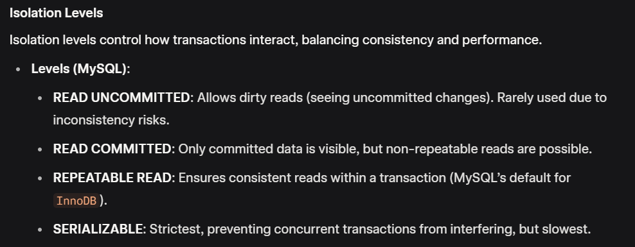

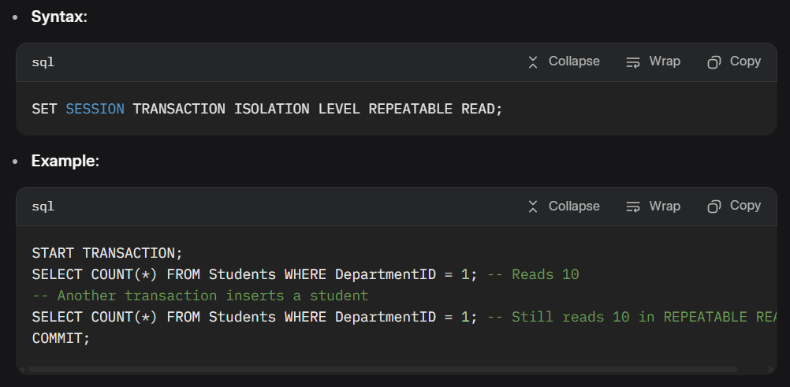

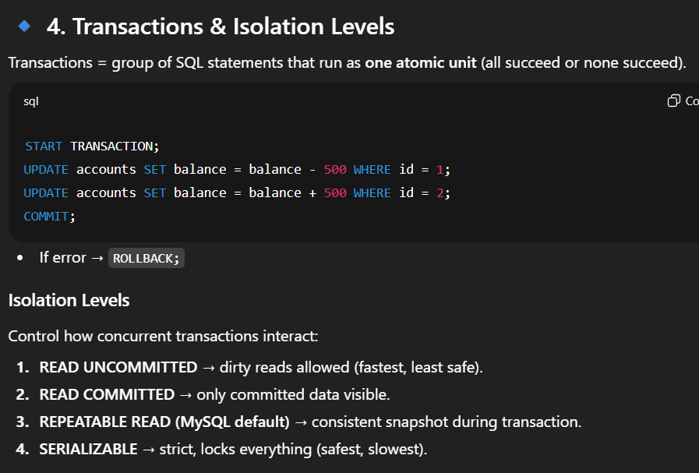

### ****Backups (mysqldump)****

***mysqldump*** is a MySQL utility for creating logical backups (SQL scripts) of databases, tables, or schemas.

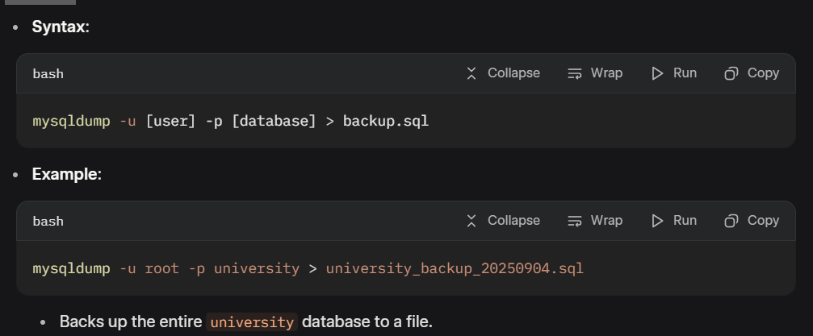

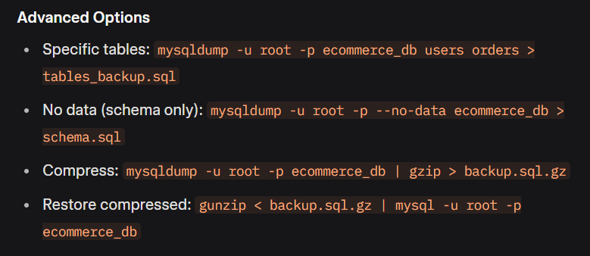

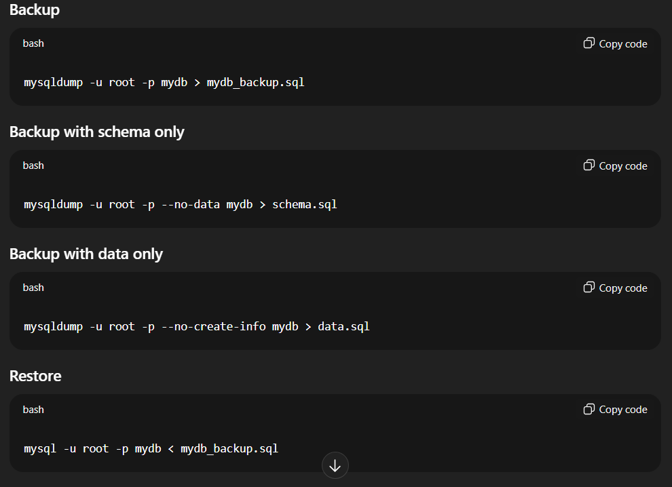

**Selectors & events • DOM manipulation • AJAX (jQuery & fetch) • JSON encode/decode in PHP • Client-side form validation**

### **Selectors & Events**

* **Selectors:**

**Selectors** allow you to target HTML elements using JavaScript or jQuery, while **events** handle user interactions like clicks or keypresses.

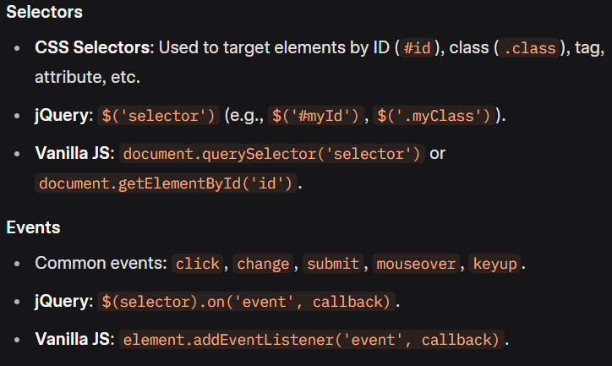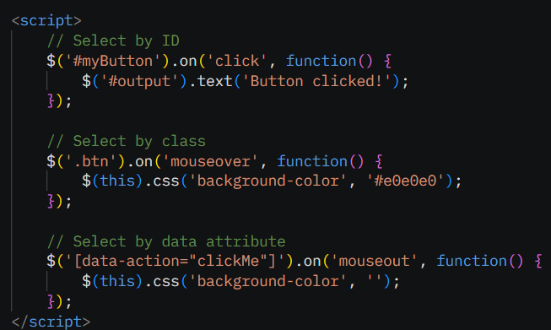

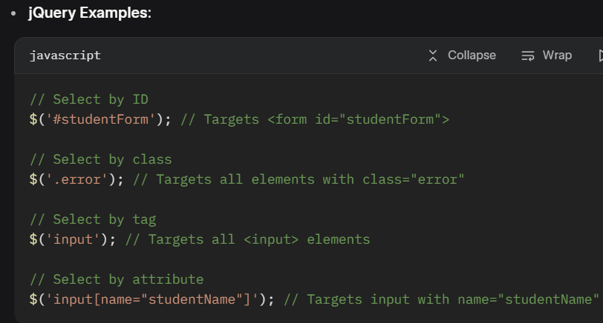

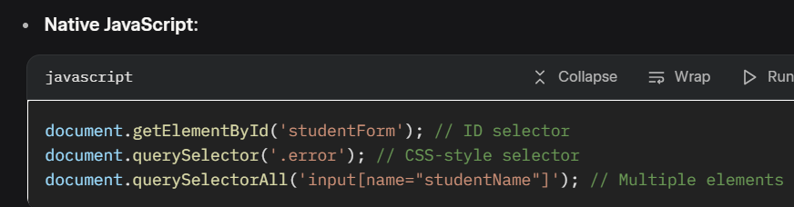

#### ****Events****

Events trigger JavaScript/jQuery code when user actions (e.g., clicks, form submissions) occur.

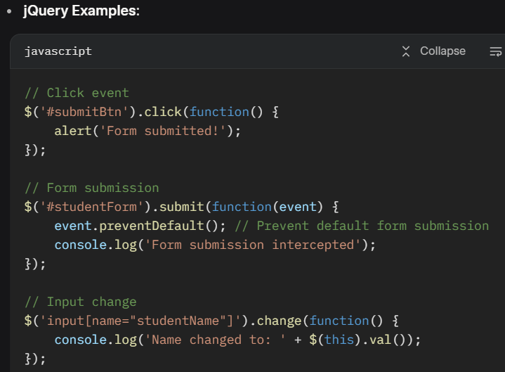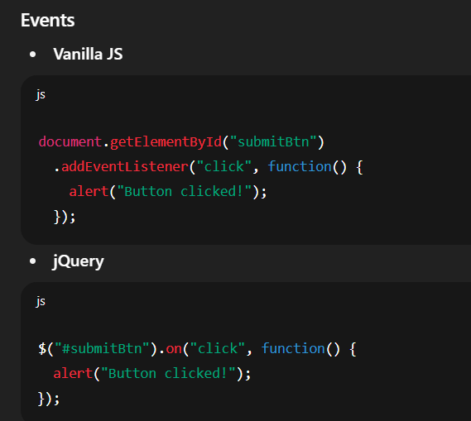

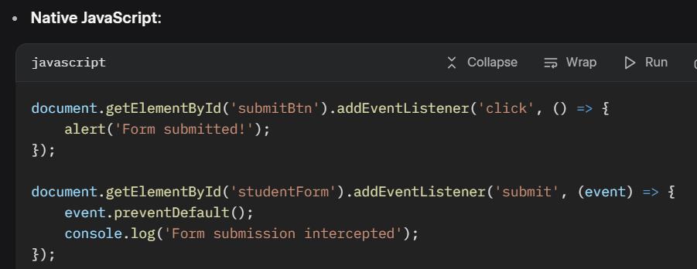

### DOM Manipulation

**DOM Manipulation** involves dynamically modifying HTML elements’ content, attributes, or styles using JavaScript or jQuery.

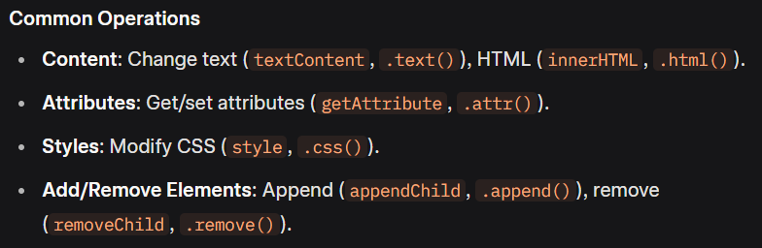

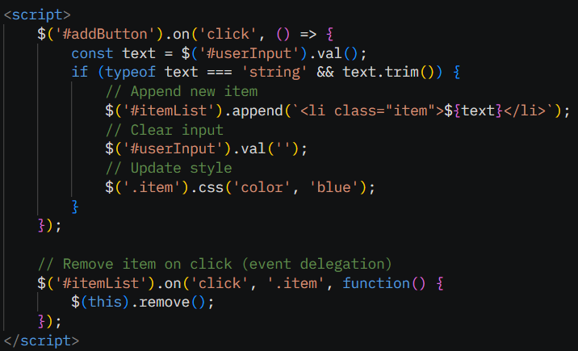

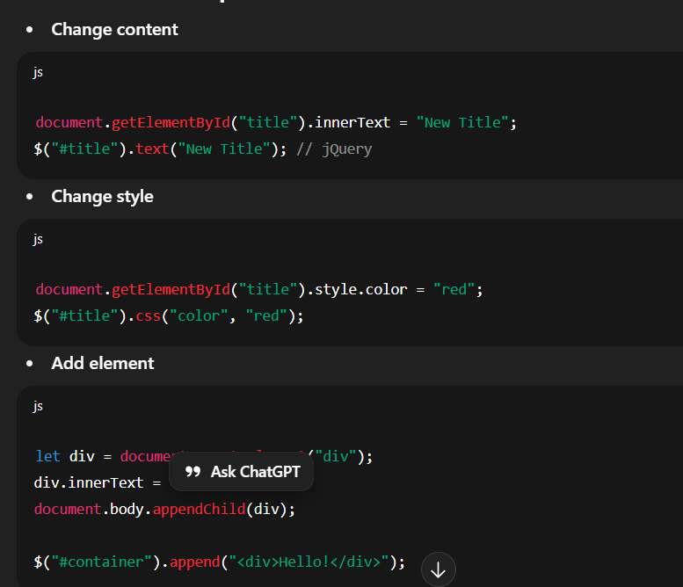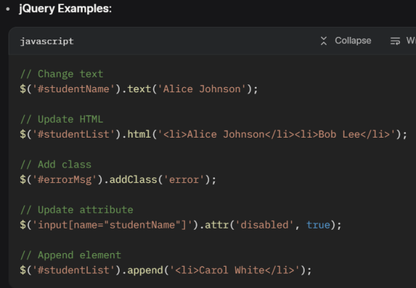

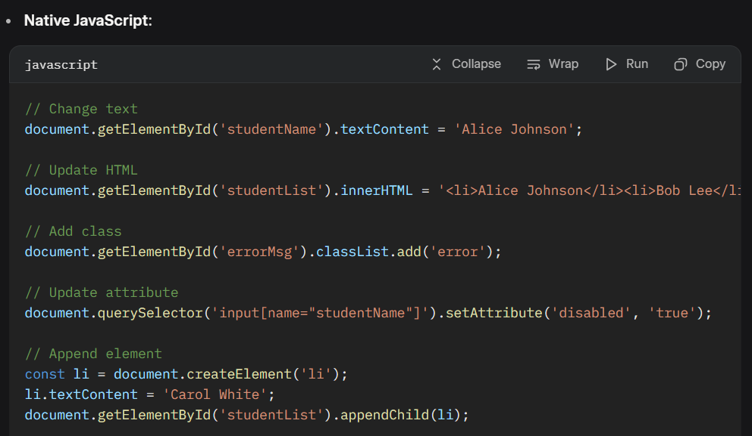

### ****AJAX (jQuery & fetch)****

AJAX (Asynchronous JavaScript and XML) enables asynchronous communication with a server, often to fetch or send data without reloading the page.

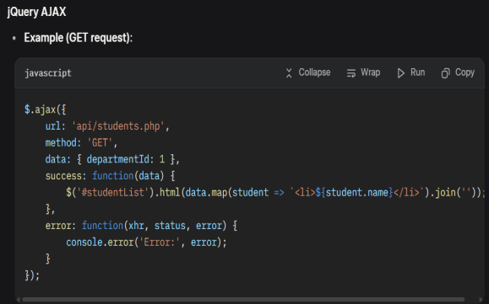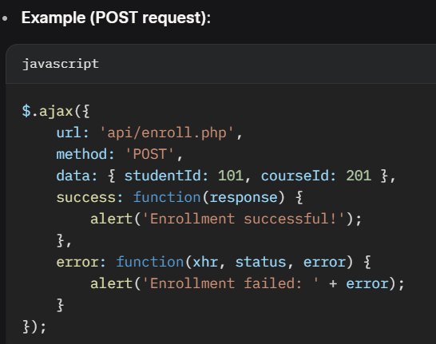

#### Fetch API (Vanilla JS)

* Modern alternative to XMLHttpRequest, using Promises.

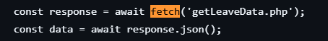

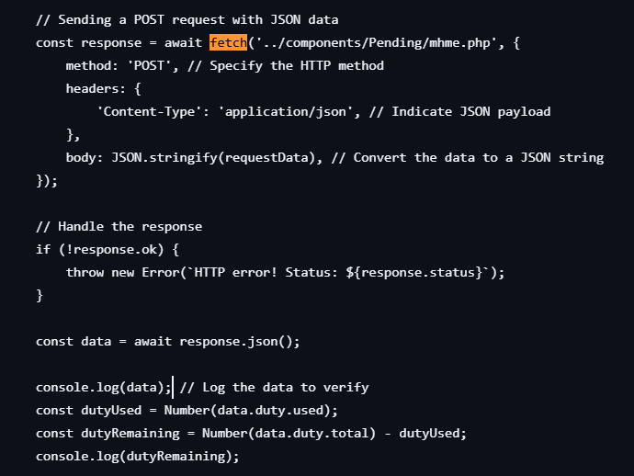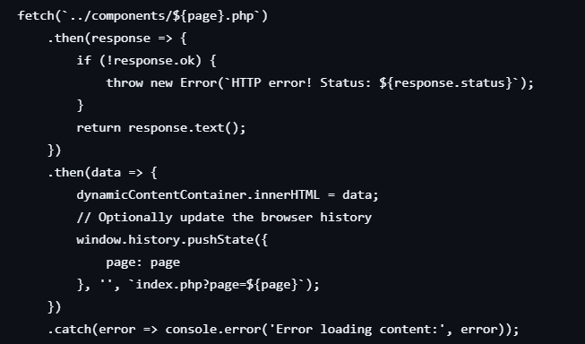

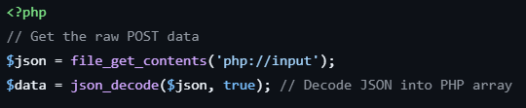

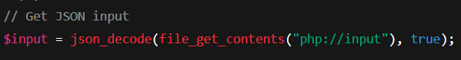

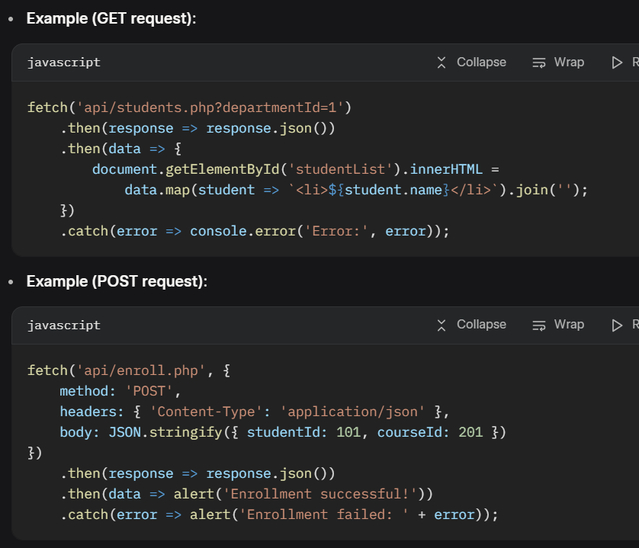

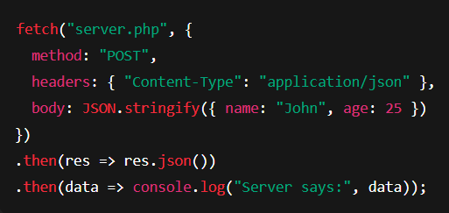

### JSON Encode/Decode in PHP

PHP provides ***json_encode()*** and ***json_decode()*** to handle JSON data, commonly used in APIs and AJAX.

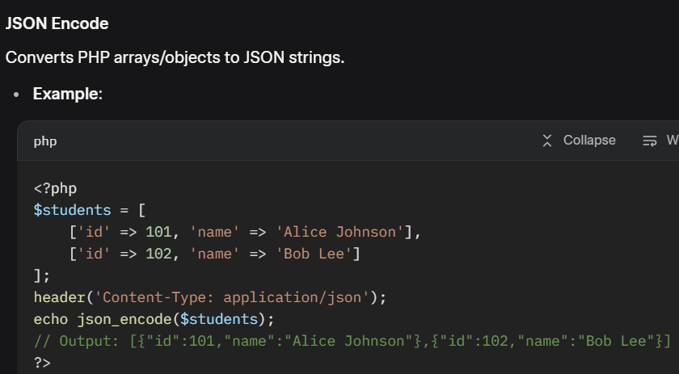

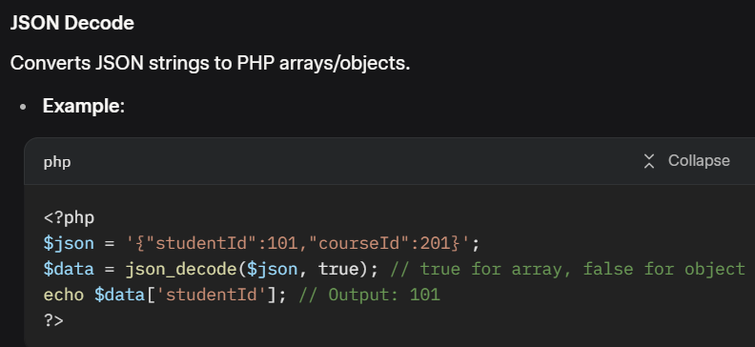

### ****Client-side Form Validation****

Client-side form validation ensures user input is valid before sending to the server, improving UX and reducing server load.

#### Approaches

* **HTML5 Validation**: Built-in attributes (required, type="email", pattern).
* **JavaScript**: Custom validation logic.
* **Libraries**: Validate.js, jQuery Validation Plugin.

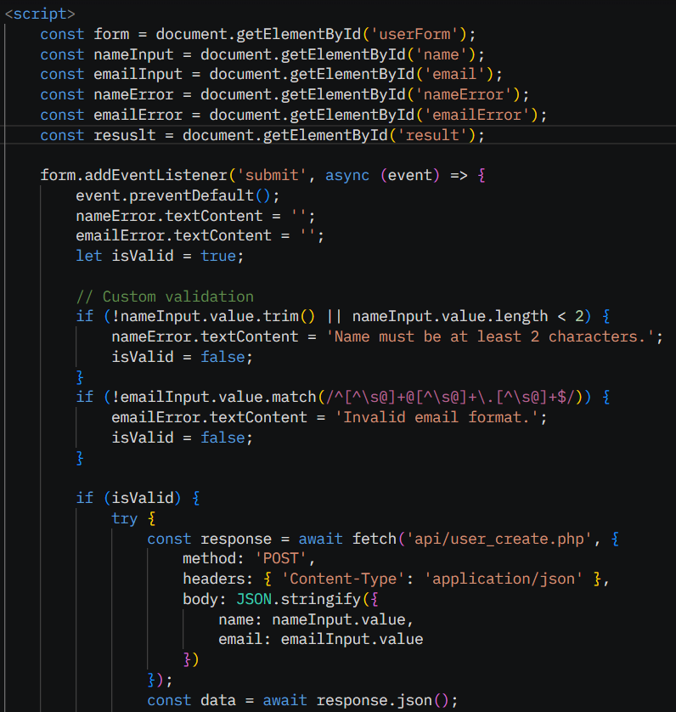

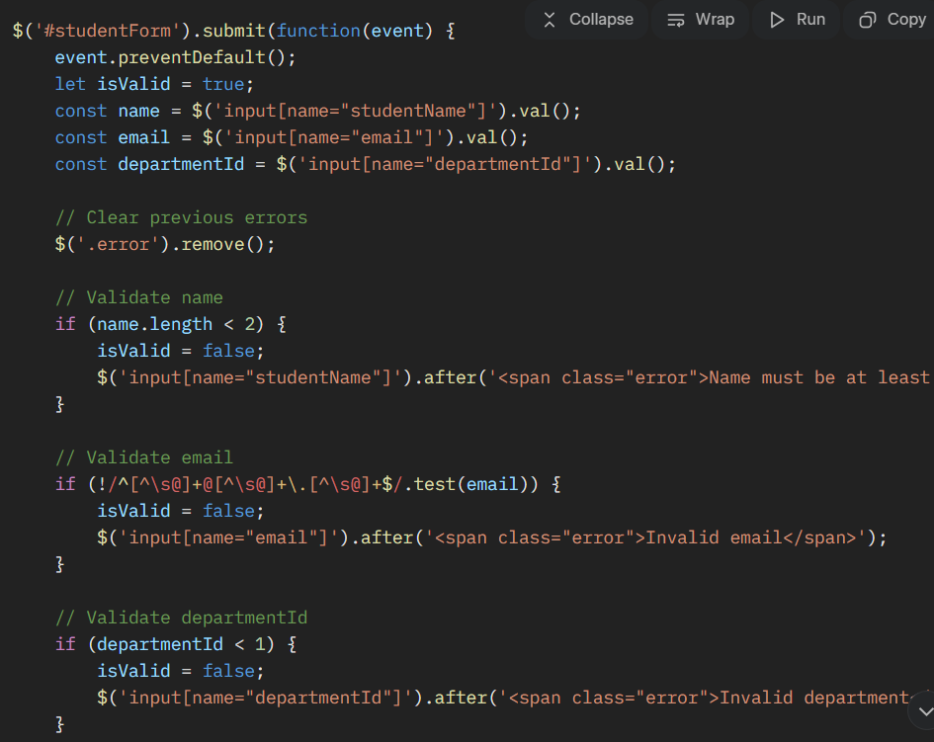

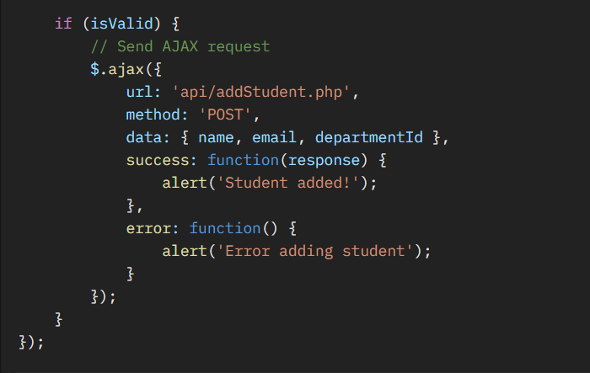

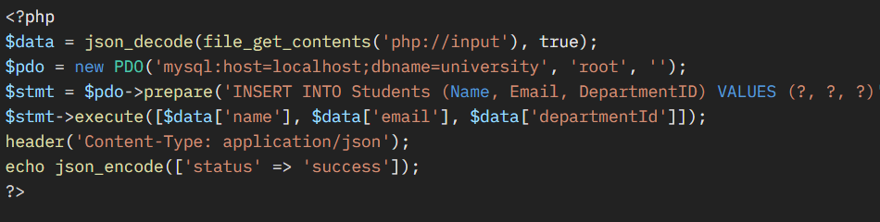

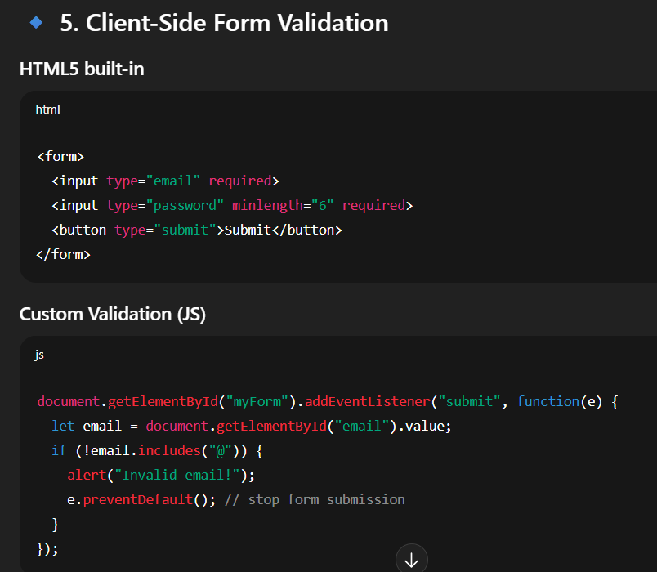

**WEEK 4**

**HTTP verbs/status codes • Headers • cURL GET/POST/PUT/DELETE • cURL error handling & timeouts • SSL & certificates**

### ****HTTP Verbs/Status Codes****

#### ****HTTP Verbs****

HTTP verbs (methods) define the action to perform on a resource in a **REST API**.

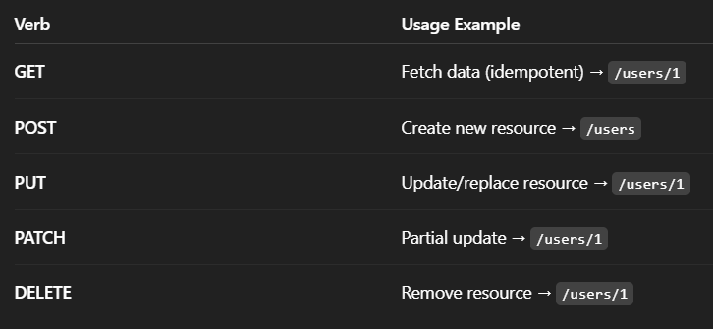

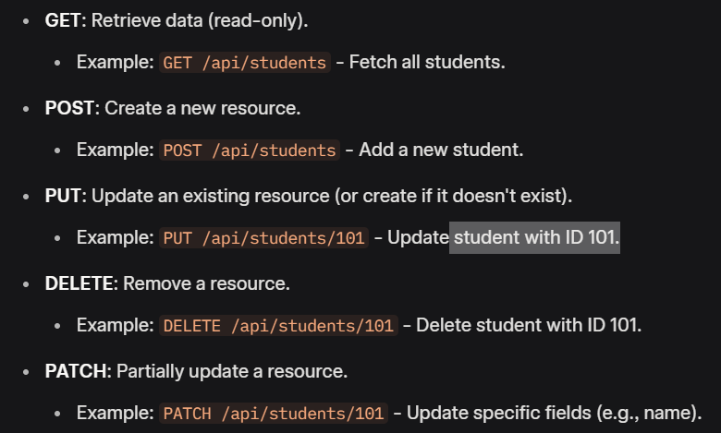

#### ****HTTP Status Codes****

Status codes indicate the result of an HTTP request.

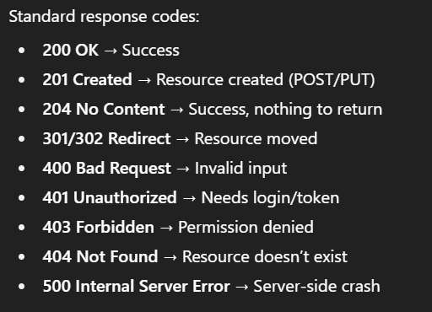

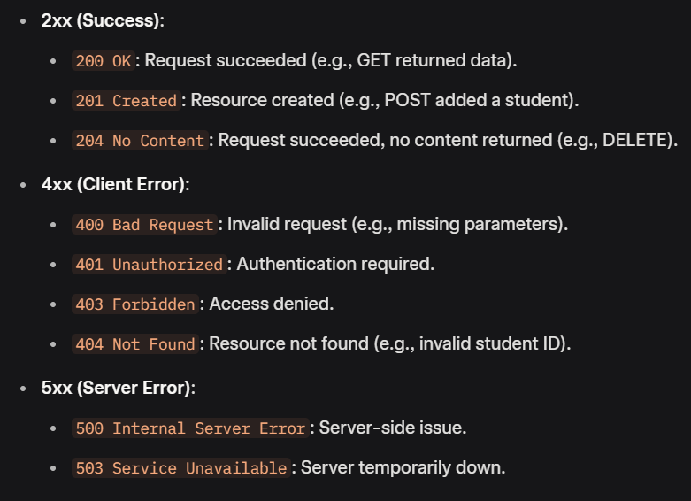

· **1xx (Informational)**: Request received, continuing (e.g., 100 Continue).

· **2xx (Success)**:

* 200 OK: Request succeeded.
* 201 Created: Resource created.
* 204 No Content: Successful, no response body.

· **3xx (Redirection)**:

* 301 Moved Permanently: Resource moved.
* 302 Found: Temporary redirect.

· **4xx (Client Error)**:

* 400 Bad Request: Invalid request syntax or data.
* 401 Unauthorized: Authentication required.
* 403 Forbidden: Access denied.
* 404 Not Found: Resource not found.
* 429 Too Many Requests: Rate limit exceeded.

· **5xx (Server Error)**:

* 500 Internal Server Error: Generic server error.
* 503 Service Unavailable: Server temporarily down.
* **Headers:**

HTTP headers provide metadata about requests and responses, controlling behavior like caching, authentication, or content type.

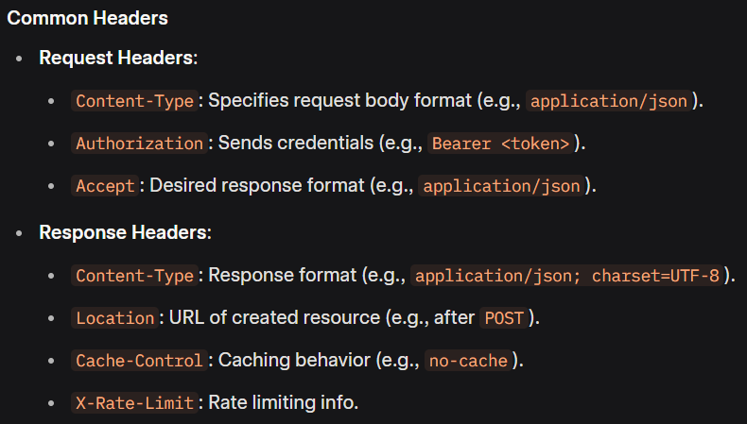

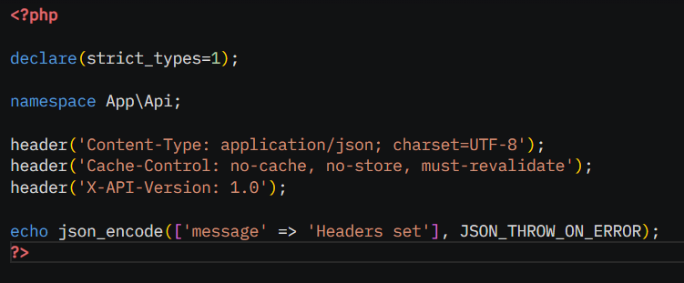

## What is a PHP Header?

The header() function in PHP is used to send **raw HTTP headers** to the client **before any output** is sent (i.e., before HTML or echo).

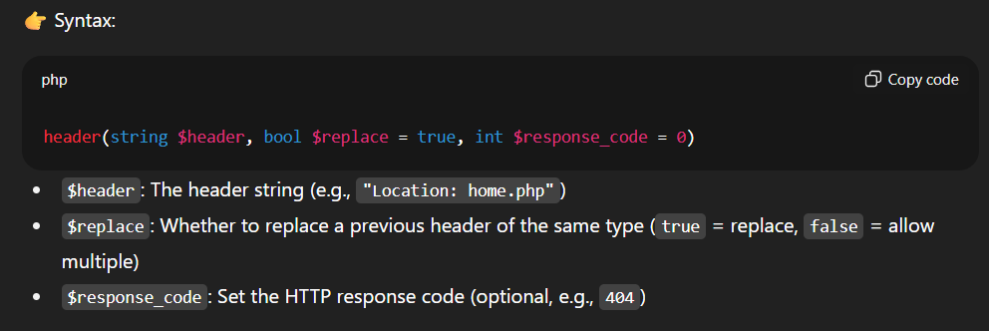

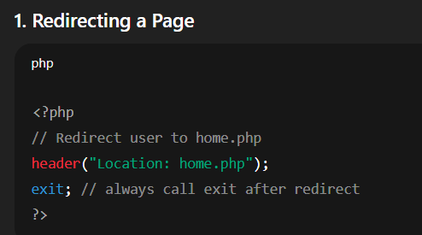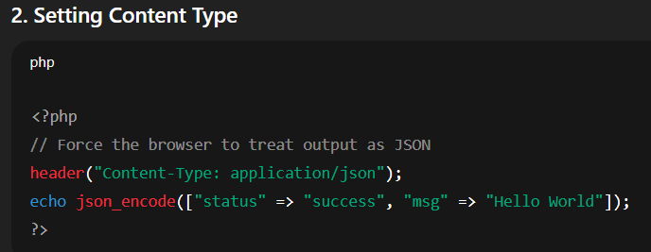

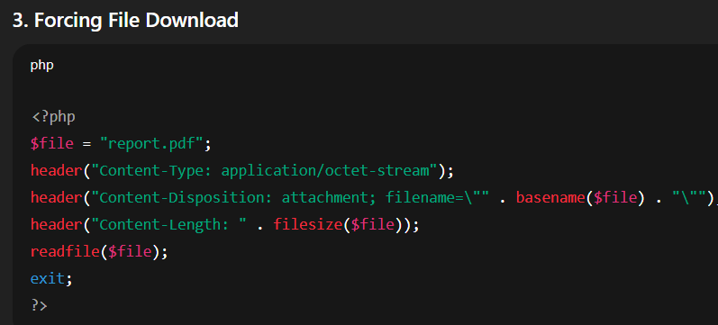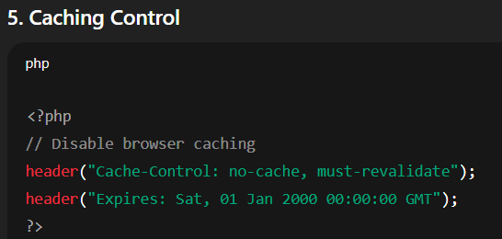

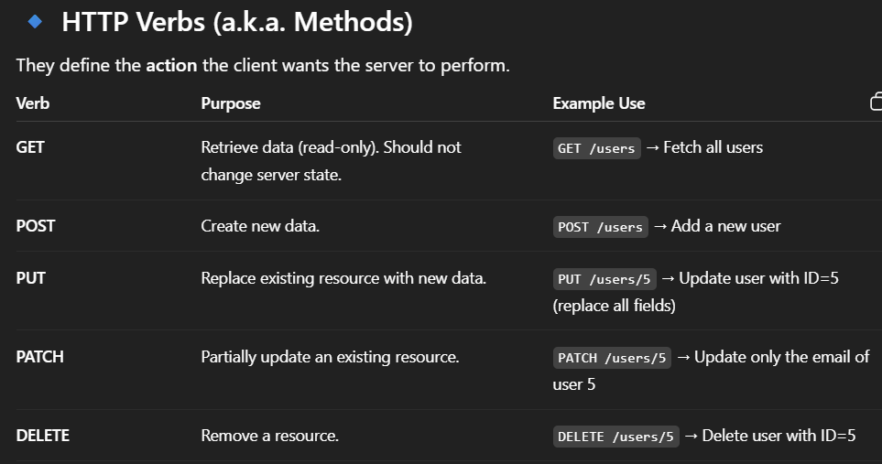

* **cURL GET/POST/PUT/DELETE**

cURL is a PHP library for making HTTP requests.

cURL is a PHP library for making HTTP requests, supporting all verbs.

#### GET

* Retrieve data from an endpoint.

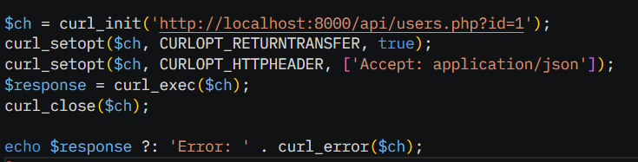

#### POST

* Create a new resource.

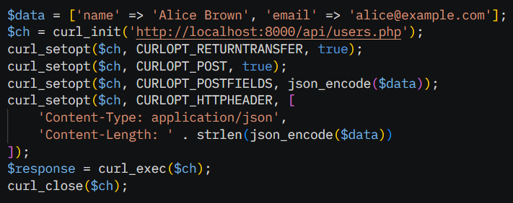

#### PUT

* Update an existing resource.

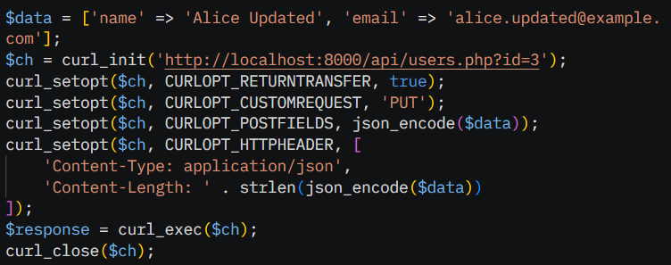

**--- PATCH ---**

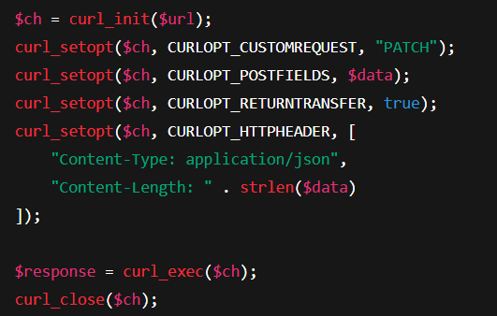

#### DELETE

* Remove a resource.

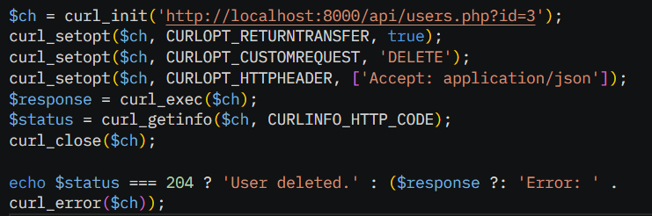

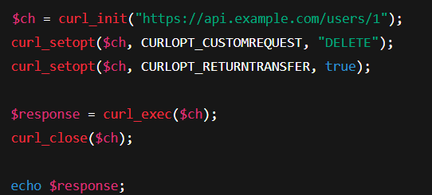

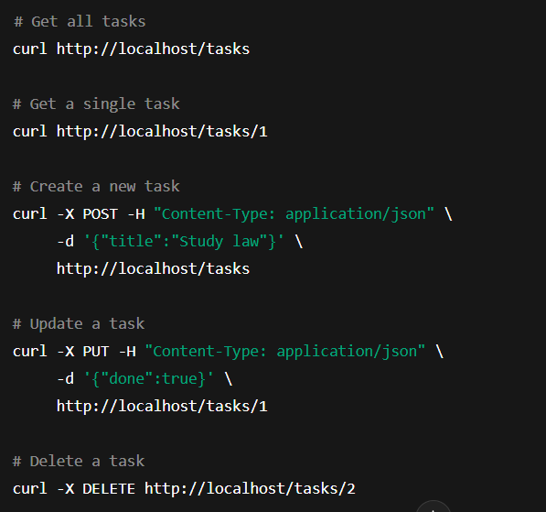



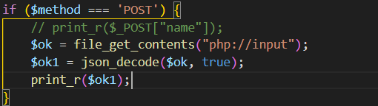



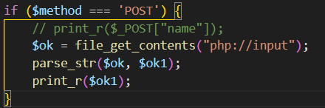

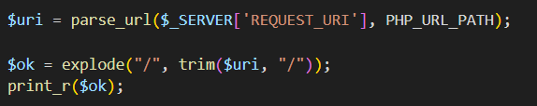

### cURL Error Handling & Timeouts

Proper error handling and timeouts ensure robust cURL requests.

#### Error Handling

* Check **curl_exec()** return value (false on failure).
* Use **curl_error()** and **curl_errno()** for error details.
* Retrieve HTTP status with **curl_getinfo($ch, CURLINFO_HTTP_CODE)**.

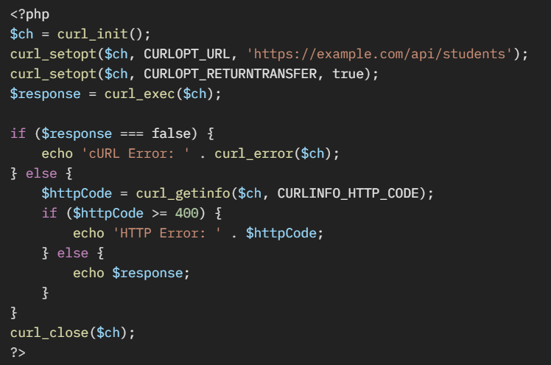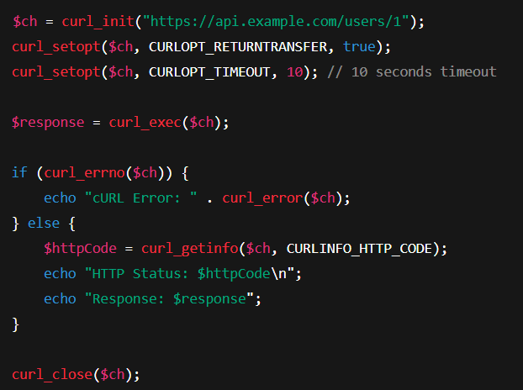

#### Timeouts

* **Connection Timeout**: Time to establish a connection (**CURLOPT_CONNECTTIMEOUT**).
* **Total Timeout**: Maximum request duration (**CURLOPT_TIMEOUT**).

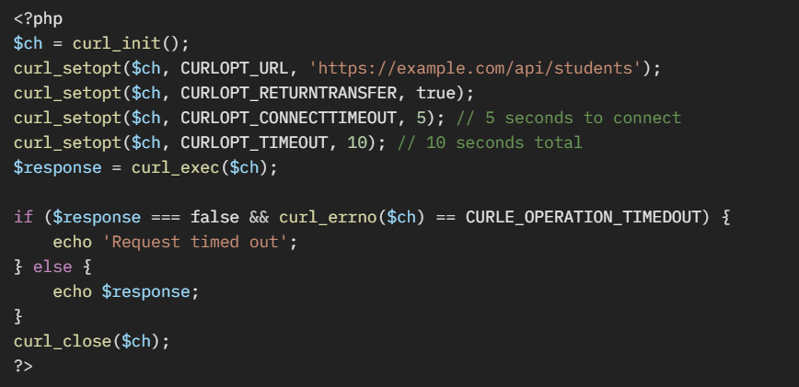

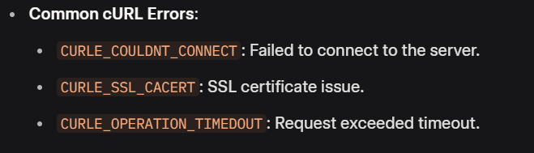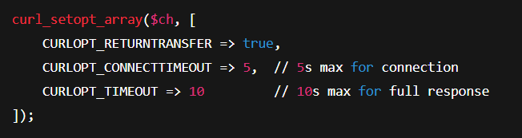

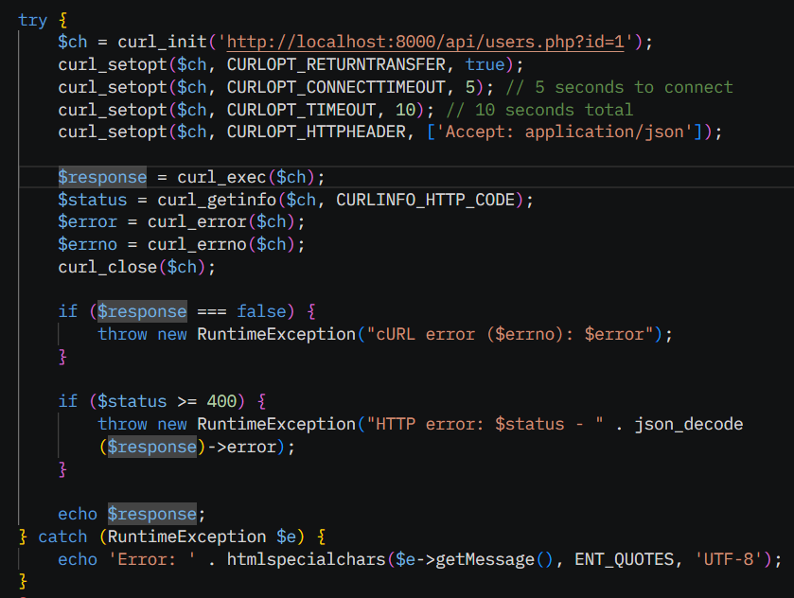

* **SSL & Certificates**

SSL (Secure Sockets Layer) ensures secure communication via HTTPS. Certificates verify server identity.

· By default, cURL checks SSL certificates.

· If using **self-signed certs** (dev/test), you may get errors like SSL certificate problem.

When you make HTTPS requests with cURL, it checks the server’s **SSL/TLS certificate** to make sure:

* The site is trusted (signed by a known Certificate Authority).
* The certificate hasn’t expired or been tampered with.

#### Configuring PHP cURL for SSL

* Enable **CURLOPT_SSL_VERIFYPEER** and **CURLOPT_SSL_VERIFYHOST** for security.
* Provide a CA certificate bundle for verification.

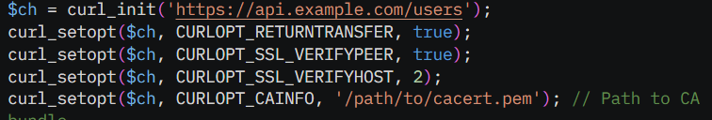

**Note:** Download **cacert.pem** from https://curl.se/docs/caextract.html or use system CA bundle.

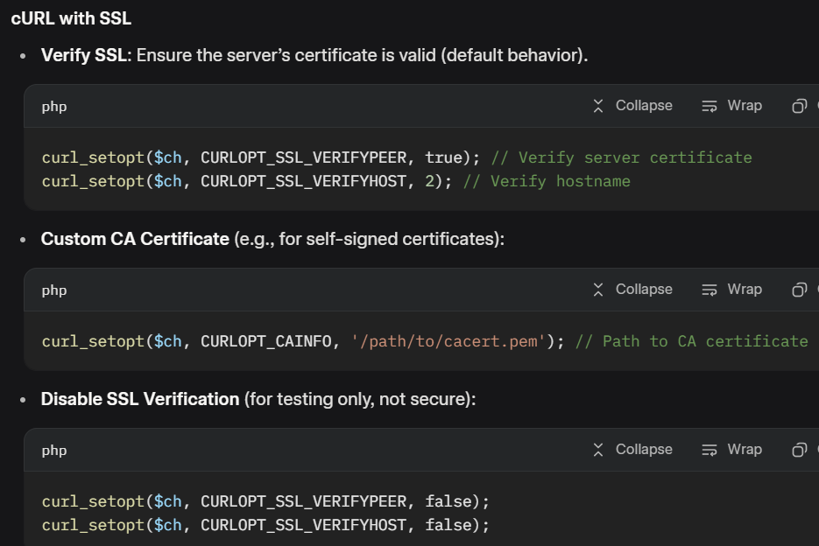

# Client Certificates (for APIs that require them)

Some APIs (like banking or payment gateways) require **your app** to present a client certificate.

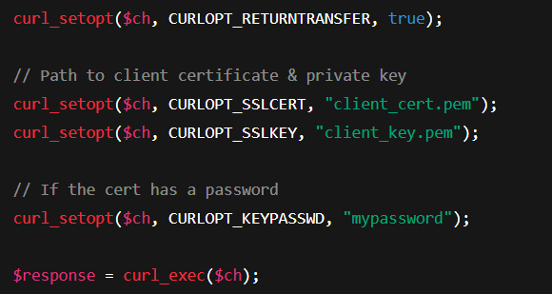

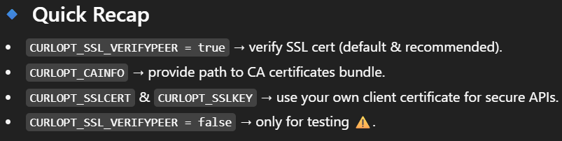

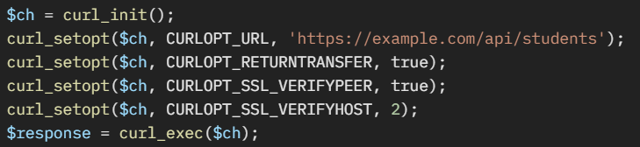

**REST constraints • Routing (vanilla) • JSON responses • Pagination & filtering • Error contracts**

* **REST constraints**

REST (Representational State Transfer) isn’t just “using GET/POST” — it’s an **architectural style** for designing APIs. Roy Fielding (who defined REST) described **6 constraints** that make an API truly RESTful.

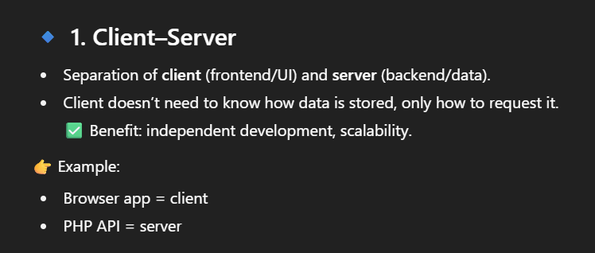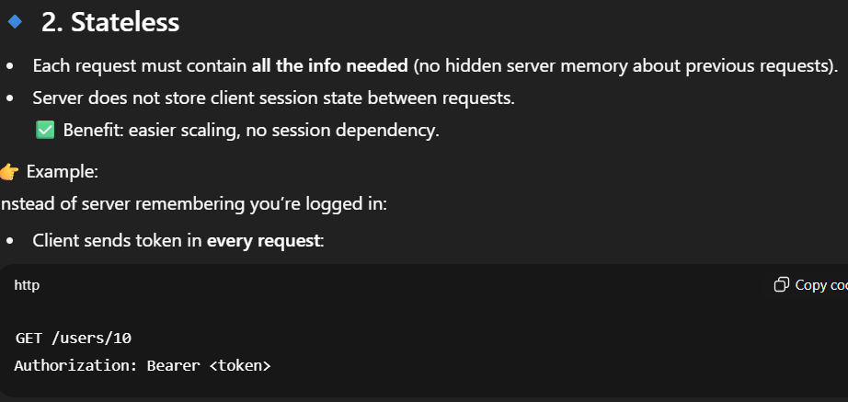

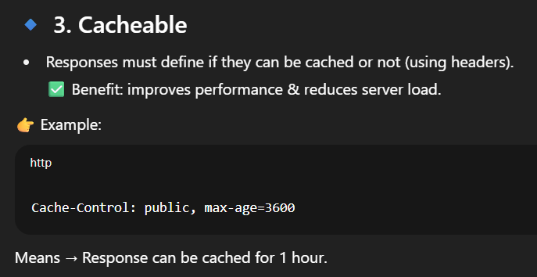

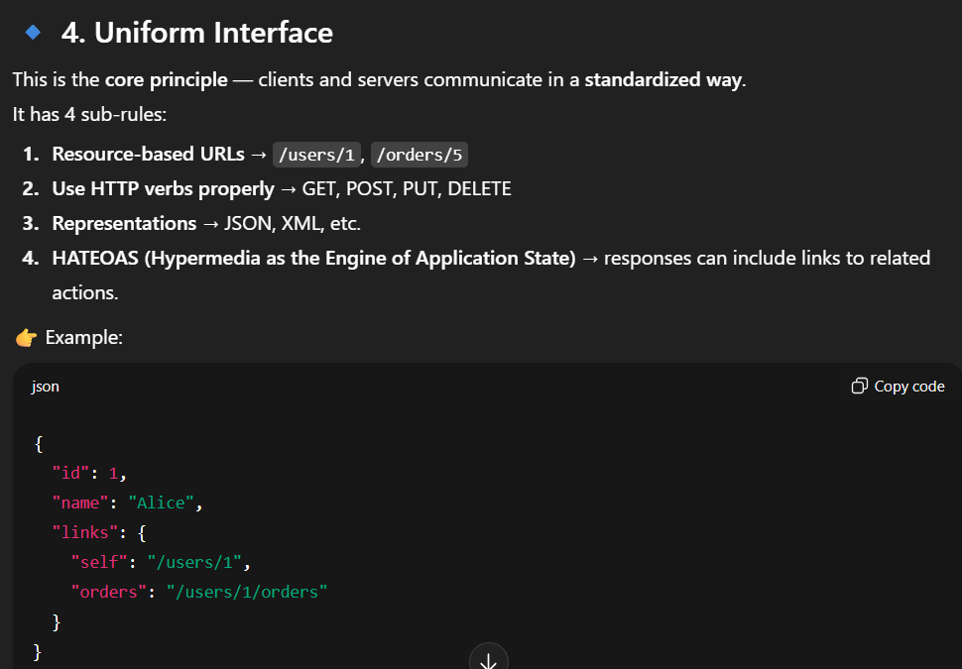

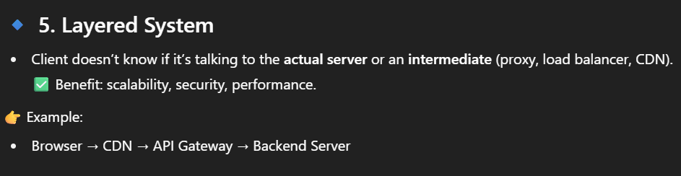

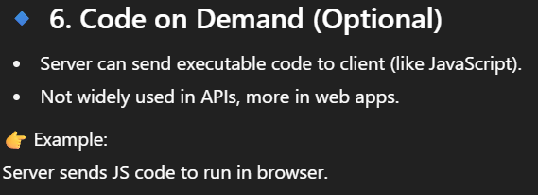

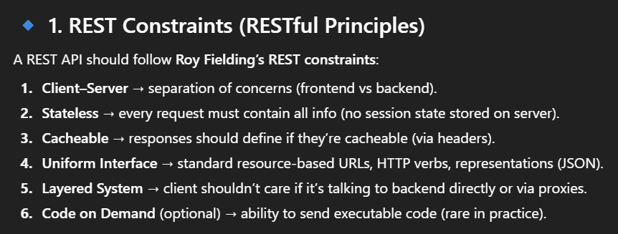

* **Routing (vanilla)**

Routing in vanilla PHP involves mapping HTTP requests (method and URL) to specific code without a framework. This is typically done by parsing the request URI and method.

Routing = mapping URLs to actions. In **vanilla PHP** (no framework)

# What is Routing?

Routing decides **which code should run** based on the URL (path + method).  
For example:

* GET /users → show all users
* POST /users → create a new user
* GET /users/5 → show user with ID 5
* **Setup**:
* Use a web server (e.g., Apache) with **.htaccess** to route all requests to **index.php**

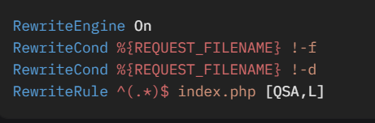

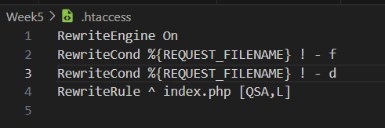

To disable rename **.htaccess** to **.htaccess_disabled** or just stop the server

# 1. Basic Routing with *$_SERVER*

In vanilla PHP, you can use **$_SERVER['REQUEST_URI']** (URL path) and **$_SERVER['REQUEST_METHOD']** (HTTP verb).

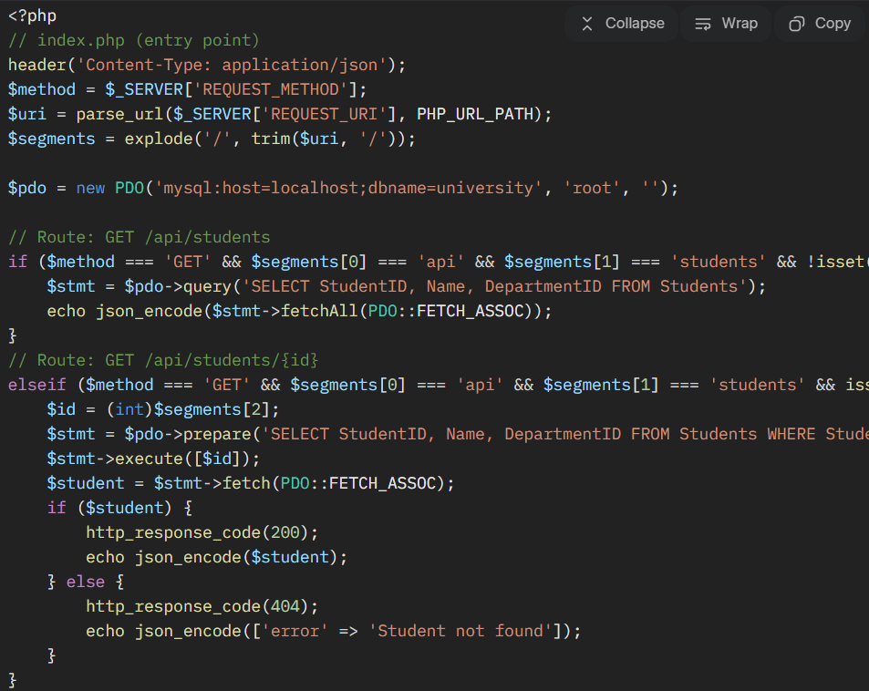

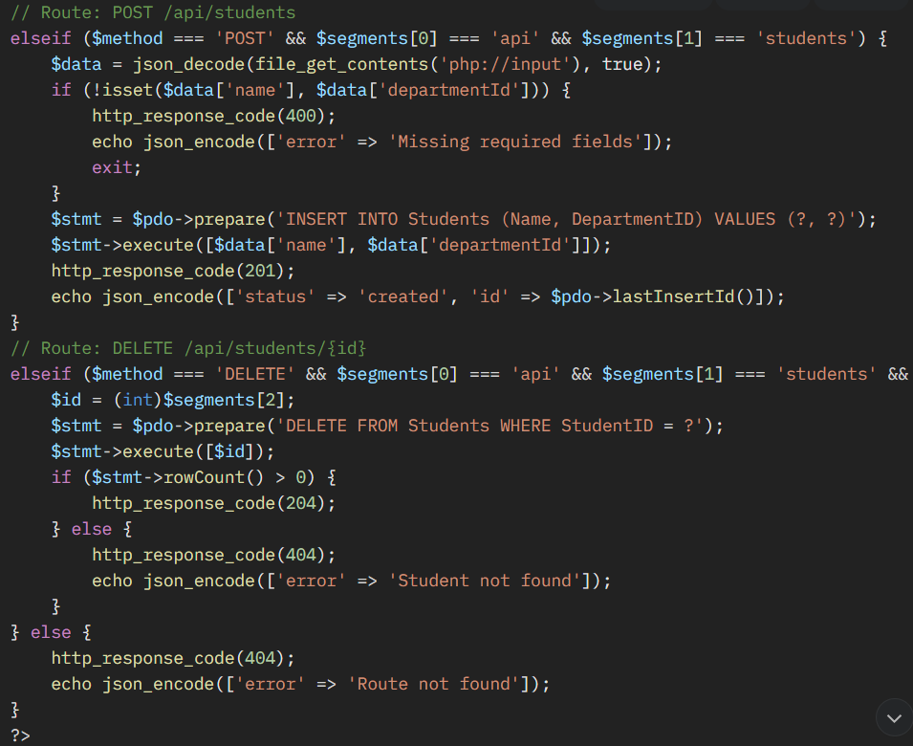

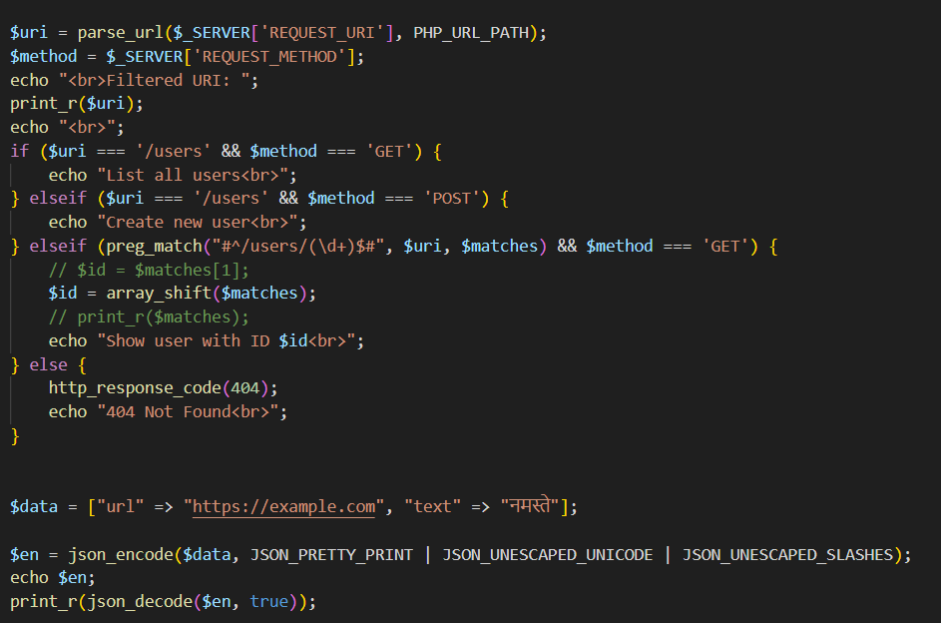

# 2. Using a “routes table” (cleaner)

Instead of writing big if-else, define routes in an array:

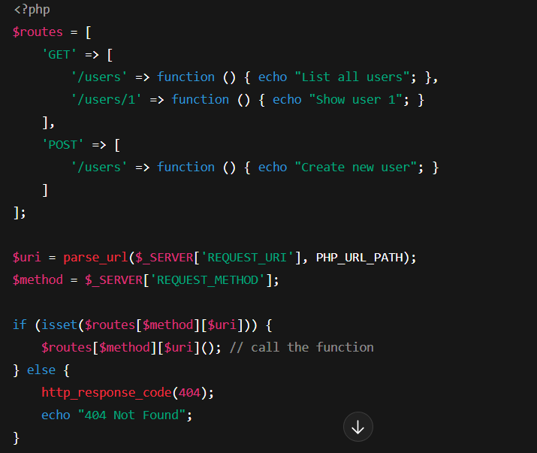

# RESTful Example (Users API)

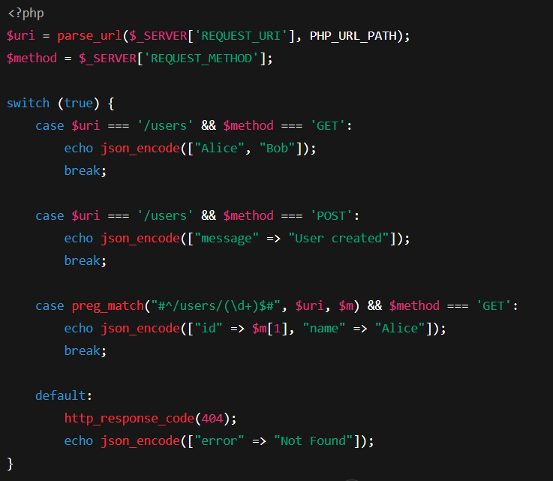

### ****JSON Responses****

JSON is the standard format for REST API responses, ensuring interoperability.

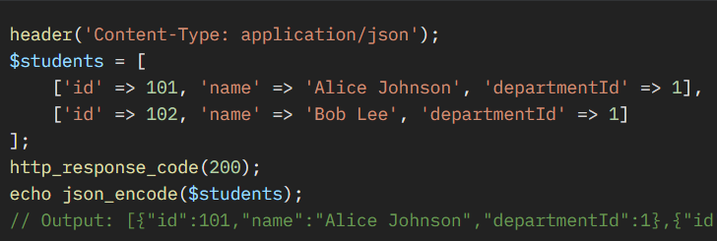

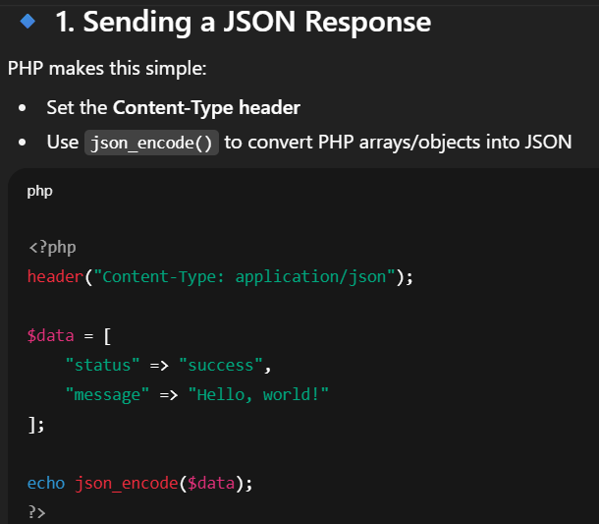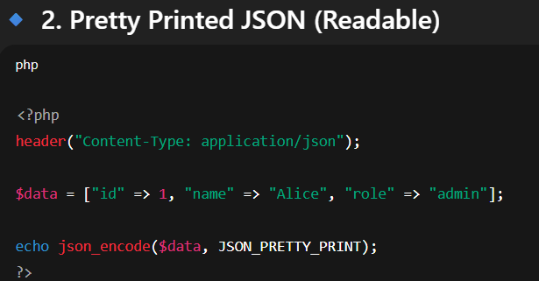

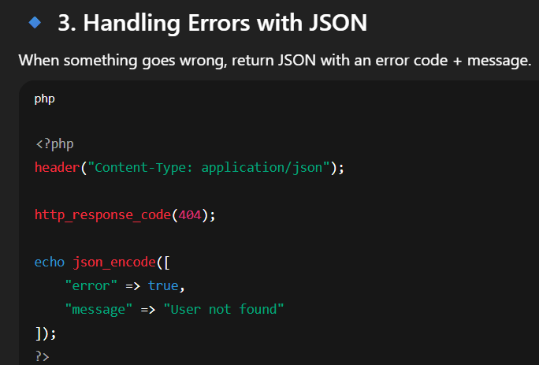

# Useful Options in json_encode

* + - JSON_PRETTY_PRINT → formatted output
    - JSON_UNESCAPED_SLASHES → don’t escape /
    - JSON_UNESCAPED_UNICODE → keep UTF-8 characters readable

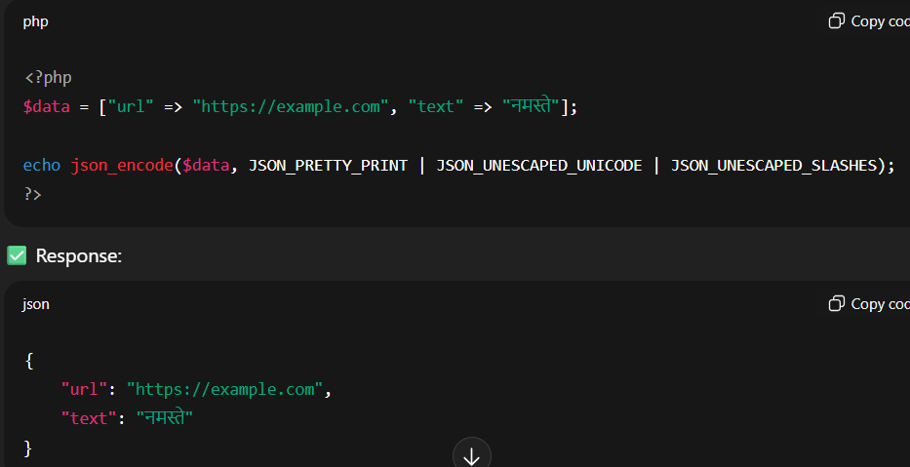

* Pagination & Filtering

Pagination and filtering optimize API performance by limiting and refining data returned.

# 1. Why Pagination & Filtering?

* **Pagination** → Split large results into pages (e.g., 10 users at a time).
* **Filtering** → Allow clients to request only data they need (e.g., only users from India, or only active users).

✅ This avoids sending thousands of records at once → better performan

#### ****Pagination****

* **Approach**: Use query parameters like page and limit to control the number of records returned.

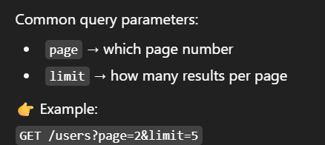

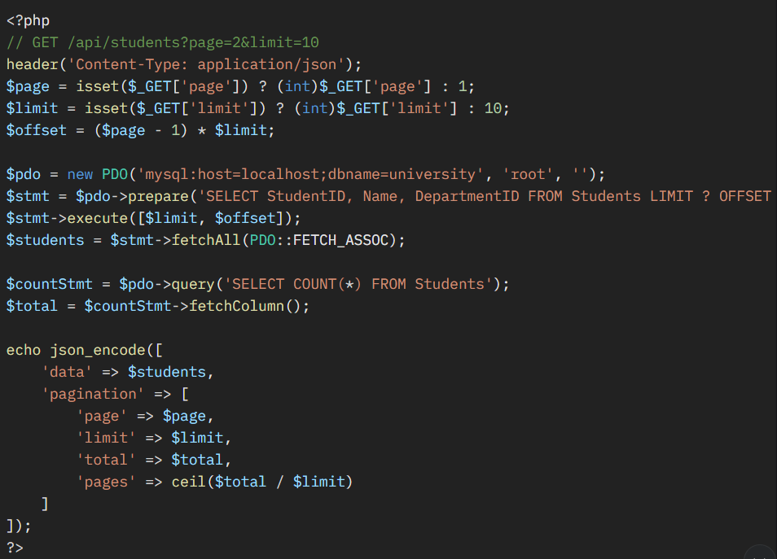

#### ****Filtering****

* **Approach**: Use query parameters to filter results (e.g., departmentId, name).

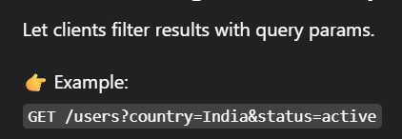

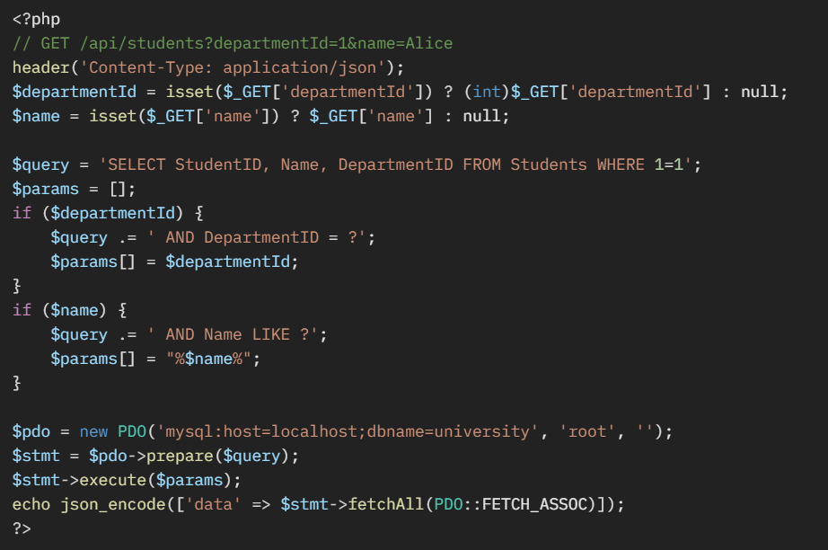

* **Error Contracts**

An error contract defines a consistent format for error responses, making it easier for clients to handle errors.

A good error response usually has:

* + - **code** → machine-readable error code (string/number)
    - **message** → human-readable message
    - **details** → optional extra info (field validation errors, stack traces, etc.)
    - **status** → HTTP status code (sometimes included inside JSON too)

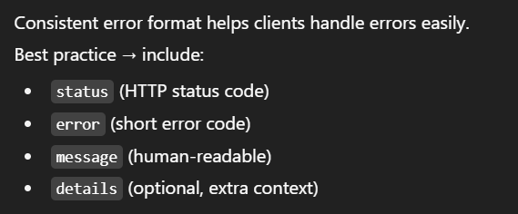

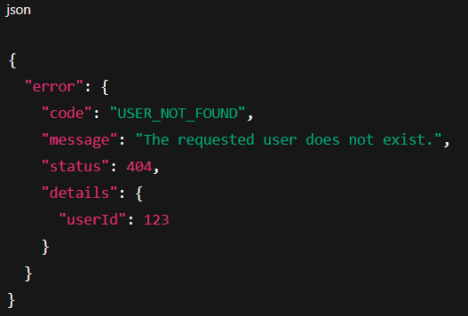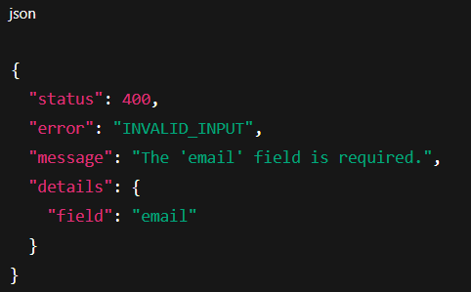

**API keys • JWT structure & validation • OAuth2 grant types overview • Rate limiting & throttling • API docs (OpenAPI)**

### ****API Keys****

API keys are simple tokens used to authenticate API requests, often for tracking or access control.

* **How It Works**:
  + A unique key (e.g., abc123xyz) is assigned to a client.
  + The client includes the key in requests (e.g., as a header or query parameter).
  + The server validates the key against a stored list.

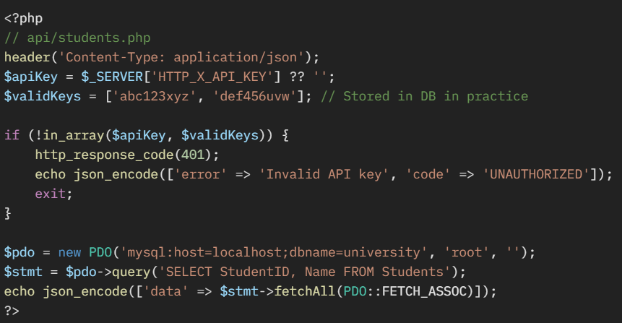

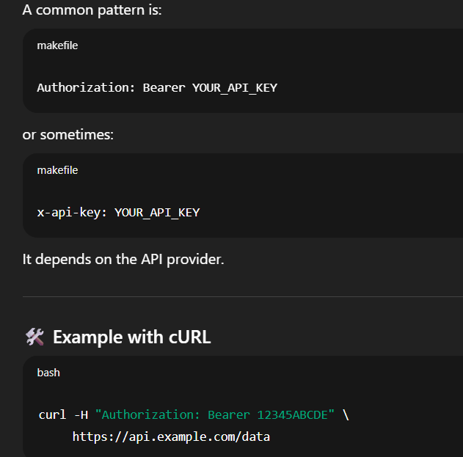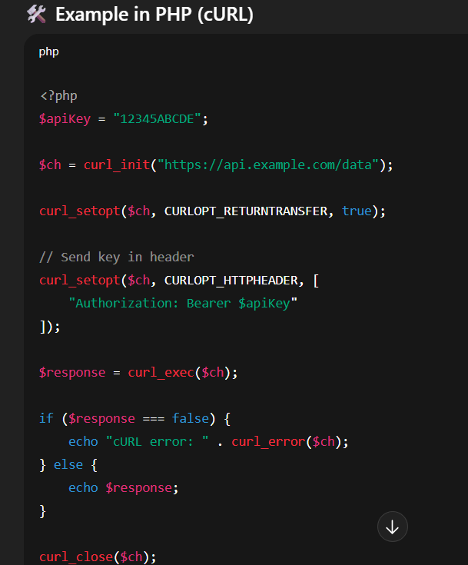

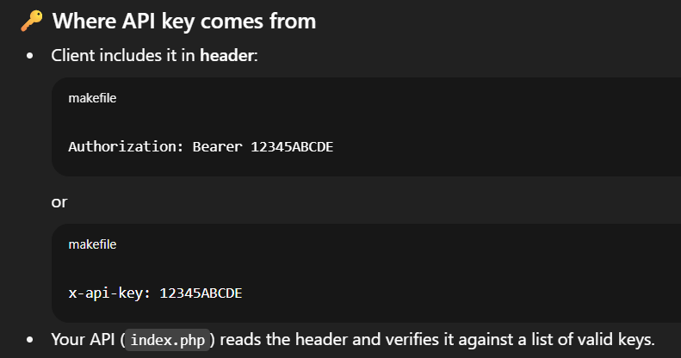

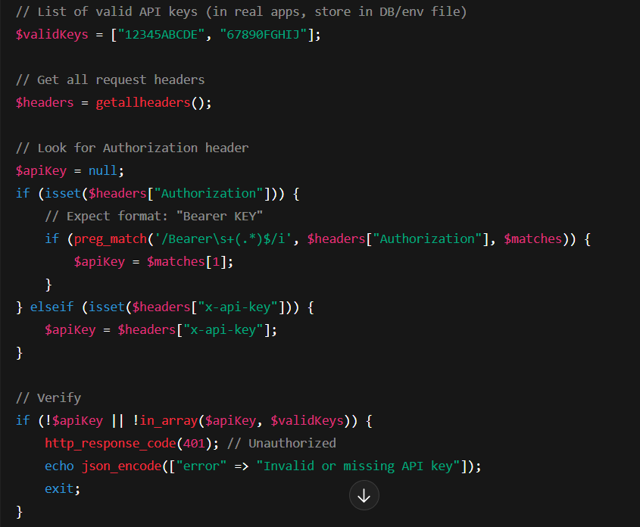

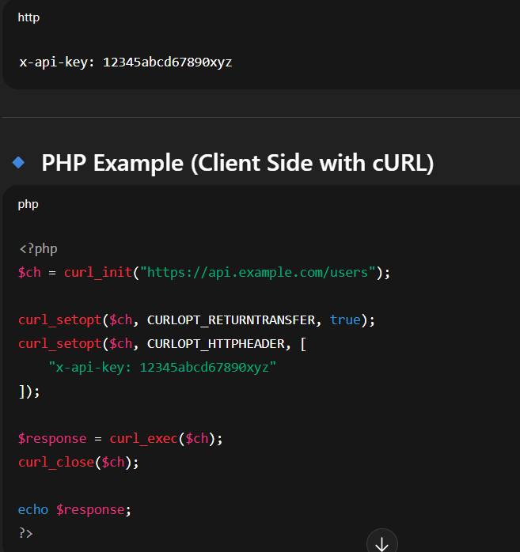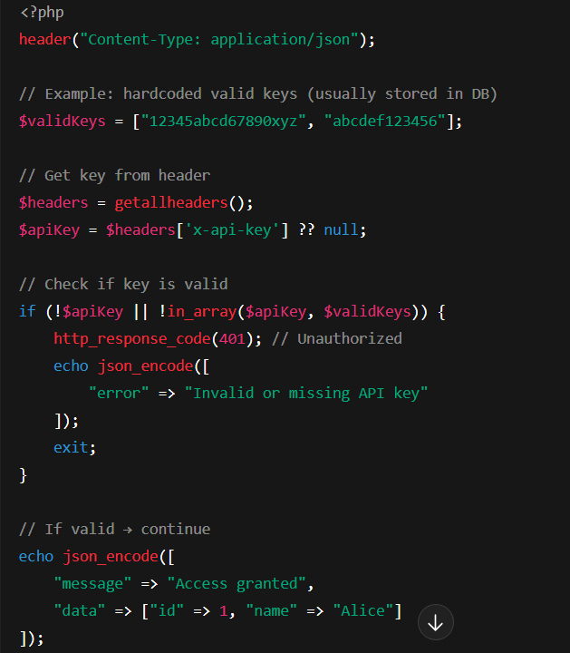

### ****JWT Structure & Validation****

JSON Web Tokens (JWTs) are compact, self-contained tokens for secure data exchange, often used for authentication.

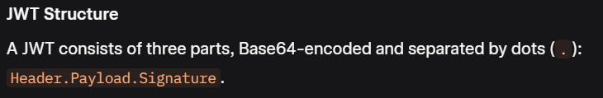

JWT (JSON Web Token) is a compact, URL-safe token for authentication, consisting of three parts: **Header, Payload,** and **Signature**, **Base64-encoded** and joined by dots (**.**).

#### Structure

* **Header**: JSON object with algorithm (e.g., {"alg":"HS256","typ":"JWT"}).
* **Payload**: Claims (e.g., sub for user ID, exp for expiration).
* **Signature**: HMAC or RSA signature to verify integrity.

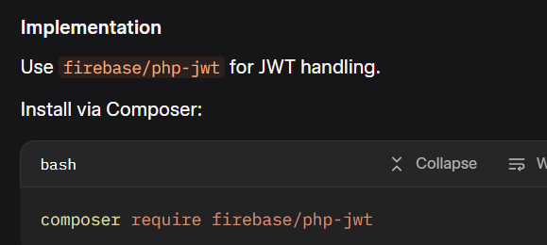

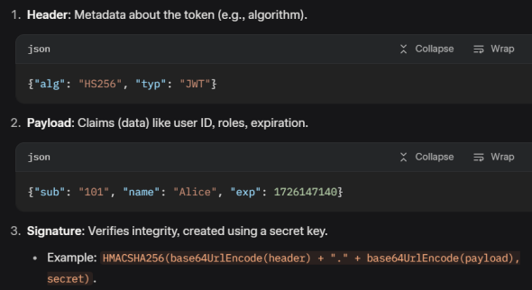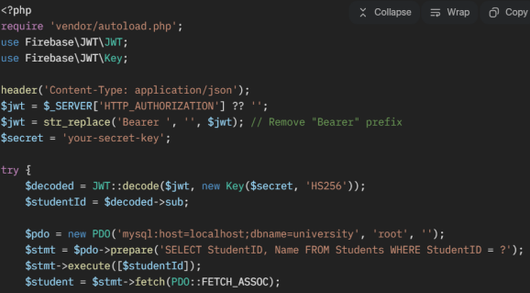

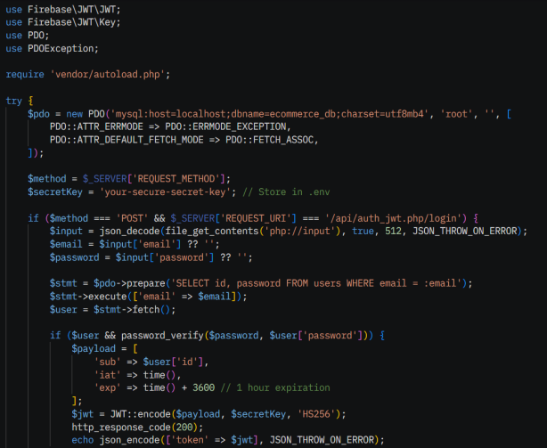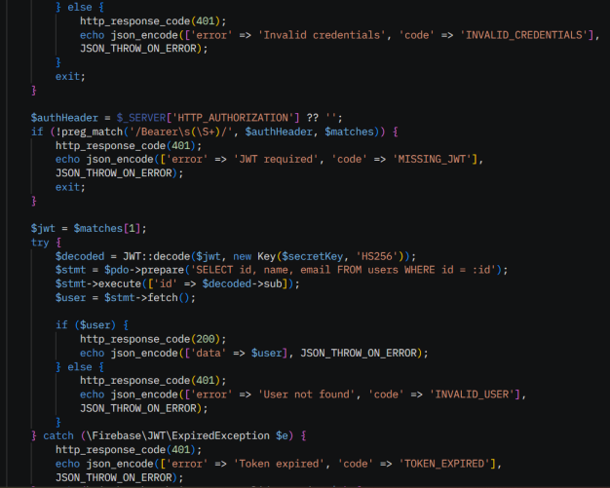

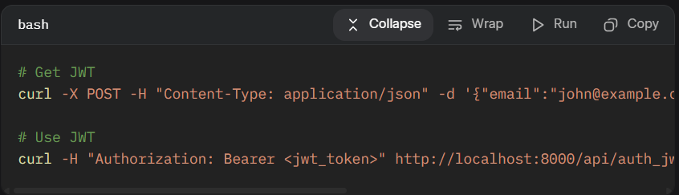

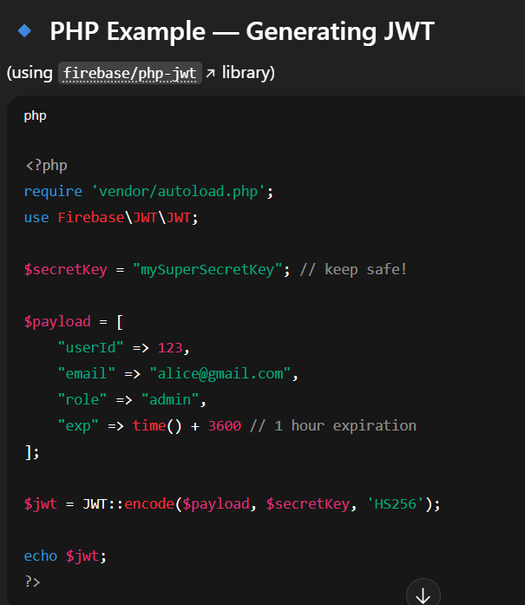 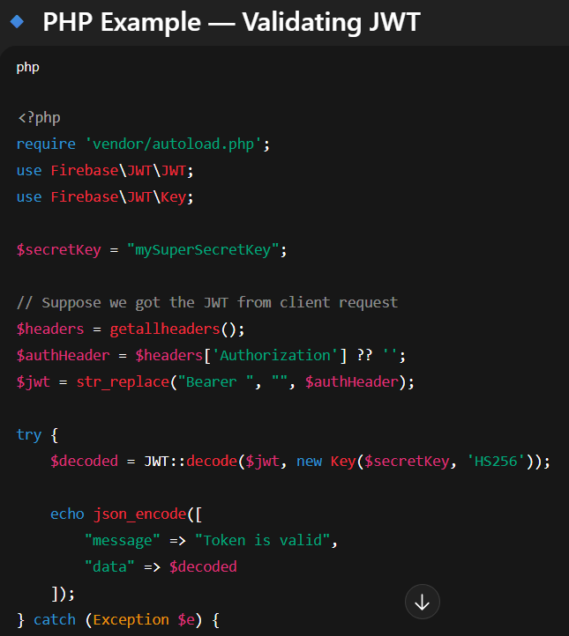

* **OAuth2 Grant Types Overview**

# What is OAuth2?

OAuth2 is a **standard way for apps to access resources on behalf of a user** — without sharing the user’s password.

**Example:** You log in to a third-party app with **“Login with Google”**.

* That app never sees your Google password.
* Instead, Google gives it a **token** (limited access).

# Main Grant Types (Flows)

OAuth2 has different "grant types" = **ways to get tokens**, depending on the situation.

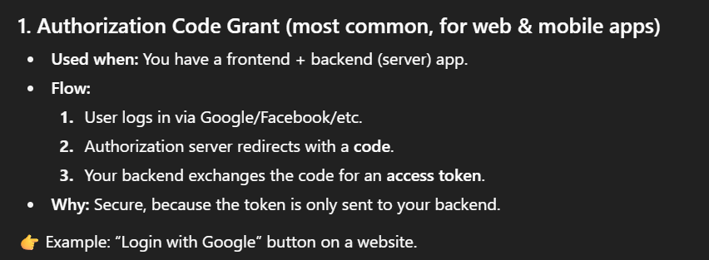

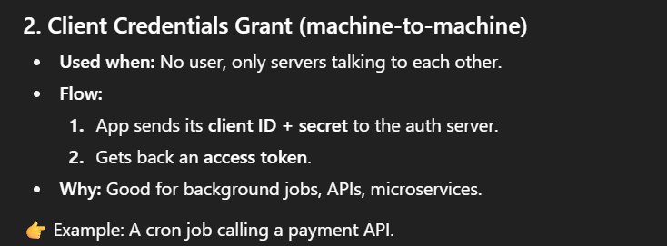

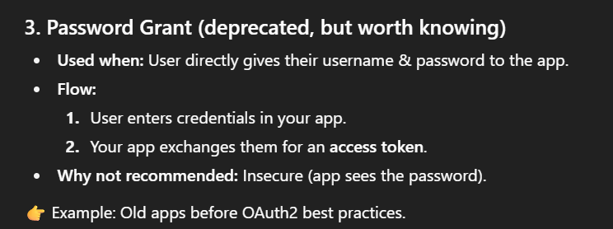

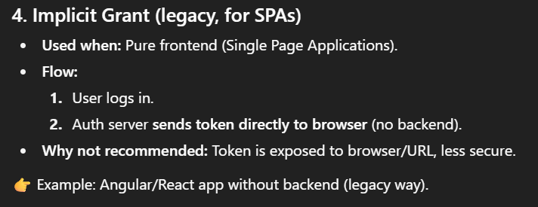

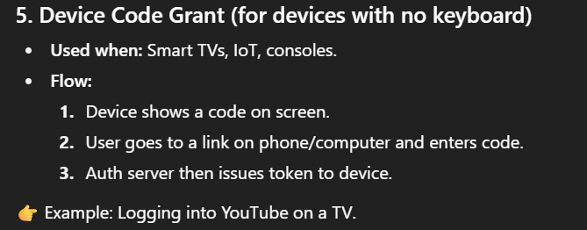

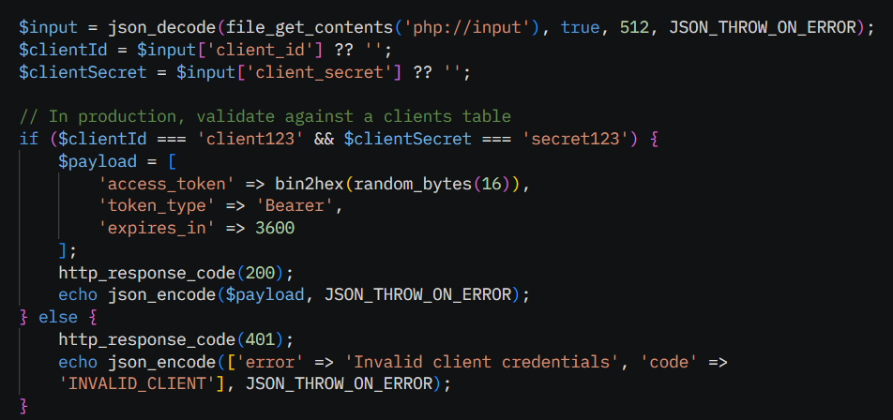

* **Rate Limiting & Throttling**

# What is Rate Limiting?

Rate limiting = **controlling how many requests a client can make in a certain time**.

**Example:**

* API allows **100 requests per minute per user**.
* If a client sends the 101st request → API returns error (usually **429 Too Many Requests**).

# Why Rate Limit?

* Protect server from overload (DDOS, bots).
* Control costs (if your API calls expensive services).
* Fair usage (one client shouldn’t block others).

# What is Throttling?

Throttling = **slowing down requests** instead of blocking.

**Example:**

* API allows 10 requests per second.
* If client sends 20 requests at once, server processes them slowly (queue/delay) instead of rejecting.

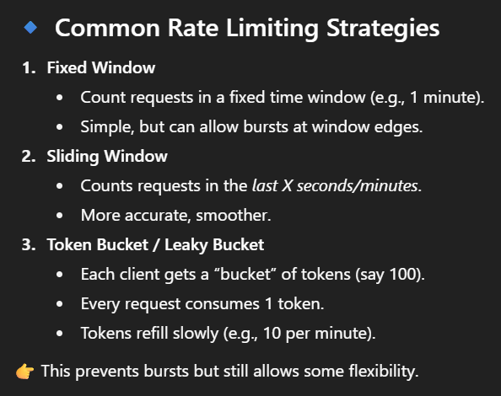

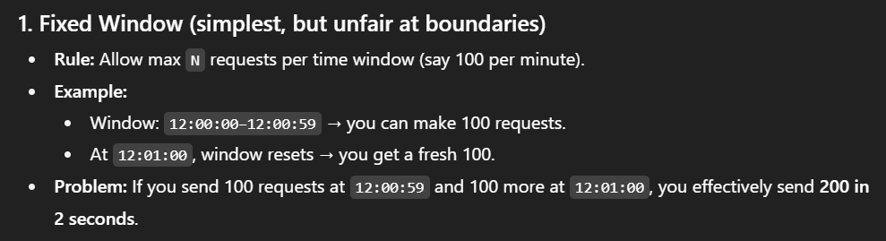

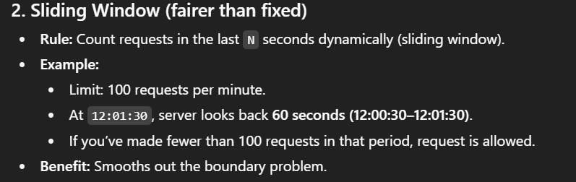

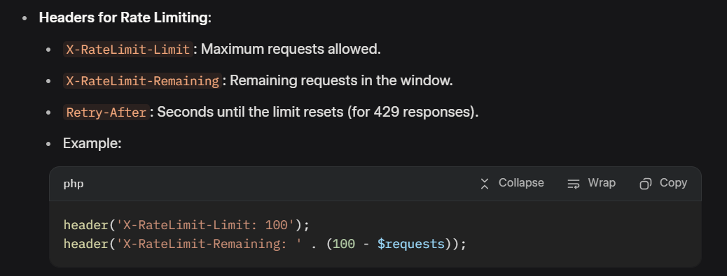

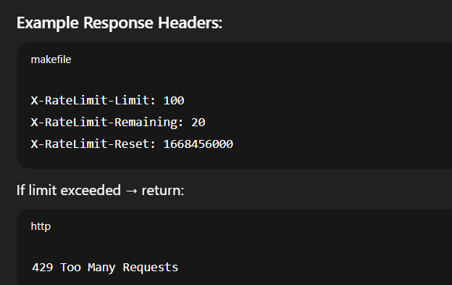

* **API Docs (OpenAPI):**

OpenAPI (formerly **Swagger**) is a standard for documenting REST APIs, providing a machine-readable specification (JSON/YAML) and tools for interactive documentation.

**Key Components**:

* **Info**: API title, version, description.
* **Paths**: Endpoints and operations (e.g., GET /students).
* **Schemas**: Data models (e.g., Student object).
* **Security**: Authentication methods (e.g., API key, OAuth2).

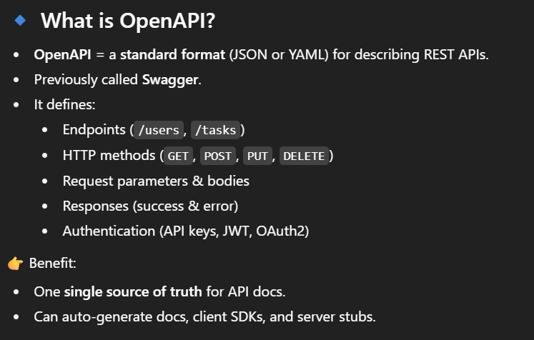

**Example OpenAPI Spec (YAML)**

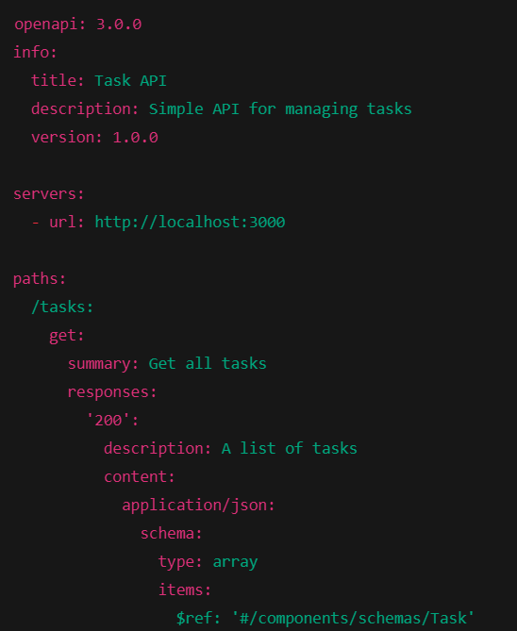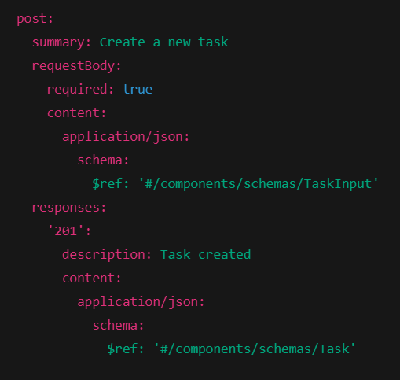

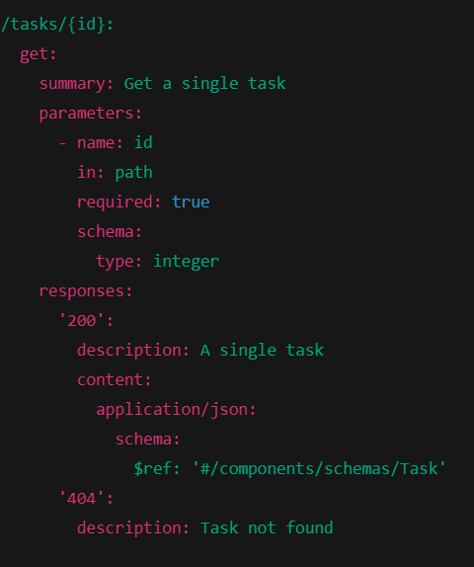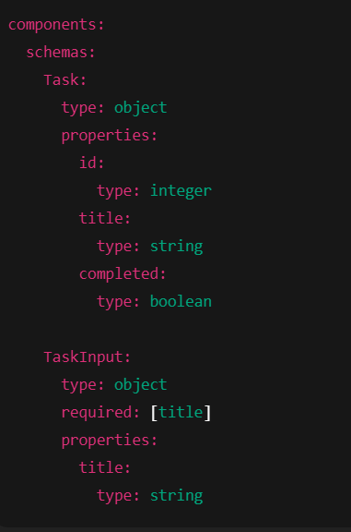

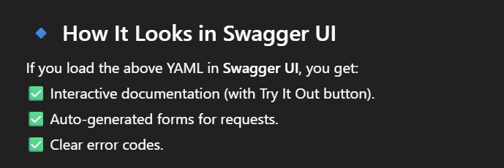

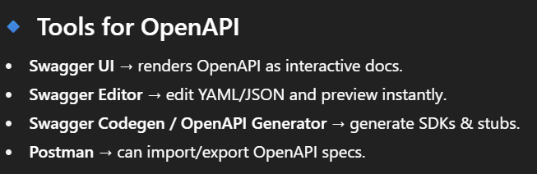

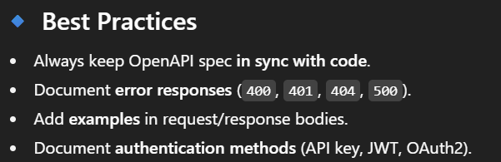

**Choose 2 public APIs (e.g., Weather, News) • Data fetching & caching • Cron for refresh • Error retries/backoff**

* **Choose 2 public APIs (e.g., Weather, News):**
* **Open-Meteo Weather API**: A free, open-source weather API with no API key required. It provides current weather and forecasts via simple GET requests (e.g., for a location like a university campus in New York).

**Endpoint:** <https://api.open-meteo.com/v1/forecast?latitude=40.7128&longitude=-74.0060&current_weather=true&hourly=temperature_2m.>

**https://openweathermap.org/**

* **NewsAPI**: A free news API (developer plan) that requires a free API key (sign up at newsapi.org). It fetches top headlines or search results (e.g., university-related news). **Endpoint:** <https://newsapi.org/v2/top>headlines?country=us&category=science&apiKey=YOUR_API_KEY.

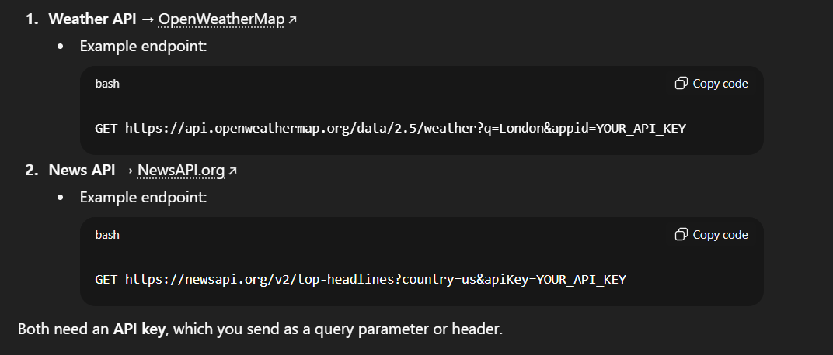

### ****Data Fetching****

Data fetching involves making HTTP requests to the APIs using cURL or similar. Handle JSON responses and store raw or parsed data.

#### ****Fetching from Open-Meteo Weather API****

* **Example** (Current weather for New York):

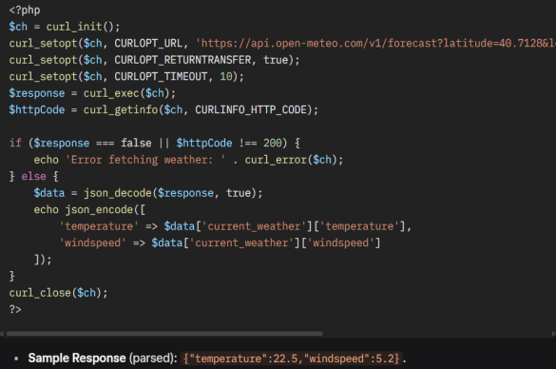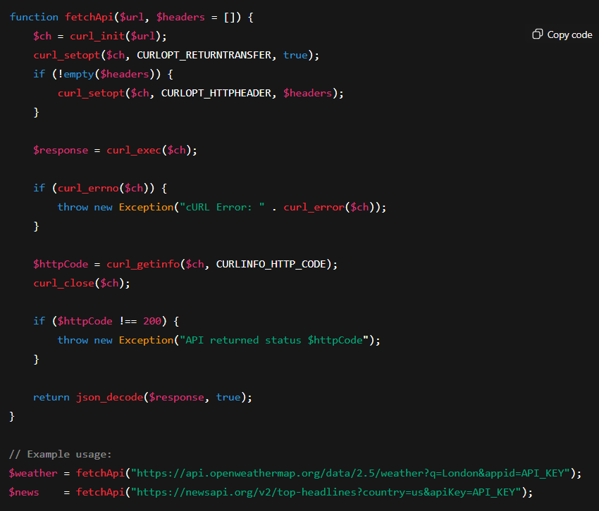

### ****Caching****

To avoid hitting the API every request (which costs time & rate limit), cache the response.

Caching stores API data locally (e.g., in a database) to reduce requests, improve performance, and handle rate limits. Use timestamps to expire cache (e.g., refresh weather every 30 minutes, news every hour).

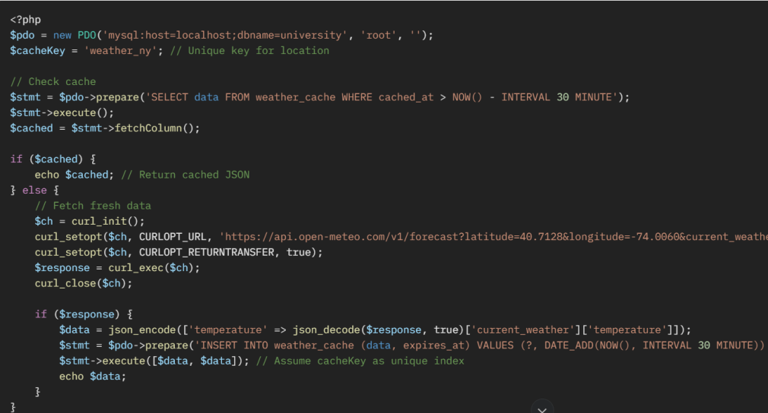

* **Cron for Refresh**

Cron is a time-based job scheduler in Unix-like operating systems, including Linux, used to automate system maintenance and administration tasks, such as running scripts or commands at specific times, dates, or intervals.

Use cron jobs (on a server) to periodically refresh cached data automatically, ensuring up-to-date info without manual intervention.

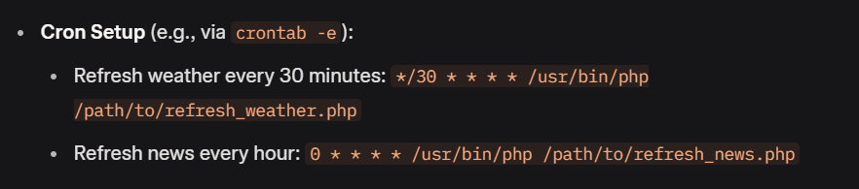

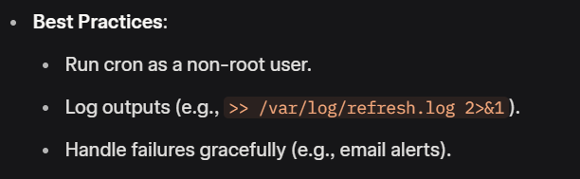

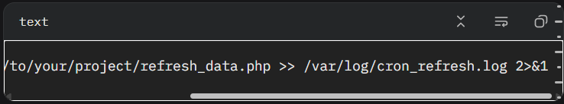

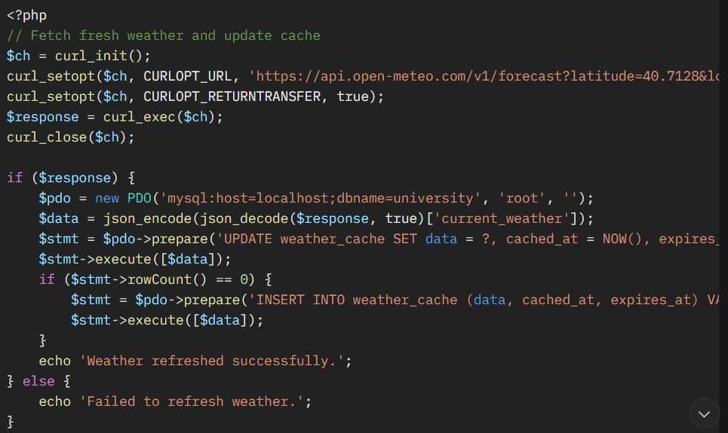

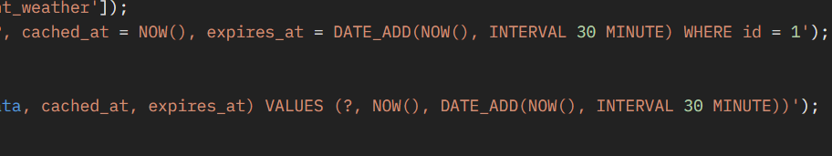

* **In Windows this can be done using the task Scheduler:**

### Create a **script.bat** file and include the **php.exe**path and **cron.php**file path.

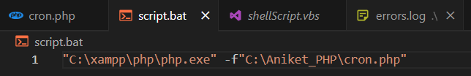

**2**. Now Create a **ShellScript.vbs** file and include the **script.bat**path.

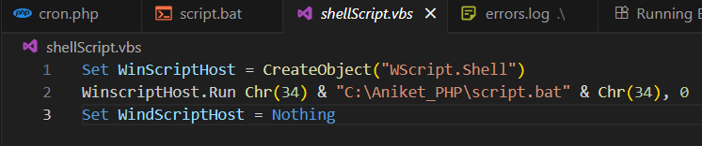

### 3.Open Task Scheduler ->Create Task-> Give a NAME -> GO TO -> Triggers -> New -> (Select as you please) **[Enable] -**> GO TO -> Actions -> NEW -> SELECT OUR (**shellScript.vbs**) file -> OK -> CONDITIONS-> **Disable**[Start the task only if the Computer is on AC Power ]

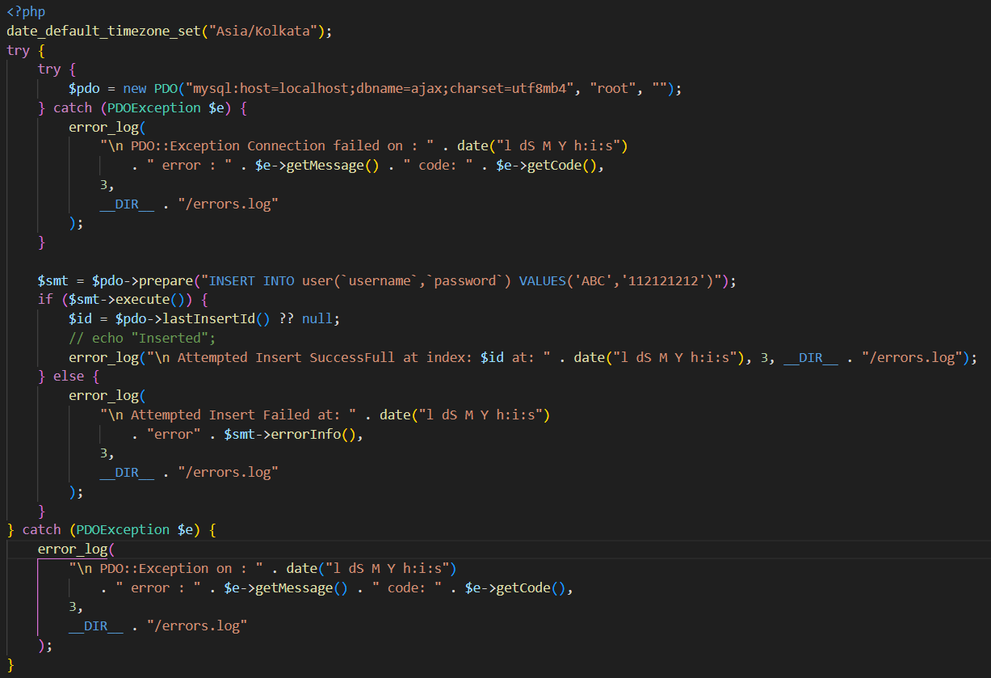

### **Error Retries and Exponential Backoff**

Sometimes APIs fail (network issue, 500 error). Best practice = **retry with backoff**.

**Error Retries** involve attempting a failed operation multiple times before giving up, while **Exponential Backoff** increases the delay between retries to avoid overwhelming the server during temporary issues (e.g., network timeouts or rate limits).

Implement retries with exponential backoff for transient errors (e.g., network issues, rate limits). Retry up to 3 times, doubling wait time (e.g., 1s, 2s, 4s).

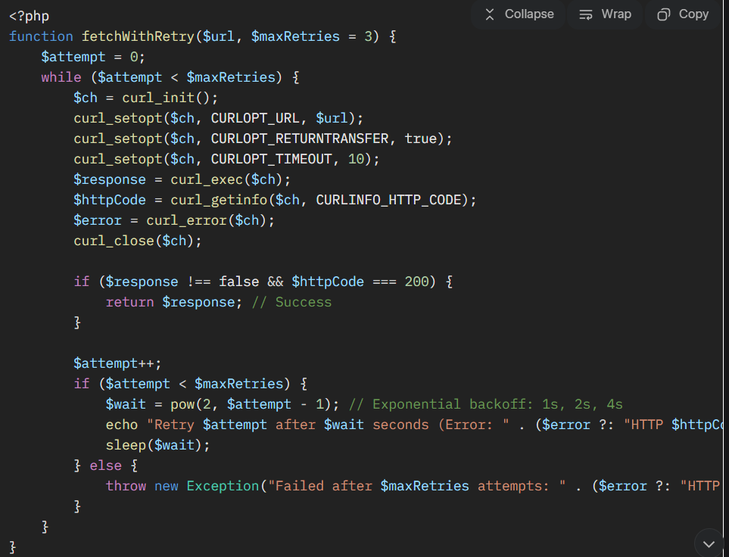

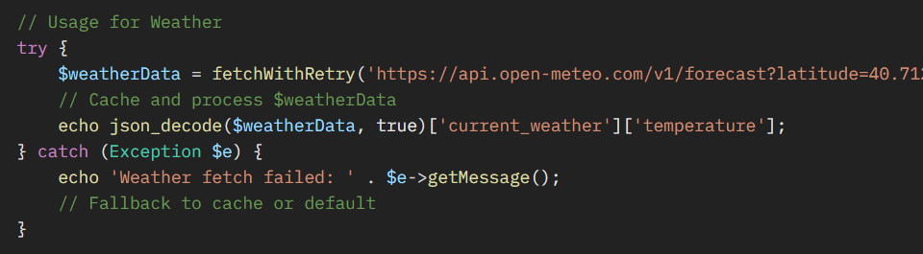

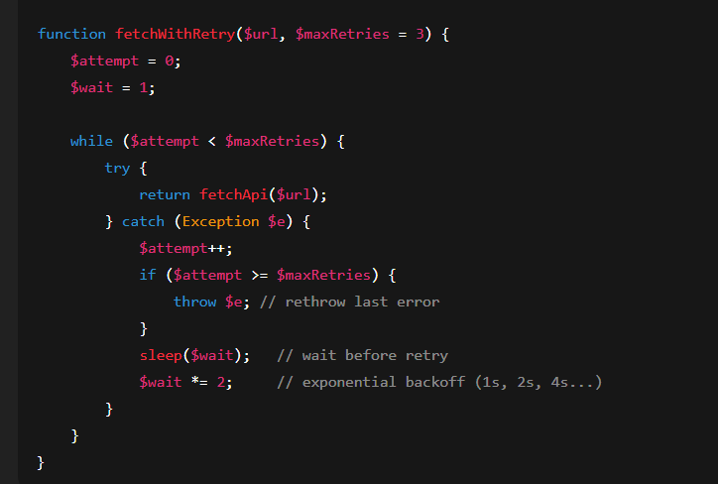

**Search & filtering • Pagination • Export CSV/JSON • Dockerize local run (optional)**

### Search & Filtering

**Search & Filtering** allows clients to narrow down results using multiple criteria (exact matches, ranges, text search, etc.).

Search and filtering allow clients to query specific data using parameters (e.g., name, departmentId) to narrow results.

* **Implementation**:
  + Use query parameters for filtering (e.g., ?name=Alice&departmentId=1).
  + Support partial matches for search (e.g., LIKE for names).
  + Sanitize inputs to prevent SQL injection.

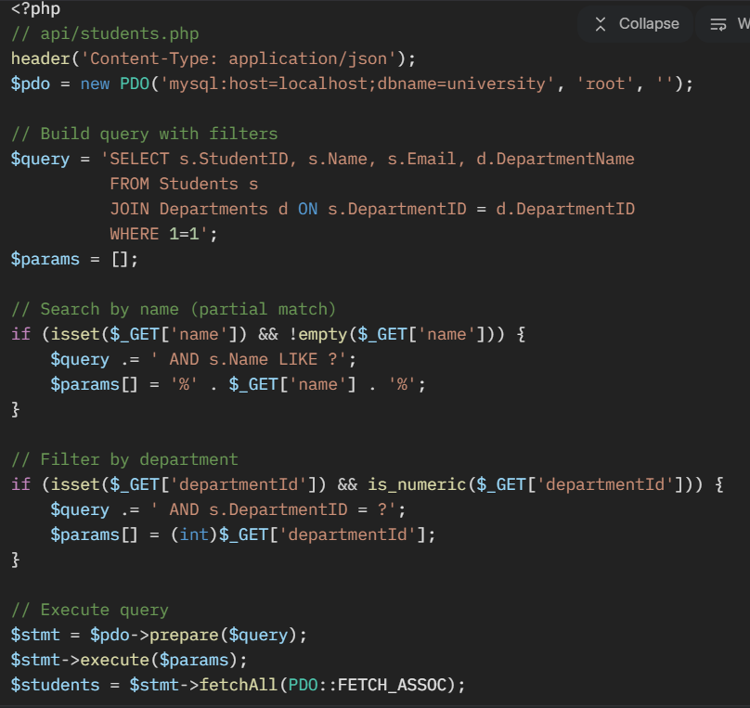



### ****Pagination****

Pagination limits the number of results returned, improving performance and usability.

**Implementation**:

* Use **page** and **limit** query parameters.
* Include metadata (e.g., total records, pages) in responses.
* Use SQL **LIMIT** and **OFFSET** for pagination.

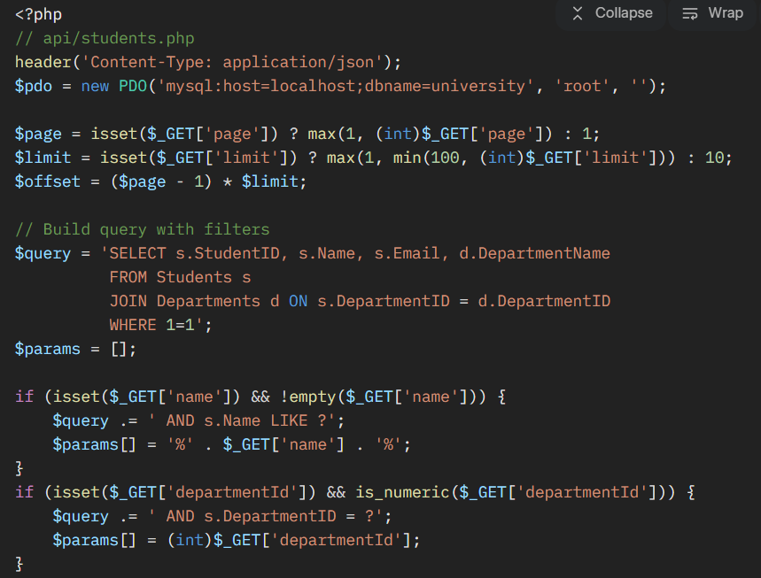

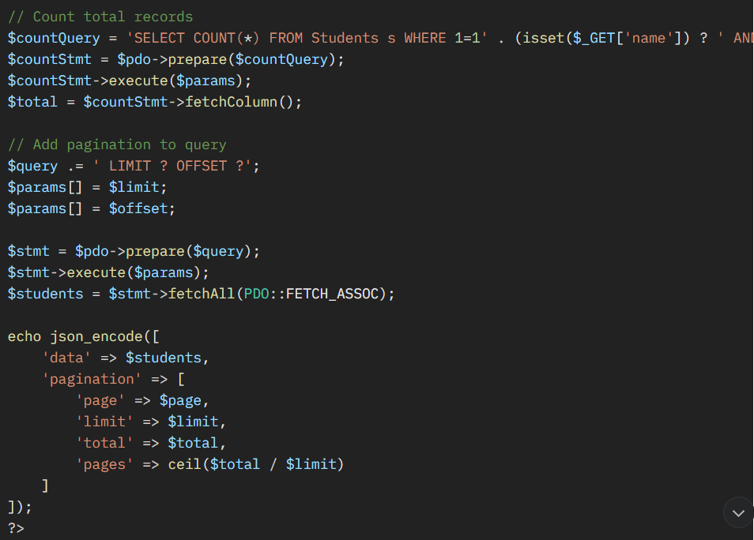

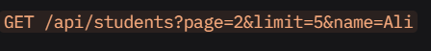

### ****Export CSV/JSON****

Allow clients to export data in CSV or JSON format for analysis or reporting.

**Implementation**:

* Add a **format** query parameter (e.g., **?format=csv** or **?format=json**).
* For CSV, stream headers and data to avoid memory issues.
* For JSON, reuse the existing response format.

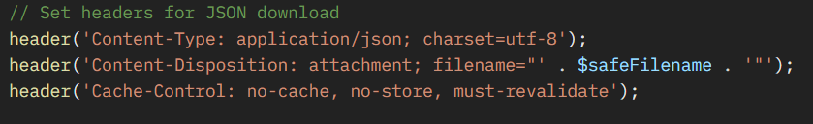

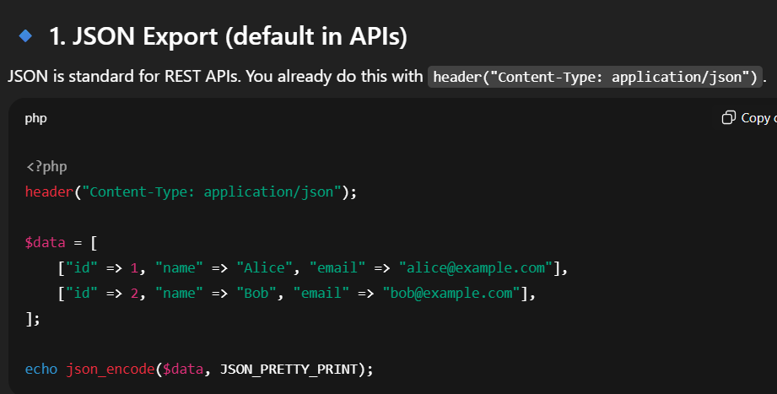

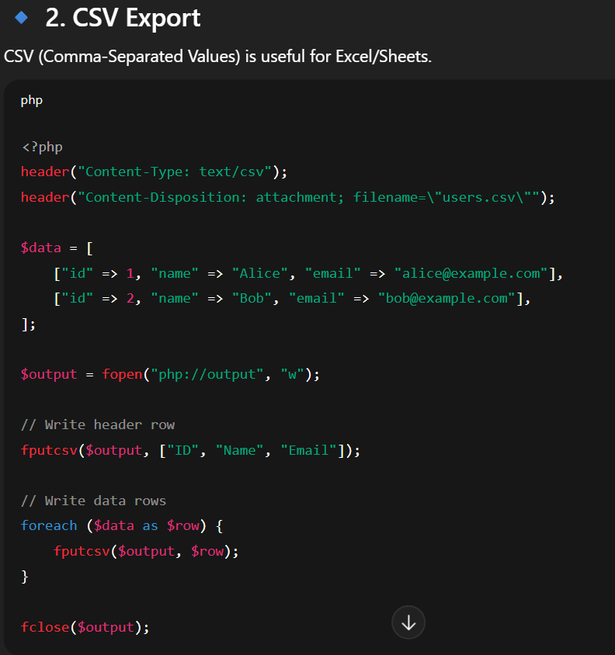

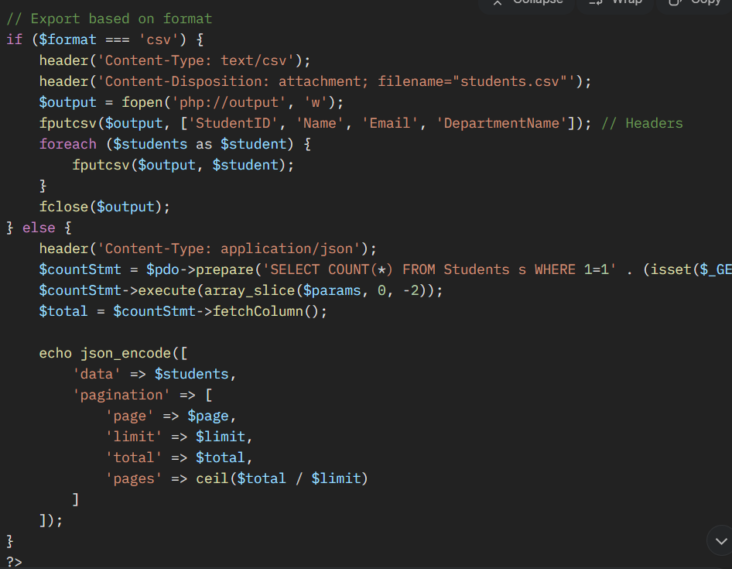

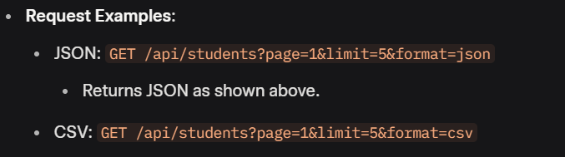

### ****Dockerize Local Run (Optional)****

Docker containerizes the API, database, and dependencies for consistent local development.

Docker is a **platform** (or tool) that helps you build, run, and manage applications inside **containers**.

A **container** is like a lightweight, portable box that contains everything your application needs to run:

* the code
* libraries
* dependencies
* configurations

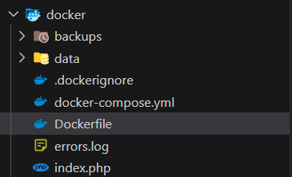

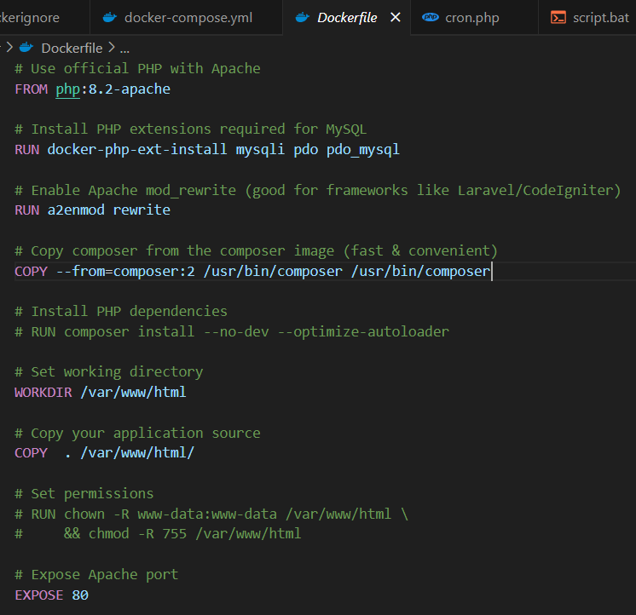

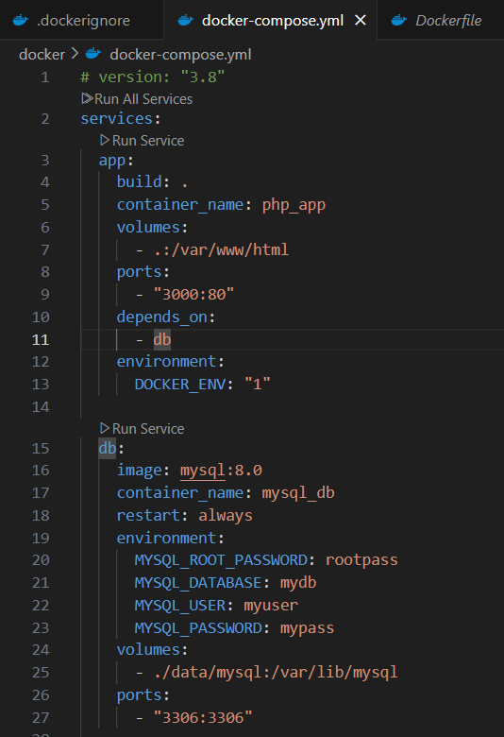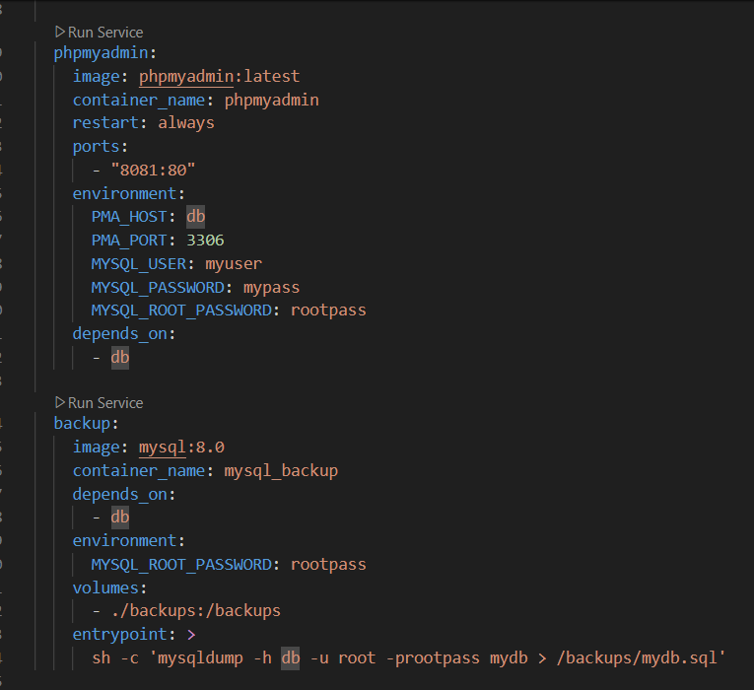

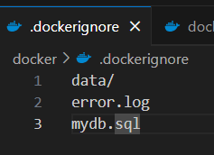

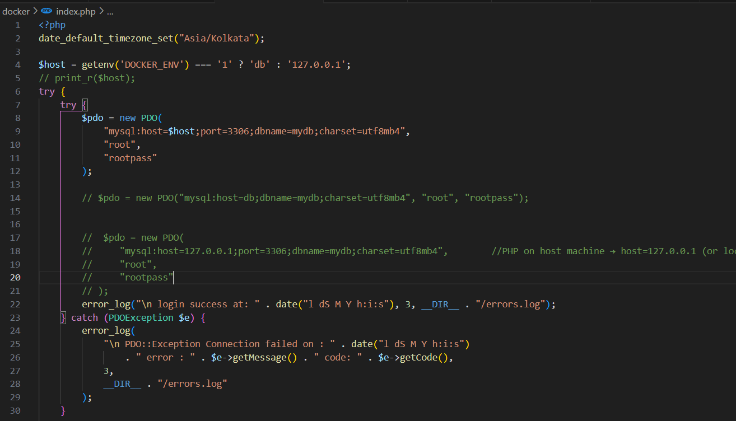

* **To start the docker Container:**



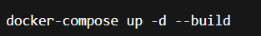

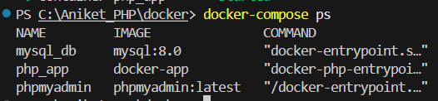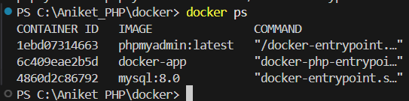

* **To stop the docker container:**



* **Accessing the Mysql through CLI:**

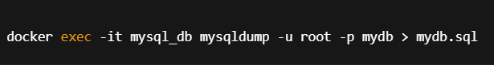

Here the “***mysql_dump***” is the mysql service container name in ***docker-compose.json***



Here “***db***” is ***service name*** of the mysql.

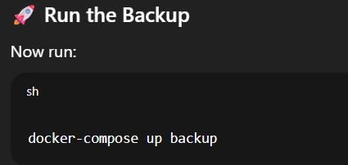

After running “**docker-compose up backup**” a backup file will be created in backups filder named “**mydb.sql**”

### How it works:

* + **App (PHP + Apache)** → http://localhost:3000
  + **phpMyAdmin** → http://localhost:8081
  + **MySQL** → port 3306 (so you can connect with tools like MySQL Workbench)
  + **Database stored persistently in ./data/mysql**

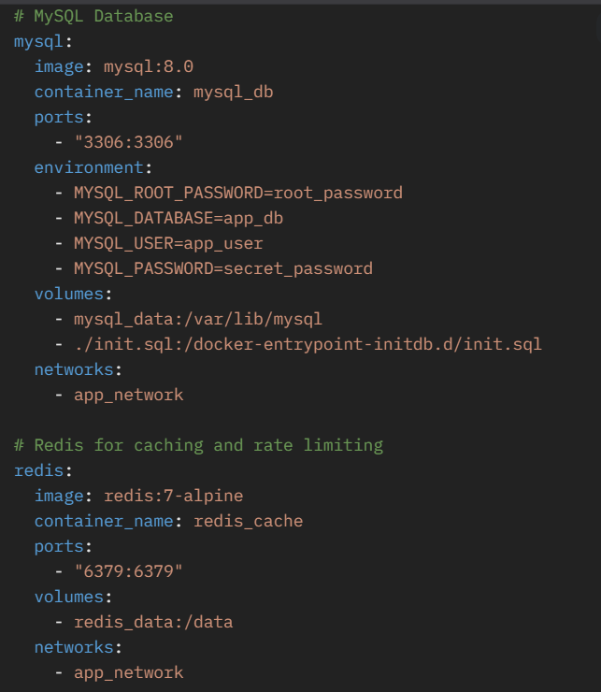

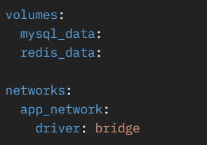

Here:

The line **./init.sql:/docker-entrypoint-initdb.d/init.sql** in **docker-compose.yml** is a volume mount that tells Docker to copy a local file (**init.sql**) into the MySQL container's initialization directory.

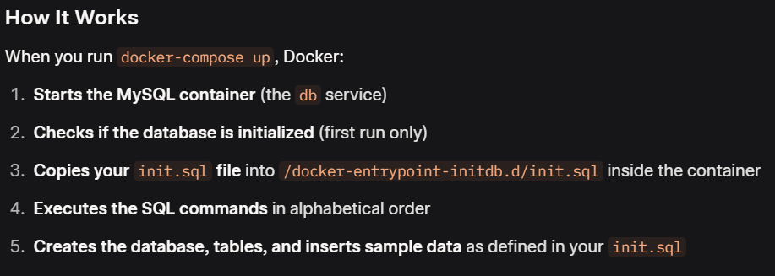

The line - db-data:/var/lib/mysql ensures that your data is persistently stored and automatically restored when you restart the container.

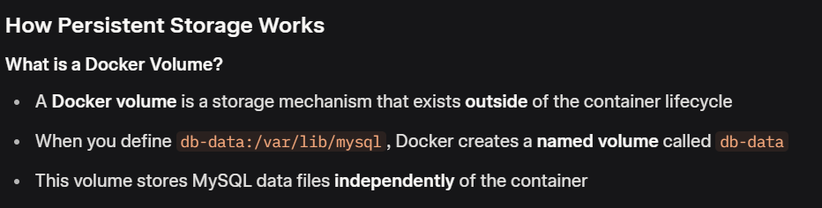

**Project setup (Laravel + Sail/Vite) • Folder structure & lifecycle • Config & env • Routing basics • Controllers**

* **Project setup (Laravel + Sail/Vite):**

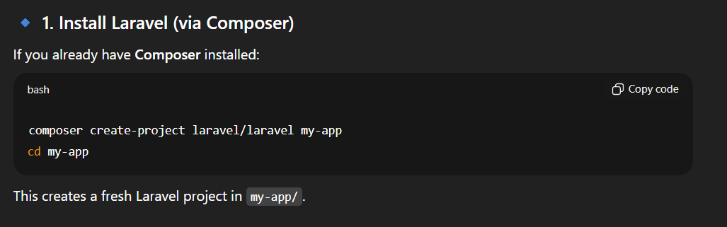

We can directly run the laravel project locally using the “**php artisan serve**”. You can see ur application live on **localhost.**

**To Dockerize:**

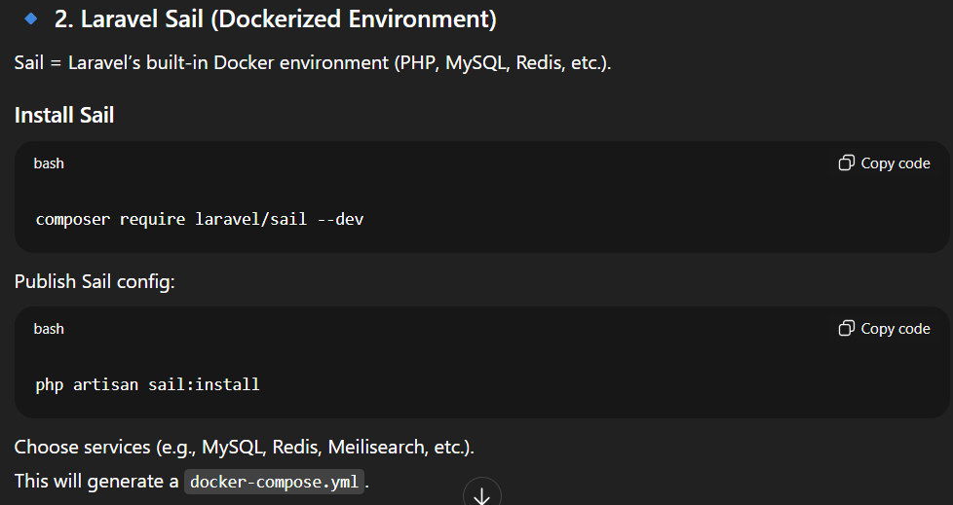

“**composer require laravel/sail --dev**” is not required only the second command.

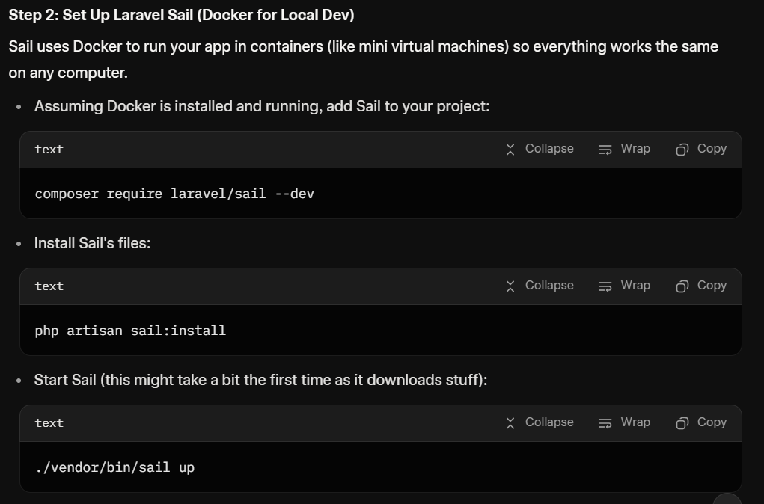

“./vendor/bin/sail up” won’t work as it requires **windows subsystem for linux(WSL)** and **docker** so we need to install linux subsytem on windows.

Open terminal:

1. **wsl --install** OR **wsl --install -d ubuntu**
2. **wsl -l -v** :to list all the subsystem
3. **wsl --set-default ubuntu**
4. **wsl -d ubuntu** OR **wsl** :to start all the instances
5. **wsl --terminate ubuntu :** to start only ubuntu
6. **wsl --shutdown** : to stop all the services

After installing wsl and docker start both of them and verify using the “**wsl -l -v**”. and run this command.

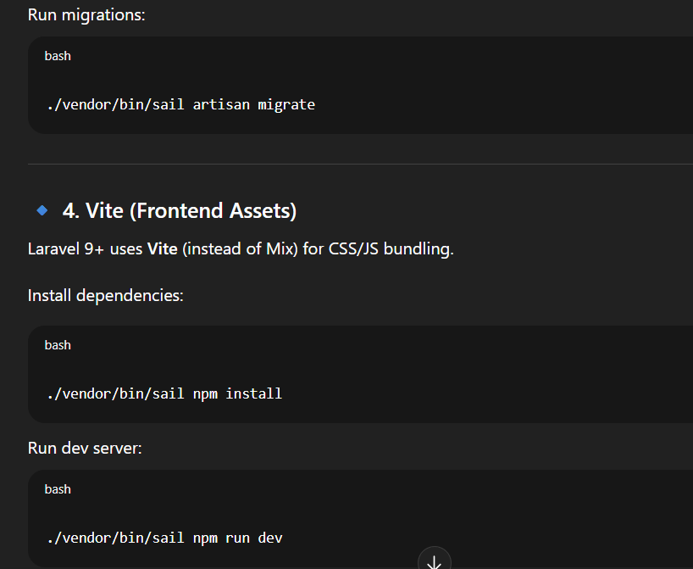

Now run “**./vendor/bin/sail up -d**” this will start the docker container and the laravel project will run independently as a docker container on “**https://localhost**” in case of port error make changes in **compose.yml** file

To close the application “**./vendor/bin/sail down**”

**Note:**

To avoid writing “**./vendor/bin/sail**” again and again we can use alias.

In linux terminal:

**- alias sail=”bash vendor/bin/sail”**

Now no need to write ./vendor/bin/sail just use sail like “**sail up -d**” and “**sail down**”

**Global Installation (Rarely used):**

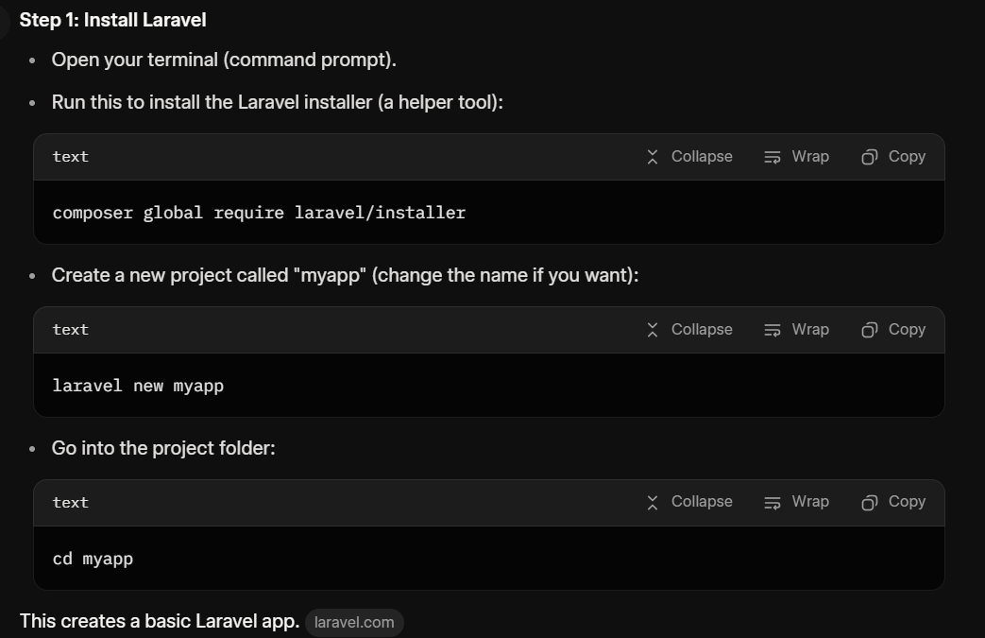

* **Folder structure & lifecycle:**

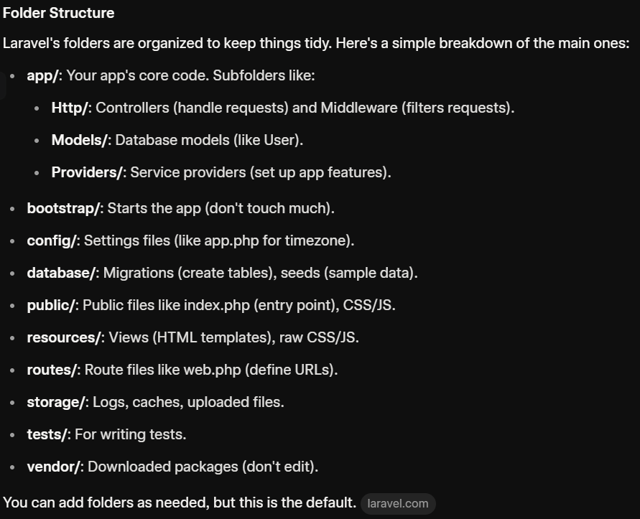

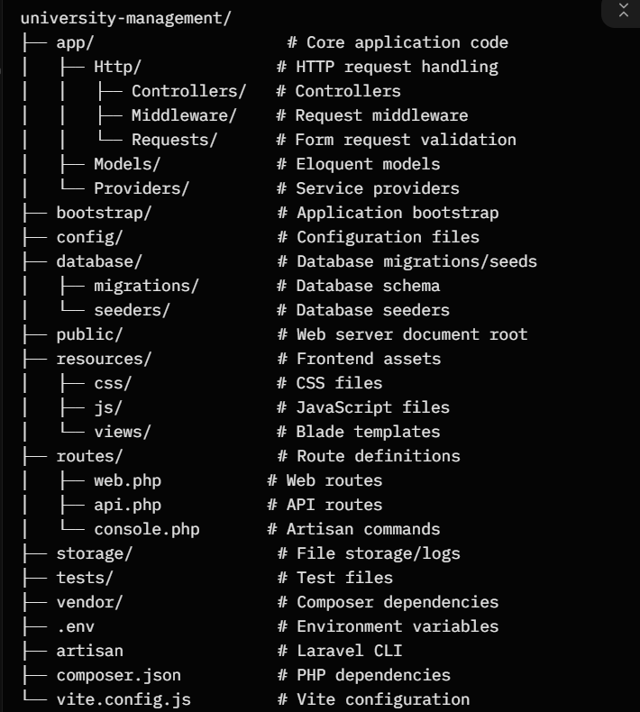

* Application Lifecycle:

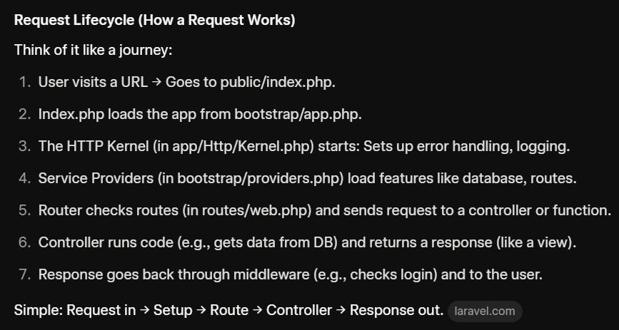

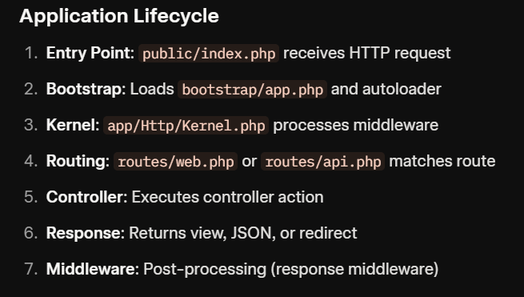

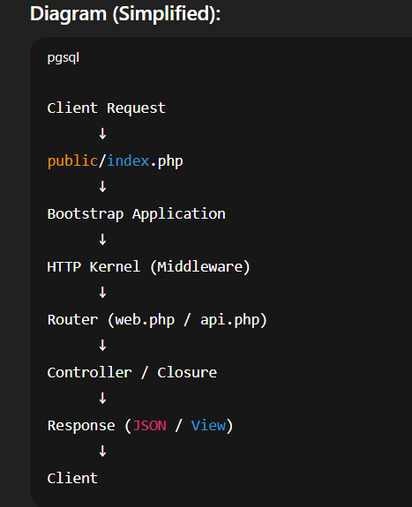

* **Config & env:**

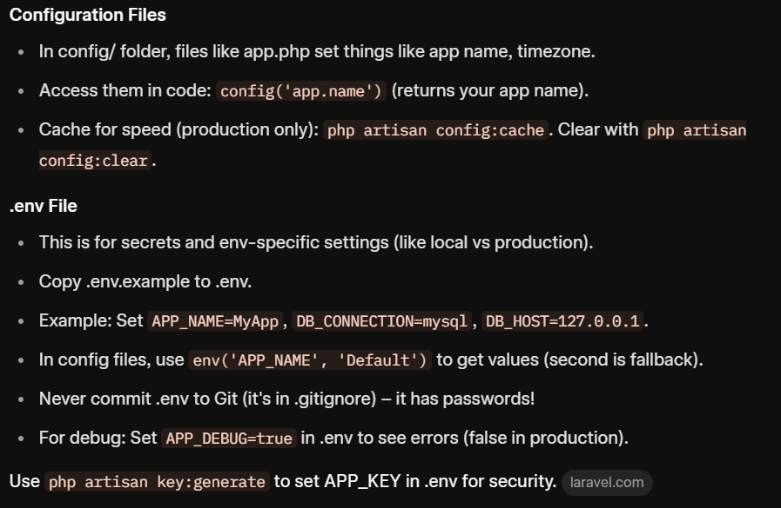

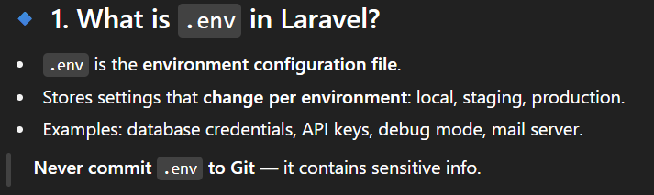

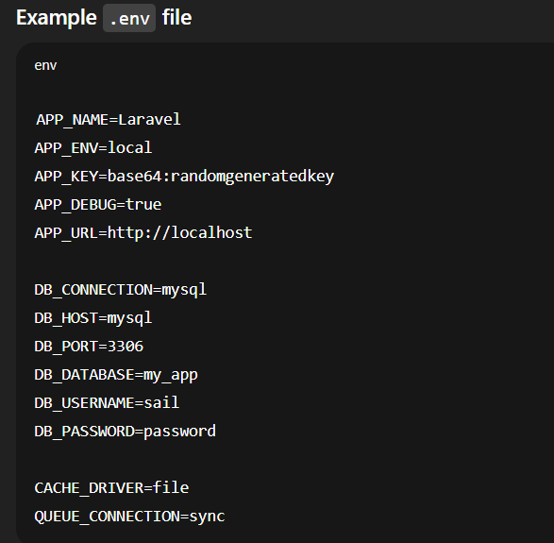

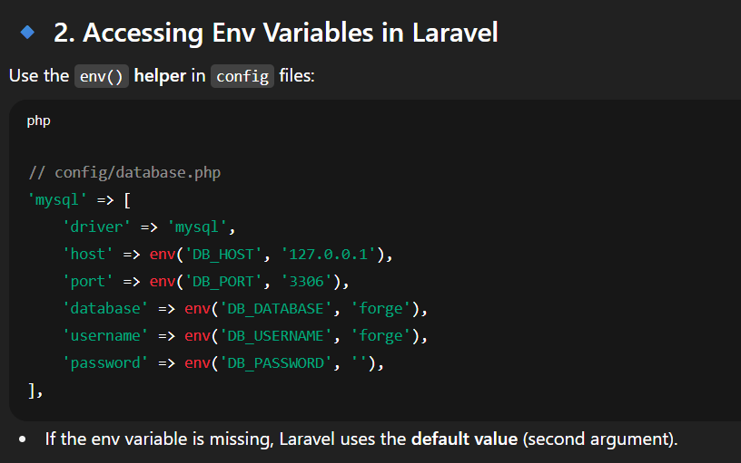

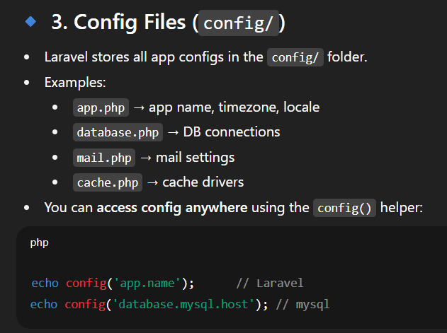

* **Routing basics:**

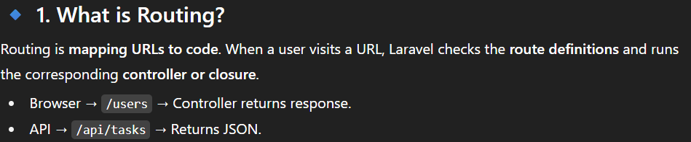

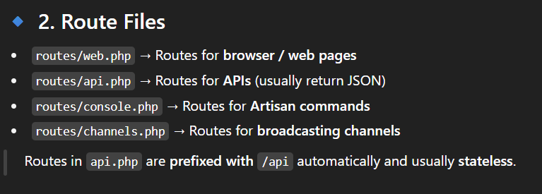

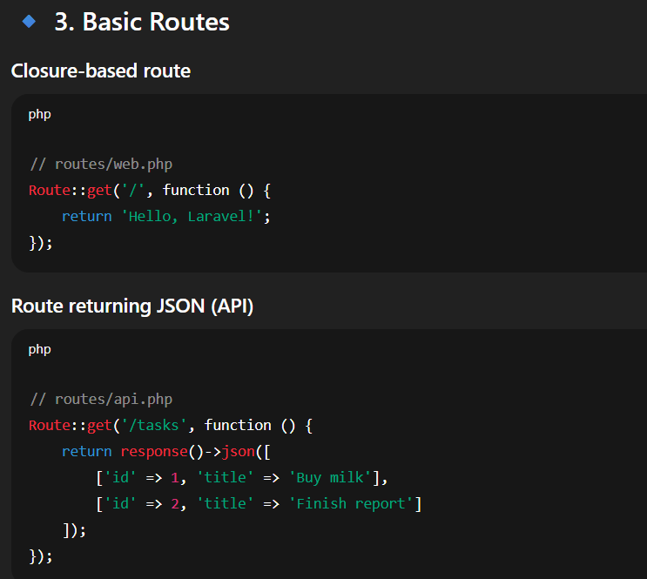

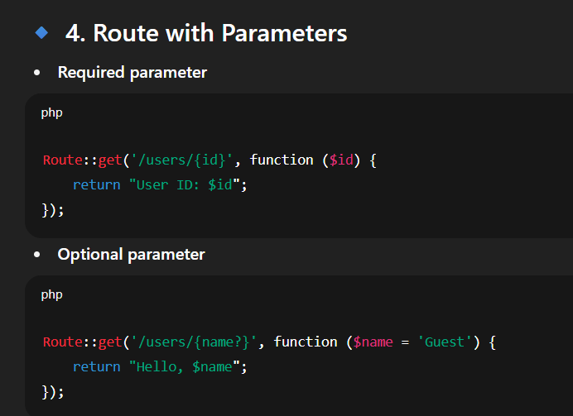

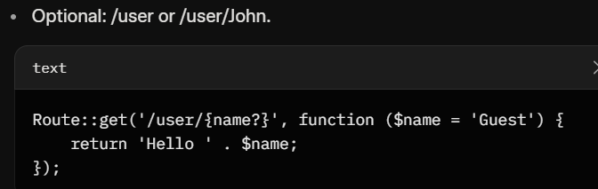

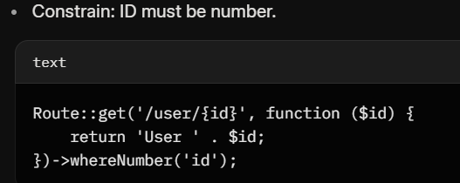

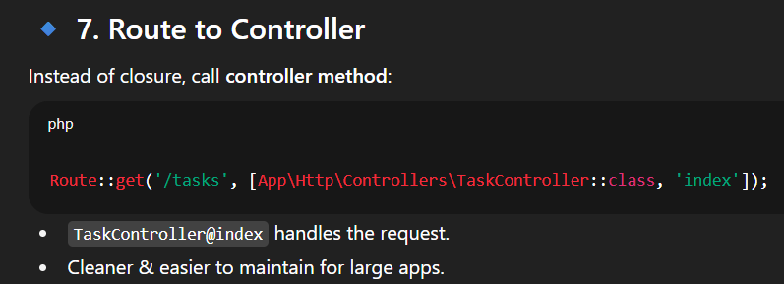

Old Laravel <=7 new Laravel >=8

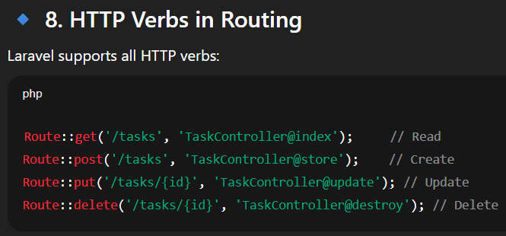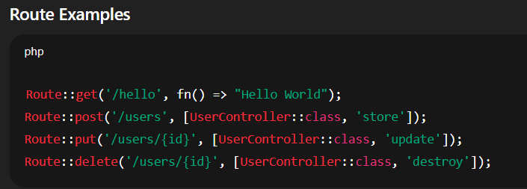

**Route Groups:**

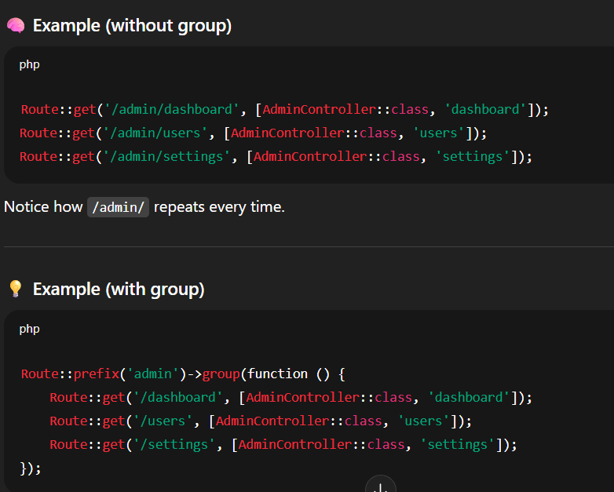

# Middleware

### ✅ What is Middleware?

Middleware is like a **security guard** that checks your request **before it reaches your controller**.

Think of it like:

"Are you logged in?"  
"Do you have admin access?"  
"Are you making too many requests?"

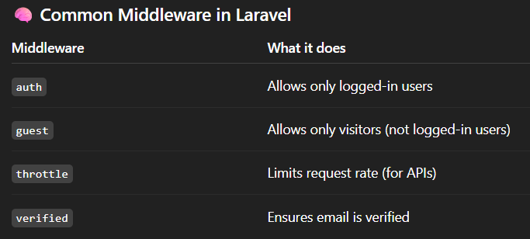

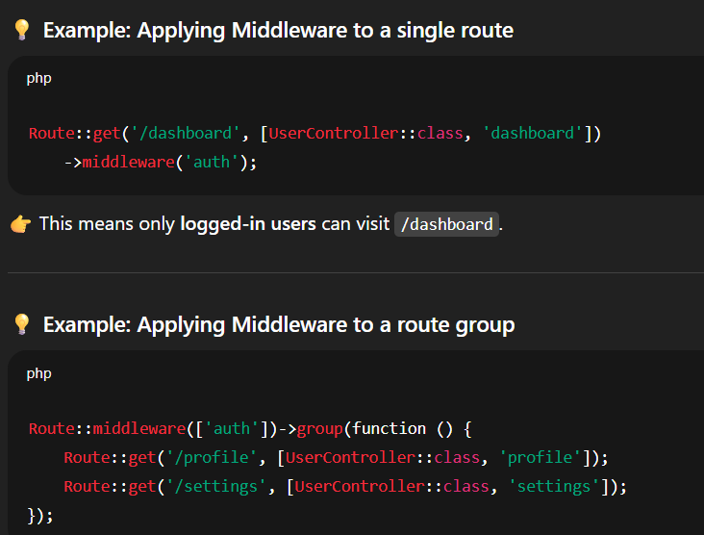

**Routing to a Controller:**

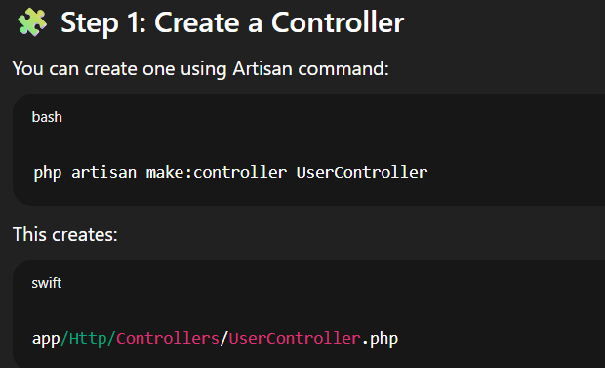

**Step 2: Add a method in the controller**

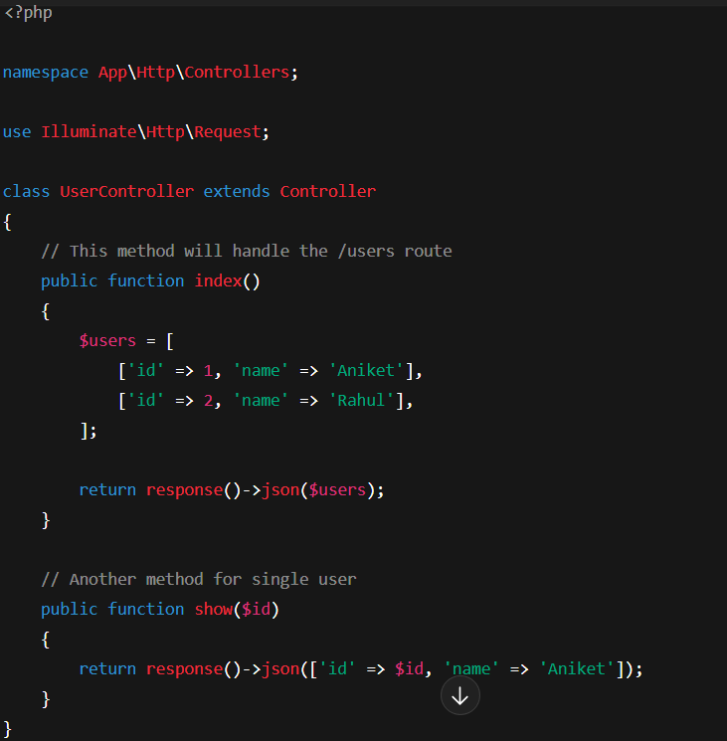

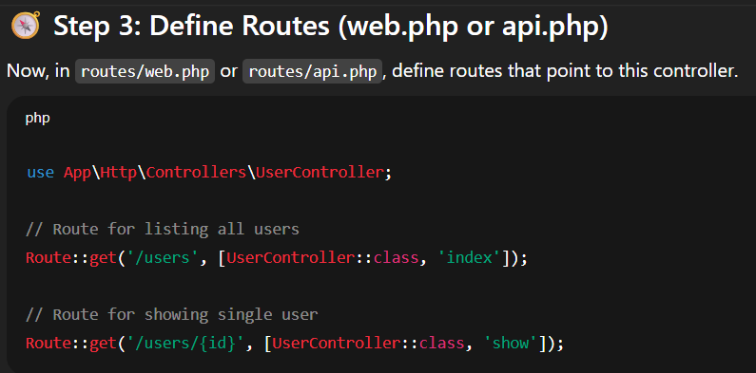

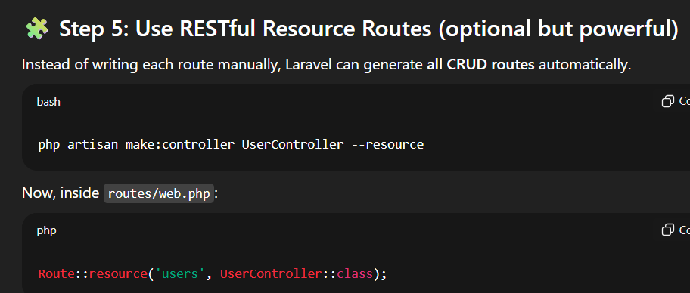

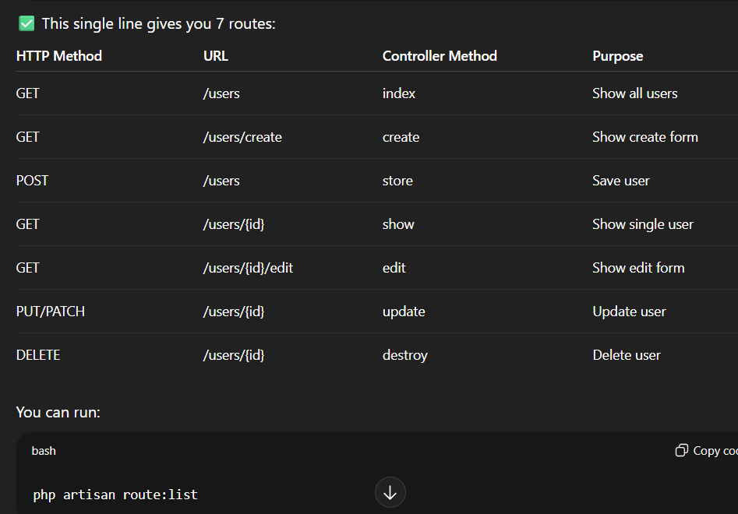

* **Controllers:**

Controllers group route logic into classes.

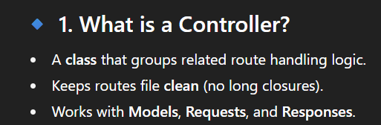

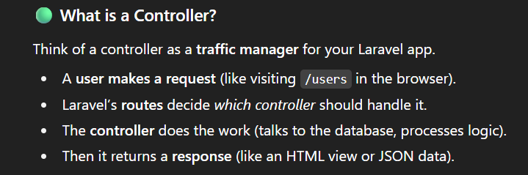

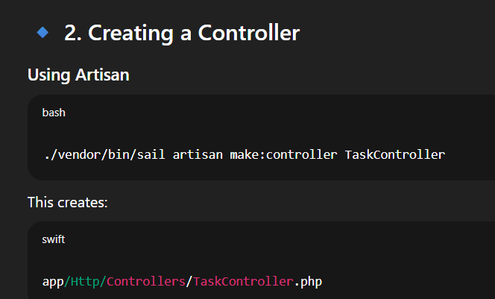

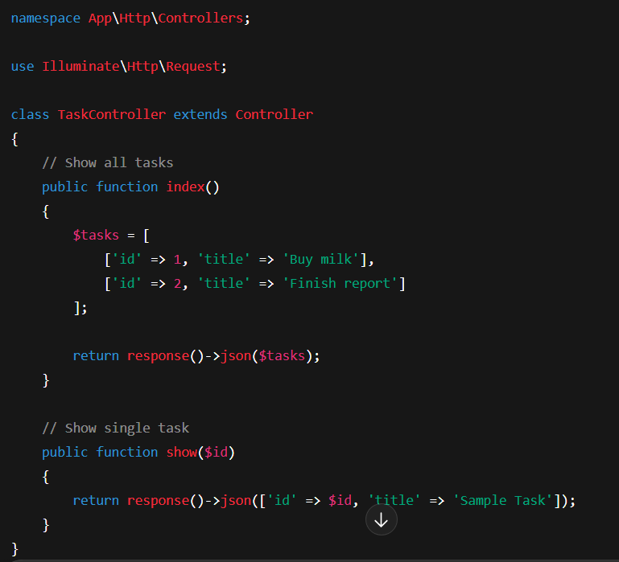

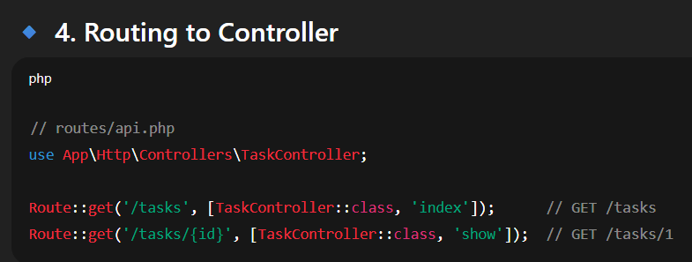

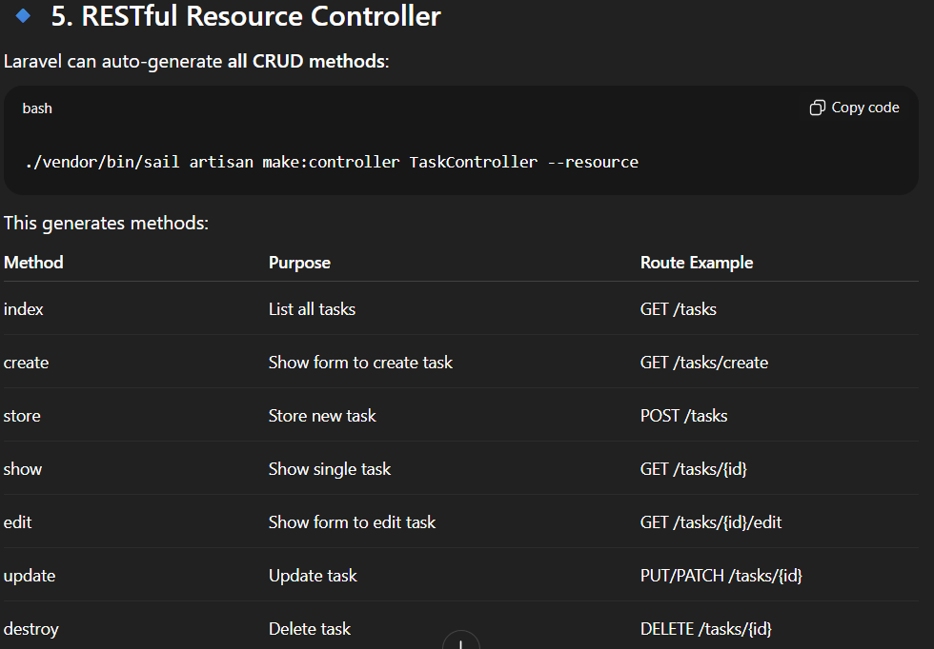

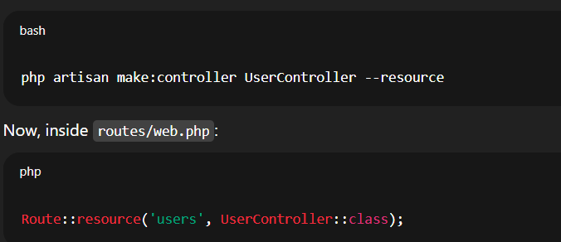

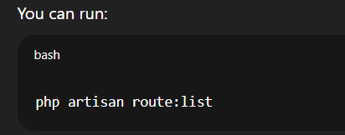

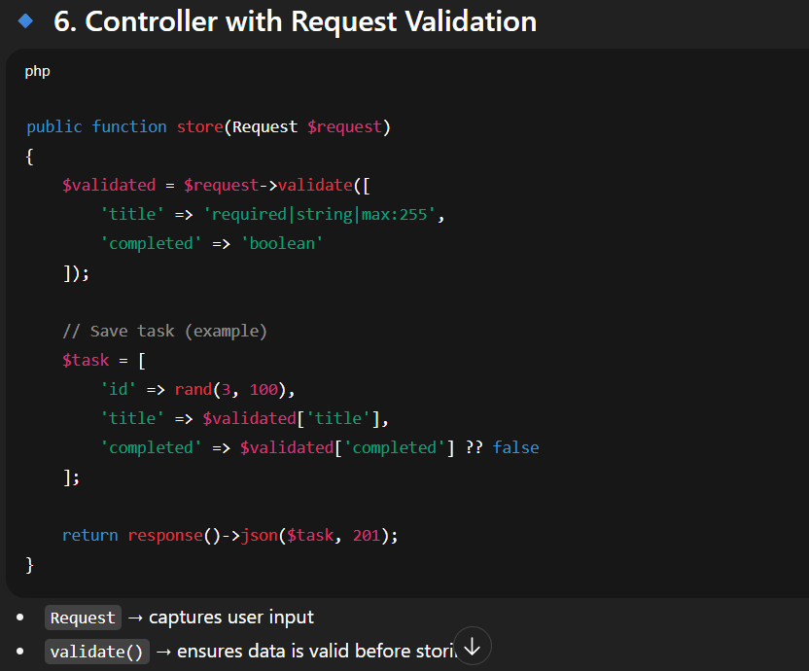

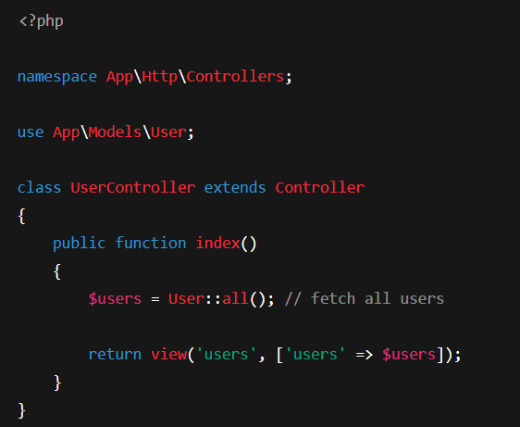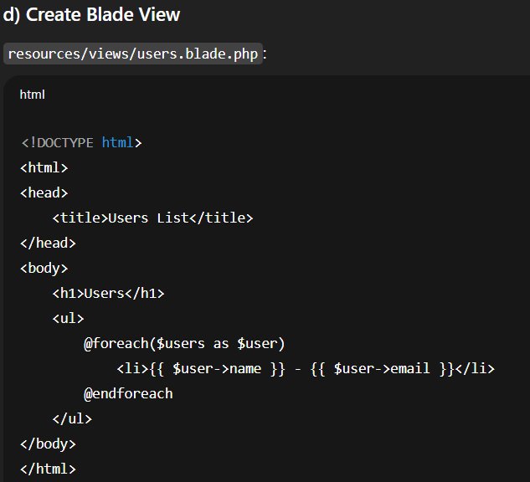

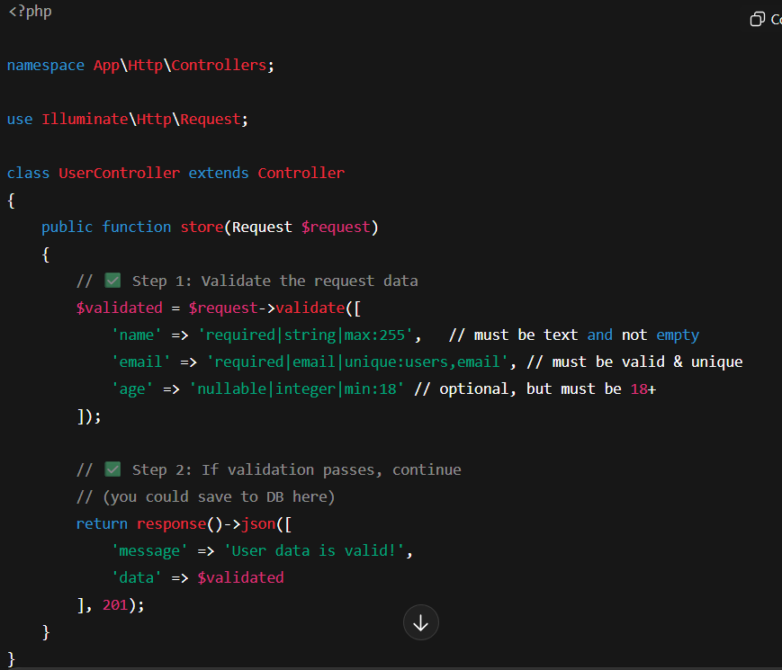

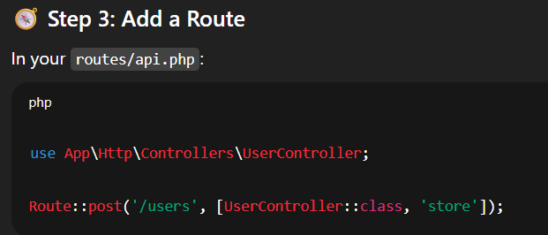

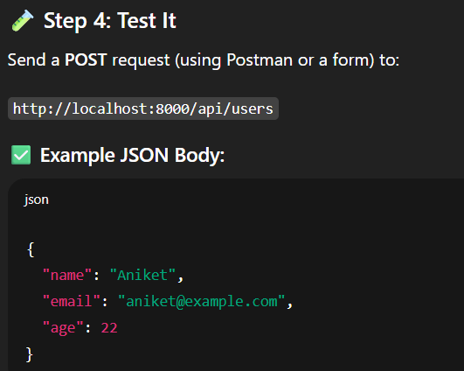

* **Model:** tables

Create a table in **PHPMYADMIN** or in **database/migrate/files**

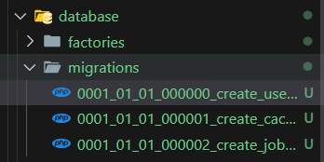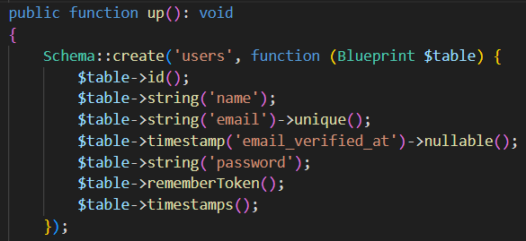



1. **Create a Model:**

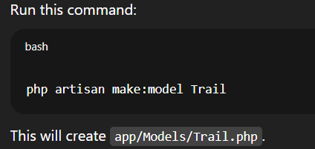

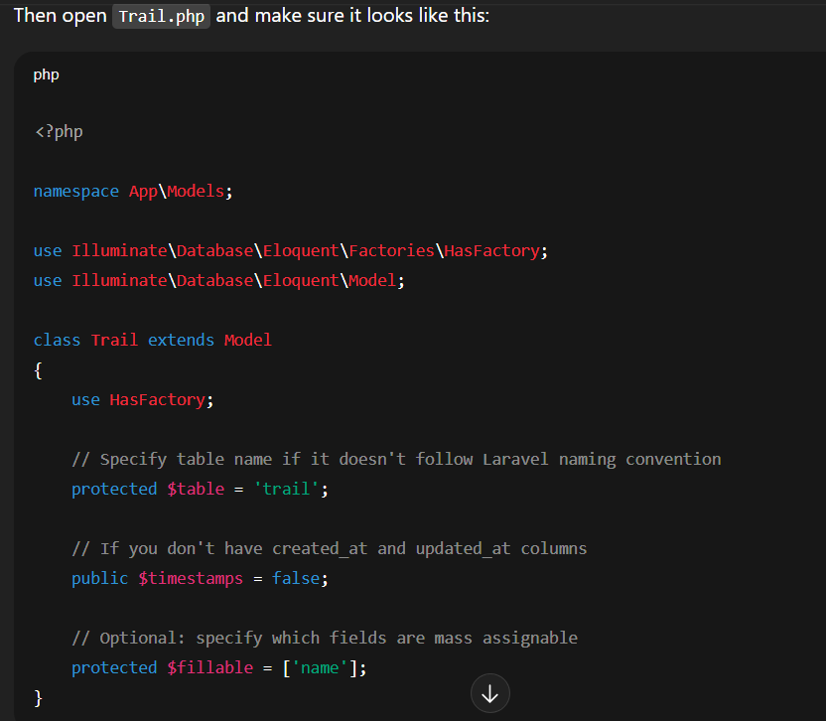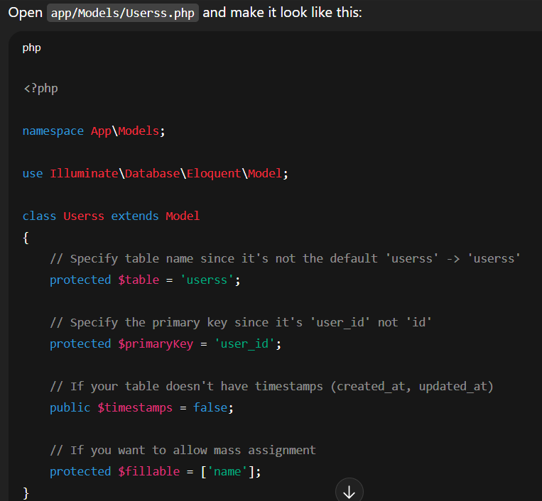

**2: Create a Controller:**

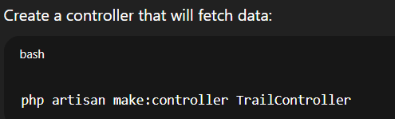

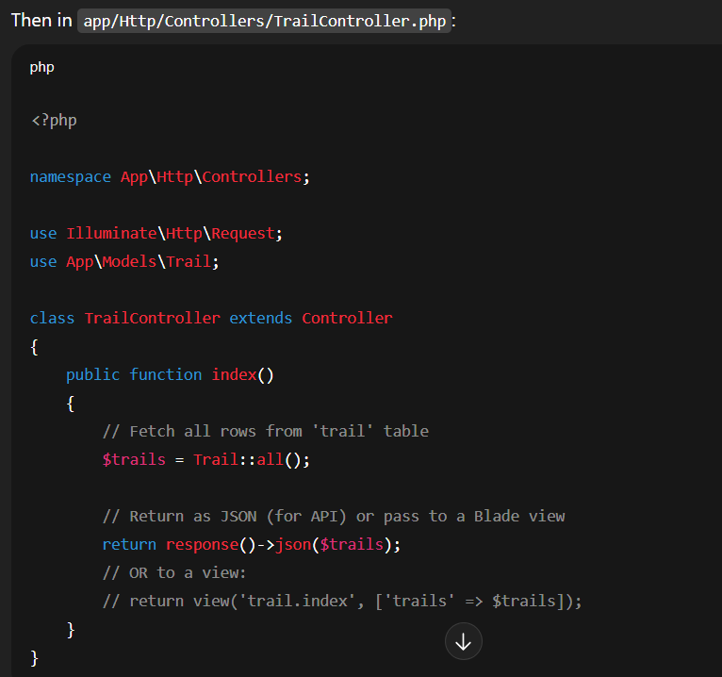

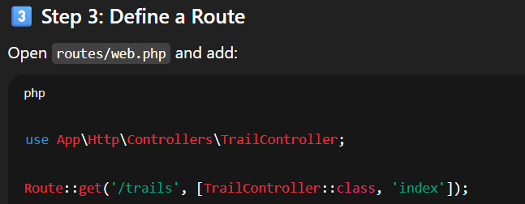

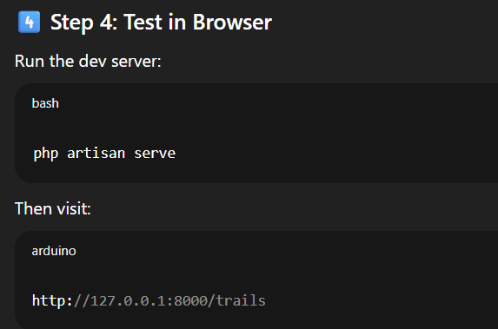

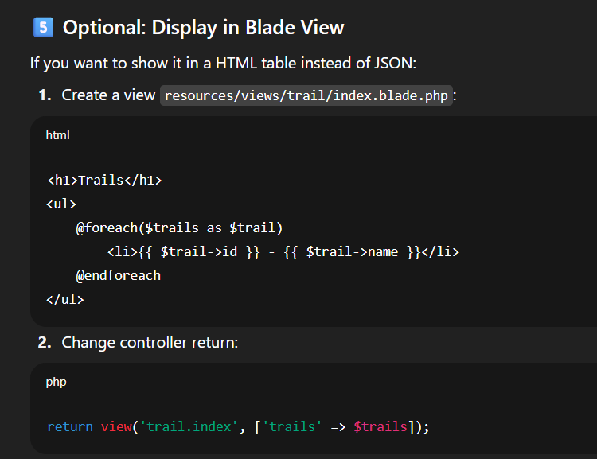

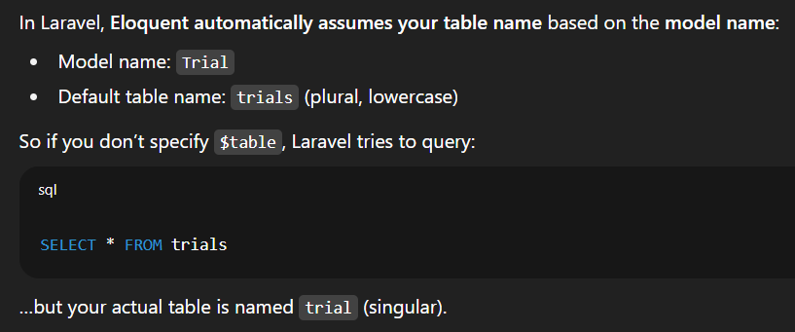

**Blade layouts/components • Blade directives • Forms & CSRF • Form Request Validation • Localization (intro)**

### **1. Blade Layouts/Components**

Blade lets you create reusable layouts (like a master template) and components (small reusable UI bits, like buttons).

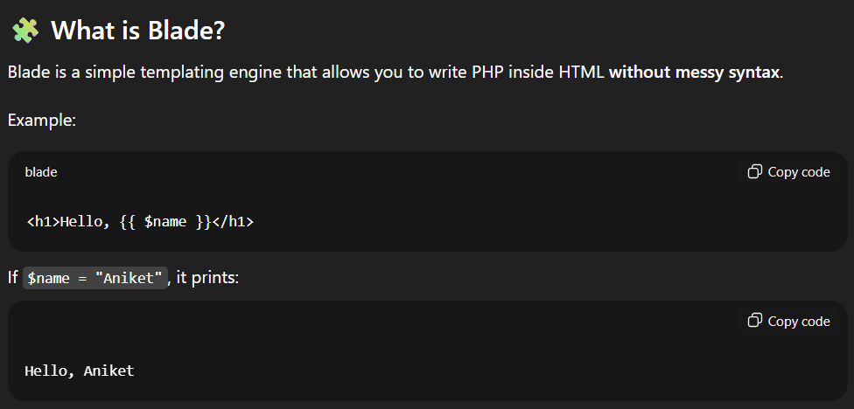

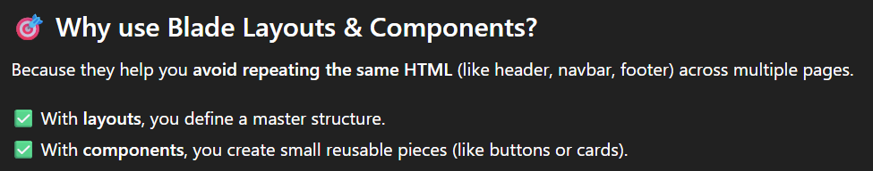

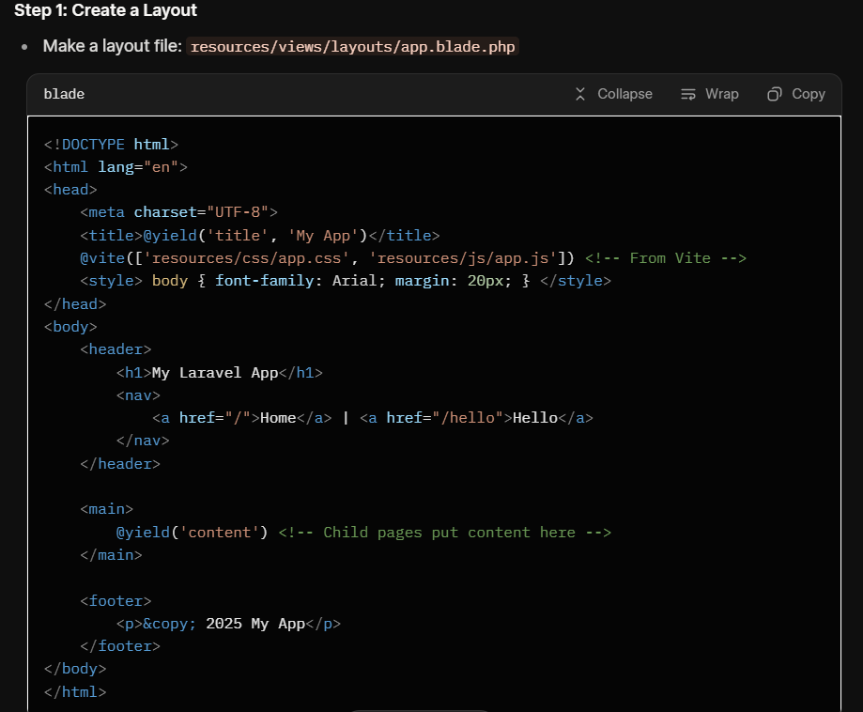

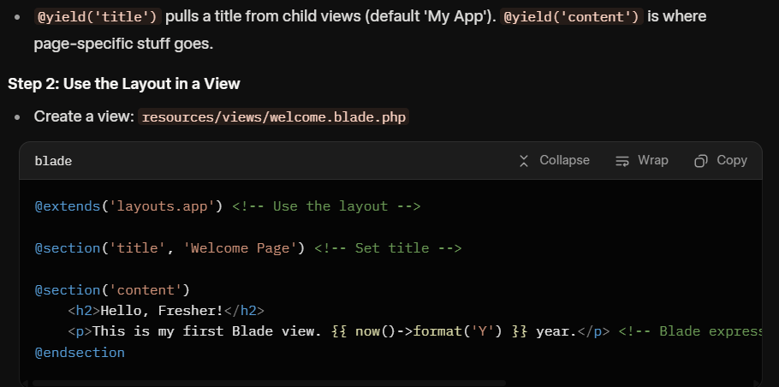

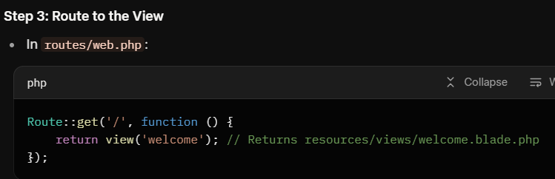

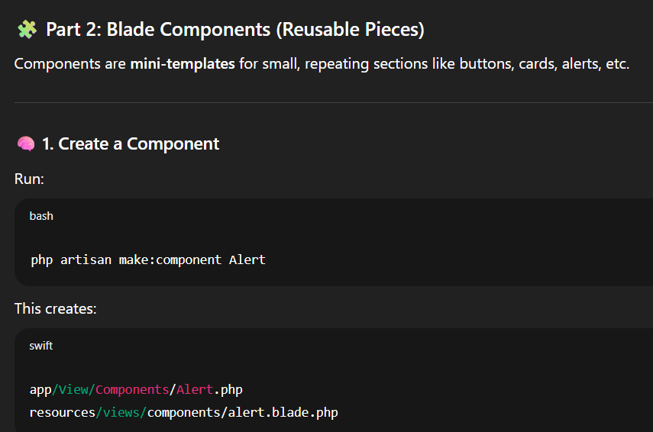

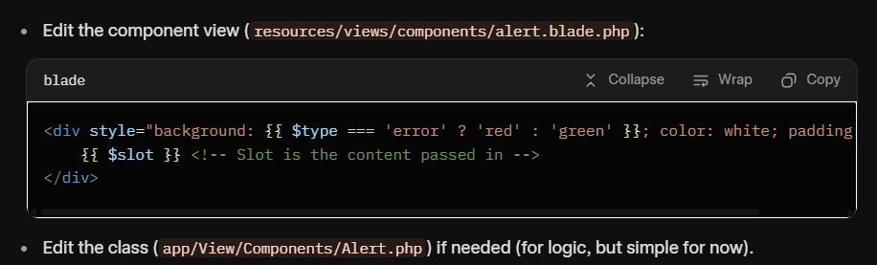

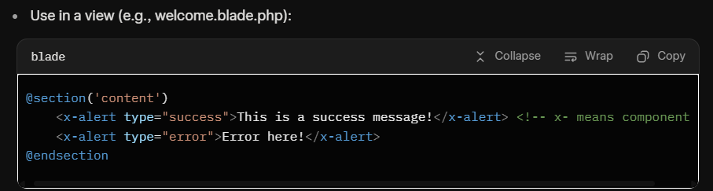

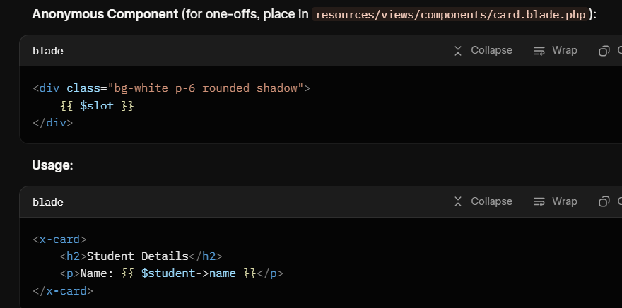

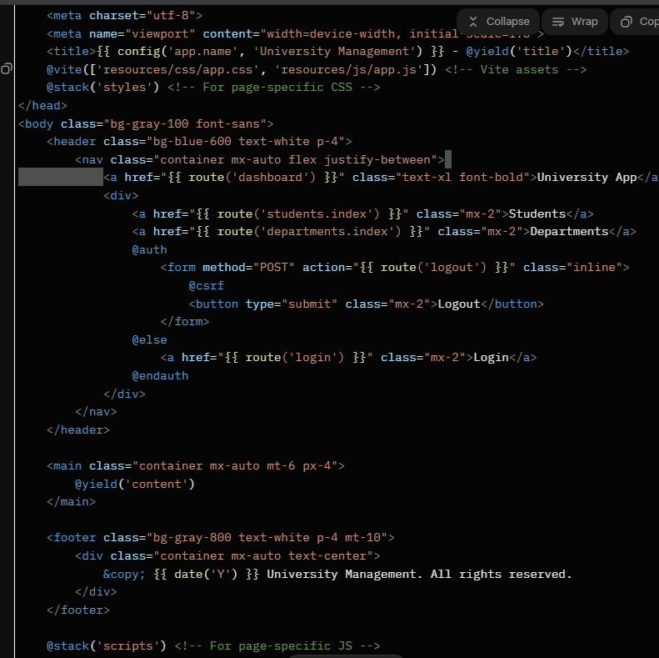

Welcome.blade.php

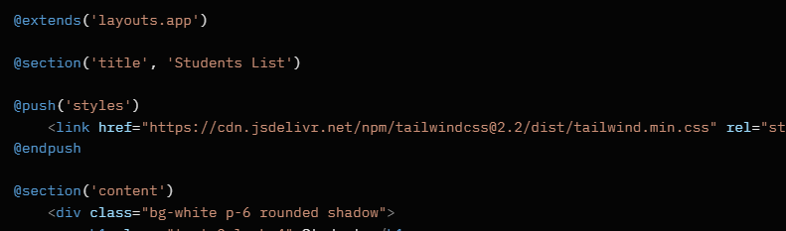

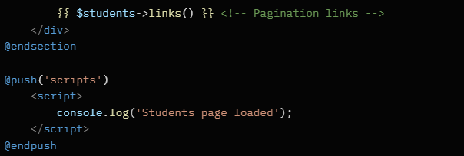

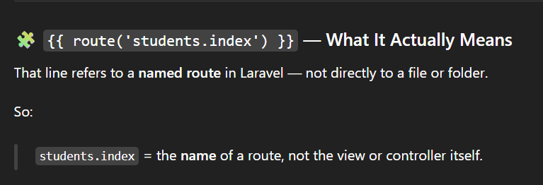

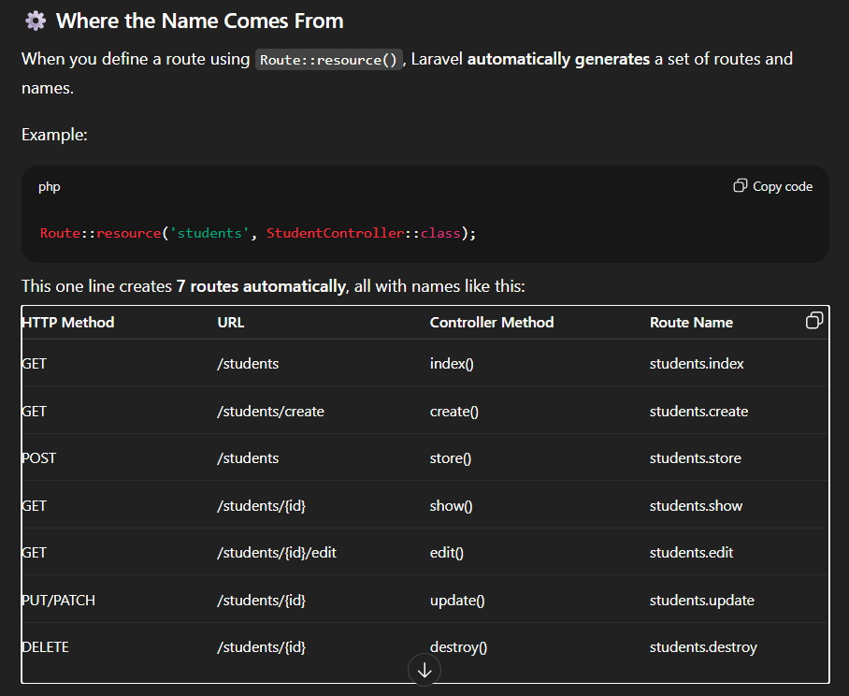

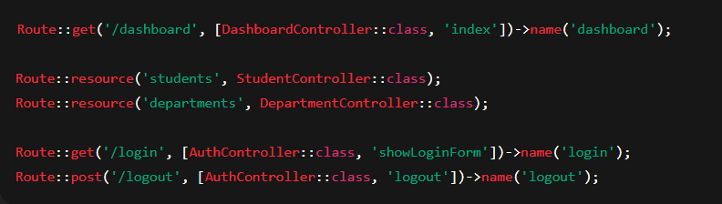

* **Blade directives:**

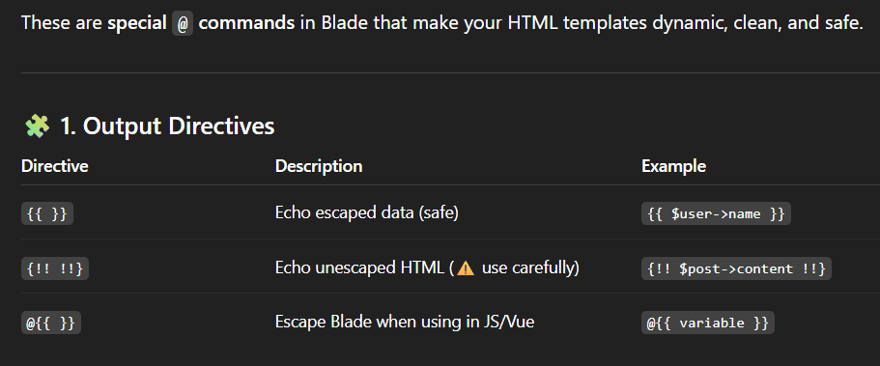

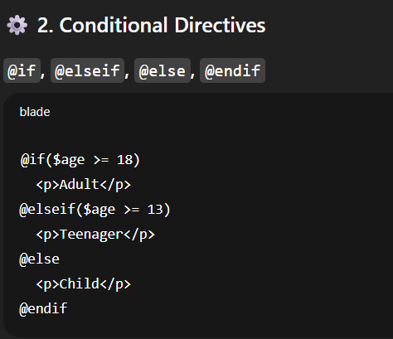 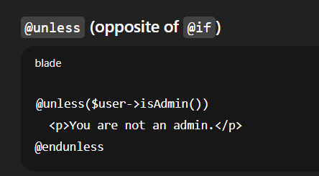 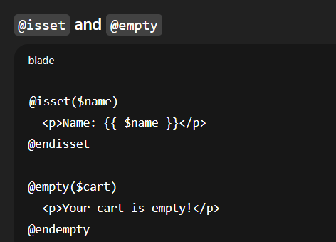

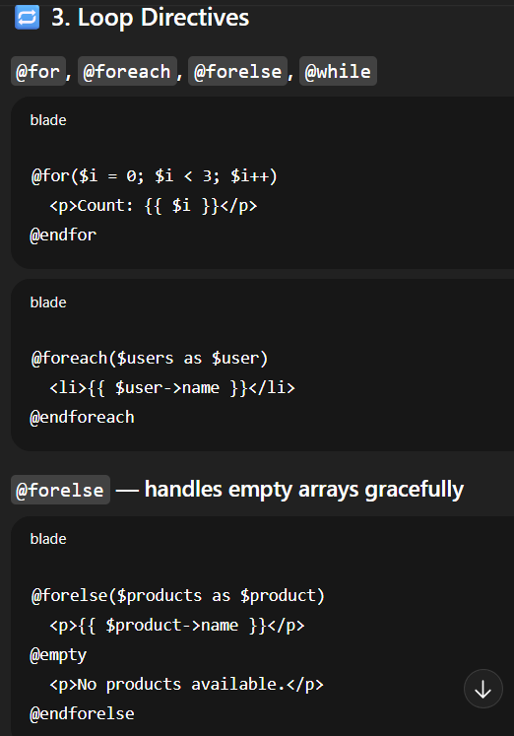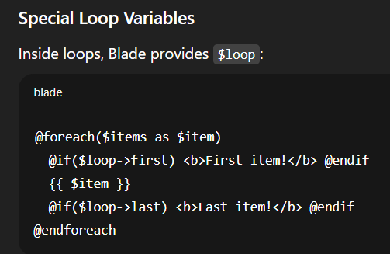

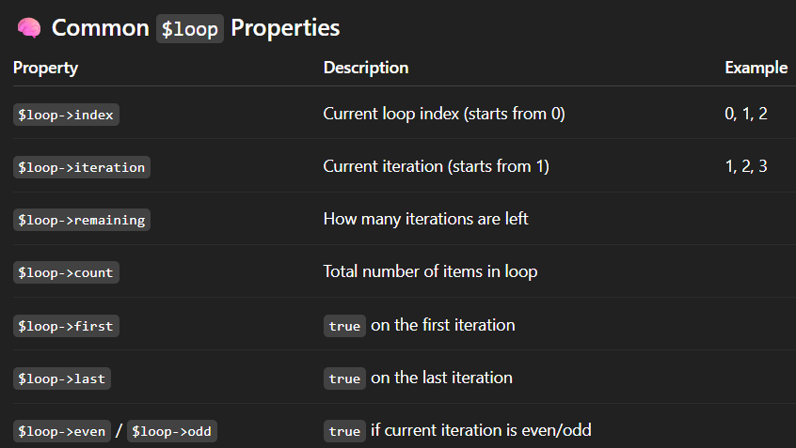

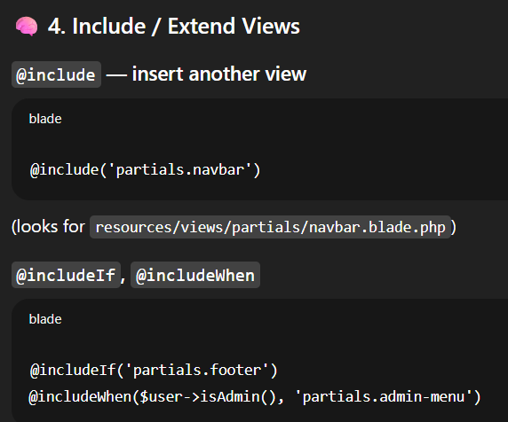

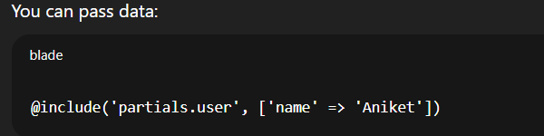

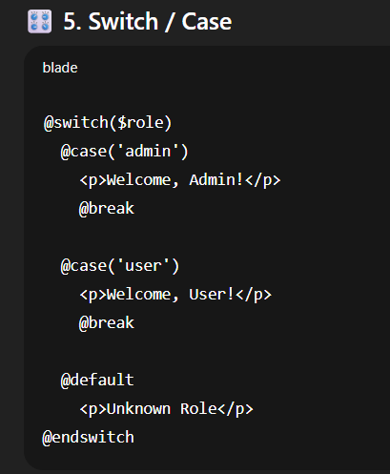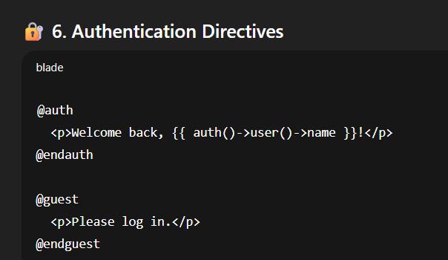

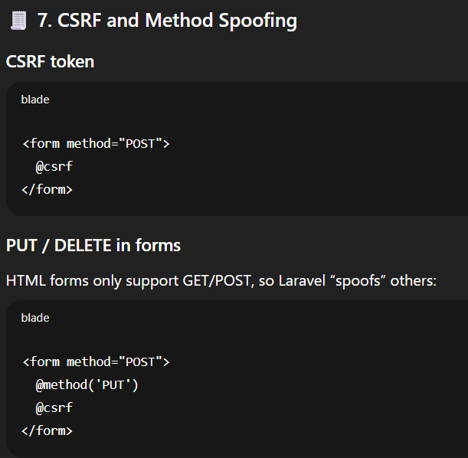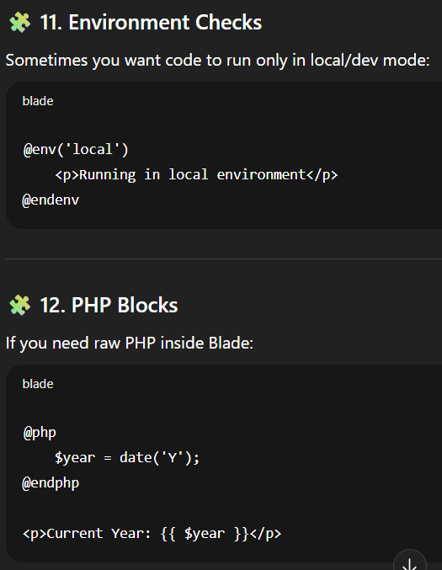

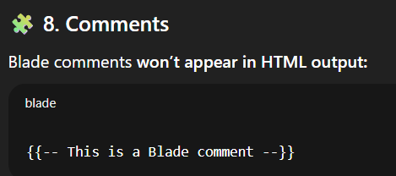

* **Forms & CSRF Protection**

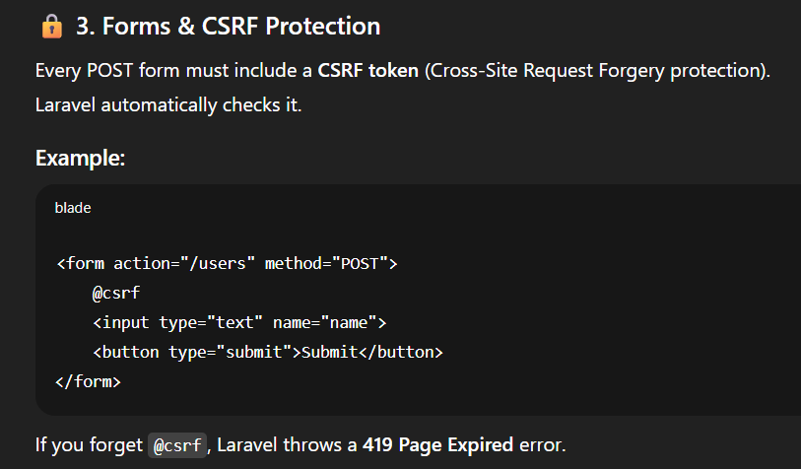

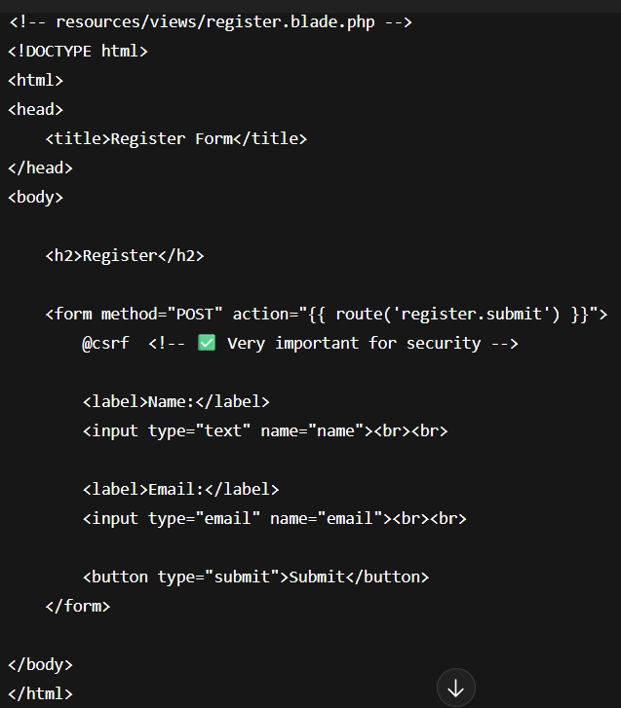

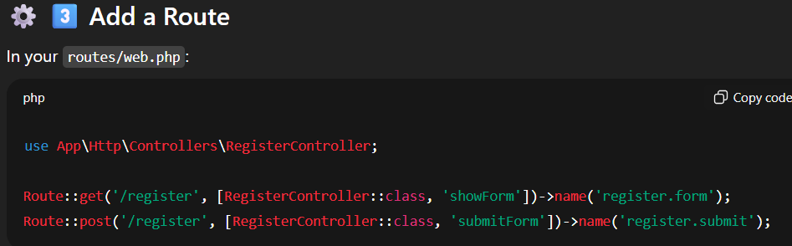

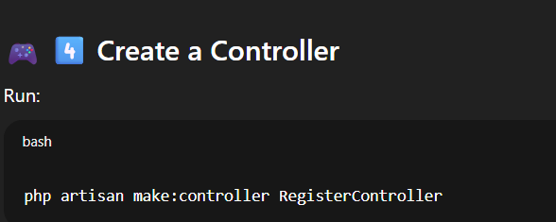

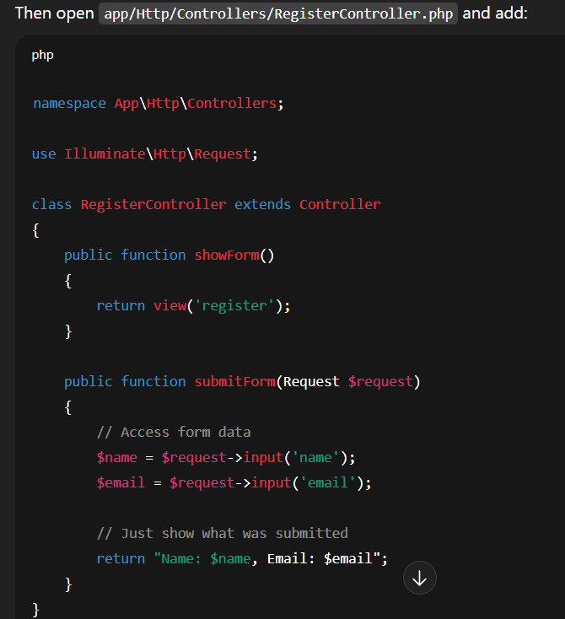

* **Form Request Validation**

You can validate input directly in your controller, but it’s better to use **Form Request Classes**.

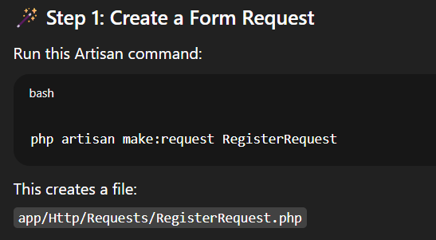

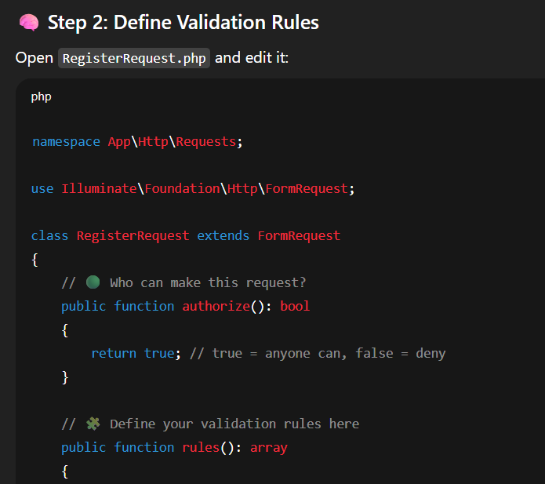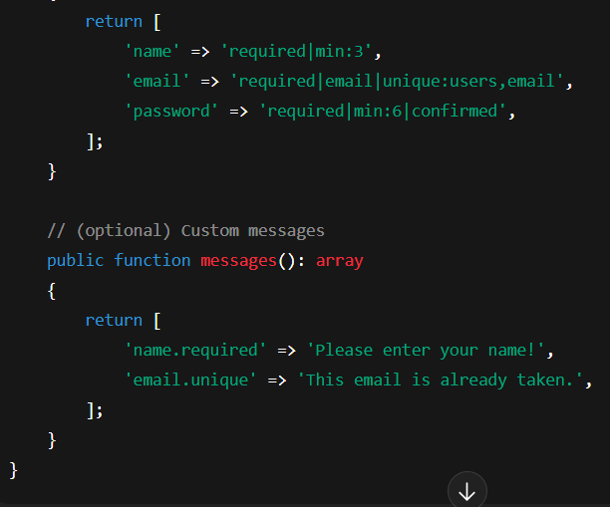

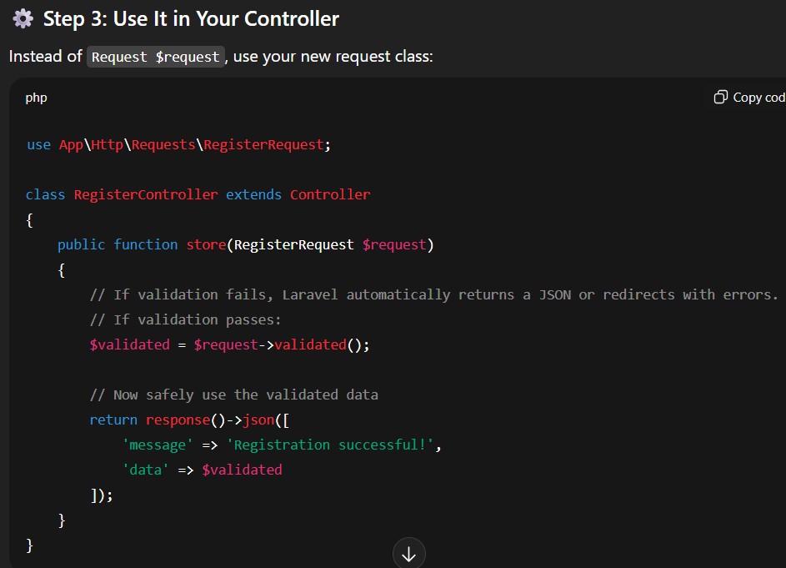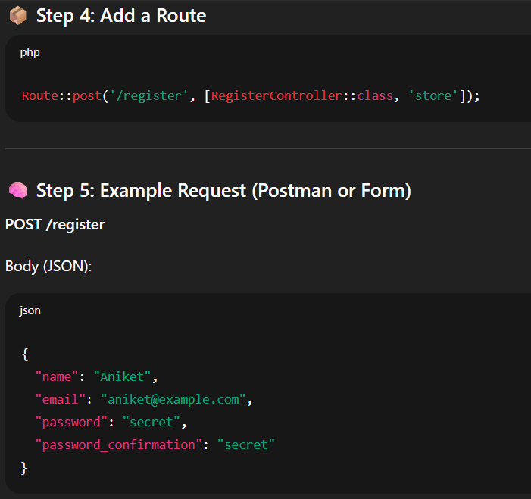

* Localization (Intro)

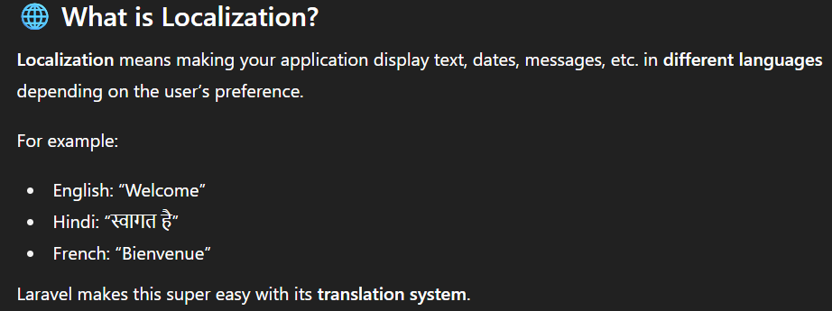

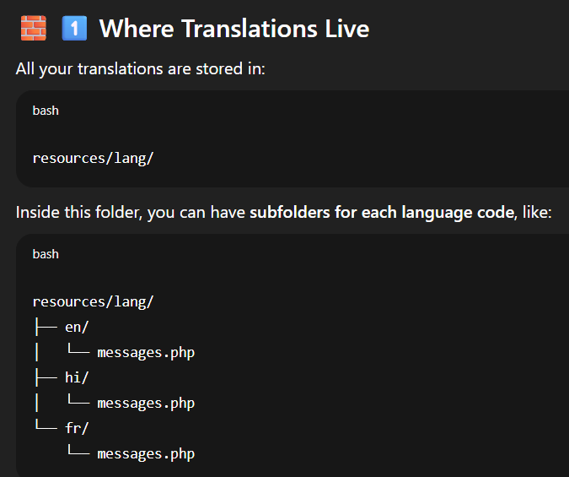

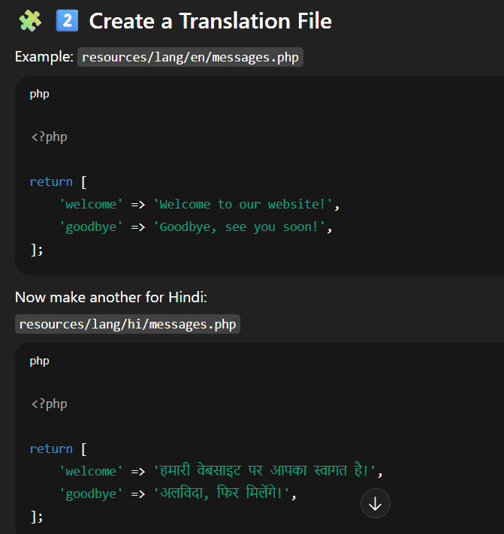

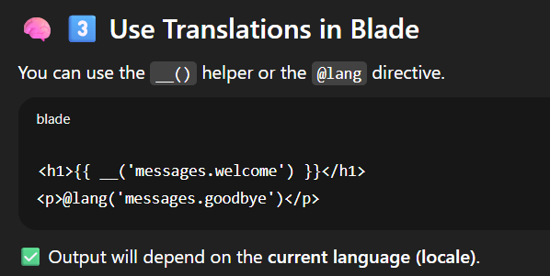

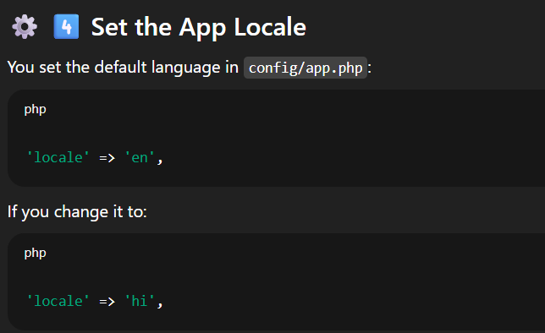

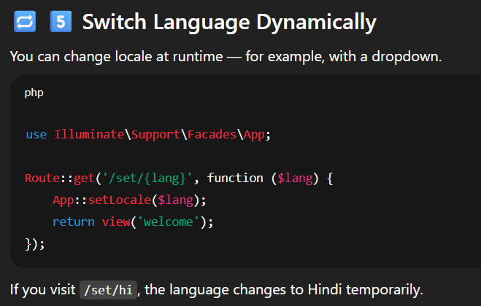

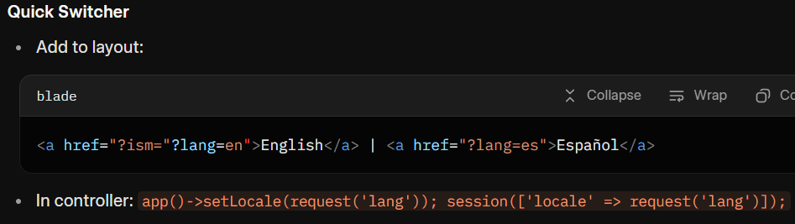

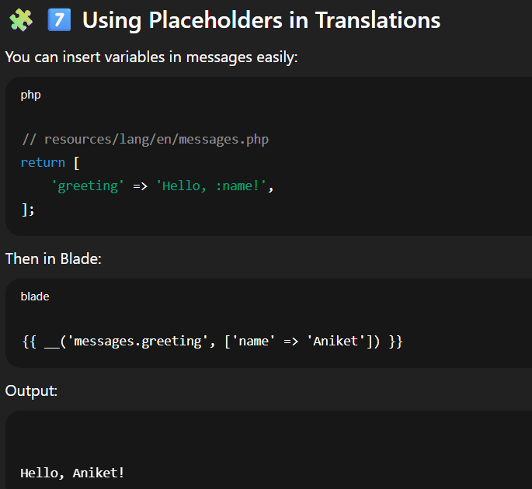

**Migrations & schema builder • Seeders & Factories • Faker • Eloquent models • Mass assignment & casts**

* **Migrations & schema builder:**

Migrations are like **version control for your database**. They let you define tables and columns in PHP instead of writing raw SQL.

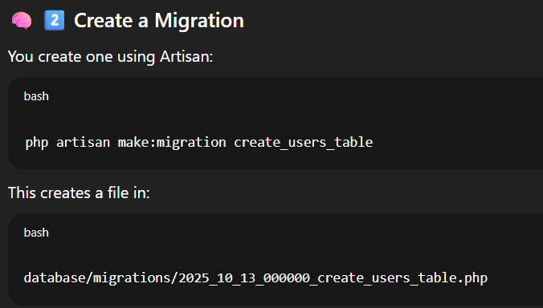

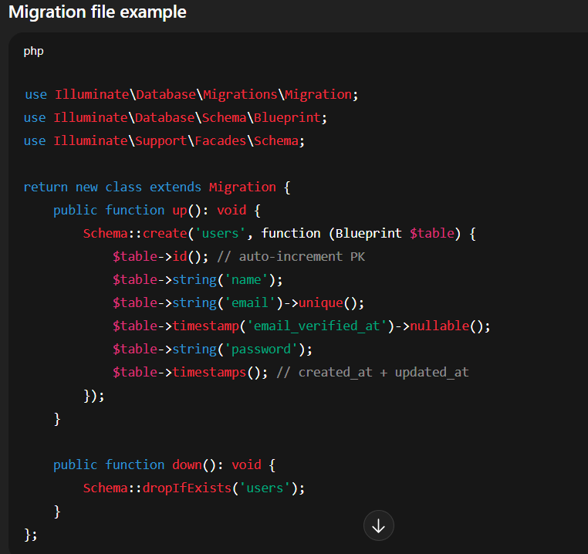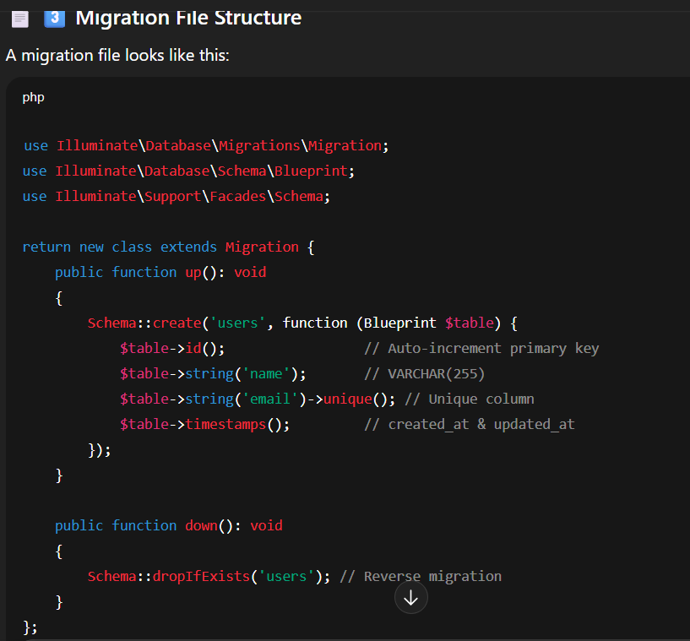

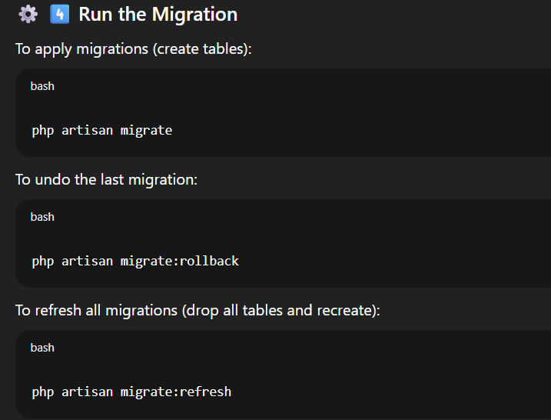

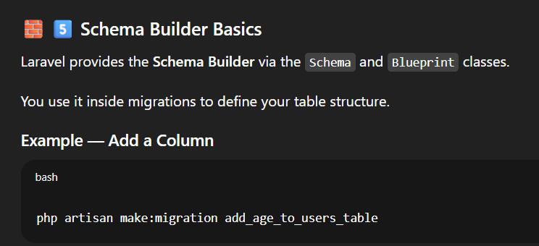

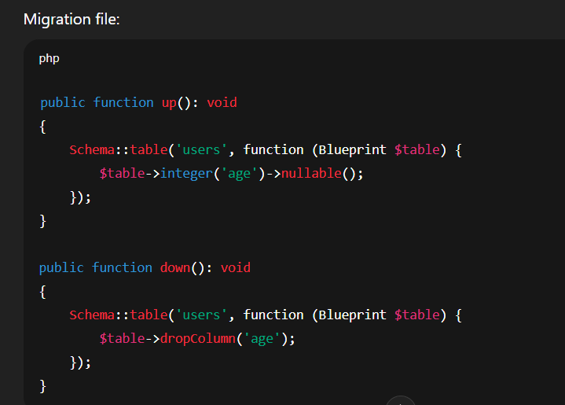

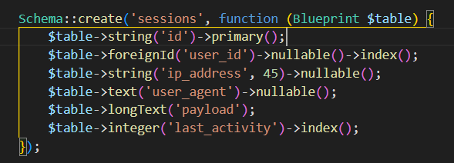

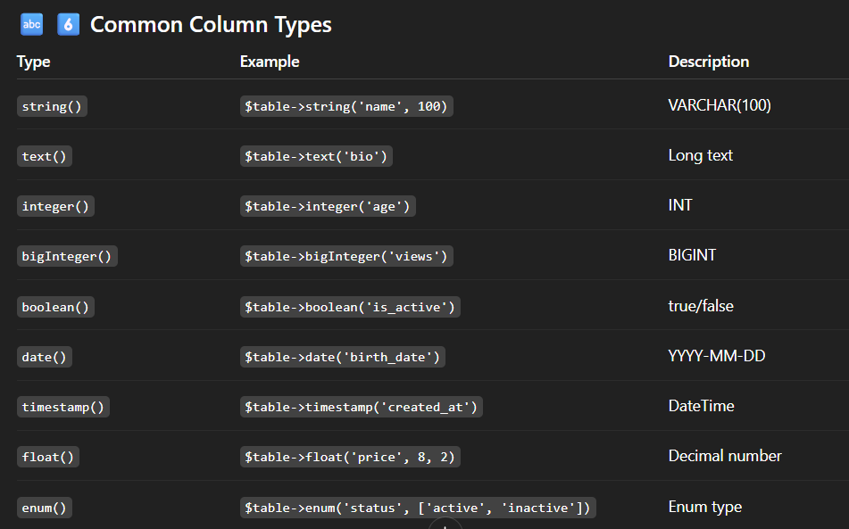

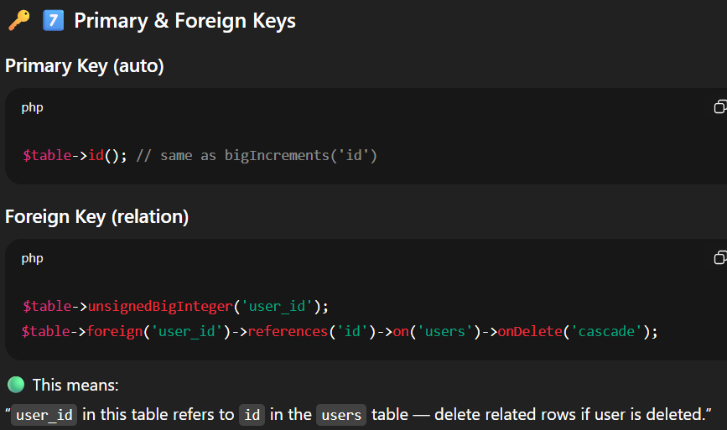

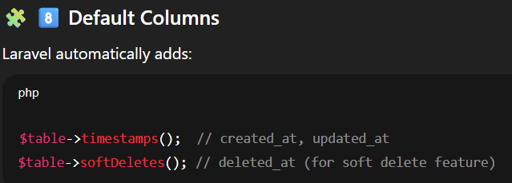

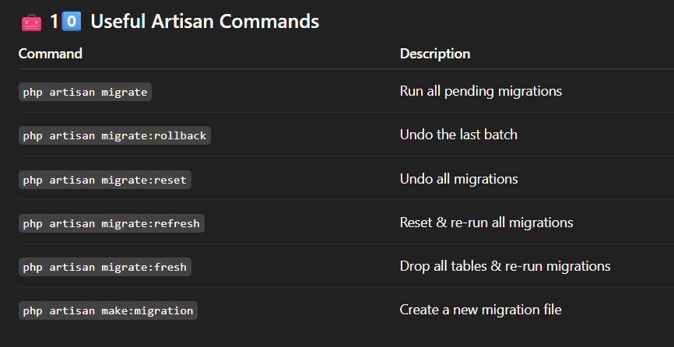

* Seeders & Factories

Seeders = populate database with **sample/dummy data**.  
Factories + Faker = generate realistic dummy data.

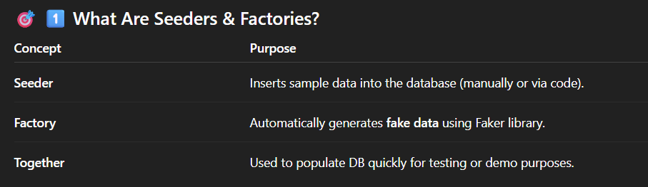

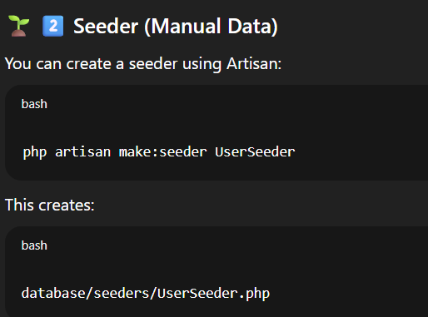

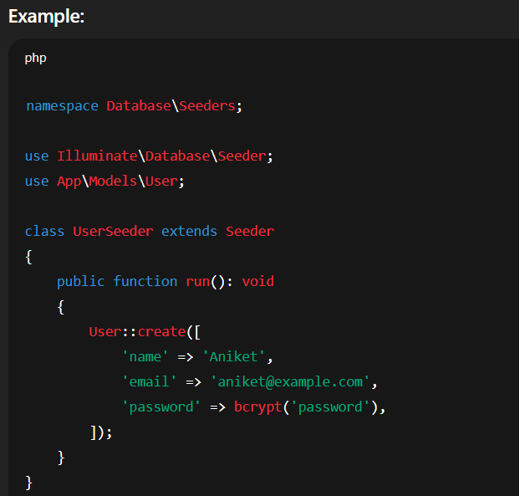

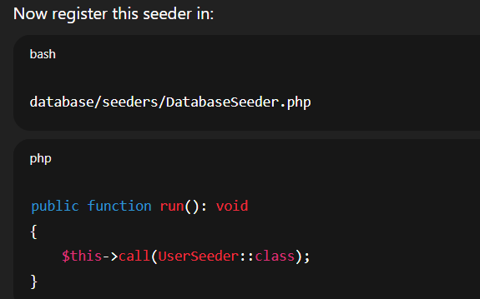

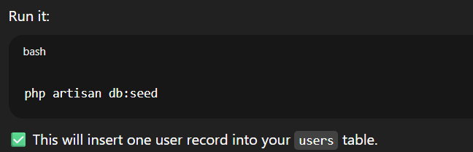

If not registered in **Databaseseeder.php** you can use:

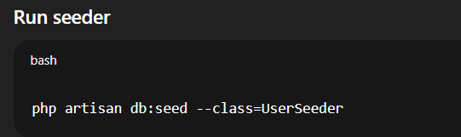

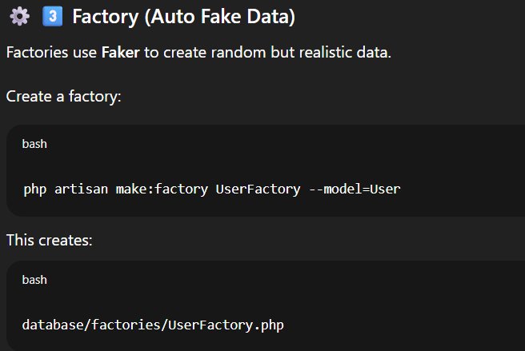

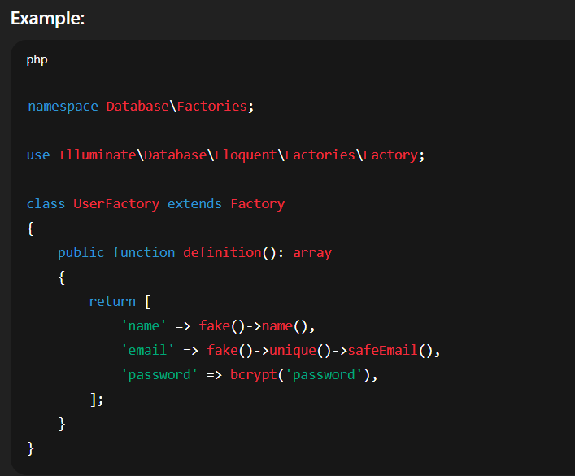

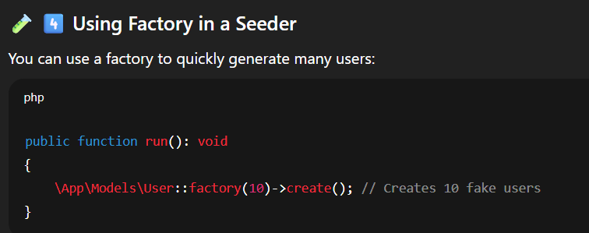

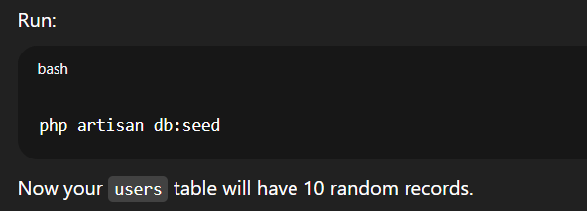

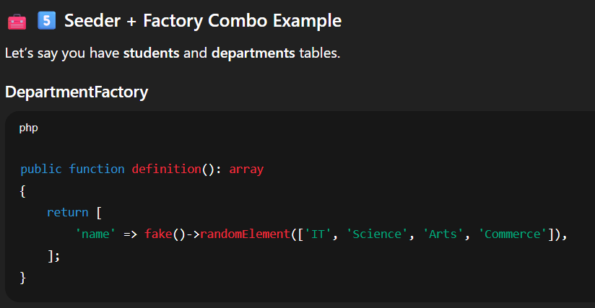

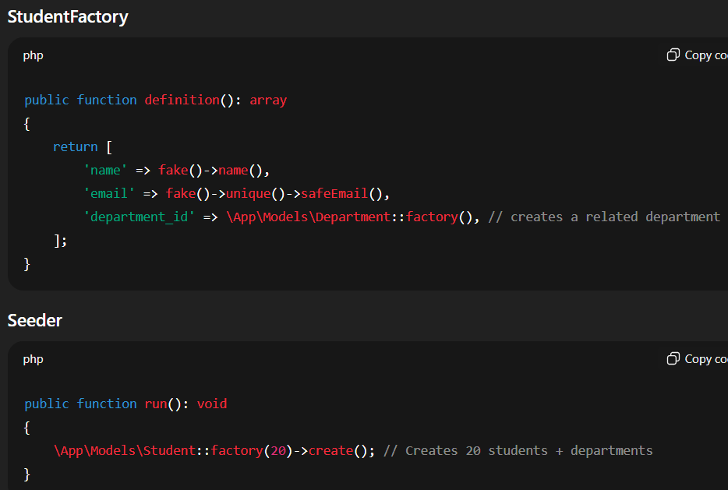

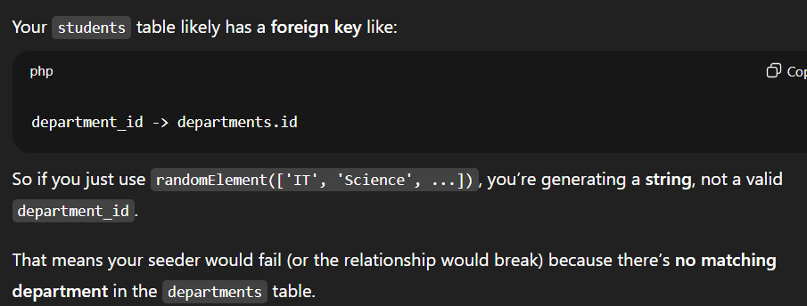

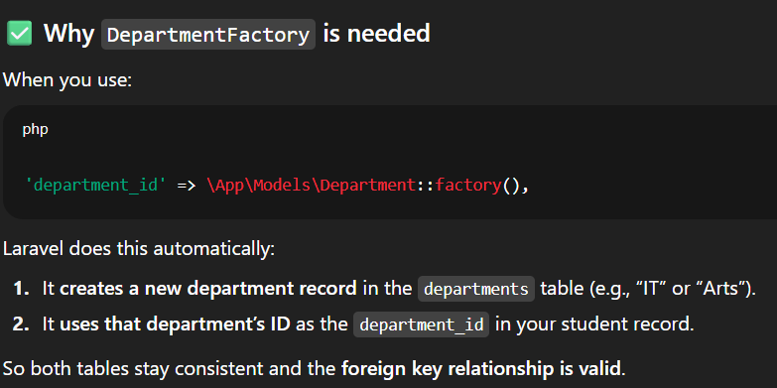

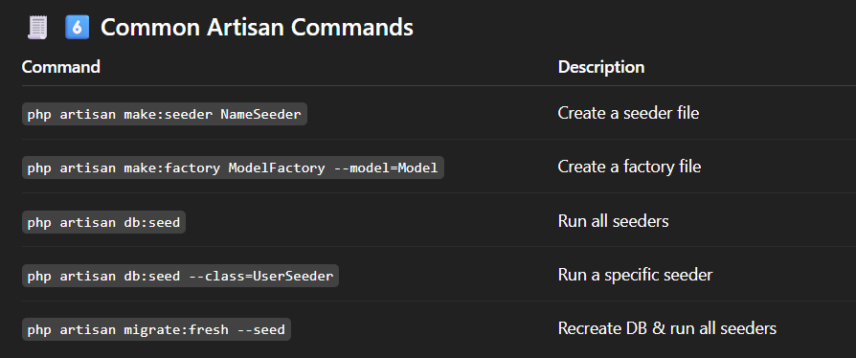

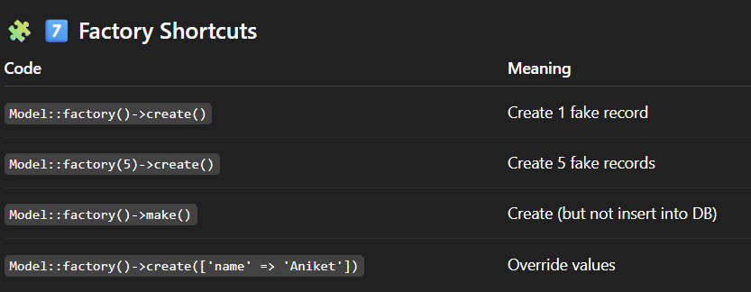

* **Faker**

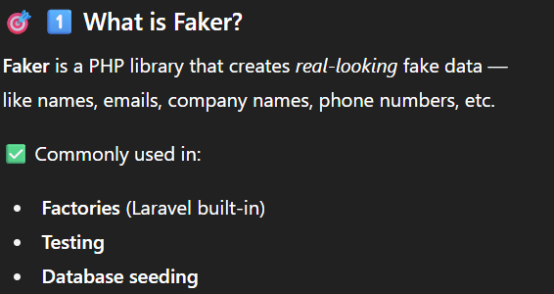

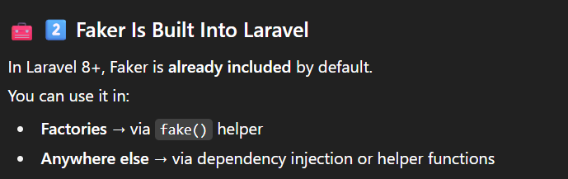

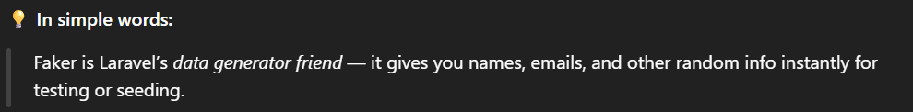

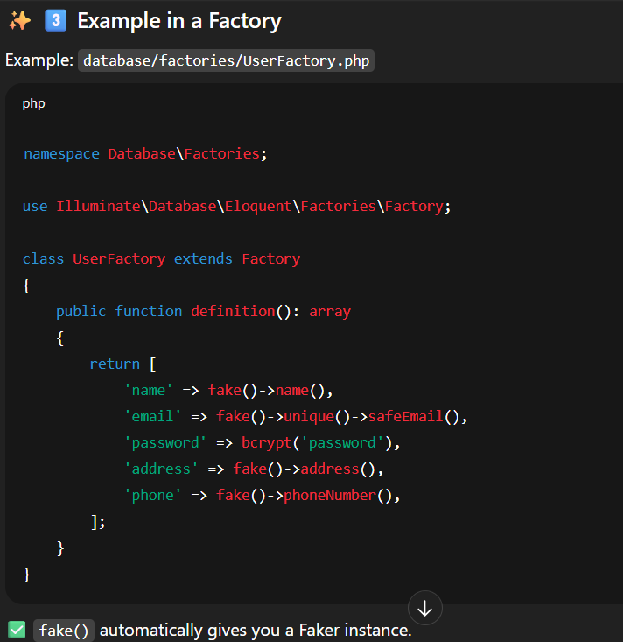

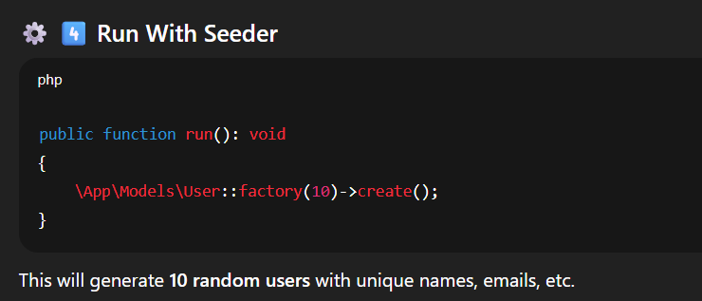

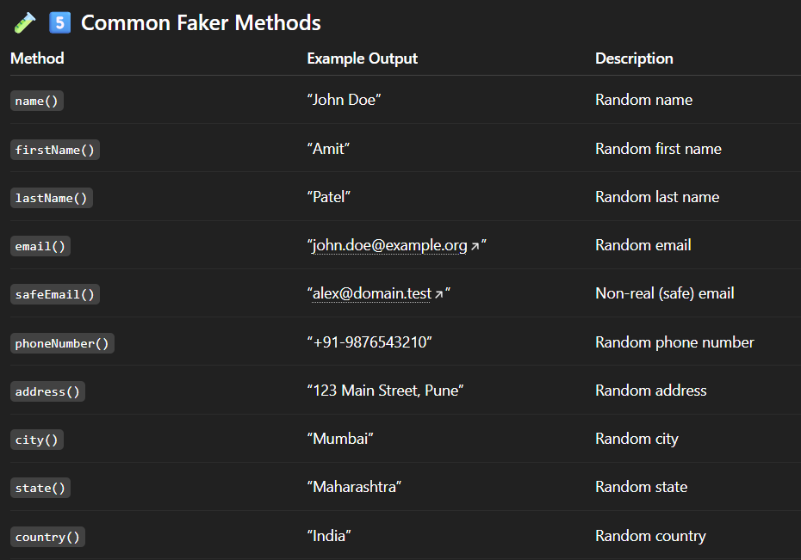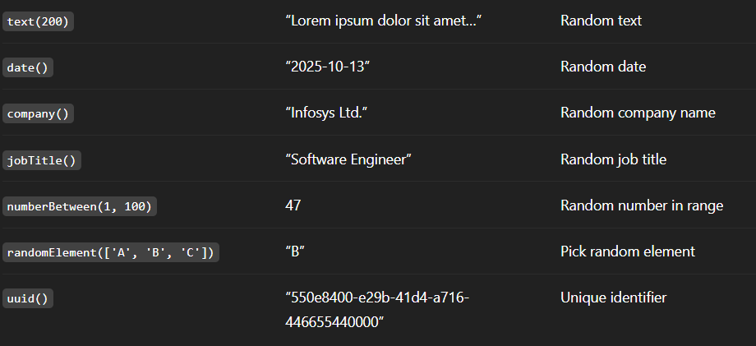

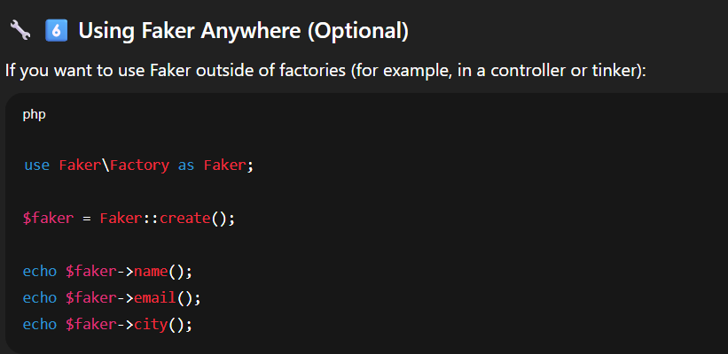

* Eloquent models

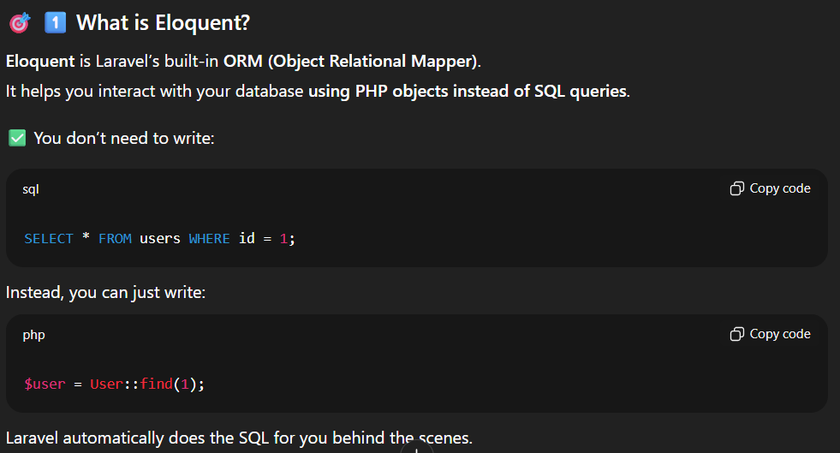

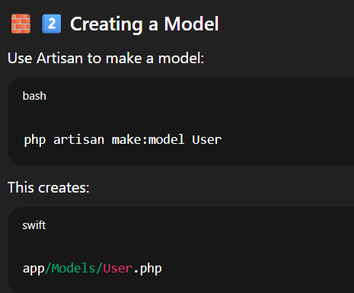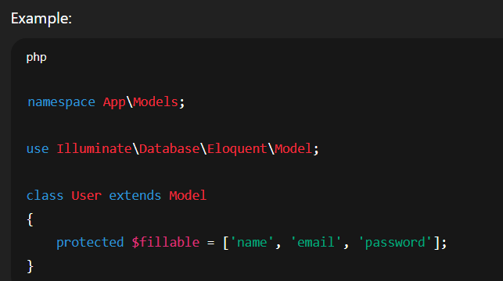

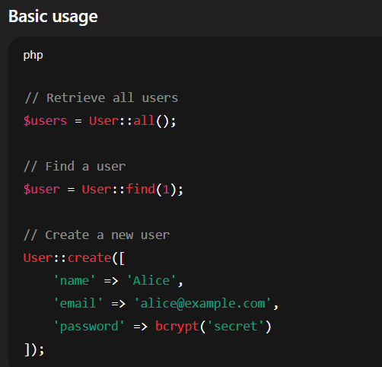

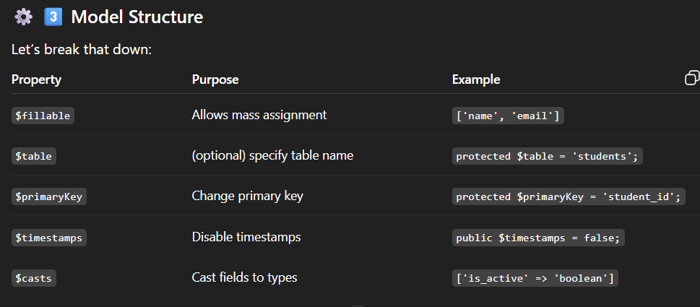

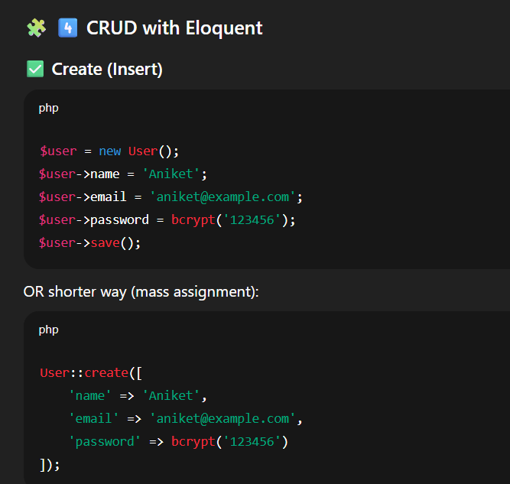

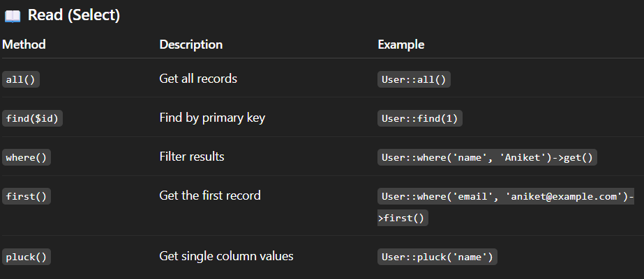

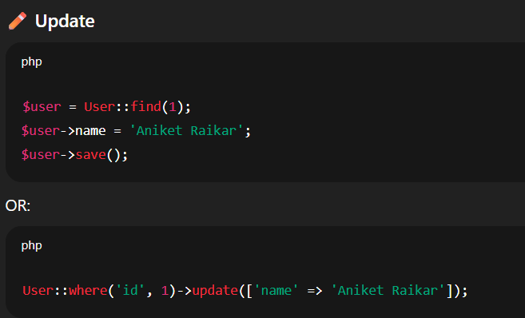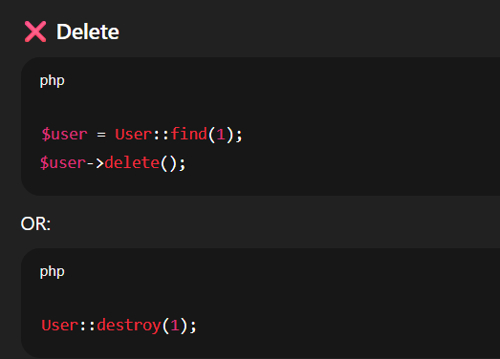

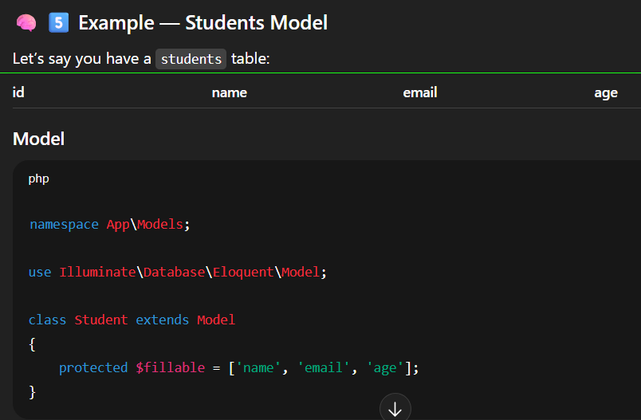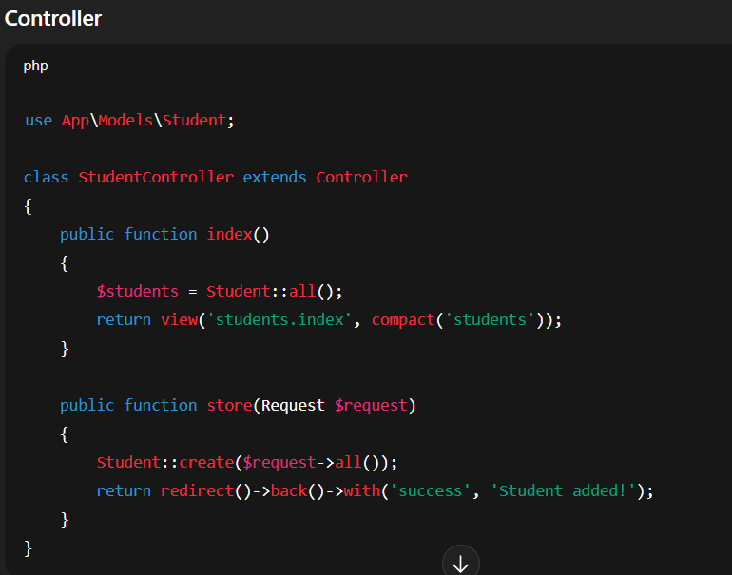

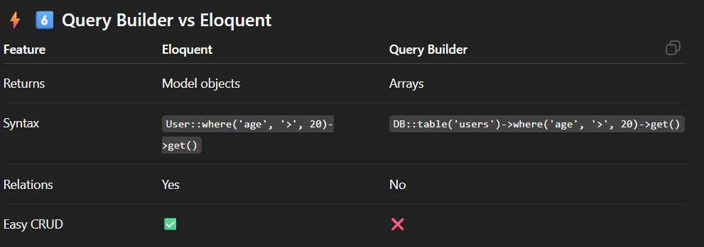

* **Mass assignment & casts**

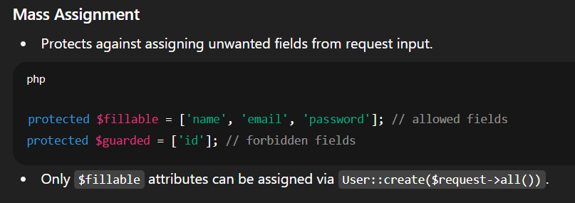

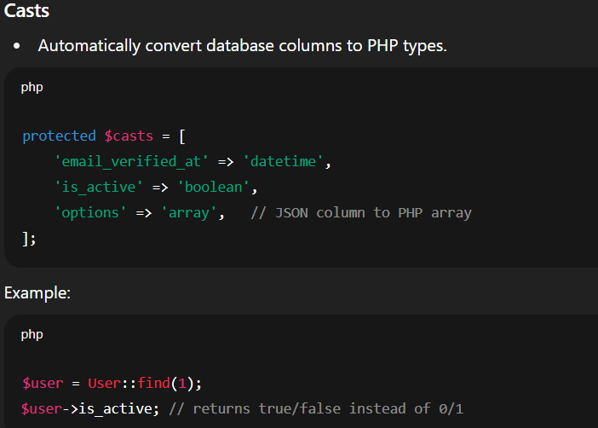

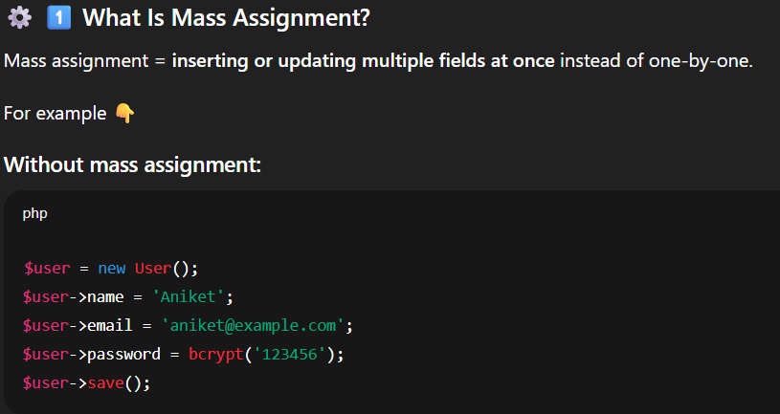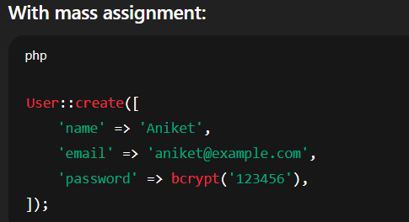

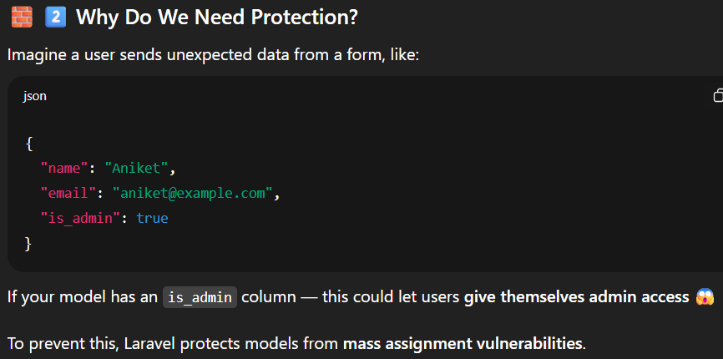

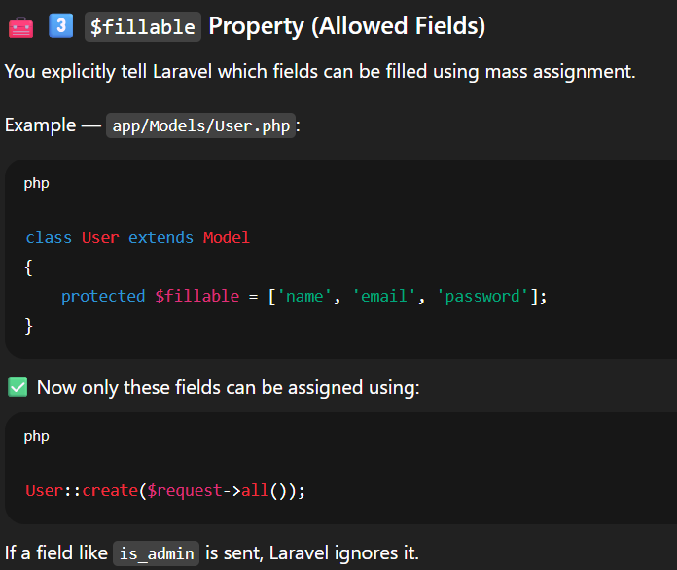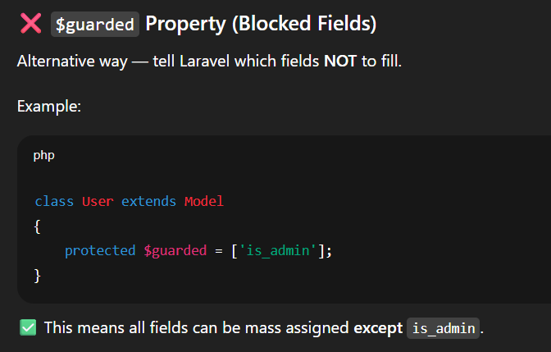

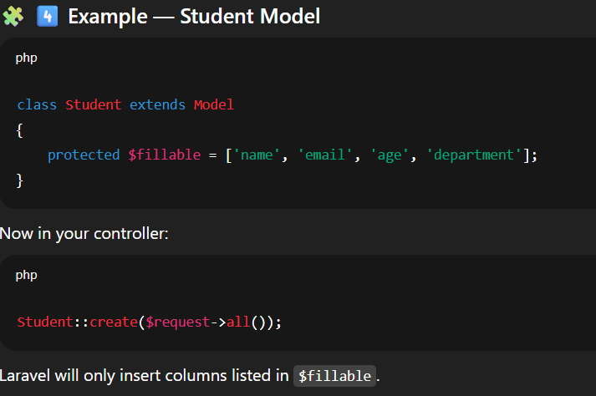

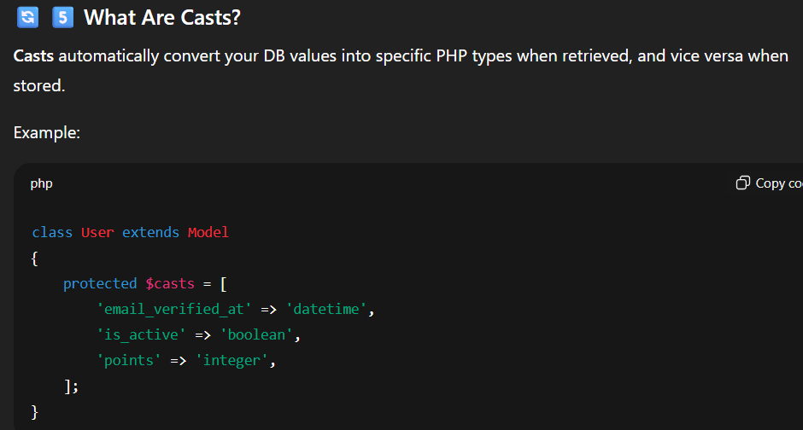

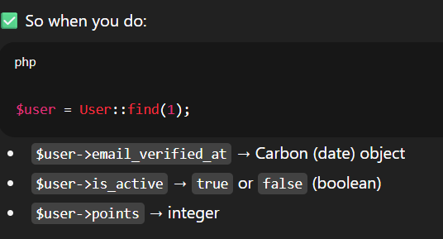

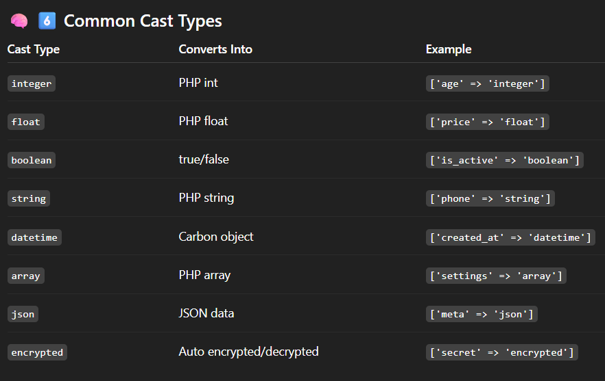

**Relationships (1-1, 1-n, n-n, morph) • Query builder vs Eloquent • Eager loading • Scopes & accessors/mutators • Pagination**

* **Relationships (1-1, 1-n, n-n, morph) :**

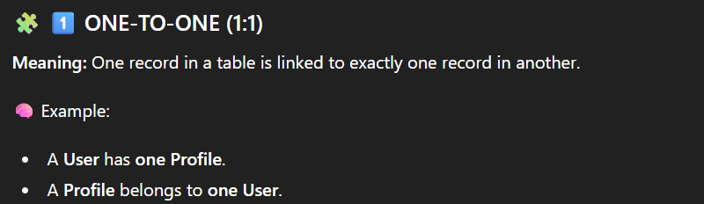

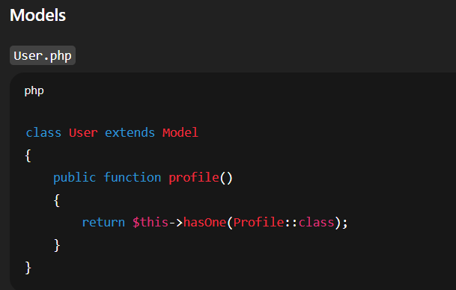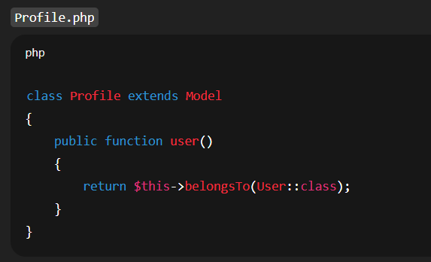

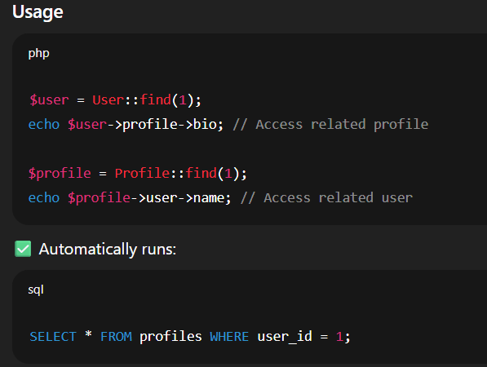

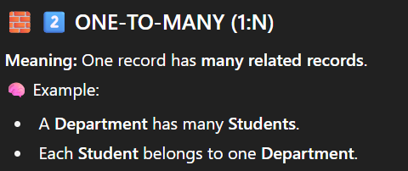

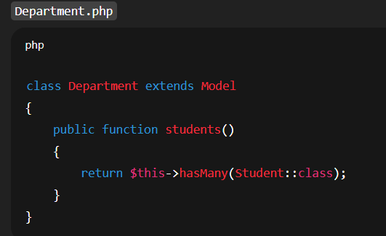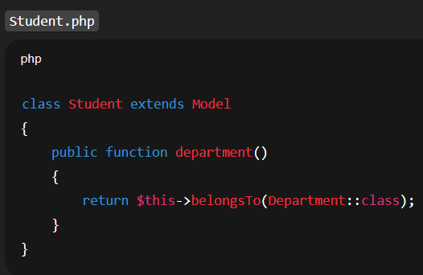

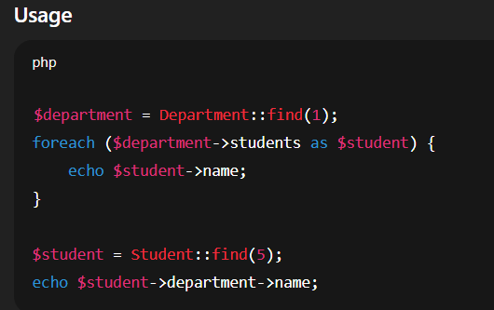

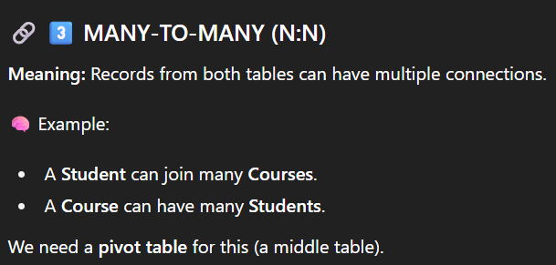

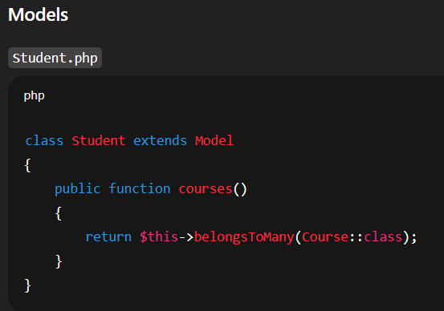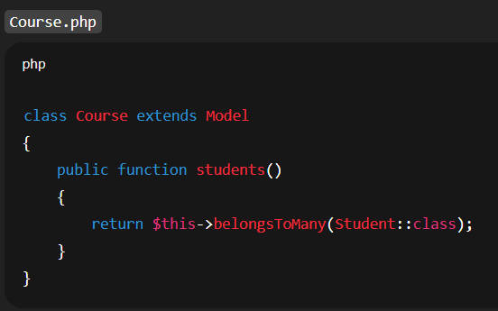

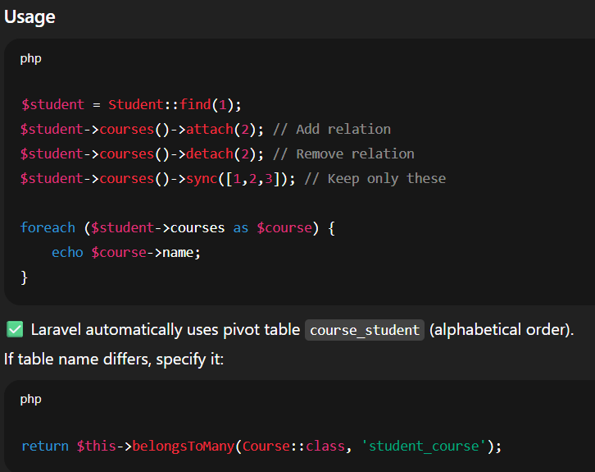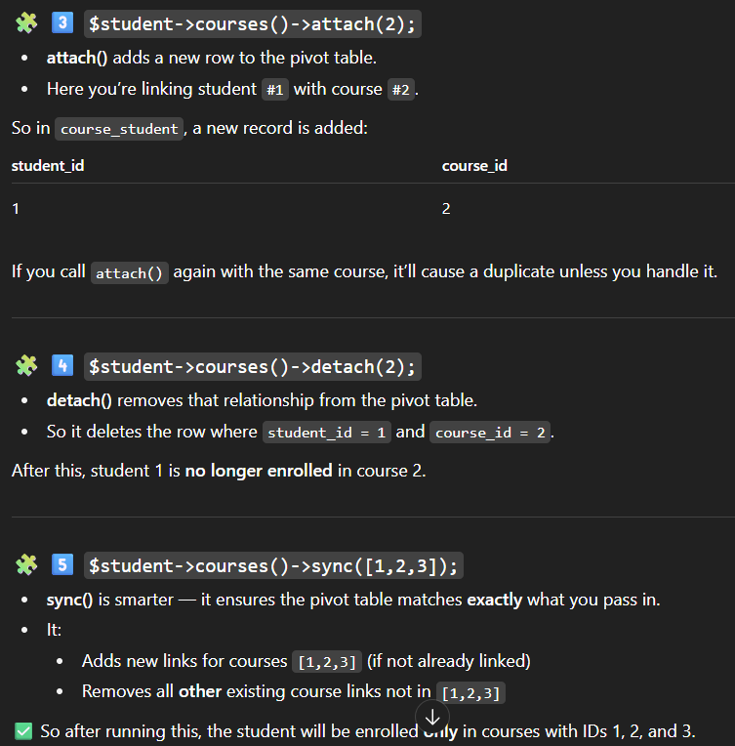

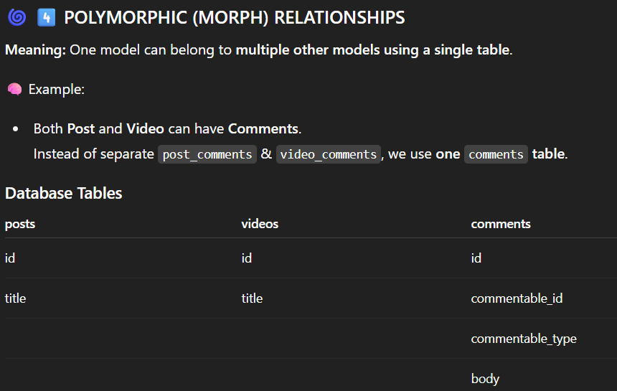

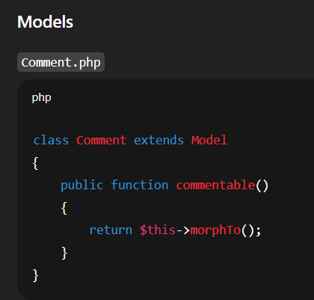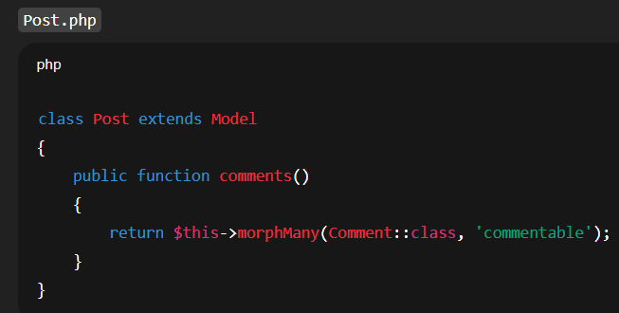

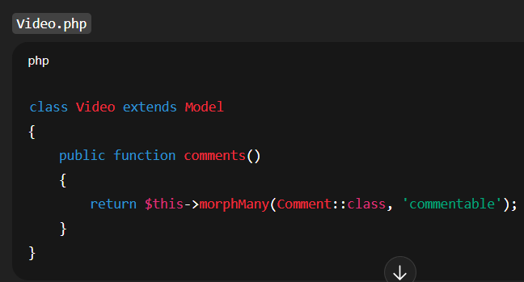

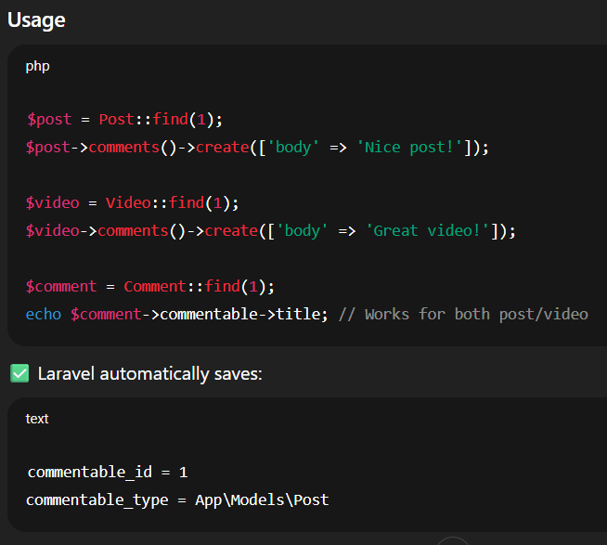

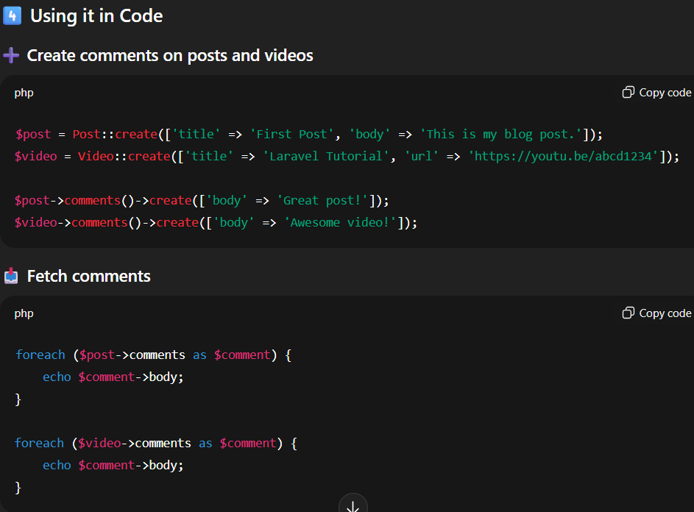

* **Query builder vs Eloquent:**

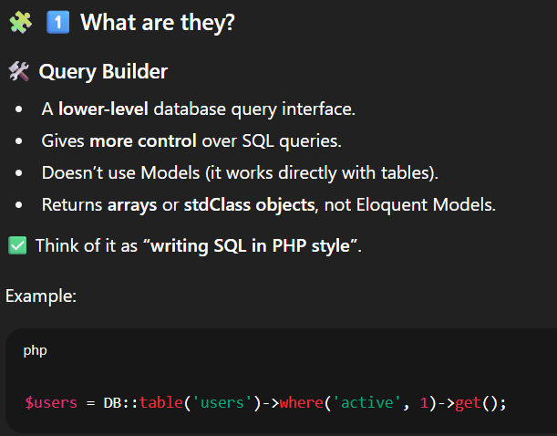 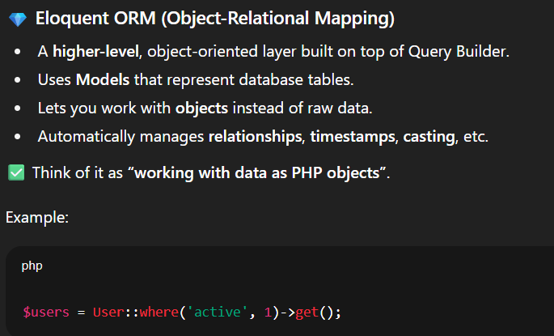

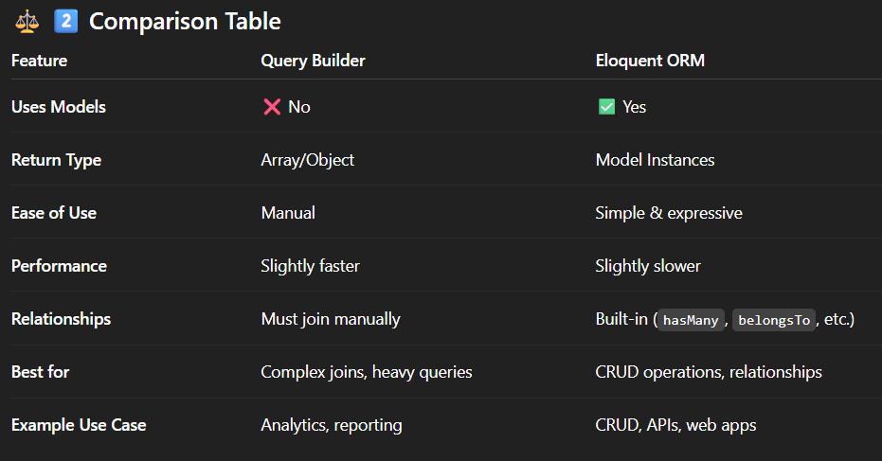

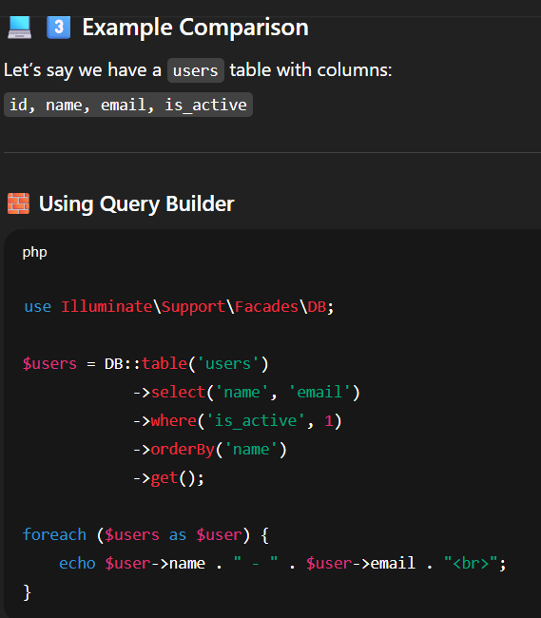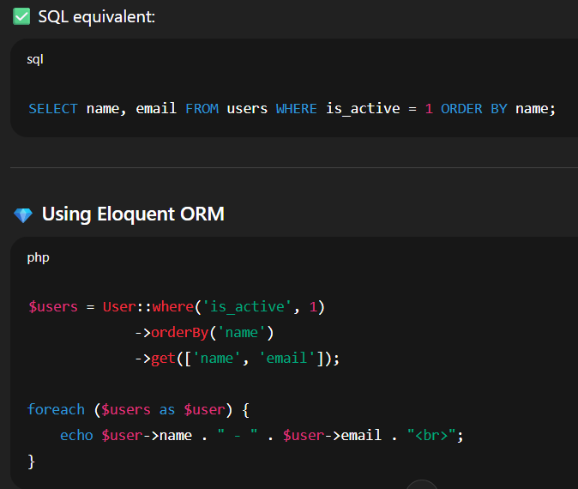

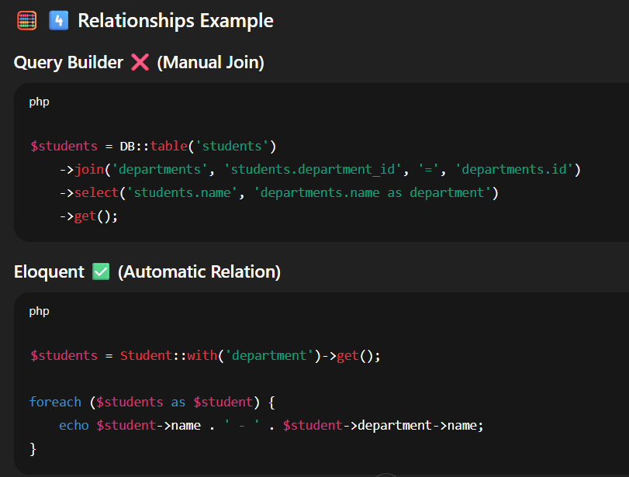



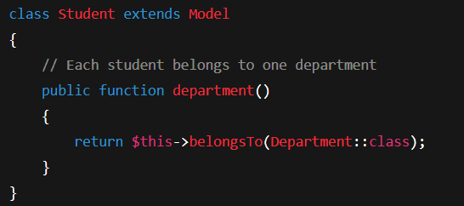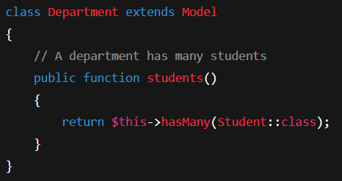

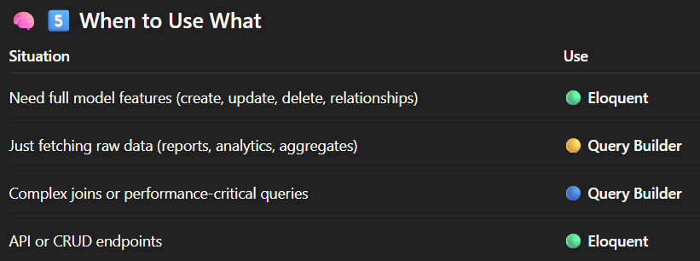

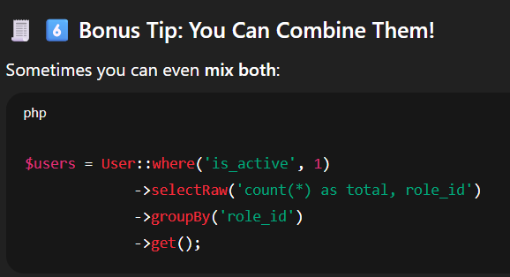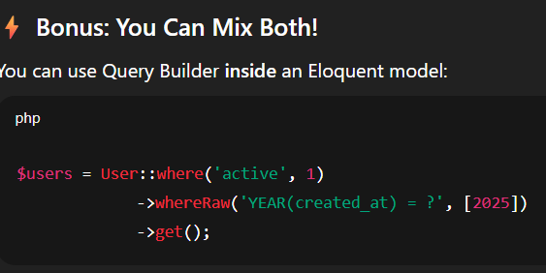

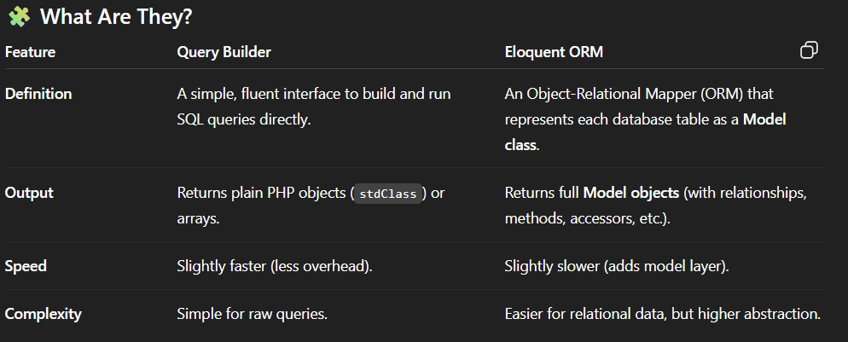

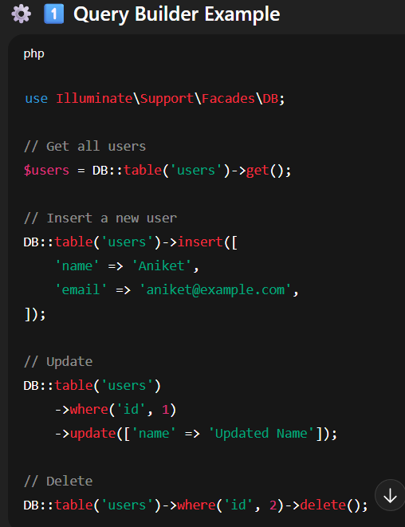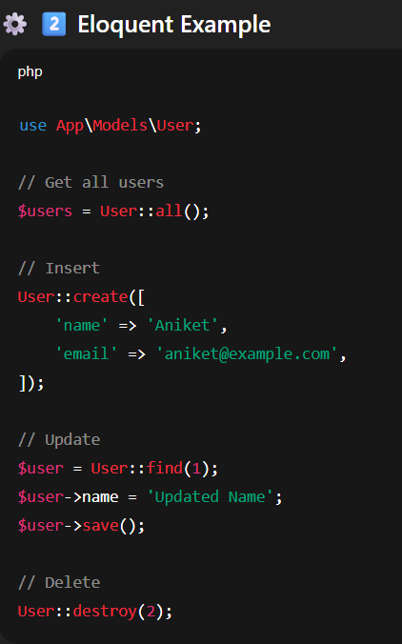

* Eager Loading

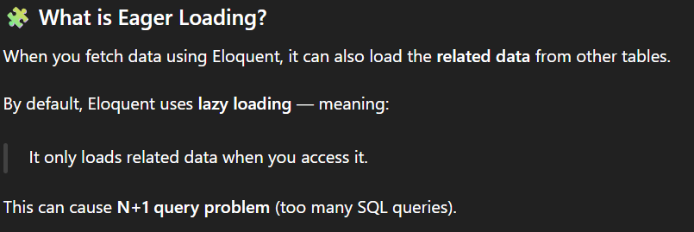

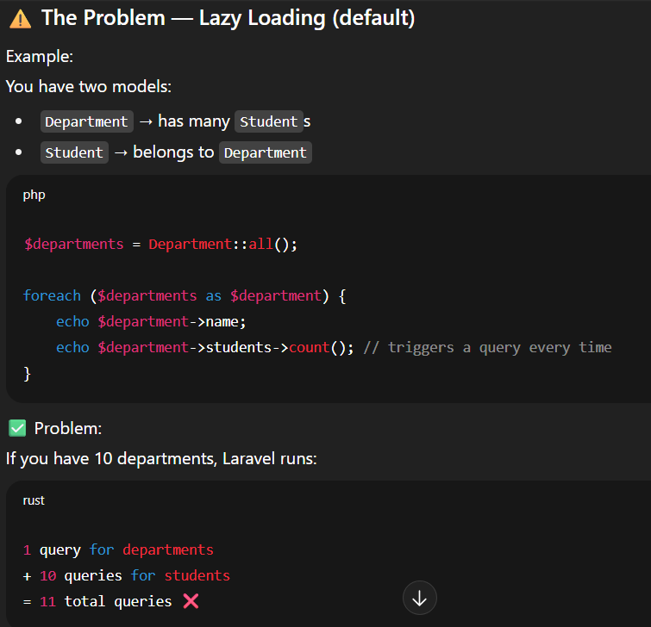

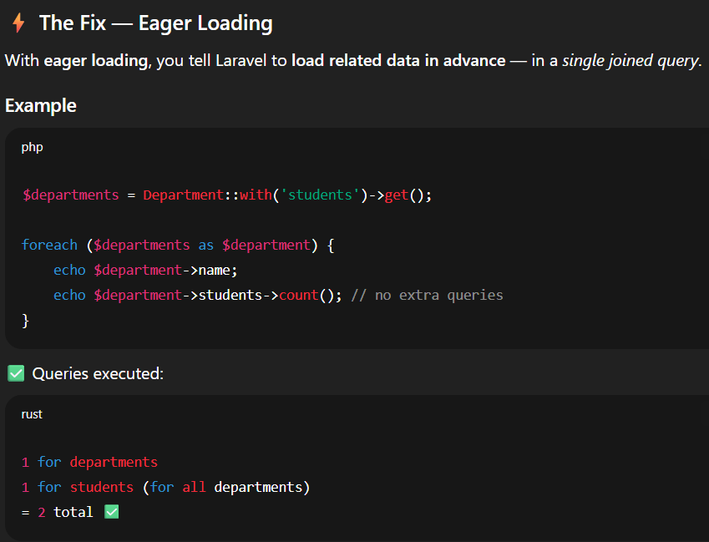

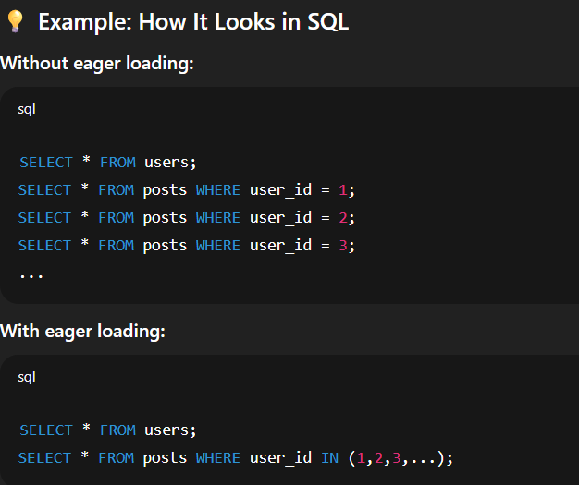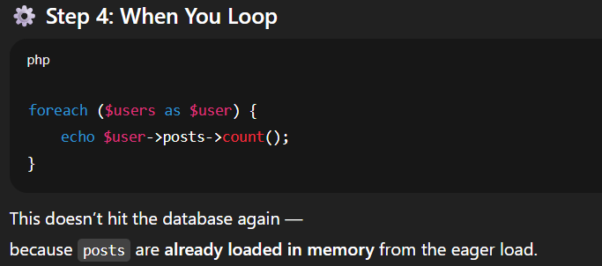

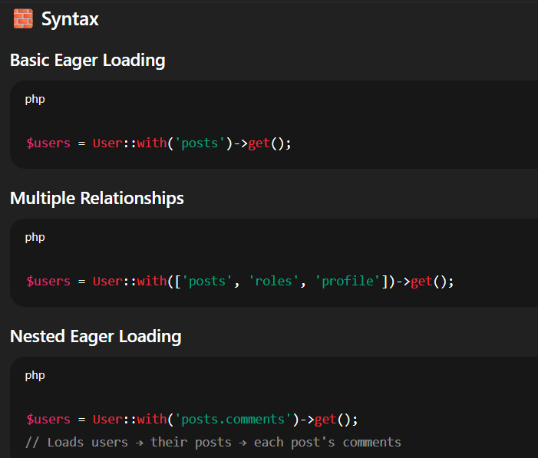

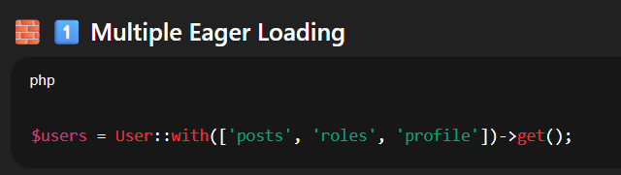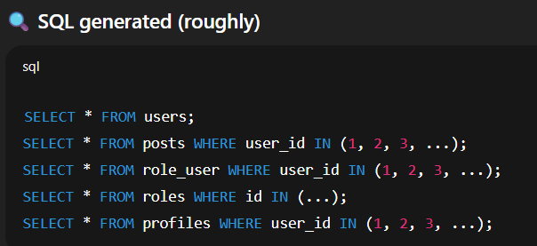

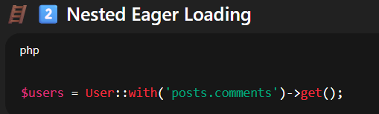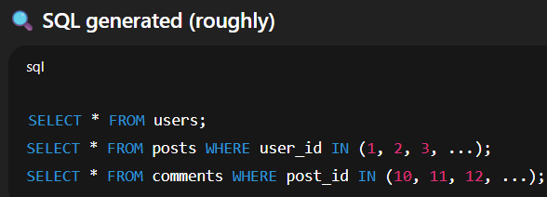

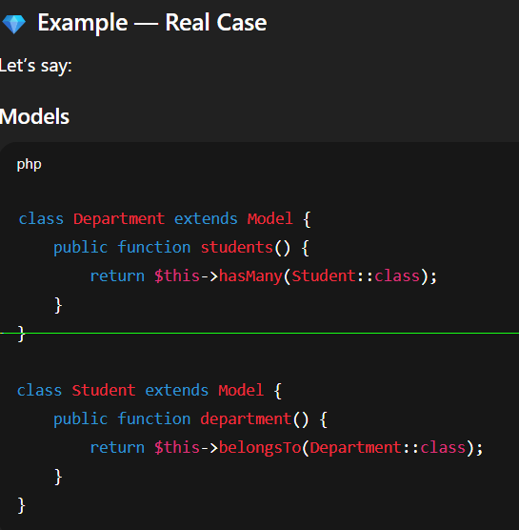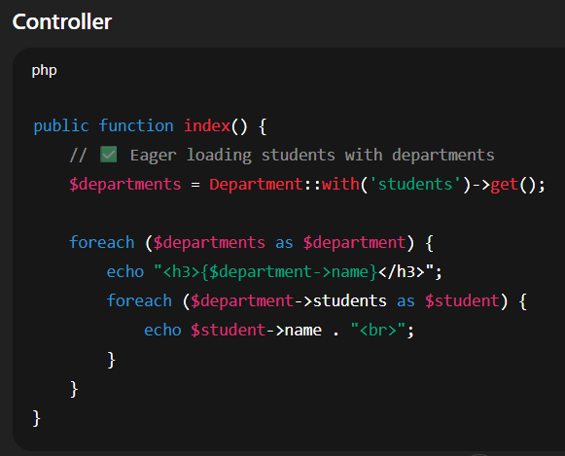

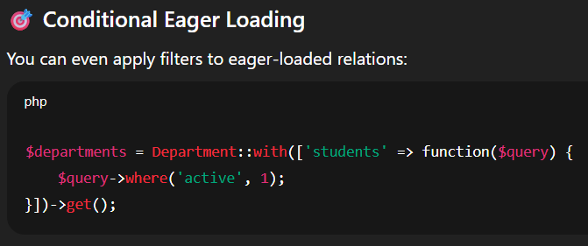

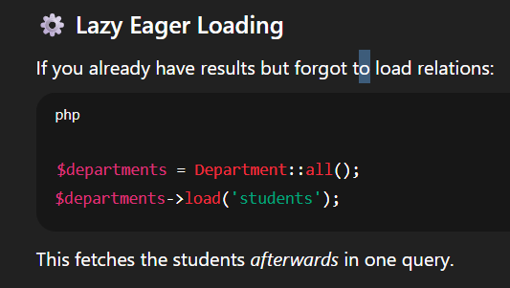

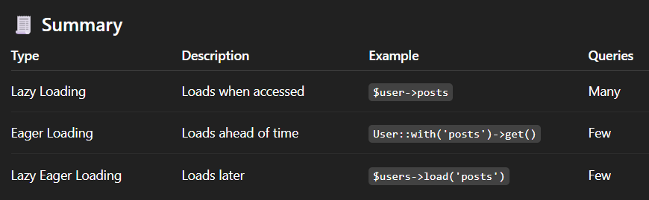

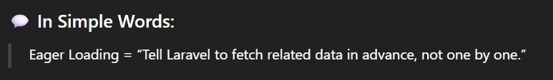

* **Scopes & accessors/mutators:**

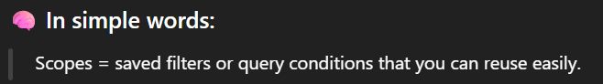

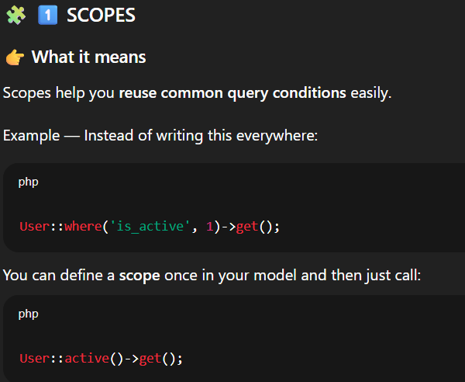

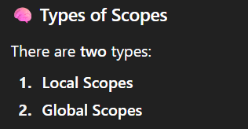

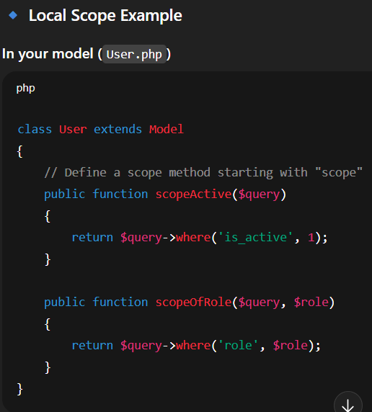

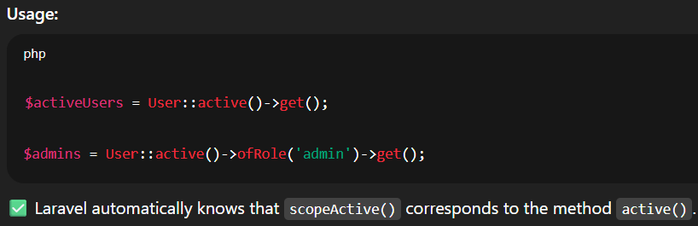

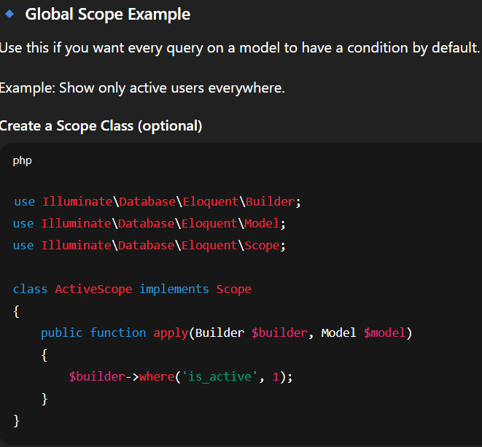

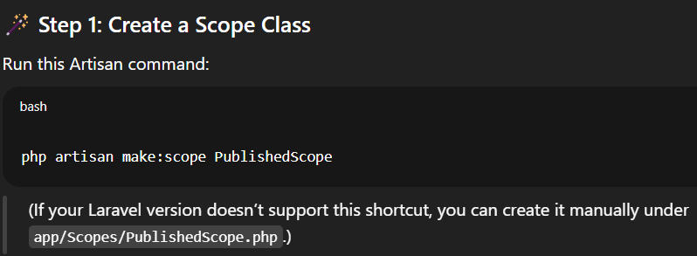

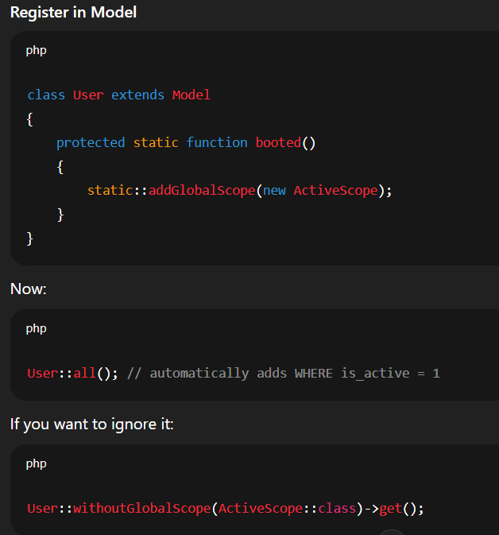

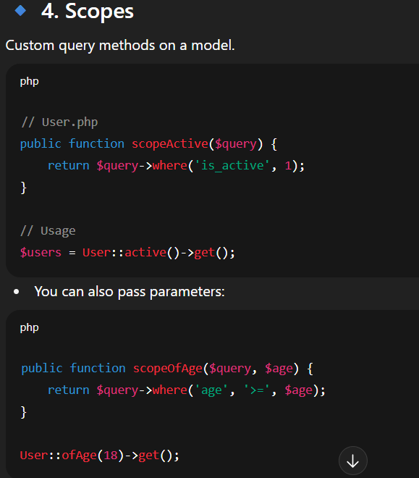

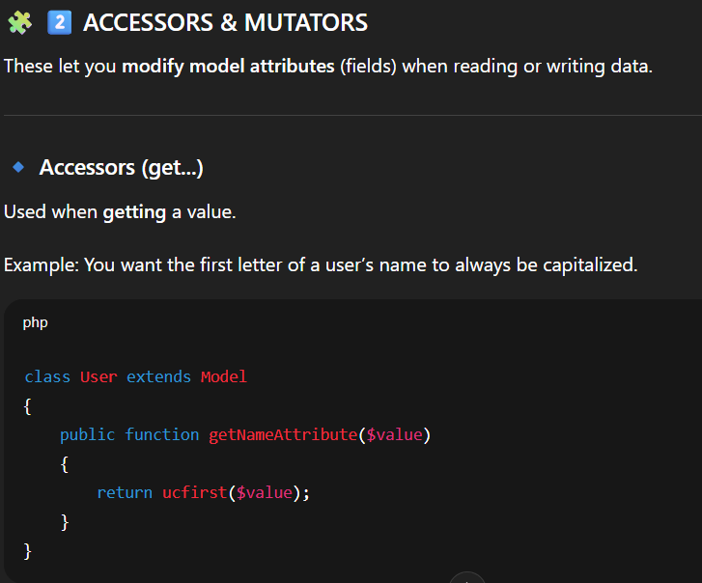

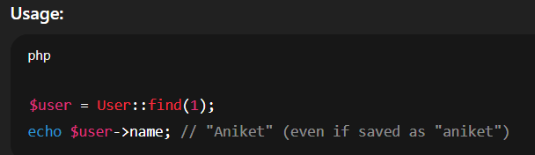

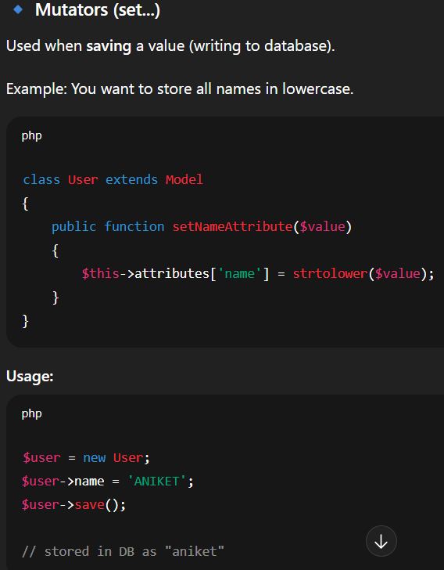

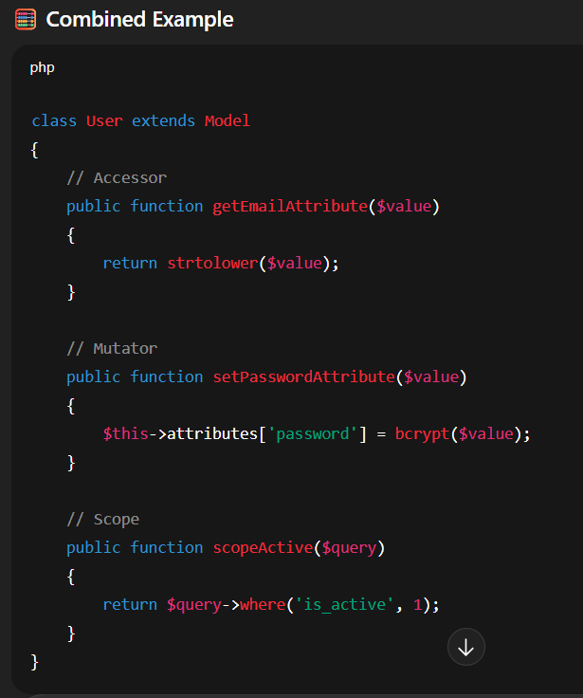

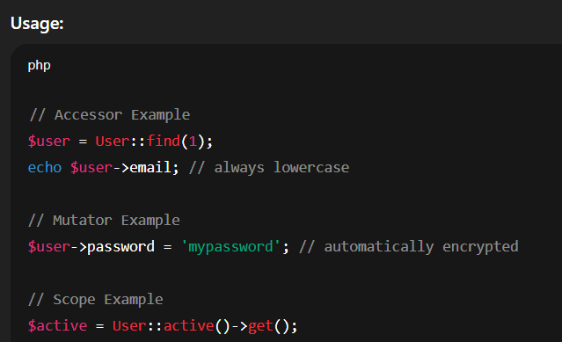

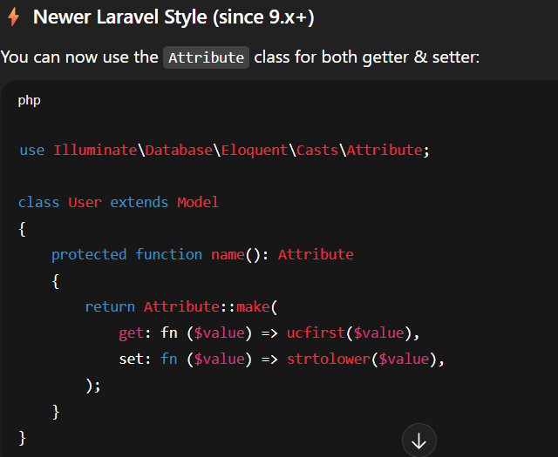

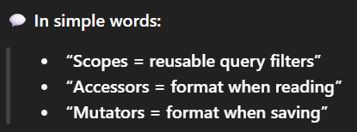

* **Pagination:**

